OPTIMIZATION FOR BIOGAS TO CHEMICALS VIA TRI-REFORMING. ANALYSIS OF FISHER-TROPSH FUELS FROM BIOGAS.
Borja Hernandez, Mariano Martin
Department of Chemical and Textile Engineering, Universidad de Salamanca, Plz. Caídos 1-5, 37008, Salamanca, Spain.
Abstract
This paper presents an optimization approach of biogas to syngas via tri-reforming. The optimization, formulated as a NLP problem, is performed for three syngas ratios: according to the product that wants to be obtained: methanol, ethanol or FT-fuels. As a result, the optimal operating conditions and biogas composition are defined. For the production of ethanol, a biogas composed by CH₄/CO₂ 52/48% is desired, requiring 0.035 molO₂/mol Biogas in the reformer. For the production of methanol and FT, the biogas with the largest content of methane is desired to be reformed with 0.275 molO₂/mol biogas. The largest H₂:CO ratio required for methanol is achieved by feeding steam in a WGS reactor after the reformer. The syngas optimization study is completed including the tri-reformer model into a process integration problem for the production of FT fuels from biogas via high and low temperature FT synthesis. The production cost for a plant fed with 12 MMm³/y of biogas results in $3/gal for biodiesel via HTFT and $1.7/gal via LTFT. A scale-up study is also carried out for plants with both modes of operation, showing a cut point for profitability at 450MMm³/y.

1-Introduction
Developed societies generate large volumes of organic wastes such as the sludge from water treatment, urban and forest residues or manure [1]. Most of this organic wastes require of treatment before disposing them back to the environment. Here, anaerobic digestion represents a technology that allows not only processing and stabilizing the waste, but that also generates additional value in form of biogas and digestate as part of a circular economy [2-4]. For decades, these products were the only ones obtained, being the biogas only applied for power production [5, 6] and as source of methane for natural gas networks [5][7][8]. However, biogas is an interesting carbon source not only because of the methane, but also due to its application in syngas generation. Initially, biogas was upgraded transforming the methane into syngas and hydrogen via steam (SR) [9-12] and auto-thermal (ATR) [13, 14] reforming. However, the inherent CO₂ of biogas can be also applied to syngas production via dry reforming (DR) [15]. Hernandez and Martin evaluated the possibility of using this biogas for the production of methanol via combined SR and DR [15]. Dry reforming does not only upgrade the biogas [16], but it also reduces CO₂ emissions in the process [15]. The syngas produced from the reformer was also evaluated by Hernandez et al. [17] for the production of other chemicals such as DME, ethanol or F-T fuels. However, the study was conceived as a product design problem and the evaluation was only based on the H₂:CO ratio and no process design has been performed for each of the chemical components produced except for methanol. The methanol production process defined by Hernandez and Martin [15] was thermodynamically evaluated by Vita,A. et al. [18] proposing upgrades such as the use of tri-reforming (TR) and providing a range of profitability for the process.
TR is a technology that combines three methane reforming processes [19]: SR (Eq. (1)), partial oxidation (POX) (Eq. (2)) and DR (Eq. (3)). The synergetic combination of these three technologies has the merit of high economical advantage of SR [20,21], high energy efficiency of exothermal POX [22,23], and environmental advantage of carbon dioxide reforming [9,24,25] .
$CH_{4}+H_{2}O ↔CO+3H_{2}$ $∆H_{298K}^{0}=+206\frac{kJ}{mole}$ (1)
$CH_{4}+\frac{1}{2} O_{2} ↔CO+2H_{2}$ $∆H_{298K}^{0}=-36\frac{kJ}{mole}$ (2)
$CH_{4}+CO_{2} ↔2CO+2H_{2}$ $∆H_{298K}^{0}=+247\frac{kJ}{mole}$ (3)
Kinetic models have been proposed and optimized for the study of tri-reforming process from methane [26,27] and natural gas [28, 29]. The integration of tri-reforming in process optimization and design has been only recently addressed by Balasubramanian et al. [30]. They performed an MINLP optimization selecting the optimal reformer, including tri-reforming, for different H₂: CO syngas ratios and using natural gas as raw material [30]. However, there are not optimization studies referred to biogas TR and complete process design of fuels production has been also omitted. Thus, in this work we propose a parametric optimization approach evaluating different O₂:Biogas ratios. The optimization is first applied for the production of syngas with different H₂:CO ratios depending on the syngas application: for the production of methanol, DME, ethanol or F-T. The study allows identifying the optimal type of reformer, the optimal biogas composition and if external supply of CO₂, steam or oxygen are required.
The manuscript is completed with a second study. A new integrated process design for the production of FT fuels from biogas as raw material is proposed for the first time. Biogas is not only used for the direct production of FT fuels, but it is also considered in the operation of complementary units such as the burner, where it is used as fuel, or the hydro-treatment unit where the hydrogen used to recover the wax obtained at low temperature FT (LTFT) is obtained from biogas reforming.
The rest of the sections of the paper are structured as follows. In Section 2, the modelling issues for the process optimization of biogas to syngas via tri-reforming are described. In Section 3, the modelling issues for the process design of syngas to Fischer-Tropsch fuels are defined. In Section 4, the results are presented. Finally, the conclusions are drawn in Section 5.
2.- Modelling issues. Biogas to syngas
The process section of syngas production from biogas is presented in Figure 1. The biogas generated from anaerobic digestion is mainly composed by methane and CO₂, apart from other substances in small quantities such as nitrogen, H₂S, steam or NH₃. These components of the biogas together with the rest of the components of the tri-reforming system belong to the set $J=\{CH_{4},CO_{2}, N_{2},,H_{2}S, H_{2}O, NH_{3}, H_{2},CO, O_{2}\}$. Before processing the biogas, some of its components need to be removed since they can reduce the catalyst efficiency. Thus, a clean-up stage is initially introduced in the modelling in order to adapt the biogas to the reformer requirements. After the reforming, it may be necessary to clean and tune-up the H₂:CO ratio of the syngas. A cleaning process to absorb the unreacted and impurities is initially proposed. It is followed by a hydrogen tuned-up section and then by a CO₂ removal section.
Figure 1. Syngas processing.
2.1 Biogas cleaning section.
Biogas is a complex mixture of gases with a wide range of components and different compositions [6, 31 ,32]. For simplification purposes, the ranges of composition provided in Table 1 are taken.
Table 1. Ranges of concentration for components of the biogas [32].
Component (%vol) | Minimum | Maximum
CH₄ | 0.37 | 0.75
CO₂ | 0.25 | 0.50
N₂ | 0.01 | 0.17
H₂S | 2•10⁻⁵ | 2•10⁻³
H₂O | 0 | 0.031
Ammonia | 1•10⁻⁶ | 3.5•10⁻⁶

The biogas is fed to a mixed-packed bed of Fe₂O₃ and zeolites for the removing of H₂S and ammonia. The bed can operate at 298-323 K and the capture of the ammonia is carried out by the zeolites, meanwhile for H₂S captured is performed as follows [8]:
$Fe_{2}O_{3}+3 H_{2}S→Fe_{2}S_{3}+3H_{2}O$ (4)
The removal of ammonia is modelled assuming an efficiency of 100% and the removal of H₂S is modelled following the stoichiometry of the reaction assuming complete conversion of the sour gas. The Fe₂O₃ of the bed can be regenerated using oxygen [8].
Figure 2. Biogas cleaning and reforming.
2.2 Biogas Tri-reforming.
As previously presented, TR combines the highly endothermic steam and dry reforming reactions with the exothermic partial oxidation of methane, improving the energy efficiency of the process [23]. Apart from these three reactions, the competitive water-was shift (WGS) reaction needs to be taken into account during the reforming processes [15][29], see eq. (5).
$CO+H_{2}O ↔CO_{2}+H_{2}$ $∆H_{298K}^{0}=-41\frac{kJ}{mole}$ (5)
The modelling of the reformer is based on chemical equilibria. The kinetic studies of Arab Aboosadi et al. [33] and Chein et al. [27] showed that oxygen reacts with methane at the beginning of the reactor and then the components are distributed according to the equilibriums achieved. Thus, TR is implemented in the optimization as follows. The mass balances in the tri-reformer are decomposed in two stages and one energy balance is carried out for the entire unit. In the first stage, the oxygen reacts as in eq. (2) and a conversion of 100% is assumed. In the second stage, DR, SR and WGS occur until the equilibria given by eqs. (6)-(8) is achieved [34][35].
$k_{p}=e^{\left[31.447-\frac{29580}{T}\right]}=\frac{P_{CO}P_{H_{2}}}{P_{CH_{4}}P_{CO_{2}}}$ (6)
$k_{p}={10}^{\left[-\frac{11650}{T}+13.076\right]}=\frac{P_{CO}P_{H_{2}}^{3}}{P_{CH_{4}}P_{H_{2}O}}$ (7)
$k_{p}={10}^{\left[\frac{1910}{T}-1.784\right]}=\frac{P_{CO_{2}}P_{H_{2}}}{P_{CO}P_{H_{2}O}}$ (8)
The atomic balances are also performed in this second stage as follows:
${\left.mol_{CH_{4}}\right|}_{in}={\left.mol_{CH_{4}}+mol_{CO}+mol_{CO_{2}}\right|}_{out}$ (9)
${\left.4∙mol_{CH_{4}}+2∙mol_{H_{2}O}\right|}_{in}={\left.4∙mol_{CH_{4}}+2∙mol_{H_{2}}+2∙mol_{H_{2}O}\right|}_{out}$ (10)
${\left.mol_{H_{2}O}\right|}_{in}={\left.mol_{H_{2}O}+mol_{CO}+2∙mol_{CO_{2}}\right|}_{out}$ (11)
The energy balance in the reactor is computed as from eq. (12):
$Q\left('reformer^{'}\right)=Q_{prod}+Q_{react}=\sum_{i}{fc(i,}reformer,HE2)∙\left(∆H_{f}+\int_{T_{ref}}^{T_{out}}{C_{p}dT}\right)-\sum_{i}{fc(i,}HE1, reformer)∙\left(∆H_{f}+\int_{T_{ref}}^{T_{out}}{C_{p}dT}\right)-\sum_{i}{fc(i,}HE6, reformer)∙\left(∆H_{f}+\int_{T_{ref}}^{T_{out}}{C_{p}dT}\right)$ (12)
The amount of fuel required to be burned is computed assuming that the energy in Q(‘reformer’) is provided by lower heating value (LHV) of the fuels fed in the burner. The LHV is determined as function of the components that are recycled from the F-T and the supported biogas fed following eq. (13). For the parametric optimization of biogas to syngas described in this section, the recycling of gases from FT is set to zero.
$Q\left('reformer^{'}\right)=LHV_{CH_{4}}∙\left(m_{CH_{4} Biogas}+m_{CH4 FT}\right)+LHV_{H_{2}}m_{H_{2} FT}+LHV_{CO}m_{CO FT}$ (13)
2.3 Syngas cleaning and composition adjustment.
The gas coming out of the reformer is sent to a purification stage, Figure 2, where the H₂:CO ratio is tuned-up according to the product that wants to be synthesized. First, water is removed in a two-step process using a flash before compression and a dephlegmator right after. Next, a PSA system is used to remove the last traces of hydrocarbons and nitrogen in order to avoid the deposition of carbon on the catalyst surface [36]. It operates at 298 K and 4.5 bar using silica gel as adsorbent with an assumed efficiency of 100% [37]. Thus, the gas coming out from the reformer needs to be compressed and cooled down. The compressor is modelled assuming polytrophic behaviour. During the cool down, the water condensates and it is discharged. The PSA system is modelled as two beds, one operating and other one in regeneration to allow the continuous operation of the plant.
Figure 3. Syngas purification.
Next, the syngas H₂:CO ratio is tuned-up. Three systems are allowed to modify the ratio: A WGS reactor to increase the amount of hydrogen, a bypass and a hybrid membrane-PSA system to reduce the hydrogen [37].
The last cleaning stage is based on the removal of CO₂ for the preparation of the syngas as it can be seen in Figure 3. CO₂ can be fully or partially removed dependent on the composition required for synthesis. For methanol production, the CO₂ composition is required to be from 2% to 8% in volume [38]. In the production of ethanol and Fisher-Tropsch fuel the CO₂ content is limited up to 6% in volume to avoid the reduction of CO conversion [39]. To achieve this concentration, only part of the gas stream needs to be treated in the PSA system. The PSA absorbs the excess of CO₂ using Zeolite 5A or 13X. It works at 298 K and 5 bar with an adsorption capacity around 0.1 kg of CO₂ per kg of zeolite that allows the removal of 95% of the CO₂ [40]. Thus, the stream coming from previous stage needs to be compressed and cooled it down. In this section, the water also condensates and it needs to be separated before access to the PSA membrane by mean of Flash-4.
2.4 Solution procedure.
The problem addressed in this section is divided in three cases according to the syngas application. The H₂:CO ratios are fixed to 2.5 for methanol [41], 1 for ethanol and 1.7 for FT fuels [30]. The following objective function, eq. (14), is evaluated for the three cases. The values for the prices of the components involved in the objective function are $3.3/1000 ft³ for methane [42], $0.021/kg for the O₂ [28], $26 per tonne of CO₂ [43]. The utilities are assumed to have a price of $5.7•10⁻⁵/kg for cooling water, $0.019/kg for steam and $0.06/kWh for electricity [44]. Finally, the Fe₂O₃ bed cost to remove H₂S is $90 per kg of H₂S removed [15].
$profit=C_{H_{2}}F_{H_{2}}-C_{elec}\sum_{iϵCompressors}{W_{i}}-C_{CH_{4}}\sum_{iϵCH_{4}inlets}{F_{CH_{4}}}-C_{O_{2}}F_{O_{2}^{'}Triref^{'}}-C_{CO_{2}}\sum_{iϵCO_{2}inlets}{F_{CO_{2}}}-C_{q}\sum_{jϵQ_{heat}}{Q}+C_{w}\sum_{kϵQ_{refrig}}{Q}-C_{H_{2}S}F_{H_{2}S}-C_{H2O}F_{H2O}$ (14)
The equations involved in the problem show non-linearity such as the logarithmic, exponential and inverse functions of the equilibrium equations. Therefore, an NLP optimization is applied to every syngas ratio and changing the O₂:Biogas ratio. It consists of 866 variables and 678 equations. The O2:Biogas ratios evaluated go from zero to 0.3:1.
3.-Modelling issues. FT process design.
In this section we present the modelling issues for the design of the biogas to FT fuels integrated process. FT synthesis produces alkanes that need to be introduced in the component set as $J=\{CH_{4},CO_{2}, N_{2},H_{2}S, H_{2}O, NH_{3}, H_{2},CO, O_{2},LPG, Gasoline,Diesel,Heavy\}$. We consider 4 more fractions of alkanes as it is presented in section 3.2.
The process superstructure is presented in Figure 4. It addresses the two possible modes of Fischer-Tropsch synthesis. On the one hand, FT-fuels production can be carried out at high temperature, between 590 K and 630 K. On the other hand, the operation can be performed at low temperature, between 440 K and 530 K [45]. Depending on the mode of operation selected in the FT synthesis, the design of the reactor is different and the products obtained are also different [45], which modifies the separation and purification operations required.
In HTFT only traces of waxes are obtained together the rest of the products in the same stream, requiring a separation performed in two stages [46]: First, the most valuable liquid organic products, gasoline and diesel, are separated from the gases and water obtained in the FT synthesis. Second, fuels are separated and purified by means of a distillation column.
LTFT is carried out in a fixed bed reactor, obtaining a stream composed of two phases: A liquid phase composed by the heavy fractions (waxes) and a gas phase with the rest of FT products [46]. The amount of waxes obtained in this synthesis is more significant and a recovery of diesel and gasoline is also considered in the modelling of the process. The recovery is performed using a hydro-cracking reactor, which uses the hydrogen previously separated from the syngas and produces gasoline and diesel that are lately separated in a distillation column such as in HTFT.

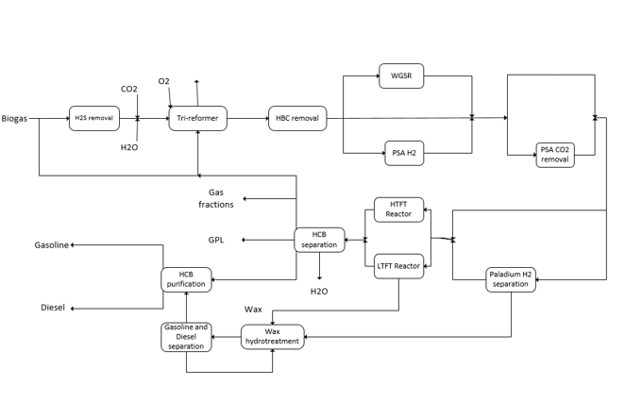
Figure 4. Integrated process of biogas to FT-fuels via tri-reforming.
In the following sections, the models in each of the process stages are defined. We start the definition from the syngas previously presented in Section 2. Its generation is not presented again but it is also included in the process design and integration. The only difference to be noticed is that the H₂:CO ratio of the syngas is not fixed as before. Now, the boundaries are provided in the feed of the reactor, allowing the separation of hydrogen. Thus, in section 3.1 the hydrogen separation and FT reactants adjustment are discussed. Then, in section 3.2 the FT reactor is defined in its two modes of operation. Finally, in section 3.3, the separation, purification and hydro-treatment stages are presented in two parts: first, the separation of products involved in the HTFT and second, the LTFT.

3.1. Hydrogen generation and adjustment for Fischer-Tropsch
The syngas is initially fed to a palladium membrane where hydrogen is separated. The separation efficiency of the membrane is assumed to be 100%, working at 12 bar and 298 K [47]. Thus, the syngas needs to be compressed and cooled down before reaching the membrane. To avoid the presence of liquid water, a dephlegmator is defined before Sppliter-4. Two streams are obtained from the membrane. The hydrogen permeated is recovered at 1 bar of pressure and the stream that contains the rest of components is assumed not to have pressure drop [47].
Since H₂:CO ratio between 1 and 2 needs also to be ensured in the later F-T reactor, a splitter is previously required to separate the correct amount of hydrogen. Splitter-4 divides the flow in two streams that are later mix. One stream goes to the membrane and the other stream is a bypass sent to mixer M-4.
After the mixer, the syngas with a H₂:CO ratio between 1 and 2 needs to be compressed up to 30 bar; and a temperature between 440 K and 530 K for the LTFT reactor or between 590 K and 630 K for the HTFT reactor [46]. Thus, a compressor followed by a heat exchanger are defined before the reactor.
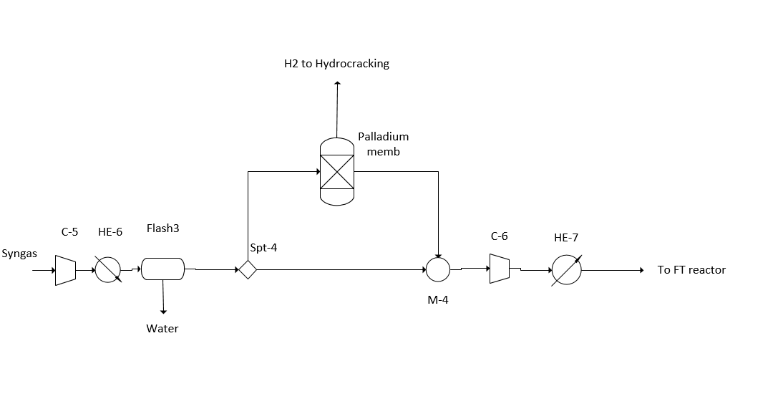
Figure 5. H₂ separation and synthesis.
3.2 Fischer-Tropsch reactor.
The reactions taking place in a Fischer-Tropsch reactor are equivalent to a polymerization where larger chains are achieved thanks to the dissociation of CO over the catalyst. The main reactions can be seen in eqs. (15)-(16). The first reaction in eq. (15) corresponds to methanation, the second is the water gas shift and the third reaction is the Boudouard reaction. The methanation reaction and the Boudouard are undesirable [48] [49].
(15)
The reaction given in eq. (16) is desired, and is the most dominant reaction when applying cobalt-based catalyst. When using iron-based catalyst, the WGS reaction also occurs.
$nCO+\left(n+\frac{m}{2}\right)H_{2}→C_{n}H_{m}+nH_{2}O$ (16)
The operating conditions depend on the types and quantities of Fisher-Tropsch products desired. Two operating modes can be selected: HTFT (590-630 K) with pressures between 10 bar and 40 bar and iron based catalyst, or LTFT (440-530 K) with iron or cobalt catalyst [48][50]. The iron catalyst working around around 30 bar provides high selectivity for C₁₀-C₁₈, which means high selectivity for diesel production [46][48][50]. The H₂:CO ratio shows an optimal for H₂:CO=1.3:1 when the reactor is optimized individually [48], but limits between 1:1 and 2:1 are used as boundaries [50] [51].
To determine the operating conditions in each of the two modes proposed, Anderson-Schulz-Flory distribution is assumed to model the products distribution [52]. The fraction of mass of the hydrocarbons, w_{i}, depends on the probability of chain growth, α. A conversion of 0.9 in CO is considered based on the results by Park & Norbeck (2009).[53] According to the studies of Song (2004),[54] α is a function of the temperature, and the ratio CO to H₂ through eqs. (17)-(18) determine w_{i}. The effect of α on the distribution of products obtained in the reaction is presented in Figure 6.
$w_{i}=α^{i-1}{\left(1-α\right)}^{2}∙i$ (17)
$α=\left(0.2332∙\left(\frac{y_{∞}}{y_{H_{2}}+y_{∞}}\right)+0.633\right)∙\left(1-0.0039∙\left(\left(T_{Synthesis}+273\right)-533\right)\right)$ (18)
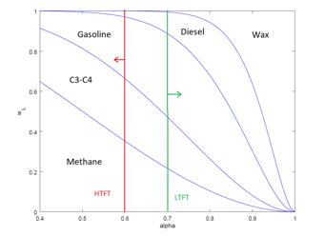
Figure 6. Distribution of products from FT reaction and ranges of operation for HTFT and LTFT.
Figure 6 also includes the ranges of products obtained for HTFT and LTFT when eqs. (17) and (18) are analyzed. It can be seen that the products obtained are different and the strategies proposed in this work are also different since the low concentration of some products results in numerical errors during the optimization. Thus, the global problem is divided in two sub-problems, one for the integration and optimization of the HTFT process and another for the LTFT process. The model to compute the distribution of products for the LTFT mode is presented in section 3.2.1 and for the HTFT is presented in section 3.2.2.

3.2.1 Modeling of the LTFT reactor
The distribution of the different fractions for LTFT can be seen in Figure 6 and are computed by numerical integration. The integration for light fractions is performed straightforward since the number of components is low. However, a simplification is required when more components are included in the fraction. The approach defined by Martin and Grossmann [55] is used for calculating the fractions as a function of α, see eq. (19) to (24).
$frac_{CH_{4}}={\left(1-α \right)}^{2}+α∙{\left(1-α\right)}^{2}∙2$ (19)
$frac_{LPG}=α^{2}∙{\left(1-α\right)}^{2}∙3+α^{3}{∙\left(1-α\right)}^{2}∙4$ (20)
$frac_{gasoline}=3∙\left(α^{4}\left(1-α\right)∙5+α^{9}∙{\left(1-α\right)}^{2}∙10\right)$ (21)
$frac_{Diesel}=5∙\left(α^{10}∙{\left(1-α\right)}^{2}∙11+α^{19}∙{\left(1-α\right)}^{2}∙20\right)$ (22)
$frac_{Heavy}=1-frac_{CH_{4}}-frac_{C_{3}C_{4}}-frac_{gasoline}-frac_{Diesel}$ (23)
$fc\left(j,HE7,FTreactor)\right)=fc\left(j,FTreactor,HE8\right)$ (24)
The mass balance per fraction is given as from eq. (25) to (34). The shape of this reactor is also considered since it contains an internal separator as defined in Figure 7. It separates the products in liquid, mainly waxes, and gas fractions, the rest of components [45][46].
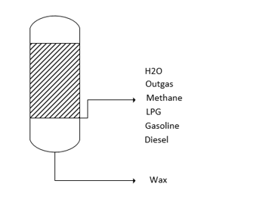
Figure 7. Generic industrial fixed bed LTFT cooling and recovery process.
$fc\left(Wa,FT_{reactor}, HE8\right)=fc\left(Wa,HE7,FT_{reactor}\right)+\left(\frac{MW_{Wa}}{MW_{CO}}\right)∙Conv_{CO}∙fc\left(CO,HE7,FT_{reactor}\right)$ (25)
$fc\left(CO,FT_{reactor}, HE8\right)=\left(1-Conv_{CO}\right)∙fc\left(CO,HE7,FT_{reactor}\right)$ (26)
$fc\left(H_{2},FT_{reactor},HE8\right)=\left(1-Conv_{CO}\right)∙fc(CO,HE7,FT_{reactor})$ (27)
$fc\left(CO_{2},FT_{reactor},HE8\right)=fc\left(CO_{2},HE7,FT_{reactor}\right)$ (28)
$Mass Product=Conv_{CO}∙\left(fc \left(H_{2},HE7, FT_{reactor}\right)+\left(1-\frac{MW_{Wa}}{MW_{CO}}\right)fc\left(CO,HE7,FT_{reactor}\right)\right)$ (29)
$fc\left(CH_{4},FT_{reactor}, HE8\right)=frac_{CH_{4}}∙Mass Product$ (30)
$fc\left(LPG,FT_{reactor}, HE8\right)=frac_{C_{3}C_{4}}∙Mass Product$ (31)
$fc\left(Gasoline,FT_{reactor}, HE8\right)=frac_{Gasoline}∙Mass Product$ (32)
$fc\left(Diesel,FT_{reactor}, HE8\right)=frac_{Diesel}∙Mass Product$ (33)
$fc\left(Heavy,FT_{reactor}, HE8\right)=frac_{Heavy}∙Mass Product$ (34)

3.2.2 Modeling of the HTFT reactor
HTFT generates products of lower α. Experimental results showed that the product of HTFT contains waxes up to 5% and diesel between 5-10% [46]. Performing the analysis of eqs. (17) and (18), the content is even lower: Only traces of waxes (up to 0.05%) and diesel fractions up to 3% are obtained [52]. Thus, the waxes content in the product are assumed to be zero and no recovery of them by hydrocracking is needed in the following separation section. The computational resources required to model the production of diesel and waxes as well as for waxes recovery can be applied to provide more accurate results in the prediction of gasoline fraction. Now, the integrals are not reduced and they are computed following eqs. (19) and (20) for C₁-C₂ fraction and LPG. Meanwhile gasoline and diesel fractions are computed as in eqs. (35) and (36):
$frac_{gasoline}=α^{4}∙{\left(1-α\right)}^{2}∙5+α^{5}∙{\left(1-α\right)}^{2}∙6+α^{6}∙{\left(1-α\right)}^{2}∙7+α^{7}∙{\left(1-α\right)}^{2}∙8+α^{8}∙{\left(1-α\right)}^{2}∙9+α^{9}∙{\left(1-α\right)}^{2}∙10$ (35)
$frac_{Diesel}=1-frac_{CH4}-frac_{LPG}-frac_{Gasoline}$ (36)
Hence, the mass balances for HTFT reactor are given as eqs. (37) to (46). The reactor is a fluidized bed where products are obtained in the same stream, as presented in [46].
$fc\left(Wa,FTreactor, HE20\right)=fc\left(Wa,HE7,FTreactor\right)+\left(\frac{MW_{Wa}}{MW_{CO}}\right)∙Conv_{CO}∙fc\left(CO,HE7,FT_{reactor}\right)$ (37)
$fc\left(CO,FTreactor, HE20\right)=\left(1-Conv_{CO}\right)∙fc\left(CO,HE7,FT_{reactor}\right)$ (38)
$fc\left(H_{2},FT_{reactor},HE20\right)=\left(1-Conv_{CO}\right)∙fc(CO,HE7,FT_{reactor})$ (39)
$fc\left(CO_{2},FT_{reactor},HE20\right)=fc\left(CO_{2},HE7,FT_{reactor}\right)$ (40)
$Mass Product=Conv_{CO}∙\left(fc \left(H_{2},HE7, FT_{reactor}\right)+\left(1-\frac{MW_{Wa}}{MW_{CO}}\right)fc\left(CO,HE7,FT_{reactor}\right)\right)$ (41)
$fc\left(CH_{4},FT_{reactor}, HE20\right)=frac_{CH_{4}}∙Mass Product$ (42)
$fc\left(LPG,FT_{reactor}, HE20\right)=frac_{C_{3}C_{4}}∙Mass Product$ (43)
$fc\left(Gasoline,FT_{reactor}, HE20\right)=frac_{Gasoline}∙Mass Product$ (44)
$fc\left(Diesel,FT_{reactor}, HE20\right)=frac_{Diesel}∙Mass Product$ (45)
$fc\left(Heavy,FT_{reactor}, HE20\right)=frac_{Heavy}∙Mass Product$ (46)

3.3 Separation and purification
The separations assumed in the model depend on the products obtained from the FT reactor. In previous section 3.2, two modes of operation are defined resulting in two different composition of the FT product. Therefore, this section is structured in two parts: In section 3.3.1 the separation and wax hydro-treatment sections for the LTFT products are presented and in section 3.3.2 the purification of HTFT products is presented.

3.3.1 Separation and purification of LTFT products.
LTFT reactor is composed of two outlet streams as presented in Figure 7. One liquid containing the waxes and another one in gas phase, composed by the rest of components. The fractions obtained in the gas stream from the LTFT reactor need to be separated since diesel and gasoline are desired to be obtained as purified products from the plant. The outlet stream of the reactor is composed by the organic fractions generated and water. The separation is presented in Figure 8 and it is carried out by a successive flash, three phase separator and distillation column [55] [56].
Flash-5 separates the lightest components (H₂, CO, CO₂ and C1-C2 fraction) from the other LTFT reactor products. The separation efficiency is assumed to be 1 and it is carry out by cooling down the reactor outlet stream until 303K. The gas stream composition is complex and further separation is not preferred since it involves larger costs and the stream can be used as substitute for the biogas in the burner of the reformer. It saves the biogas raw material used for heating the burner.
After Flash-5, the liquids products are sent to a three-phase separator, which may work at different pressures depending on the gas-liquid equilibrium [57-59]. Current case works at atmospheric pressure because of allowing LPG recovery in the gas fraction. The pressure reduction is performed by means of Valve-1. Furthermore, two liquid streams are also obtained from the three-phase separator: One of organic components (Gasoline and Diesel) and another of water.
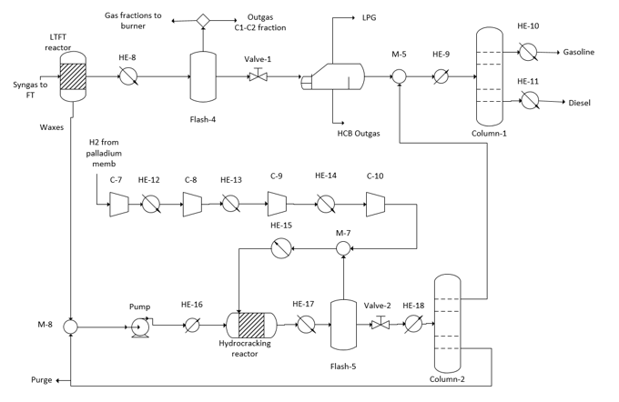
Figure 8. Separation, purification and wax recovery.
The water stream is sent to treatment and the rest of hydrocarbons go to the next stage of purification. The two liquid fractions are separated in a distillation system. The distillation tower for the oil mixture, Column-1, have 120ºC for the top light fractions, gasoline, and 250ºC for the heavier ones, diesel.
Apart from the diesel separated in the outlet gas stream of the LTFT reactor, the liquid wax produced in the LTFT reactor can be also recovered to obtain more diesel and gasoline. The wax reacts with hydrogen in a hydrocracker. Hydrocracking reactor works at 140 bar and a range of temperature between 570 K and 670 K is assumed [60][61]. Therefore, the hydrogen previously separated by a palladium membrane needs to be compressed up to the hydrocracker pressure and the wax is also pumped. The conversion and the selectivity to diesel is dependent on the temperature following eq. (47) and (48) [55][61]:
$X_{Hydro_{react}}=0.000185714∙{\left(T_{Hydro_{reactor}}\right)}^{2}-0.128829∙T_{Hydro_{reactor}}+22.6931$ (47)
$S_{Diesel}= -0.00014286∙{\left(T_{Hydro_{reactor}}\right)}^{2}+0.099514∙T_{Hydro_{reactor}}-16.383$ (48)
The input of hydrogen and heavy fraction to the reactor are modelled as from Eq. (49) to (52). It is assumed that the hydrogen that left the reactor is be 600 ft³ of the hydrogen per bbl to be left with the products, and representing around 7.5 % of the total hydrogen fed in the hydrocracker [55] [61] [62].
$fc\left(Diesel, Hydro_{reactor}, HE17\right)=X_{Hydro_{react}}∙S_{Diesel}∙mass_{Hydro}$ (49)
$fc\left(Gasoline, Hydro_{reactor}, HE17\right)=X_{Hydro_{react}}∙{(1-S}_{Diesel})∙mass_{Hydro}$ (50)
$fc\left(Heavy, Hydro_{reactor}, HE17\right)={(1-X}_{Hydro_{react}})∙mass_{Hydro}$ (51)
$fc\left(H_{2}, Hydro_{reactor}, HE17\right)=0.15∙mass_{Hydro}$ (52)
The products obtained from the reactor are separated in Flash-6 where hydrogen is recovered in the gas stream and sent it back to the hydrocracker. The other products are sent to a distillation column. Column-2, separates diesel and gasoline from wax fractions. The distillation is carried out at atmospheric pressure, being the pressure of the fed reduced by mean of Valve 2. The temperature given by the light fractions in the top of the tower is 220 ºC and in the bottom the wax is recovered at 300 ºC. The light fractions composed by diesel and gasoline are sent to Mix-7 where they are separated from each other in Column-1.
3.3.2 Separation and purification of HTFT products
Products from the HTFT reactor are obtained in the same outlet as gases. The stream is composed by different organic fractions and water that need to be separated. The separation is carried out by a successive flash, three phase separator and distillation column as it can be seen in Figure 9.
Each of the units are modelled as presented in section 3.3.1. Flash-7 works at 30 bar and 303 K, separating H₂, CO, CO₂ and C1-C2 fractions in the gas stream. The three phase separator works at atmospheric pressure, removing LPG and Water from the rest of organics liquids. Finally, the distillation column is used to separate and purify Diesel and Gasoline fractions.
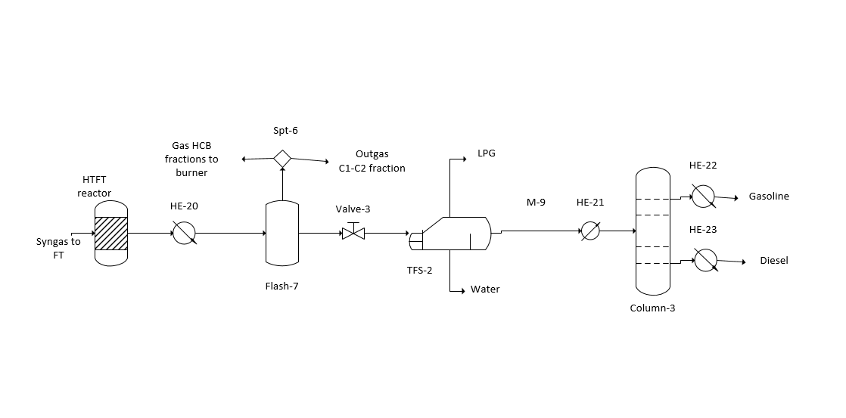
Figure 9. Separation and purification of HTFT products.
3.4 Solution procedure.
The integration and process design problem defined in this section is optimized in order to maximize the profit of the process. The global MINLP problem has been divided in two NLP problems attending to the reactor mode of operation.
Five objective functions, eqs. (53) to (57) are defined in order to evaluate the weight of each product on the final result and if the biogas fed as fuel has any influence on the final objective function. Eq. (53) includes all the profit generated by all the products and the cost of biogas as a methane source in the burner is included. In eq. (54) the price of the biogas sent to the burner is not included. Eq. (55) is similar to eq. (53) but the price of diesel is not included. The same sensibility analysis is performed in eq. (56), where the price of gasoline is not included, or in eq. (57), where butane price is not included. The values for the prices involved in the objective function for O₂, CO₂, and utilities are the same that defined in section 2.4. The products are assumed to have a price of $1.7/gal for crude gasoline, $1.9/gal for crude diesel [63] and $580 per tonne for LPG [64].
$profit=C_{gasoline}F_{gasoline}+C_{diesel}F_{diesel}+C_{LPG}F_{LPG}-C_{elec}\sum_{iϵCompressors}{W_{i}}-C_{CH_{4}}\sum_{iϵCH_{4}inlets}{F_{CH_{4}}}-C_{O_{2}}F_{O_{2}^{'}Triref^{'}}-C_{CO_{2}}\sum_{iϵCO_{2}inlets}{F_{CO_{2}}}-C_{q}\sum_{jϵQ_{heat}}{Q}+C_{c-w}\sum_{kϵQ_{refrig}}{Q}-C_{H_{2}S}F_{H_{2}S}-C_{H2O}F_{H2O}$ (53)
$profit=C_{gasoline}F_{gasoline}+C_{diesel}F_{diesel}+C_{LPG}F_{LPG}-C_{elec}\sum_{iϵCompressors}{W_{i}}-C_{O_{2}}F_{O_{2}^{'}Triref^{'}}-C_{CO_{2}}\sum_{iϵCO_{2}inlets}{F_{CO_{2}}}-C_{q}\sum_{jϵQ_{heat}}{Q}+C_{c-w}\sum_{kϵQ_{refrig}}{Q}-C_{H_{2}S}F_{H_{2}S}-C_{H2O}F_{H2O}$ (54)
$profit=C_{gasoline}F_{gasoline}+C_{LPG}F_{LPG}-C_{elec}\sum_{iϵCompressors}{W_{i}}-C_{CH_{4}}\sum_{iϵCH_{4}inlets}{F_{CH_{4}}}-C_{O_{2}}F_{O_{2}^{'}Triref^{'}}-C_{CO_{2}}\sum_{iϵCO_{2}inlets}{F_{CO_{2}}}-C_{q}\sum_{jϵQ_{heat}}{Q}+C_{c-w}\sum_{kϵQ_{refrig}}{Q}-C_{H_{2}S}F_{H_{2}S}-C_{H2O}F_{H2O}$ (55)
$profit=C_{diesel}F_{diesel}+C_{LPG}F_{LPG}-C_{elec}\sum_{iϵCompressors}{W_{i}}-C_{CH_{4}}\sum_{iϵCH_{4}inlets}{F_{CH_{4}}}-C_{O_{2}}F_{O_{2}^{'}Triref^{'}}-C_{CO_{2}}\sum_{iϵCO_{2}inlets}{F_{CO_{2}}}-C_{q}\sum_{jϵQ_{heat}}{Q}+C_{c-w}\sum_{kϵQ_{refrig}}{Q}-C_{H_{2}S}F_{H_{2}S}-C_{H2O}F_{H2O}$ (56)
$profit=C_{gasoline}F_{gasoline}+C_{diesel}F_{diesel}-C_{elec}\sum_{iϵCompressors}{W_{i}}-C_{CH_{4}}\sum_{iϵCH_{4}inlets}{F_{CH_{4}}}-C_{O_{2}}F_{O_{2}^{'}Triref^{'}}-C_{CO_{2}}\sum_{iϵCO_{2}inlets}{F_{CO_{2}}}-C_{q}\sum_{jϵQ_{heat}}{Q}+C_{c-w}\sum_{kϵQ_{refrig}}{Q}-C_{H_{2}S}F_{H_{2}S}-C_{H2O}F_{H2O}$ (57)
Every objective function of the integration problem is set independently as an NLP problem with over 2,500 variables and 2,000 equations for the LTFT process. Meanwhile for the HTFT process the NLP problem is composed of 1,700 equations and 2,000 variables. Both modes of operation are modelled in GAMS and solved using a multi-start approach with CONOPT 3.0. After the process optimization, a heat integration is performed externally defining the heat exchanger network. Finally, an economic evaluation is accomplished to estimate the production cost of diesel and gasoline and the investment required for the plant. They are performed from the optimization that uses eq. (54) as objective function for HTFT and LTFT processes.

4-Results.
The results of the two studies performed are presented in this section. In section 4.1 for the parametric optimization of biogas to syngas via tri-reforming and in section 4.2 for the process design problem of biogas to FT fuels.
4.1- Parametric optimization of syngas production.
The results for the parametric optimization of biogas to syngas via tri-reforming are compared in this section. Three H₂:CO ratios are analysed according to the syngas use: methanol (2.5:1), ethanol (1:1) or FT-fuels (1.7:1) production. Figure 10 presents the values of the objective function, eq. (14), under different O₂:Biogas ratios. The maximum profit obtained by the objective function is 0.015 when syngas is applied to methanol production, 0.007 when it is applied to ethanol and 0.016 to FT synthesis. The optimal values are achieved when the O₂:Biogas ratio feed in the process is 0.275 for methanol production, 0.035 for ethanol and 0.275 for FT fuels production.
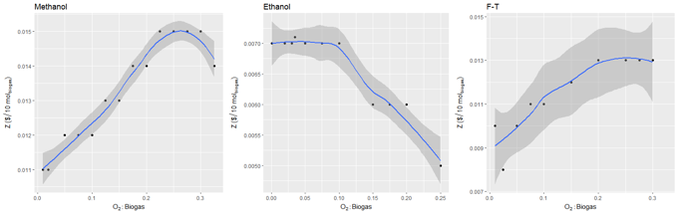
Figure 10. Parametric optimization results.
However, O₂:Biogas ratio does not only influences on the profit. The optimal composition of the biogas is also affected as well as the process operation conditions. Figure 11 presents the influence of O₂:Biogas ratio on the biogas composition in the process feed and Table 2 summarizes the compositions when largest credit is obtained. It can be seen that when the O₂:Biogas ratio in the tri-reformer increases, the CO₂ composition in the biogas decreases. At small O₂:Biogas ratios, the oxygen of CO₂ is used as a substitute of O₂ in the reformer, allowing more syngas production. The behavior of the methane content in the biogas as a function of the ratio is opposite to the behavior of the CO₂ content, showing an increase for larger O₂:Biogas ratios. Meanwhile the water content shows a step just before achieve the optimal for the three syngas products studied. This water content always takes the minimum value when the global optimal is achieved. Methane it is preferred since it contains more atoms of hydrogen per mole.
In Table 2, it can be seen that for methanol and FT production the composition obtained for the global optimal is the same. In both cases, the maximum methane content is desired. However, for ethanol production a different biogas composition is suggested since the ratio H_{2:}CO required is not so large. Methane works as a source of hydrogen being lower quantities required when the process is optimized.
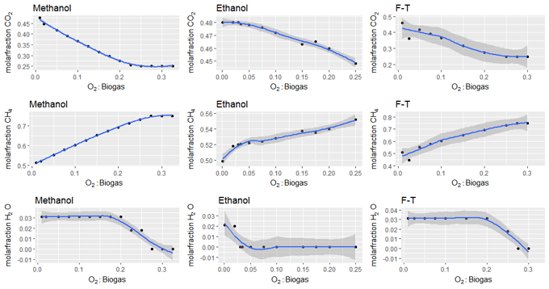
Figure 11. Influence of O₂:Biogas ratio on biogas composition.
Table 2. Global optimal composition of biogas.
Component | Methanol (H₂:CO=2.5) | Ethanol (H₂:CO=1) | F-T (H₂:CO=1.7)
CO₂ | 0.25 | 0.479 | 0.25
CH₄ | 0.75 | 0.521 | 0.75
H₂O | 1•10⁻¹⁰ | 1•10⁻¹⁰ | 1•10⁻¹⁰
N₂ | 1•10⁻⁴ | 1•10⁻⁴ | 1•10⁻⁴
SH₂ | 2•10⁻⁵ | 2•10⁻⁵ | 2•10⁻⁵
NH₃ | 1•10⁻⁶ | 1•10⁻⁶ | 1•10⁻⁶

Despite same compositions of biogas are obtained for methanol and FT syngas production, the process conditions are different as presented in Table 3. To allow achieving the ratio required for methanol and FT, another source of hydrogen is required. It can be seen in Table 3 that the second source of hydrogen, after adjusting the composition, is the addition of water in the WGS reactor of the syngas composition adjustment stage. It is preferred to add water after the reforming than before. For all the cases, the addition of steam and CO₂ before the reforming is not selected. The reformer works at 1273K for methanol and FT production and 1231K for ethanol production in the global optimal of each case. Instead of the temperature is larger for methanol and FT, the biogas required to be burned is lower since energy is produced from the POX of the biogas involved in the process. In Figure 12 it is shown how the O₂:Biogas ratio modifies the reformer parameters: For methanol, the biogas sent to the burner decreases until the optimal is achieved and then it increases again and the temperature decreases for O₂:Biogas ratios larger than 0.275. For ethanol production, a light decrease is observed in the biogas sent to burner when O₂:Biogas ratio increases; meanwhile the temperature shows a minimal for O₂:Biogas ratio of 0.1. For FT production, the biogas sent to burner behaves similar than for methanol and the temperature achieved at the reformer is always the maximum allowed.
The WGS reactor requires more water for methanol production, 0.21mol/mol of Biogas, than for FT fuels production, 0.06 mol/mol of Biogas when the process works in its global optimal; meanwhile for ethanol the reactor does not need to be included in the process. The analysis under different O₂:Biogas ratios is also showed in Figure 12. It shows that for methanol production the steam fed to the WGS reactor decreases when O₂:Biogas ratio increases and the temperature achieved is always the maximum since hydrogen generation is more promoted. However, for FT and ethanol production a similar behavior is observed, the use of a WGS reactor is never required.
Table 3. Optimal process variables.
Process variable | Methanol | Ethanol | F-T
Biogas sent to burner (mol/mol Biogas fed to process) | 0.092 | 0.302 | 0.092
O₂:Biogas | 0.275 | 0.035 | 0.275
T_{reformer} (K) | 1273 | 1231 | 1273
Fraction WGS | 1 | 0 | 1
Fraction PSA CO₂ | 0.66 | 0 | 0
H₂O WGS (mol/mol Biogas fed in the process) | 0.206 | 0 | 0.062
Heat required (kJ/mol Biogas fed in the process) | 70.4 | 51.9 | 63.9
Refrig required (kJ/mol Biogas fed in the process) | 105 | 71.2 | 91.1

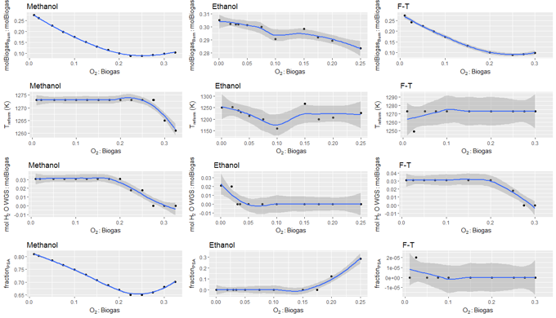
Figure 12. Effect of O₂:Biogas ratio on process variables.
In Table 3 the fraction of flow sent to PSA membranes for CO₂ removal is also presented. It can be seen that only methanol requires PSA treatment, being necessary to treat 66% of the syngas obtained when the credit obtained by eq. (14) is maximized. In Figure 12 it can be seen that for methanol production, the flow fraction sent to the PSA decreases before the optimal and then increases. For FT fuels, it is never required and for ethanol it is only required for O₂:Biogas ratios larger than 0.175.
The utilities consumption is also presented in Table 3. It can be seen that the syngas applied to ethanol production requires the lowest consumption of utilities. The reformer in ethanol production works at lower temperature and no WGS reactor is required. Thus, less heat and refrigeration are required. Opposite, the production of syngas for methanol requires the largest quantities of water in the WGS reactor. Therefore, more heat and refrigeration are involved than in the other two cases.
4.2 Results of optimal biogas to F-T Diesel production processes
4.2.1 Process operation.
The results for the optimal operation of FT production process using biogas as raw material are presented in this section. The results of the two modes of operation, HTFT and LTFT, are compared through it. The results for the economic optimization are first presented in Table 4 comparing the five objective functions defined in section 3.4. It can be seen that LTFT provides large profitability for the process than LTFT. Table 4 also presents the contribution of each of the terms and a sensibility analysis using the definitions from eq. (54) to (57).
Table 4. Economic Results for optimal HTFT and LTFT processes.
Objective function |  | HTFT | LTFT
Z ($/mol of Biogas fed) Eq. (53) |  | 7•10⁻⁴ | 2.2•10⁻³
 | Diesel ($/mol of Biogas fed) | 1•10⁻⁴ | 1.8•10⁻³
 | Gasoline ($/mol of Biogas fed) | 1•10⁻³ | 1.4•10⁻³
 | Butane ($/mol of Biogas fed) | 9•10⁻⁴ | 4•10⁻⁴
 | Electricity ($/mol of Biogas fed) | -4•10⁻⁴ | -5•10⁻⁴
 | Steam ($/mol of Biogas fed) | -6•10⁻⁴ | -6•10⁻⁴
 | Ref. water ($/mol of Biogas fed) | -3•10⁻⁴ | -3•10⁻⁴
Z ($/mol of Biogas fed) Eq. (54) |  | 7•10⁻⁴ | 2.3•10⁻³
 | Diesel ($/mol of Biogas fed) | 1•10⁻⁴ | 1.8•10⁻³
 | Gasoline ($/mol of Biogas fed) | 1•10⁻³ | 1.5•10⁻³
 | Butane ($/mol of Biogas fed) | 9•10⁻⁴ | 4•10⁻⁴
 | Electricity ($/mol of Biogas fed) | -4•10⁻⁴ | -5•10⁻⁴
 | Steam ($/mol of Biogas fed) | -6•10⁻⁴ | -6•10⁻⁴
 | Ref. water ($/mol of Biogas fed) | -3•10⁻⁴ | -3•10⁻⁴
Z ($/10mol of Biogas fed) Eq. (55) |  | 6•10⁻⁴ | 8•10⁻⁴
 | Diesel ($/mol of Biogas fed) | 0 | 0
 | Gasoline ($/mol of Biogas fed) | 1•10⁻³ | 1.5•10⁻³
 | Butane ($/mol of Biogas fed) | 9•10⁻⁴ | 6•10⁻⁴
 | Electricity ($/mol of Biogas fed) | -4•10⁻⁴ | -4•10⁻⁴
 | Steam ($/mol of Biogas fed) | -6•10⁻⁴ | -6•10⁻⁴
 | Ref. water ($/mol of Biogas fed) | -3•10⁻⁴ | -3•10⁻⁴
Z ($/10mol of Biogas fed) Eq. (56) |  | -2•10⁻⁴ | 9•10⁻⁴
 | Diesel ($/mol of Biogas fed) | 1•10⁻⁴ | 1.9•10⁻³
 | Gasoline ($/mol of Biogas fed) | 0 | 0
 | Butane ($/mol of Biogas fed) | 8•10⁻⁴ | 4•10⁻⁴
 | Electricity ($/mol of Biogas fed) | -4•10⁻⁴ | -6•10⁻⁴
 | Steam ($/mol of Biogas fed) | -5•10⁻⁴ | -6•10⁻⁴
 | Ref. water ($/mol of Biogas fed) | -2•10⁻⁴ | -3•10⁻⁴
Z ($/10mol of Biogas fed) Eq. (57) |  | -2•10⁻⁴ | 1.9•10⁻³
 | Diesel ($/mol of Biogas fed) | 1•10⁻⁴ | 2•10⁻³
 | Gasoline ($/mol of Biogas fed) | 9•10⁻⁴ | 1.4•10⁻³
 | Butane ($/mol of Biogas fed) | 0 | 0
 | Electricity ($/mol of Biogas fed) | -4•10⁻⁴ | 6•10⁻⁴
 | Steam ($/mol of Biogas fed) | -5•10⁻⁴ | 6•10⁻⁴
 | Ref. water ($/mol of Biogas fed) | -3•10⁻⁴ | 3•10⁻⁴

It can be also seen in Table 4 that the optimal value of the objective function is not modified for HTFT process when the cost of methane contained in the biogas is included. The amount of Outgas produced in HTFT is enough large that does not require from external biogas supply once outgas has been recycled. For LTFT process, a light change is observed from the result of the objective function, eq. (53), to the one without methane, eq. (54).
Attending to the contribution of each component to the final profit, the following conclusions are obtained: Gasoline and butane are the two components that generate more added value to the HTFT. The maximum profit is never positive when one of both is not included as valuable product in the objective function since the amount produced is larger than for diesel. For LTFT, the most valuable product is diesel and the least valuable is butane. The lower temperatures achieved in the FT reactor promote the generation of large amount of products with larger chains such as diesel and waxes.
The contributions of each component also modify the biogas composition and process operation parameters. The optimal biogas composition is presented in Table 5 and the main operating conditions of the process are presented in Table 6. It can be seen that larger amounts of methane are preferred for LTFT mode than for HTFT. The selection is given because of the large hydrogen quantities required in the process. Instead of a lower H₂:CO ratio is observed at the entrance of LTFT reactor (see Table 6), more hydrogen is required in LTFT process to recover the wax via hydro-cracking. Opposite to the methane composition, the CO₂ shows less concentration for LTFT and the rest of the components achieve their minimum value.
Table 5. Optimal biogas composition for HTFT and LTFT processes.
Component | HTFT | LTFT
Methane | 0.622 | 0.69
CO₂ | 0.378 | 0.31
SH₂ | 2•10⁻⁵ | 2•10⁻⁵
N₂ | 1•10⁻⁴ | 1•10⁻⁴
H₂O | 1•10⁻¹⁰ | 1•10⁻¹⁰
NH₃ | 1•10⁻⁶ | 1•10⁻⁶

The results of the main operating parameters for the optimization of both processes following eq. (53) are presented in Table 6. It can be seen that tri-reforming is preferred than a combined dry and steam reforming as it has been suggested in previous works for syngas [30] or methanol production [18]. Large amounts of oxygen are required for LTFT than for HTFT process that allow achieving also higher temperatures at the reactor. However, the conversion in the reformer is larger for HTFT process since lower quantities of methane are desired to be contained in the biogas fed.
The cleaning section of the syngas does not require of WGS reactor to generate large quantities of H₂ as it is obtained for syngas with H₂:CO ratios of 1 (ethanol production in section 4.1). However, CO₂ reduction by means of PSA membranes is desired not only because of ensuring a CO₂ concentration lower than the maximum allowed, but also to improve the FT reactor efficiency since large CO and H₂ are ensured. After the membrane, a 32% of the syngas needs to be sent to a palladium membrane where hydrogen is recovered in LTFT process.
The results obtained for the parameters of the FT reactor in Table 6 show that HTFT reactor requires to operate with an H₂:CO ratio larger than LTFT. The rest of the parameters are in agreement with the model defined. Larger temperatures resulting in lower α_{FT} are obtained in the HTFT reactor. The products obtained from the HTFT reactor contain higher quantities of light products such as methane and LPG and low compositions of diesel and waxes. Contrary, the LTFT reactor promotes the generation of products with larger chains. The fraction with higher production corresponds to gasoline (0.036 mol per mol of Biogas fed in the process). Furthermore, LTFT reactor also generates waxes that are treated to improve the process profitability and the gasoline production up to 0.037 mol per mol of Biogas fed in the process and the diesel production changes from 0.019 to 0.021 mol/mol of biogas fed. The hydrocracking of the waxes is performed at 623K, resulting in a conversion of 0.567 and a selectivity to diesel of 76%.
Table 6. Main operating parameters for economic optimization, eq. (53).
OPERATING VARIABLE | HTFT | LTFT
Dry reforming reactor temperature (K) | 1234 | 1273
Biogas burned (mol /mol Biogas fed in the process) | 0.176 | 0.0376
O₂ fed in tri-reforming (mol /mol Biogas fed in the process) | 0.1434 | 0.2715
X_{CH4} | 0.92 | 0.9
Fraction sent to WGS | 0 | 0
CO₂ removed in PSA per mol of biogas fed in the process | 0.022 | 0.018
Fraction sent to Palladium membrane | - | 0.317
T_{SynthesisFT} (K) | 590 | 507.3
H₂:CO in synthesis reactor | 1.203 | 1
CO₂ in synthesis reactor (% vol) | 0.05% | 0.9%
α_{FT} | 0.575 | 0.844
T_{Hydrothermal} (K) | - | 623
X_{Wax} | - | 0.567
S_{Wax to diesel} | - | 0.759
Fraction of outgas sent to burner | 0.003 | 0.844
Outgas produced from reactor (mol /mol Biogas fed in the process) | 0.468 | 0.264
Butane produced in the process (mol/mol Biogas fed in the process) | 0.058 | 0.024
Gasoline produced (mol /mol Biogas fed in the process) | 0.025 | 0.037
Diesel produced (mol /mol Biogas fed in the process) | 0.001 | 0.022
Cooling water (kg/mol of biogas fed in the process) | 4.69 | 5.73
Steam required (kg/mol of biogas fed in the process) | 0 | 0.0025
Electricity required (kW/mol of biogas fed in the process) | 265.9 | 359.1

The optimization based on eq. (53) is considered the most typical since credit can be obtained for selling all the products. However, performing the sensitivity analysis by deleting the credit from each of the products, different results are obtained. The results when any of the products are not included in the objective function as presented in Table 7. The two first columns of Table 7 shows the parameters of the optimal solution when the biogas fed to the burner is considered as a valuable product since the methane can be used for other facilities. As result, it can be seen that no biogas is suggested to be burned in the reformer. All the fuel come from the outgas. The rest of the process parameters are not affected for HTFT process and lightly affected for the LTFT process. The main changes observed are a decrease of the fraction of hydrogen separated in the palladium membrane and light increase in the FT-reactor temperature and H₂:CO ratio. The hydrocracking reactor works at lower temperature, resulting in lower conversions. However, the products obtained are roughly the same.
Based on the sensibility analysis performed for the products, it can be seen in Table 7 that the oxygen required in the tri-reformer decreases in HTFT and LTFT processes when gasoline is not included in the objective function, eq. (56). The reformer also shows differences in the operational parameters when diesel is not included in the objective function, requiring to work at lower temperatures and resulting in larger conversions. Once the syngas is produced, the tune-up and cleaning section never requires the use of a WGS reactor for hydrogen generation and in the HTFT process. PSA membranes are required to capture the CO₂ when butane (eq. (57)) and gasoline (eq. (56)) are not included in the objective function. The next stage in the process is the FT reactor, which also modifies its operating conditions in order to promote the generation of fuels defined in the objective function. The reactor does not show changes of temperature when it works in HTFT mode (the maximum reactor temperature is always achieved), using the H₂:CO ratio to promote the generation of the products desired. However, in LTFT mode the generation of products defined in the objective functions is given by modifying both parameters, the temperature and the H₂:CO ratio. In both modes of operation, the H₂:CO ratio is always larger when diesel is not included in the objective function, helping to reduce the length of the chain, α_{FT}. The following stage in the LTFT mode is the recovery based on hydro-treatment. It can be seen in Table 7 that the temperatures are larger when components with larger chains are not included in the objective function. For example, the exclusion of diesel, eq. (55), requires large temperatures, not only to have waxes conversion but also to obtain a low selectivity to diesel and promote gasoline production.

Table 7. Main operating variables results for optimal solution of eqs. (54), (55), (56) and (57).
OPERATING VARIABLE | HTFT eq. (54) | LTFT eq. (54) | HTFT eq. (55) | LTFT eq. (55) | HTFT eq. (56) | LTFT eq. (56) | HTFT eq. (57) | LTFT eq. (57)
Dry reforming reactor temperature (K) | 1234 | 1273 | 1245 | 1242 | 1253 | 1273 | 1273 | 1273
Biogas burned (mol/mol of Biogas) | 0 | 0 | 0.167 | 0.1188 | 0 | 0.0455 | 0.1798 | 0.0495
O₂ fed in tri-reforming | 0.1434 | 0.275 | 0.1526 | 0.163 | 0.1402 | 0.275 | 0.055 | 0.275
X_{CH4} | 0.92 | 0.9 | 0.911 | 0.917 | 0.936 | 0.9 | 0.9 | 0.9
Fraction sent to WGS | 0 | 0 | 0 | 0 | 0 | 0 | 0 | 0
CO₂ removed in PSA per mol of biogas fed in the process | 0.022 | 0 | 0 | 0 | 0.019 | 0 | 0.0039 | 0
Fraction sent to Palladium membrane | - | 0.172 | - | 0 | - | 0.317 | - | 0.317
T_{SynthesisFT} (K) | 590 | 509 | 590 | 519 | 590 | 508 | 590 | 507
H₂:CO in synthesis reactor | 1.203 | 1.212 | 1.24 | 1.2447 | 1.202 | 1 | 1.203 | 1
CO₂ in synthesis reactor (%vol) | 0.05 | 1.5 | 0.8 | 1 | 0.05 | 0.9 | 0.07 | 0.9
α_{FT} | 0.575 | 0.805 | 0.573 | 0.774 | 0.575 | 0.825 | 0.575 | 0.825
T_{Hydrothermal} (K) | - | 654 | - | 673 | - | 647 | - | 623
X_{Wax} | - | 0.567 | - | 0.876 | - | 0.491 | - | 0.567
S_{Wax to diesel} | - | 0.795 | - | 0.565 | - | 0.85 | - | 0.795
Fraction of outgas sent to burner | 0.594 | 0.401 | 0.012 | 0.898 | 0.595 | 0.427 | 0.991 | 0.391
Outgas produced from reactor (mol per mol of biogas fed in the process) | 0.4683 | 0.2979 | 0.4923 | 0.3217 | 0.472 | 0.2636 | 0.364 | 0.2636
Butane produced in the process (mol per mol of biogas fed in the process) | 0.0578 | 0.0284 | 0.0584 | 0.0343 | 0.0544 | 0.0235 | 0.0449 | 0.0235
Gasoline produced (mol per mol of biogas fed in the process) | 0.0254 | 0.0378 | 0.0255 | 0.0401 | 0.0257 | 0.0354 | 0.0198 | 0.0342
Diesel produced (mol per mol of biogas fed in the process) | 0.0013 | 0.0212 | 0.0013 | 0.0161 | 0.0013 | 0.0243 | 0.001 | 0.024

4.2.2 Economic evaluation.
An economic evaluation of the two plants for HTFT and LTFT process has been carried out in order to estimate the main costs of the plant and the final price that the fuel can reach following the economic optimization variables achieved in previous optimization. The plant size has been designed to be fed with a flow of 12 M m³/y of biogas, which is a tenth of the maximum potential biogas in the region of Madrid [15]. Despite the population density in the region is large (805 inhabitants/km²) and the waste generation is concentrated, the region is small, 8,030 km² [66] and larger plants can be designed for other locations. Therefore, a scale-up study is also presented in this section.
Investment Cost
The factorial method is used to estimate the investment cost of the facility [67]. It is based on the cost estimation for the units involved in the process that is performed as follows:
- SH₂ iron foam has been estimated following the cost per kg of SH₂ removed [15]. A cost of $260 per year is estimated for the optimal composition of biogas obtained when 12 M m³/y of biogas are processed.
- The cost of hydrocarbon and CO₂ removal beds has been estimated considering two components. First, the cost of the vessel using the Matche’s cost estimator [68] and, second, the cost of the molecular sieves following the correlations presented by Almena and Martin [69].
- Flash separators and tri-phase separator have been estimated using the cost of the vessel given by the weight of the metal [69].
- The cost of pump and compressors is estimated as a function of the power consumption required per unit [69].
- Fired heater cost has been estimated as a cylindrical fired heater, with the heat requirements given by the optimization and using Matche correlations [68].
- Heat exchangers cost, that also includes FT and hydro-treatment reactors and evaporator and condenser from distillation columns, has been computed by the heat exchanger area following the correlations presented in Almena and Martin [69].
- Distillation columns cost are estimated considering the cost of the vessel and the plates as presented in Almena and Martin [69]. The number of plates is computed from the optimization results and using short-cut methods with an efficiency of 80% per plate. The distillation column of HTFT process is composed of 10 plates, the distillation column of LTFT that separates gasoline and diesel is composed of 13 plates and the distillation column after hydro-treatment is composed of 12 plates.
Figure 13 shows the contribution to the investment cost per type of unit. It can be seen that the cost involved in heat exchanger processes is larger than the other equipment required in both HTFT and LTFT processes.
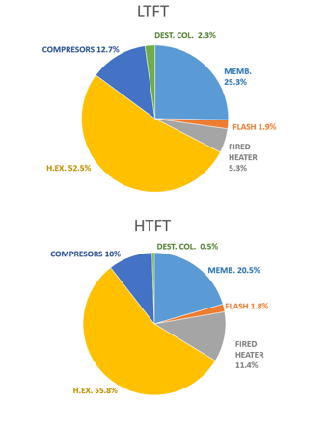
Figure 13. Unit Cost distribution.
Using the factorial method [67] for plants that process gases and considering a feed of 12 M m3/y of biogas, the capital cost of the plant adds up to $8 M for the HTFT plant and $19 M for the LTFT plant.
Production Cost
Production Cost is estimated considering maintenance, labor, administration and management, other expenses and units amortization, except for the membranes, which have to be replaced annually. All these items are estimated based on Silla´s method [70]. The cost of the raw materials and utilities are computed using the prices presented in the description of the objective function. The distribution of costs per year for HTFT and LTFT plants are shown in Figure 13. It can be seen that they are highly controlled because of the equipment cost, which represents more than 60% of the production costs in both cases.
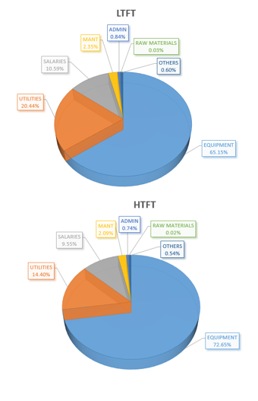
Figure 14. Cost distribution.
The costs are distributed between the production of LPG, gasoline and diesel maintaining the current ratios of prices per kg. The price of each component is computed using a factor as presented in eq. (58). Where $\$_{avg}$ is the average price, which is computed following eq. (59).
$factor_{i}=\frac{\$_{i}}{\$_{avg}}$ (58)
$\$_{avg}=\frac{\$_{LPG}+\$_{gasoline}+\$_{diesel}}{3}$ (59)
Thus, for the HTFT process the production cost of LPG is $610/ton, for gasoline a production cost of $2.57/gal is obtained and for diesel it is $3.02/gal. The prices with this technology are not competitive with the current selling price: $580/ton for LPG, $2.5/gal for gasoline and $2.9/gal for diesel. Therefore, the production of the fuels following the current process and the size designed for a 10% of potential biogas is not profitable.
The LTFT process shows lower production costs. A production cost of $520/ton is obtained for LPG. For gasoline a production cost of $1.25/gal is obtained and for diesel a value of $1.67/gal results. The LTFT process reduces the production costs, resulting in a more competitive process with prices lower than the current selling price but not much lower than the current production cost, which is estimated to be $1.7/gal for gasoline and $1.9/gal for diesel (Taxes, distribution and marketing costs have been discounted from [62]). Thus, this current process might be competitive with current prices if a taxes to promote sustainability are defined.
The current processes can be also evaluated with other processes that produce biodiesel from wastes. A production cost of €0.31/gal of diesel was obtained for a plant that produces 90 Mgal of diesel [71]. To allow the production of such as diesel quantities, the processes need to be scale-up and the cost of the anaerobic digester needs to be included in the economic analysis of both processes. The cost of anaerobic digester is computed as presented in [71]. The production prices of both modes of operation, HTFT and LTFT, with and without the cost of anaerobic digester are summarized in Figure 15. To produce 90 Mgal of fuels (diesel, gasoline and LPG), LTFT plant requires to treat 60 M m³/y and HTFT requires 85 M m³/y. As result, the average price of the fuels produced are $1.03/kg for LTFT and $1.8/kg HTFT Focusing on diesel, the production prices obtained are $3.3/gal for LTFT and $5.4/gal for HTFT. Thus, the new processes are less competitive than the developed previously and the production costs are larger than the current selling price when the anaerobic digester cost is included in the CAPEX. Figure 15 also shows a cut-point for LTFT and HTFT processes. It can be seen that LTFT process is more profitable than HTFT for plants smaller than 450 M m³/y of biogas.
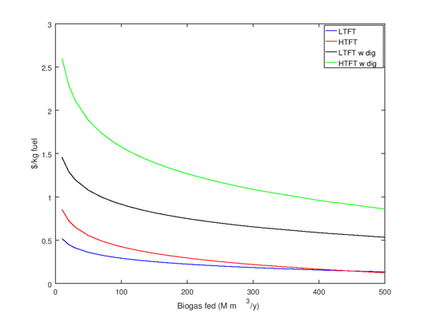
Figure 15 –Scale up of production costs for FT facilities.

5- Conclusions.
In this work an optimization approach has been performed to evaluate the biogas tri-reforming for the production of different syngas ratios. As result, the work provides the optimal process conditions and optimal biogas composition for three different syngas applications. The optimization selects a biogas mainly composed by 52% of methane and 48% of CO₂ when syngas is later applied to ethanol production. Meanwhile for methanol and FT fuels production the biogas with largest content of methane is selected. The largest H₂:CO ratio required for methanol is achieved introducing more steam in a WGS reactor after the reformer. Apart from the WGS reactor, which is only required for the production of methanol and FT, a PSA system is also needed to capture the CO₂ when syngas is applied to methanol production.
The work is completed with a second section where the tri-reformer model is defined within a process integration problem for the production of FT fuels from biogas at high and low temperatures of operation. The integration does not only applied the biogas as raw material for the process, but it also used it as fuel or for the production of extra hydrogen in the reformer when it needs to be used in the hydro-treatment of the waxes. This hydrogen is endogenously generated in the process, avoiding the external demand and ethical issues because of the use of fossil based hydrogen as well as allowing the implementation of the LTFT plant in isolated locations. The study applied to a plant fed directly with biogas, considering it as a waste with zero cost and from a plant fed with wastes, which requires treatment via anaerobic digestion. For the plant fed with 12 MMm³/y of biogas results in a production cost of $3/gal for diesel via HTFT and $1.7/gal via LTFT. The production cost obtained are larger than the current production cost of fuel but lower than the final selling price, in the case of LTFT process. Therefore, LTFT might become a sustainable solution if taxes promoting sustainability are implemented. In the case of the same plants (producing 12MMm3/y of biogas via anaerobic digestion) fed with wastes, the production costs increases up $4.6/gal for LTFT and $9/gal for HTFT, which are not profitable comparing with the current selling prices of diesel.

6- References
[1] Eurostat Waste statistics. 2017. Available in: http://ec.europa.eu/eurostat/statistics-explained/index.php?title=Waste_statistics Last acceded: May 2018.
[2] Masullo, A. Organic wastes management in a circular economy approach: Rebuilding the link between urban and rural areas. Ecological engineering; 2017, 101, 84-90.
[3] Stambasky, J. Introduction to EBA and the Circular Economy. 6th April 2016. EBA’s Circular Economy Workshop. 2016. Available in: http://european-biogas.eu/members-only/presentations-reports/circular-economy-workshop/
[4] Ellen MacArthur Foundation. Towards the circular economy I. 2012. Available in: https://www.ellenmacarthurfoundation.org/assets/downloads/publications/Ellen-MacArthur-Foundation-Towards-the-Circular-Economy-vol.1.pdf
[5] Wellinger, A. Murphy, J. Baxter, D. The biogas handbook: Science, production and applications. Edt. Woodhead Publishing. 2013.
[6] Leon, E. Martin, M. Electricity production from manure based biogas. Energy Convers. Manage. 2016, 114, 89.
[7] Tippayawong, N. Thanompongchart,P. Biogas quality upgrade by simultaneous removal of CO2 and H2S in a packed column reactor. Energy. 2010, 35, 4531-4535.
[8] Ryckebosch, E. Drouillon, M. Vervaeren, H. Techniques for transformation of biogas to biomethane. Biomass and bioenergy. 2011, 35 1633-1645.
[9] Braga, L.B. Silveira, J.L. da Silva, M.E. Tuna, C.E. Marchin, E.B. Pedroso, D.T. Hydrogen production by biogas steam reforming: A technical, economic and ecological analysis. Renewable and sustainable Energy Reviews. 2013, 28, 166-173.
[10] Cipiti, F. Barbera, O. Briguglio, N. Giacoppo, G. Italiano, C. Vita, A. Design of a biogas steam reforming reactor: A modelling and experimental approach. International Journal of Hydrogen Energy. 2016, 41 (27), 11577-11583.
[11] Avraam, D.G. Halkides, T.I. Liguras, D.K. Bereketidou, O.A. Goula,M.A. An experimental and theoretical approach for the biogas steam reforming reaction. Int. J. Hydrogen Energy. 2010, 35, 9818-9827.
[12] Kolbitsch, P. Pfeifer, C. Hofbauer, H. Catalytic steam reforming of model biogas. Fuel. 2008, 87, 701-706.
[13] Araki, S. Hino, N. Mori, T. Hikazudani, S. Autothermal reforming of biogas over a monolithic catalyst. Jounal of Natural Gas Chemistry. 2010, 19, 477-481.
[14] Xuan, J. Leung, M.K.H. Leung, D.Y.C. Ni, M. Integrating chemical kinetics with CFD modelling for autothermal reforming of biogas. Int. J. Hydrogen Energy. 2009, 34, 9076-9086.
[15] Hernandez, B. Martin, M. Optimal Process operation for biogas reforming to methanol: effects of dry reforming and biogas composition. Ind. Eng. Chem. Res., 2016, 55 (23), 6677-6685.
[16] Lau, C.S. Tsolakis, A. Wyszynski, M.L. Biogas upgrade to syn-gas (H2-CO) via dry and oxidative reforming. Int. J. of Hydrogen Energy, 2011, 36, 397-404.
[17] Hernandez, B. Leon, E. Martin, M. Bio-waste selection and blending for the optimal production of power and fuels via anaerobic digestion. Chemical Engineering Research and Design, 2017, 121, 163-172.
[18] Vita, A. Italiano, C. Previtali, D. Fabiano,C. Palella, A. Freni, F. Bozzano, G. Pino, L. Manenti,F. Methanoll synthesis from biogas: A thermodynamic analysis. Renewable Energy. 2018, 118, 673-684.
[19] Song, C. Tri-reforming of methane: A novel concept for catalytic production of industrially useful synthesis gas with desired H2/CO ratios. Catal. Today 2004, 98, 463-484.
[20] Bartels, J.R. Pate, M.B. Olson, N.K. An economic survey of hydrogen production from conventional and alternative energy sources. Int. J. Hydrogen energy. 2010, 35, 8371-8384.
[21] Shu, J. Grandjean, B.P.A. Kaliaguine, S. Methane steam reforming in asymmetric Pd- and Pd-Ag/porous SS membrane reactors. Applied Catalysis A: General. 1994, 119, 305-325.
[22] Souza, M.V.M. Schmal,M. Autothermal reforming of methane over Pt/ZrO2/Al2O3 catalysts. Applied Catalysis A: General. 2005, 281, 19-24.
[23] Solovev, SA. Kurilets, Y. Orlik, S.N. Tri-reforming of methane on structured Ni-containing catalysts. Theor. Exp. Chem. 2012, 48, 199-205.
[24] Challiwala, M.S. Ghouri, M.M. Linke, P. El-Halwagi, M.M. Elbashir, N.O. A combined thermos-kinetic analysis of various methane reforming technologies: Comparison with dry reforming. Journal of CO2 Utilization. 2017, 17, 99-111.
[25] Gangadharan, P. Kanchi, K.C. Lou, H. Evaluation of the economic and environmental impact of combining dry reforming with steam reforming of methane. Chemical Engineering Research and Design. 2012, 90, 11, 1956-1968.
[26] Wu, KT. Yu, CT. Chein, RY. Numerical modelling on catalytic Tri-reforming Reaction of Methane for Syngas Production. Energy Procedia. 2017, 105, 4198-4203.
[27] Chein, RY. Wang, CY. Yu, C. Parametric study on catalytic tri-reforming of methane for syngas production. Energy. 2017, 118, 1-17.
[28] Noureldin, M.B. Elbashir, N.O. El-Halwagi, M. Optimization and selection of Reforming Approaches for Syngas Generation form Natural/Shale gas. Ind. Eng. Chem. Res., 2004, 53 (5), 1841-1855.
[29] Cho, W. Song, T. Mitsos, A. McKinnon, J.T. Ko, G.H. Tolsma, J.E. Denholm, D. Park, T. Optimal design and operation of a natural gas tri-reforming reactor for DME synthesis. Catalysis Today. 2009, 139, 261-267.
[30] Balasubramanian, P. Bajaj,I. Hasan, M.F. Simulation and optimization of reforming reactors for carbon dioxide utilization using both rigorous and reduced models. Journal of CO2 Utilization, 2018, 23, 80-104.
[31] Japaraju, P. Rintala,J. 17-Generation of heat and power from biogas for stationary applications: boilers, gas engines and turbines, combined heat and power (CHP) plants and fuel cells 404-427. Biogas Handbook 2013, 404. DOI: 10.1533/9780857097415.3.404#
[32] Jahn, M. Heddrich, M. Weder,A. Reichelt, E. Lange,R. Oxidative dry-reforming of biogas: Reactor design and SOFC. Syst. Integ. Energ. Technol. 2013, 1 (1) 48-58 DOI: 10.1002/ente.201200007
[33] Arab Aboosadi, Z. Jahanmiri, A.H. Rahimpour, M.R. Optimization of tri-reformer reactor to produce synthesis gas for methanol production using differential evolution (DE) method. Appl. Energy 2011; 88:2691-701.
[34] Luyben, W.L. Design and Control of the Dry Methane Reforming Process. Ind. Eng. Chem. Res. 2014, 53 (37), 14423-14439.
[35] Roh, H.-S. Lee, D.K. Koo,K.Y. Jung, U.H. Yoon, W.L. Natural gas steam reforming for hydrogen production over metal monolith catalyst with efficient heat-transfer. Int. J. Hydrogen Energy, 2010, 35 (3), 1613-1619.
[36] Bader, A. Bauersfeld, S. Brunhuber, C. Pardemann, R. Meyer, B. Modelling of a chemical reactor for simulation of a methanisation Plant Presentation 063:064. Proceedings of the 8th International Modelica Conference, March 20th-22nd , 2011, Technical University, Dresden, Germany. https://modelica.org/events/modelica2011/Proceedings/pages/papers/44_4_ID_202_a_fv.pdf Last accessed: May, 2018.
[37] Martin, M. Grossmann, I.E. Energy optimization of bioethanol production via gasification of switchgrass. AIChE. J. 2011, 57 (12) 3408-3428. DOI: 10.1002/aic. 12544.
[38] Lee, S. Methanol Synthesis from Syngas. Handbook of alternative Fuel Technologies; Taylor and Francis: Boca Raton. FL, 2007; Chapter 9.
[39] Phillips, S. Aden,A. Jechura, J. Dayton, D. Eggeman, T. Thermochemical ethanol via indirect gasification and mixed alcohol synthesis of lignocellulosic biomass. Technical Report, 2007, NREL/TP-510-41168.
[40] Riboldi, L. Bolland, O. Overview on Pressure Swing Adsorption (PSA) as CO2 capture technology: state-of-the-art, limits and potentials. Energy Procedia. 2017, 114, 2390-2400.
[41] Lee, S. Methanol synthesis from Syngas. Handbook of alternative Fuel Technologies; Taylor and Francis: Boca Raton. FL, 2007; Chapter 9. ISBN: 0-8247-4096-6
[42] EIA Natural Gas Prices. 2017 Last Access: February 2018. Available in: https://www.eia.gov/dnav/ng/ng_pri_sum_dcu_nus_m.htm.
[43] Global CCS Institute. The CO₂ market. 2018. Available in: https://hub.globalccsinstitute.com/publications/accelerating-uptake-ccs-industrial-use-captured-carbon-dioxide/2-co2-market
[44] Franceschin, G. Zamboni, A. Bezzo, F. Bertucco,A. Ethanol from corn: a technical and economical assessment based on different scenarios. Chem. Eng. Res. Des. 2008, 86 (5) 488-498. DOI: 10.1016/j.cherd.2008.01.001
[45] De Klerk, A. Fischer-Tropsch Refining; Wiley-VCH: Weinheim, 2011
[46] Rodriguez Vallejo, D.F. de Klerk, A. Improving the interface between Fischer-Tropsch Synthesis and Refining. Energy & Fuels. 2013, 27, 3137-3147. DOI: dx.doi.org/10.1021/ef400560z
[47] Acquaviva, J. High-Performance, Durable, Palladium Alloy Membrane for Hydrogen Separation and Purification. 2009. Available in: http://www.hydrogen.energy.gov/pdfs/review09/pd_07_acquaviva.pdf
[48] Dry, M. E. The FischerTropsch process: 19502000. Catal. Today 2002, 71, 227–241
[49] Brown, R. C.; Wright, M. Biomass conversion to fuels and electric power. In Biofuels: Environmental Consequences and Interactions with Changing Land Use. Proceedings of the Scientific Committee on Problems of the Environment (SCOPE) International Biofuels Project Rapid Assessment, 2225 September 2008, Gummersbach Germany. Howarth, R. W., Bringezu, S., Eds.; Cornell University, Ithaca, NY, USA, pp 5364. http://cip.cornell.edu/biofuels/ (accessed month day, year).
[50] Li, C. Modeling and optimization of industrial Fischer-Tropsch synthesis with the slurry bubble column reactor and iron-based catalyst. Chinese J. of Chem. Eng. 2018, 26, 5, 1102-1109.
[51] Weng, L. Men, Z. Multiphase Reactor Engineering for Clean and Low-Carbon Energy applications. Chp. 7 Fischer-Tropsch Processes and reactors. 2017, DOI: 10.1002/9781119251101.ch7
[52] Schulz, H., Schaub, G. Claeys, M. Riedel, T. Transient initial kinetic regimes of Fischer-Tropsch synthesis, App. Cat. A, 1999, 186, 215-227.
[53] Park, C.S. Norbeck, J.M. Synthetic diesel production from Carbonaceous Feed Stocks. 2009. www.eri.ucr.edu/ISAFXVCD/ISAFXVAF/SyDPCFS.pdf
[54] Song Hyun-Seob, S. Ramkrishna,D. Wright, H. Operating Strategies for Fischer-Tropsch Reactors: A model-directed Study, Korean J. Chem., 2004, 21, 308-317.
[55] Martin, M. Grossmann, I.E. Process optimization of FT-Diesel production from biomass. Ind. Eng. Chem. Res., 2011, 50 (23), 13485-13499.
[56] Gebreslassie, B.H. Slivinsky, M. Wang,B. You,F. Life cycle optimization for sustainable design and operations of hydrocarbon biorefinery via fast pysolysis, hydrotreating and hydrocracking. Computers and Chem. Eng., 2013, 50 (2013) 71-91.
[57] Yuan, Z. Eden, M.R. Superstructure optimization of integrated Fast Pyrolysis-Gasification for Production of Liquid Fuels and propylene. AIChE J. 2016, 62; 3155-3176.
[58] PetroWiki. Oil and gas separators. 2018. Available in: http://petrowiki.org/Oil_and_gas_separators#Separator_performance
[59] Sayda, A.F. Taylor, J. H. Modeling and control of three-phase gravity separators in oil production facilities. American Control Conference. 2007.
[60] Bezergianni, S., Kalogianni, A., Vasalos, I. A. Hydrocracking of vacuum gas oil-vegetable oil mixtures for biofuels production. Bioresour. Technol. 2009, 100, 3036–3042
[61] Berzergianni, S. Kalogianni, A. Hydrocracking of used cooking oil for biofuels production. Bioresource Technol. 2009, 100, 3927-3932.
[62] Speight, J.G. The Chemistry and Technology of Petroleum. 2nd Edition. Marcel Dekker Inc., New York. 1991.
[63] EIA. Gasoline and Diesel Fuel Update. 2018. Available in: https://www.eia.gov/petroleum/gasdiesel/ Last accessed March 2018.
[64] GlobalPetrolPrices.com LPG prices, liter. 2018. Avilable in: https://www.globalpetrolprices.com/lpg_prices/ Last accessed March 2018.
[65] Bailon, L. Hinge, J. Biogas Upgrading. Evaluation of Methods for H2S Removal. Danish Technological Institute, 2014. Available in: http://www.teknologisk.dk/_/media/60599_Biogas%20upgrading.%20Evaluation%20of%20methods%20for%20H2S%20removal
[66] Wikipedia. Comunidad Autonoma de Madrid. 2018. Available in: https://es.wikipedia.org/wiki/Comunidad_de_Madrid
[67] Sinnot, R.K. Coulson and Richardson´s Chemical Engineering, 3rd ed. Butterworth Heinemann: Singapore, 1999.
[68] Matches cost estimator. http://www.matche.com/ 2015.
[69] Almena, A. Martín, M. Techno-economic analysis of the production of epiclorhidrin from glycerol. Ind. Eng. Chem. Res. 2015, 55, 3226.
[70] Silla, H. Chemical Process Engineering. Design and Economics; Marcel Dekker Inc.: New York, 2003; ISBN: 0-8247-4274-5.
[71] Hernández, B. Martín,M. (2017) Optimal Integrated Plant for Production of Biodiesel from Waste. ACS Sustainable Chem. Eng., 2017, 5 (8), 6756-6767.

REVIEWERS:
FLAVIO MANENTI,
FARUQUE HASAN,
CHEIN,
EL-HALWAGI,
YOU, FENGYI,
EMRE GENCER???.
ELVIS AHMETOVIC.

