Optimal integrated facility for oxymethylene ethers production from methanol .
Mariano Martínª, Judit Redondoª, Ignacio E. Grossmann^{b}

ª Department of Chemical Engineering. University of Salamanca. Pza. Caídos 1-5, 37008 Salamanca (Spain)

^{b} Department of Chemical Engineering. Carnegie Mellon University. 5000 Forbes Ave. 15213. Pittsburgh, PA

Abstract.
In this work, we use a mathematical optimization approach for the evaluation of the production of oxymethylene ethers (OME’s) from methanol. OME₁, methylal, and the mixture of OME₃₋₅ are the targeted products. The process consists of formaldehyde production, OME’s synthesis from formaldehyde and methanol and separation. The processes are modelled based on chemical equilibrium for the reactors and surrogate models for the rest of the units to determine the optimal operating conditions towards the two products. The negative effect of water in the OME’s synthesis presents the alternative of partially removing water from the formaldehyde. However, no yield improvement is found. The production of OME1 results in 0.93 €/kg and an investment of 46 M€ while the production of OME3-5 mixture shows a production cost of 0.61€/kg and an investment of 51 M€ for a production capacity of 247kt/yr and 264kt/yr, respectively, from the same methanol feedstock. The effect of the methanol source in the cost from different renewable resources is also evaluated with biomass showing the most attractive OME’s prices and competitive for biomass price below 100€/ton.

Keywords: Methanol, Process optimization, renewable energy, biomass, OME

Introduction
Transition to a more sustainable transportation sector requires of a number of initiatives to facilitate access to fuels/power and operation for the costumers. Two different approaches have been used. One is the substitution of current fossil based fuels, gasoline, kerosene and diesel, with renewable based counterparts. The other is the replacement of the fleet of combustion engine vehicles by electric ones. Electric cars face two major challenges: the increase in the production capacity of renewable power,¹ and the limited capacity of the batteries and their production.² The path regarding the substitution of fuels has followed different steps. In the first place the idea was focused on the production of chemicals that could substitute gasoline, such as ethanol, first³ and second generation,⁴ as well as diesel, in the form of biodiesel from non-edible oils, cooking oil or algae.^{5,6} Aside from dedicated plants producing one fuel, FT production from biomass⁷ as well as biooil⁸ has allowed the production of mixtures of fuels that could match current fossil based ones. Apart from these alternative fuels, advanced fuels have been studied such as biobutanol, or DEM. In the case of biobutanol, either following the traditional ABE synthesis,^{9,10} or via acetone butanol^{11,12} where the yield to butanol was enhanced since no ethanol was produced. DME has been considered a substitute of diesel obtained from methanol dehydration or direct synthesis, and in both cases biomass¹³ or CO₂ hydrogenation¹⁴ have been studied. Lately OME’s have entered the scene and large cars manufacturers have considered their production.¹⁵ OME’s are a family of chemicals with different carbon numbers that can be used as substitutes of diesel avoiding particulate emissions. The possibility of producing methanol from CO₂ and power,¹⁶⁻¹⁸ has supported the development of these fuels towards zero CO₂ emissions and have included OME’s into the power to chemical initiative. However, biomass can also be a source of methanol.¹⁹
In the literature, different efforts have dealt with the production of OME’s. The thermodynamic properties of the species have been reported lately.²⁰ Thermodynamic²¹ and kinetic studies²²⁻²⁴ on the equilibria have been developed over the last years validating the technical feasibility of the production of polyoxymethylene dimethyl ethers from different intermediates including methanol, trioxane²¹ or methanol and formaldehyde. This last one is of particular interest because of the possibility of producing all the raw materials from renewable resources.^{21,25} Formaldehyde can be produced from methanol via well-established processes.^{26,27} OME’s are a family of products of different chain lengths. Zheng et al.²⁸ evaluated the optimization of the molecular size distribution but not from a process perspective.
OMEs have been considered as C1 diesel as well as they can be used as solvents.²⁹ Apart from the thermodynamic analysis of the production, the process itself has recently been presented following a simulation based approach. In particular, the analysis of the process using simulation has been reported recently. Two different paths are highlighted in the literature. The need of methanol as raw material results in several alternatives for methanol production. First, its production from biomass all the way from biomass using a simulation based approach.³⁰ However, no economic analysis is provided. Alternatively, the possibility of producing methanol from CO₂ and power has included the production of OME’s within the power to chemicals initiative. Different works have been presented to produce different OME’s short and longer chain ones.³¹ OME1, methylal, has been produced directly from aqueous, methanolic formaldehyde solutions using a reactive distillation column where only the synthesis is analysed.³² Another study at the process level has focused on the use of the intermediate trioxane and methanol as raw materials to obtain methylal.³³
Similarly, the production of longer chain chemicals such as the mixture OME₃₋₅ has also been studied using trioxane as intermediate.³⁴ However, the production of trioxane as intermediate product results in a larger process.²¹ A partial process from methanol and formalin has also been developed including the kinetics.^{35,36} In a subsequent effort, the same group has evaluated the use of membranes for the removal of water for an increased efficiency.³⁷ The control strategy for the production of higher OME’s has also been addressed.³⁸ Aside from process based studies, more general reviews have been presented on the use of power as resource to produce chemicals, developing sensitivity analysis that evaluate the maturity of the renewable power production.^{39,40} Furthermore, considering the section of methanol production and the efficiency from power to the product.¹⁷ Martín⁴¹ presented an interesting comparison of the production of DME from solar and biomass, describing the advantages of biomass based processes in terms of production costs. The issues related to the water consumption and land usage can be directly applied to OME’s. In addition, no direct process comparison has been reported on the effect of the raw material and resource towards methanol production for the production of OME’s. Furthermore, the production of formaldehyde has typically not been considered, except from biomass, nor the effect of the water concentration in the equilibrium of the production of the OME’s or the analysis of the process as a multiproduct bio/ renewable based refinery.
In this work, we present the optimization of the section of OMEs production from renewable methanol from various resources such as biomass, solar and wind or waste, as a refinery that allows optimizing the product distribution of the different products without the production of trioxane. The cost of methanol production from different routes has been used to compare the economics of the OME’s production from different renewable routes. In addition, the effect of the scale on the production of OME’s has also been evaluated, due to the issues related to distributed production of renewable based methanol. The rest of the manuscript is organized as follows. Section 2 describes sections of the process and the focus of this work. Section 3 presents the main models developed for each of the units. Section 4 shows the main process results and suggest feasible allocations for a facility that uses renewable resources for the enhanced production of methanol.

Process description.
Methanol production from Biomass
Methanol can be produced from biomass following a thermo-chemical path. It consists of the production of syngas from biomass gasification. In the literature, several studies have been reported to compare and evaluate the various technologies available for gasification, direct or indirect, as well as for raw syngas reforming, autothermal reforming, partial oxidation or steam reforming, and syngas purification including the removal of NH₃ and solids. Finally, the last stage leads to the production of a syngas with the proper CO/H₂ ratio.^{4,42} Methanol synthesis from syngas is a well know stage at the industrial level but has only been analysed recently in the context of biomass based methanol synthesis.¹⁹
Methanol production from electrolysis.
Another alternative to produce methanol from renewable resources consists of the hydrogenation of CO₂. The process requires the production of hydrogen from renewable resources. Among them, biomass could be an alternative too.⁴ However, this technology results in the release of large amounts of CO₂ using the plants to fix hydrogen and to split water. Alternatively, electrolysis is the process of choice.⁴³ Water splitting is a highly energy intensive process that requires renewable resources to attain renewable hydrogen production. Solar and wind energy can be used to produce the power required for the electrolysis, as well as for the multiple compression stages of the oxygen, to be stored, the hydrogen and finally the feed of CO₂ and hydrogen to the reactor. The hydrogen needs to be dehydrated in two stages: first, via condensation, and, after the dexo reactor to remove oxygen traces, using a zeolite bed. Once pure, the hydrogen is mixed with CO₂, compressed, and fed to the synthesis reactor.¹⁶
OME’S production
Formaldehyde production
The production of formaldehyde (FA) is governed by chemical equilibrium in gas phase
In order to achieve almost complete conversion, an excess of oxygen is fed, typically a ratio 3:1 with methanol. The oxygen is fed as air. Therefore, nitrogen dilutes the product mixture. The reaction takes place at atmospheric pressure and at a temperature in the range of 270-330ºC.⁴⁴ The recovery of the formaldehyde produced is carried out in a scrubber.⁴⁵ The liquid phase to the column is fresh water and a fraction of the liquid product from the absorption column.
Two process alternatives can be considered due to the negative effect of water in the oxyethylene ethers production. First, it is possible to partially remove water using pervaporation before using the stream of formaldehyde in the OME’s synthesis is evaluated.^{31,46} The second alternative is to directly feed the water-formaldehyde mixture to the OME’s synthetic section.

OME’s production
OME’s are a family of ethers that can be used as fuels. Two different major products are being evaluated in the literature, methylal (MAL) or OME₁ and the mixture OME₃₋₅. In this work we consider the production of both from methanol.
OME₁: The production of methylal, OME₁, is governed by a series of chemical equilibria involving hemiformals (HF) and poly(oxymethylene glycols (MG) of short chain length as follows
The reaction takes place at 50-150 ºC and 2-10 bar.²¹The feed ratio between FA and methanol, typically from 2:1 to 6:1, is to be optimized.²¹ The HF’s and MG’s are unstable, and the mixture to be separated consists of FA, water, methanol and OME₁. A system of distillation columns is considered.^{30,32} The first column recovers at the top as distillate the OME₁ and the unreacted FA. As a side extraction methanol is recovered, and water from the bottoms of the column. Methanol is recycled back to the synthesis reactor. The distillate is fed to a second column that operates at a moderate pressure to recover FA and a small amount of OME₁ over the top and product OME₁ from the bottom. The presence of OME₁ in the distillate allows reducing the operating pressure. The distillate is also recycled to the synthesis reactor. Figure 1 shows the flowsheet.
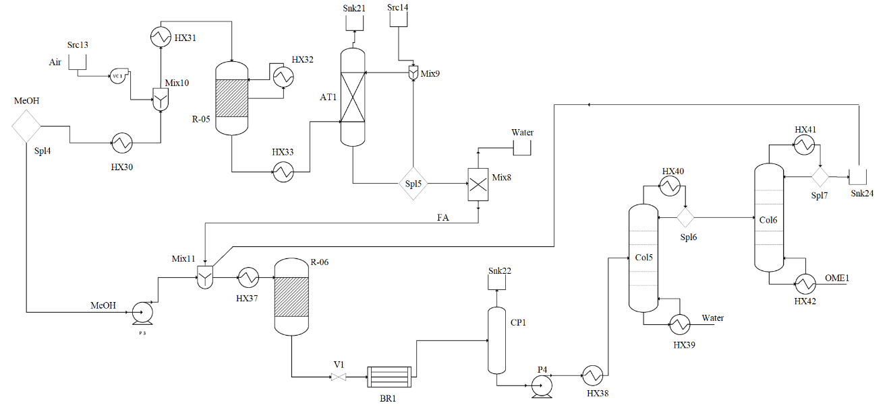
Figure 1.- Scheme for the process of OME1 production from methanol

OME₃₋₅. The production of the mixture that can be used as diesel substitutes is generated by a series of equilibria where the HF’s, MG’s and OME’s are allowed to grow. The reaction also takes place between 50-150ºC and 2-10 bar²¹ using a FA to methanol ratio from 2:1 to 6:1.²¹ The production of longer OME’s results in the generation of longer chain of OME’s. A reactive evaporator is used to decompose longer chain OME’s (OME₆-OME₇). Again HF’s and MG’s are decomposed into Methanol, water and FA. A system of two distillation columns are used to recover the fuel mixture of OME₃₋₅. The first column recovers the lighter products, FA, methanol, Water, OME₁-OME₂ as distillate and the rest as bottom product. Various studies have evaluated the removal of water from this mixture such as an absorption step,³⁶ and more recently a pervaporation unit.³³ Once water is removed, the rest is recycled to the synthesis reactor. The second column purifies the fuel mixture by removing the traces of OME₆ and OME₇ that are left after the reactive evaporation. See Figure 2 for the flowsheet.
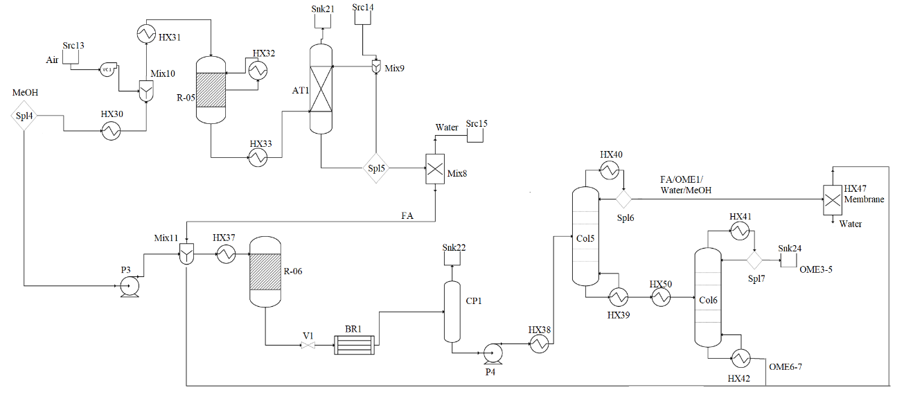
Figure 2.- Flowsheet for the production of OME3-5 mixture

Modelling considerations
In this section the modeling approach to the main units is described. The methanol synthesis stage is not considered. In general, units are modelled using first principles, mass and energy balances, thermodynamics and chemical equilibria, experimental data and rules of thumb.⁴⁸
Formaldehyde section
Synthesis reactor: The reactor for the production of FA is modelled assuming chemical equilibrium⁴⁴ where the atoms balance for carbon, hydrogen and oxygen must hold. Nitrogen exit the reactor unaffected diluting the gas mixture .
(1)
where
(2)
The ratio between the molar flow of oxygen and methanol should be typically 3 to 1.
FA recovery: The product gas is cooled down to 25 ºC using a heat exchanger modeled using mass and energy balances,⁴⁸ where the heat capacities for all species are a function of the temperature. The mixture does not condense due to the large flow of nitrogen. Next, the absorption column is modelled as a mass balance where the amount of water needed is that capable of solubilizing the FA, 0.4 kg/kg. The liquid phase exiting the column can be partially recycled back to the column and mixed with fresh water. All units operate isothermally at 25ºC. The gas phase contains mainly nitrogen, and traces of oxygen.
The absorption of formaldehyde in water is exothermic, -62kJ/mol.⁴⁹ To maintain low temperature, the unit is refrigerated. The column is built as a multibed contact unit where the heat generated is cooled down after each stage.
Water removal: In case this unit is considered, the feed is heated up until evaporation of the mixture computed using Antoine correlations for the mixture of FA, water and methanol and at moderate pressure so that the FA and methanol can be easily condensed to be fed to the OME synthesis section in the range of 2-10 bar.

OME’s production.
OME Synthesis reactor: It is modelled as an equilibrium reaction given by the molar fractions of the various species involved.
(3)
where the constants are taken from the literature.²¹ Table 1 shows the coefficients for the equilibrium constants given in the form of
(4)
Table 1.- Equilibrium constant parameters for OME’s production.²¹
Reaction | A | B
1 | -2.3250 | 2579.0
2(n=2) | -2.3105 | 3139.9
2 (n >=3) | -2.4334 | 3039.4
3 | -1.9020 | 3512.0
4 | -2-2496 | 3008.8
5 | 0.8147 | 340.25
6 | -2.4154 | 3029.6
7 | -2.4154 | 3029.6

The products of the reactor are computed from the equilibria presented in the reaction mechanism and the mass balance written in terms of atom balances for carbon, hydrogen and oxygen. The energy balance is computed from the enthalpies of formation of the species involved
(5)
Reactive evaporator: The decomposition of the longer chain OME’s is carried out at over 200ºC. The liquid mixture is heated up, modelled as a simple heat balance. The products of the evaporator are computed assuming a 90% decomposition of OME₆ and 95% decomposition of OME ₇. The atomic mass balance must hold and methanol, formaldehyde , water and CO₂ are produced. The CO₂ is released and the liquid mixture is sent to the system of distillation columns.³³
Distillation Columns: The feed to each one of the columns is assumed to be saturated liquid. Therefore, the stream is adjusted in temperature and pressure accordingly using pumps and heat exchangers. The aim is that the operating pressure allows liquid feed and a minimum temperature at the condenser of 35ºC, so that water can be used as cooling agent. The vapor pressure of the species involved is taken from different sources from the literature, and fit to Antoine equation in (6). In the appendix the values for coefficients A,B and C are given.
(6)
The distillation columns are modelled using short cut methods⁴⁷ based on experimental data and rigorous simulations from the literature to determine the reflux ratios and the yields, see Table 2. There are two particular issues. In the case of the process involving OME₁, there is an extraction from the column, therefore the stream must be accounted for in terms of the energy provided to the column, and for the case of the OME₃₋₅ where the first column uses a partial condenser, so that the distillate as a vapor is sent to a membrane, the rest of the columns use total condensers and partial reboilers.
(7)

Table 2.- Parameters for distillation column modelling
 | OME₁ |  | OME₃₋₅
 | Column 1 | Column 2 | Column 1 | Column 2
R_{min} | 2ª | 2ª | 0.05^{b} | 0.2^{b}
h | 0%Water  Up to 5% Methanol  100% FA and OME1 | Liquid distillate FA-OME1 | 100% FA/ MetOH/ Water/ OME1-2 | 100% OME3-5
- Weidert et al ³²; b) Burger et al ³⁵
Membrane: Based on recent work,^{33,46} 100% removal of water can be assumed. The feed is saturated vapor and the stream to be recycled, consisting of FA, methanol and OME₁₋₂ is condensed. The operating pressure is assumed between 1-10 bar, according to the reactor operating pressure to be computed so that the recycle can be easily condensed.
Optimization procedure.
The production of OME₁ and the mixture of OME₃₋₅ are modelled as described along the previous sections to formulate a set of non-linear programming problems. Table 3 shows the size of the four different process models, for each main product and considering the stage of partial removal of water before synthesis or not. The comparison between the base case and the evaporation is based on the yield, optimizing the product generated per kg of feed. The objective function is given by. Eq. (8). The problems are solved using a multi-start approach with CONOPT as the preferred solver. Note that the global optimum solution cannot be guaranteed.
(8)
S.t.
Mass and energy balances, phase and chemical equilibrium and thermodynamic models of each of the units as described in section 2.3
Table 3.- Model sizes of the NLP for different case studies.
 | Base case | Pervaporation
OME₁ | Eqs.: 492  Var: 639 | Eqs.: 507  Var: 651
OME₃₋₅ | Eqs: 1041  Var: 1461 | Eqs:1056  Var: 1473

Results and discussion
Process parameters.
Table 4 shows the main operating conditions for the production of OME₁. No yield improvement is found in the process that partially removes water from the secondary raw material, formaldehyde, in both cases slightly lower yield is achieved. Therefore, the alternative is no further pursued. Similar result is found for the production of OME₃₋₅ mixture. By comparing the production of OME₁ and longer chain OME’s, see Tables 4 and 5, there is a change in the need for formaldehyde. The production of OME₃₋₅ requires that twice the amount of methanol is sent to formaldehyde production compared to the production of OME₁. Furthermore, in the synthesis reactor operating conditions are selected so that the desired product is obtained. As expected, lower temperatures are required for the production of chemicals with a longer carbon chain. This result is typical of Fischer -Tropsch synthesis as well^{7,50}
Table 4.- OME₁ main operating parameters
OME₁
Formaldehyde | 270 ºC 1 bar
OME1 synthesis | 73 ºC 10 bar
Separation | Col 1 (Feed, Top, Bot)  74/52/ 136/180  P: 10 bar  Col2: (Feed, Top, Bot)  52/ 49/129  P 10 bar
To Formaldehyde | 33%
FA/MEOH (mol/mol) | 2
(kg OME /kg MEOH) | 7.93/10

Table 5.- OME ₃₋₅ Main operating parameters
OME₃₋₅
Formaldehyde | 270 ºC 1 bar
OME synthesis | 50 ºC 7.889 bar
Separation | Col 1 (Feed, Top, Bot)  30.6/30/217  P: 2.57 bar  Col2: (Feed, Top, Bot)  217; 174; 273  P: 1 bar
Mambrane | P. 3.3 bar
To Formaldehyde | 66%
FA/MeOH (mol/mol) | 2.28
(kg OME /kg MEOH) | 8.47/10

Cost estimation
The estimation of the OME’s production cost and investment is performed. The investment cost is computed using the factorial method⁵¹ . The method consists of estimating the equipment cost using the mass and energy balances of the facility to size the units. The detailed unit sizing and cost estimation procedure can be found in the supplementary material of Martín and Grossmann⁴ updated by Almena and Martín.⁵² The facility investment cost is computed using factors to estimate the piping, the insolation, and other costs. In summary factors of 3.15 and 1.4 are used to estimate the physical and total fixed costs, respectively, corresponding to a facility that processes fluids and solids.
The production costs involve maintenance, labor, chemicals, raw material (the methanol), utilities (steam, electricity and cooling water) and other expenses including taxes, fees and administration.⁵¹ A methanol cost of 0.36€/kg is assumed based on market prices⁵³ The steam costs are taken from Uresti et al ⁵⁴ and cooling water is assumed at 0.00057€/kg.⁵⁵
An interesting feature is the fact that the production cost of OME₁ is almost 50% larger than that of OME₃₋₅, 0.93€/kg vs 0.61€/kg. Figure 3 shows the breakdown of the production cost. Utilities play an important role in the case of the production of OME₁ due to the large reflux ratio required by both columns. On the contrary, the investment cost of the facility that produces OME₁ is 10% cheaper than that of OME₃₋₅, 46M€ vs 51 M€, due to the separation costs of the distribution of products involved in the production of OME₃₋₅ mixture.
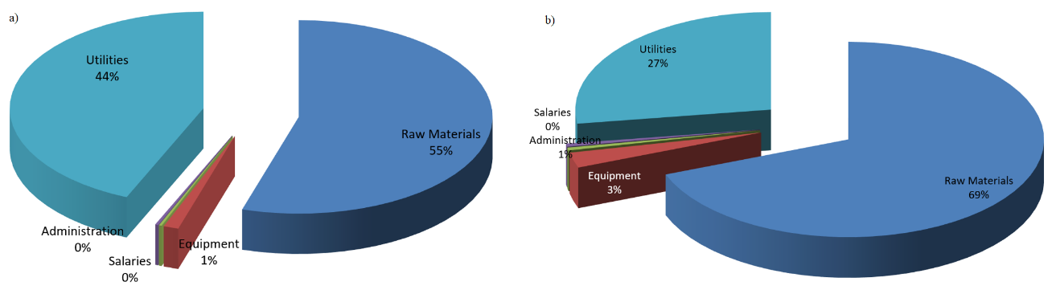
Figure 3.- Production cost distribution a: OME₁ ; b:OME ₃₋₅

Comparison for different methanol sources
Methanol can be produced from a wide range of green alternatives: from switchgrass via gasification, including with the possibility of combining it with the hydrogenation of carbon dioxide,¹⁹ using captured CO₂ and hydrogen from electrolysis¹⁶ or from biogas via reforming,⁵⁶ see Table 6.
An economic evaluation for each process was carried out in the different works resulting the following price ranges: 0.34-0.36 €/kg for the switchgrass to methanol process, 0.21-0.45 €/kg for the hydrogenation of CO₂ with electrolyzed hydrogen and 0.46 €/kg for the biogas to methanol process. Values from 0.65 €/kg to 1€/kg can be obtained for OME₁ depending on the source of methanol. It can be seen that biomass is the most competitive one. In the case of OME₃₋₅, the production cost is lower due to the reduced utilities resulting in prices from 0.32 to 0.77 €/kg. Hydrogenation of CO₂ can be promising only at places with high wind velocity and solar incidence, but the cost remains with 50% increase in other scenarios; not that favourable, see previous work¹⁶ for further discussion on methanol cost at different allocations. Figure 4 shows the range for different biomass costs (30,50,60,75,100 and 120 €/t), biogas production and solar and wind operation in Spain and UK according to the previous paper where the possibility of selling the excess of power to the grid (0.21€/kg-0.26€/kg, respectively) or not (0.3€/kg-0.45€/kg, respectively) was considered. Biomass is the most competitive source as long as its costs is below 100€/t while wind and solar can still be competitive, as well as an integrated facility that captures and hydrogenates the CO₂ from methanol production for places with high solar incidence (5 kWh/m²d) and wind velocity (above 7m/s)
Table 6.- Effect of methanol source on OME’s costs
OME Production Cost (€/t) | Methanol Production
 | Lignocellulosic  (60€/t biomass) | Gasification with CO₂ hydrogenation | CO₂ hydrogenation | Biogas reforming
Methanol cost (€/kg) | 0.17 | 0.34 | 0.21-0.45 | 0.46
OME₁ (€/kg) | 0.69 | 0.91 | 0.74-1.05 | 1.06
OME₃₋₅ (€/kg) | 0.39 | 0.59 | 0.436-0.71 | 0.731

Figure 4.- Effect of methanol source on OME’s production costs.

The production cost of any chemical is also subjected to economies of scale. In this work, we only focus on the synthesis stage, leaving out of the evaluation the economies of scale related to the different methods for methanol production. Figure 5 shows a scale up sensitivity study on the production of both OME₁ and OME₃₋₅. The production capacities are associated to typical facilities sizes. Smaller ones are wind / solar based facilities based on the size in previous work,¹⁶ the intermediate size corresponds to typical biomass processing facilities from 10-25kg/s of switchgrass and larger facilities integrated both as in Martín and Grossmann.¹⁹ For different methanol prices, achieving a production cost below 1€/kg always requires medium size facilities processing 6kg/s of biomass in the case of OME₁. The lower production costs in the case of the OME₃₋₅ process results in the need for smaller facilities to achieve the target of 1€/kg, that can use solar and wind energy to hydrogenate CO₂. The investment cost of the facility is almost linear with the production capacity of methanol for OME₁, see eq. (9), while for OME ₃₋₅, eq. (10) is obtained

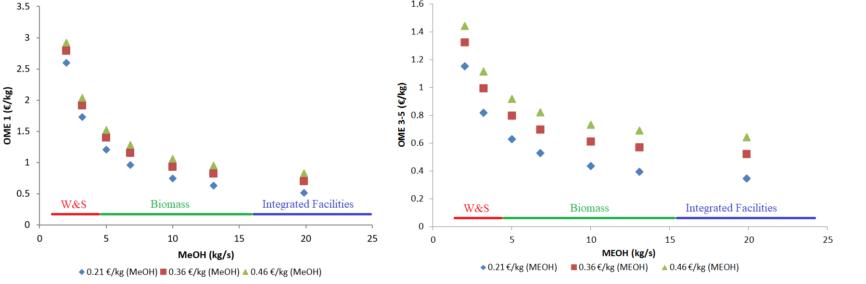
Figure 5.- Effect of scale up and methanol price on OME’s production cost
Investment (M€) _{OME1} = 3.495(MeOH(kg/s)) + 14.477 (9)
Investment (M€) _{OME3-5} = 14.165 ln(MeOH(kg/s)) + 22.301 (10)
Conclusions
In this work, we have evaluated the production of oxymethylene ethers from methanol considering different methanol sources. A direct synthesis from aqueous solution of formaldehyde and methanol is considered where first formaldehyde is produced and next either methylal, OME₁, or longer chain OME’s (OME₃₋₅) are obtained. The process is modelled using first principles, mass and energy balances, and chemical and phase equilibrium to model each unit, and optimized to evaluate the optimal operating conditions leading to each of the OME products using a mathematical optimization approach.
The production of OME₁ requires half formaldehyde production and results in 10% larger yield towards products compared to the production of OME₃₋₅. While the investment costs for OME₁ production are 10% lower than those needed for OME₃₋₅ production (45M€vs 49M€) due to the easier product separation, the production costs are 30% larger (0.93 vs 0.78 €/kg) due to the utility costs. Finally, the effect of the cost of methanol on the OME’s is evaluated. Lignocellulosic based methanol is the most competitive as long as biomass prices are below 100€/t. Wind and solar based methanol price is highly volatile depending on the availability, the possibility of selling the excess of power and the area limitations. Waste based methanol via dry reforming is the most expensive.

Nomenclature
A, B C : Antoine coefficients
C_{i}: Cost of item i
C_{p}: heat capacity (kJ/kgK)
Kp: Equilibrium constant in gas phase
Kx: Equilibrium constant in liquid phase
fc_{i} : Flow of material I (kg/s)
P_{i} : Partial pressure of component i (kPa)
Qi: Heat flow in unit i (kW)
R: reflux ratio.
x_{l}: Molar concentration of species i
y_{i}: Molar fraction of species i
Z: Objective function (€/s)

ΔHf: Formation energy of stream(kJ/kg)
Δhf: Formation enthalpy of species (kJ/kg)

Supporting Information

Thermodynamic data and additional modeling details can be found in the supporting information. This material is available free of charge via the Internet at http://pubs.acs.org.

Acknowledgement
The authors appreciate Salamanca Research group PSEM3 for software licenses, JCyL for the grant SA026G18 and the CAPD center.

References

[1] IRENA (2018) Reneable capacity statistics 2018.https://www.irena.org/publications/2018/Mar/Renewable-Capacity-Statistics-2018
https://www.irena.org/-/media/Files/IRENA/Agency/Publication/2018/Mar/IRENA_RE_Capacity_Statistics_2018.pdf

[2] BCG Boston Consulting Group (2010) https://www.bcg.com/documents/file36615.pdf https://www.bcg.com/documents/file36615.pdf

[3] Karrupiah, R.; Peschel, A.; Grossmann, I.E.; Martín, M.; Martinson, W; Zullo, L., Energy optimization of an Ethanol Plant. AICHE J. 2018, 54( 6), 1499-1525. DOI: 10.1002/aic.11480

[4] Martín, M.; Grossmann, I.E. Energy optimization of bioethanol production via gasification of switchgrass AIChE J. 2011, 57(12),3408- 3428. DOI: doi.org/10.1002/aic.12544

[5] Martín, M.; Grossmann, I.E. Simultaneous optimization and heat integration for biodiesel production from cooking oil and algae. Ind. Eng. Chem Res 2012, 51 (23), 7998–8014 DOI: 10.1021/ie2024596.

[6] Severson, K.; Martín, M.; Grossmann, I.E. Optimal integration for biodiesel production using bioethanol. AICHE J. 2013, 59(3), 834-844 DOI: 10.1002/aic.13865
[7] Martín, M.; Grossmann, I.E. Process optimization of FT- Diesel production from biomass. Ind. Eng. Chem. Res. 2011, 50 (23),13485–13499 DOI: 10.1021/ie201261t

[8] Xiu, S.; Shahbazi, A. Bio-oil production and upgrading research: A review. Renew. Sust. Energ. Revs.2012, 16(7), 4406-4414. DOI: 10.1016/j.rser.2012.04.028

[9] Mariano, A.P.; Dias, M.O.S.; Junqueira, T.L.; Cunha, M.P.; Bonomi, A.; Filho, R.M. Butanol production in a first generation Brazilian sugarcane biorefinery: Technical aspects and economics of greenfield projects. Bioresour. Technol, 2013, 135, 316-323. DOI: 10.1016/j.biortech.2012.09.109

[10] Qureshi, N.; Saha B.C.; Cotta, M.A.; Singh, V. An economic evaluation of biological conversion of wheat straw to butanol: A biofuel. Energy. Convers. Manage 2013, 65, 456 - 462. DOI: 10.1016/j.enconman.2012.09.015

[11] Malmierca, S.; Díez-Antoínez, R.; Paniagua, A.I.; Martín, M. Technoeconomic study of AB biobutanol production. Part 2: Process design. Ind. Eng. Chem. Res. 2017, 56 (6), 1525–1533 DOI. 10.1021/acs.iecr.6b02944

[12] Malmierca, S.; Díez-Antoínez, R.; Paniagua, A.I.; Martín, M. Technoeconomic study of AB biobutanol production. Part 1: Biomass Pretreatment and Hydrolysis. Ind. Eng. Chem. Res., 2017, 56 (6), 1518–1524 DOI: 10.1021/acs.iecr.6b02943

[13] Peral, E.; Martín, M. Optimal production of DME from switchgrass based syngas via direct synthesis. Ind. Eng. Chem. Res. 2015, 54, 7464-7475. DOI: 10.1021/acs.iecr.5b00823

[14] Martín, M. Optimal year-round production of DME from CO2 and water using renewable energy J. CO2 Utilization. 2015, 13,105-113. DOI: 10.1016/j.jcou.2016.01.003

[15] Ford (2015) Ford Leads Project to Develop Near Zero Particulate Emission Diesel Cars That Could Run on Converted CO2
https://media.ford.com/content/fordmedia/feu/en/news/2015/09/11/ford-leads-project-to-develop-near-zero-particulate-emission-die.html Last accessed December 2019

[16] Martin M. Methodology for solar and wind based process design under uncertainty: Methanol production from CO2 and hydrogen Comp Chem Eng. 2016, 92, 43-54 DOI: 10.1016/j.compchemeng.2016.05.001

[17] Held, M.; Tonges, Y.; Pelerin, D.; Hartl, M.; Wachtmeister, G.; Burger, J. On the energetic efficiency of producing polyoxymethylene dimethyl ethers from CO2 using electrical energy. Energy Environ. Sci., 2019, 12, 1019-1034, DOI: 10.1039/C8EE02849D

[18] Bongartz, D.; Burre, J.; Mitsos, A. Production of Oxymethylene Dimethyl Ethers from Hydrogen and Carbon DioxidePart I: Modeling and Analysis for OME1 . Ind. Eng. Chem. Res. 2019; 58 (12), 4881-4889 DOI: 10.1021/acs.iecr.8b05576

[19] Martin M., Grossmann I.E. Towards zero CO₂ emissions in the production of Methanol from switchgrass. CO2 to methanol. Comp. Chem. Eng. 2017, 105, 308–316 DOI: 10.1016/j.compchemeng.2016.11.030

[20] Himmel, D.; White, R.J.; Jacob, E.; Krossing, I. Highly correlated ab initio thermodynamics of oxymethylene dimethyl ethers (OME): formation and extension to the liquid phase. Sustainable Energy Fuels, 2017,1, 1177-1183 DOI: 10.1039/C7SE00053G

[21] Schmitz, N.; Homberg, F.; Berge, J.; Burger, J.; Hasse, H. Chemical Equilibrium of the Synthesis of Poly(oxymethylene) Dimethyl Ethers from Formaldehyde and Methanol in Aqueous Solutions Ind. Eng. Chem. Res. 2015, 54, 6409−6417 DOI: 10.1021/acs.iecr.5b01148

[22] Zhang, J.; Shi, M.; Fang, D.; Liu, D. Reaction kinetics of the production of polyoxymethylene dimethyl ethers from methanol and formaldehyde with acid cation exchange resin catalyst. React. Kinet. Mech. Catal. 2014, 11, 459−470. DOI: 10.1007/s11144-014-0771-6

[23] Oestreich, D.; Lautenschutz, L.; Arnold. U.; Sauer, J. Reaction kinetics and equilibrium parameters for the production of oxymethylene dimethyl ethers (OME) from methanol and formaldehyde Chem. Eng. Sci. 2017, 163, 92–104 DOI: 10.1016/j.ces.2016.12.037

[24] Drunsel, J.O.; Renner, M.; Hasse, H. Experimental study and model of reaction kinetics of heterogeneously catalyzed methylal synthesis. Chem. Eng. Res. Des. 2012, 90, 696-703 DOI: 10.1016/j.cherd.2011.09.014

[25] Zhang, X.; Kumar, A.; Arnold, U.; Sauer, J. Biomass-derived oxymethylene ethers as diesel additives: A thermodynamic analysis. Energy Proc. 2014, 61, 1921-1924 DOI: 10.1016/j.egypro.2014.12.242

[26] Lesch, J. E. The German Chemical Industry in the Twentieth Century; Kluwer Academic Publishers, 2000; 480.

[27] Zhenova, A.; Pellis, A.; Milescu RA, McElroy, C.R.; White, R.J.; Clark, J,H. Solvent applications of short chain oxymethylene dimethyl ether oligomers. ACS. Sust. Chem. Eng. 2019, 7(17), 14834-14849 https://doi.org/10.1021/acssuschemeng.9b02895
[28] Zheng, Y.; Tang, Q.; Wang, T.; Wang, J. Molecular size distribution in synthesis of polyoxymethylene dimethyl ethers and process optimization using response surface methodology Chem. Eng. J. 2015, 278, 183–189 DOI: 10.1016/j.cej.2014.10.056
[29] Bahmanpour, A.M.; Hoadley, A.; Mushrif, S.H.; Tanksale, A: Hydrogenation of carbon monoxide into formaldehyde in liquid media ACS. Sust. Chem. Eng 2016, 4, 3970-3977 https://doi.org/10.1021/acssuschemeng.6b00837
[30] Zhang, Z.; Oyedun, A.O.; Kumar, A.; Oestreich, D.; Arnold, U.; Sauer, J. An optimized process design for oxymethylene ether production from woody-biomass-derived syngas. Biomass Bioenerg. 2016, 90, 7-14 DOI: 10.1016/j.biombioe.2016.03.032
[31] Schmitz, N.; Burger, J.; Strofer, E.; Hasse, H. From methanol to the oxygenated diesel fuel poly(oxymethylene) dimethyl ether: An assessment of the production costs. Fuel 2016, 185, 67–72 DOI: 10.1016/j.fuel.2016.07.085

[32] Weidert, J.O.; Burger, J.; Renner, M.; Blagov, S.; Hasse, H. Development of an Integrated Reaction−Distillation Process for the Production of Methylal Ind. Eng. Chem. Res. 2017, 56, 575−582 DOI: 10.1021/acs.iecr.6b03847

[33] Bongartz, D.; Burre, J.; Mitsos, A. Production of Oxymethylene Dimethyl Ethers from Hydrogen and Carbon Dioxide—Part I: Modeling and Analysis for OME₁ Ind. Eng. Chem. Res. 2019, (12), 4881-4889 DOI: 10.1021/acs.iecr.8b05576

[34] Burre, J.; Bongartz, D.; Mitsos, A. Production of Oxymethylene Dimethyl Ethers from Hydrogen and Carbon Dioxide Part II: Modeling and Analysis for OME3−5. Ind. Eng. Chem. Res. 2019, 58, 14, 5567-5578 DOI: 10.1021/acs.iecr.8b05577

[35] Burger, J.; Ströfer, E.; Hasse, H. (2013) Production process for diesel fuel components poly(oxymethylene) dimethyl ethers from methane-based products by hierarchical optimization with varying model depth. Chem. Eng. Res. Des. 2013, 91, 2648−2662. DOI: 10.1016/j.cherd.2013.05.023

[36] Schmitz, N.; Strofer, E.; Burger, J.; Hasse, H. (2017) Conceptual Design of a Novel Process for the Production of Poly(oxymethylene) Dimethyl Ethers from Formaldehyde and Methanol. Ind. Eng. Chem. Res. 2017, 56, 11519−11530 DOI: 10.1021/acs.iecr.7b02314

[37] Schmitz,N.; Breitkreuz, C.F.; Ströfer, E.; Burger, J.; Hasse, H. Separation of water from mixtures containing formaldehyde, water, methanol, methylal, and poly(oxymethylene) dimethyl ethers by pervaporation J. Memb. Sci. 2018, 564, 806–812 Doi: 10.1016/j.memsci.2018.07.053

[38] Ai, Z.J.; Chung, C.-Y., Chien, I.-L. Design and control of poly(oxymethylene) dimethyl ethers production process directly from formaldehyde and methanol in aqueous solutions. IDAC PapersOnLin 2018, 51-18, 578-583 DOI: 10.1016/j.ifacol.2018.09.362

[39] Brynolf, S., Taljegard, M.; Grahn, M.; Hansson, J. Electrofuels for the transport sector: A review of production costs Renew. Sust. Energ. Revs. 2018, 81, 1887–1905 DOI: 10.1016/j.rser.2017.05.288

[40] Detz, R.J.; Reek, J.N.H.; van der Zwaan BCC. The future of solar fuels: when could they become competitive? Energy Environ. Sci., 2018, 11, 1653—1669 DOI:
10.1039/C8EE00111A

[41] Martín, M. Artificial vs natural reuse of CO₂ for DME production. Are we getting any close? Engineering. 2017, 3(2), 166-170 DOI: 10.1016/J.ENG.2017.02.002

[42] Sánchez, A.; Martín, M.; Vega, P. Biomass based sustainable Ammonia production: Digestion vs Gasification ACS. Sust. Chem. Eng. 2019, 7, 11, 9995-10007 DOI: 10.1021/acssuschemeng.9b01158,

[43] Martín, M.; Davis, W. Integration of wind, solar and biomass over a year for the constant production of CH₄ from CO₂ and water. Comp Chem Eng 2015, 84, 314-325 DOI: 10.1016/j.compchemeng.2015.09.006

[44] Jones, E.; Fowlie, G.G. Thermodynamics of formaldehyde manufacture from methanol. J. Appl. Chem. 1953, 3, 206-213 DOI: 10.1002/jctb.5010030504

[45] Millar, G.J., Collins, M. Industrial Production of Formaldehyde Using Polycrystalline Silver Catalyst Ind. Eng. Chem. Res. 2017, 56, 9247−9265 DOI: 10.1021/acs.iecr.7b02388

[46] Carretier, E.; Moulin, Ph.; Beaujean, M.; Charbit, F. Purification and dehydration of methylal by pervaporation. J. Memb. Sci. 2003, 217, 159-171 DOI: 10.1016/S0376-7388(03)00125-X

[47] Martín M Industrial chemical processes. Analysis and design. Elsevier Oxford. 2016

[48] Franz, A.W., Kronemayer, H., Pfeiffer, D., Pilz R.D., Reuss, G., Disteldorf, W., Gamer, A.O., Hilt, A., (2016) Formaldehyde. In Ullmann’s Encyclopedia of Industrial Chemistry. DOI: 10.1002/14356007.a11_619.pub2

[49] Hernández, B.; Martin, M. Optimization for biogas to chemicals via tri-reforming analysis of Fischer-Tropsch fuels from biogas. Energy Convers. Manage. 2018, 174, 998-1013. DOI: 10.1016/j.enconman.2018.08.074

[50] Sinnot. R.K., 1999. Coulson and Richardson, Chemical Engineering. 3ªEd. Butterworth Heinemann, Singapore, 1999
[51] Almena, A.; Martín, M. Techno-economic analysis of the production of epiclorhidrin from glycerol. Ind. Eng. Chem. Res. 2016, 55 (12), 3226-3238 DOI: 10.1021/acs.iecr.5b02555

[52] (https://www.methanex.com/our-business/pricing; https://www.gelsenchem.de/en/historical-methanol-pricing/)

[53] Pérez Uresti, S.; Martín, M.; Jiménez Gutierrez, A. Estimation of renewable-based steam costs. Applied Energy, 2019, 250, 1120–1131 DOI: 10.1016/j.apenergy.2019.04.189

[54] Franceschin, G.; Zamboni, A.; Bezzo, F.; Bertucco, A. Ethanol from corn: a technical and economical assessment based on different scenarios Chem. Eng. Res. Des., 2008, 86, 5, 488-498 DOI: 10.1016/j.cherd.2008.01.001
[55] Hernández, B.; Martín, M. Optimal composition of the biogas for dry reforming in the Production of Methanol. Ind. Eng. Chem. Res. 2016, 55, 23, 6677-6685 DOI: 10.1021/acs.iecr.6b01044

For Table of Contents Use only

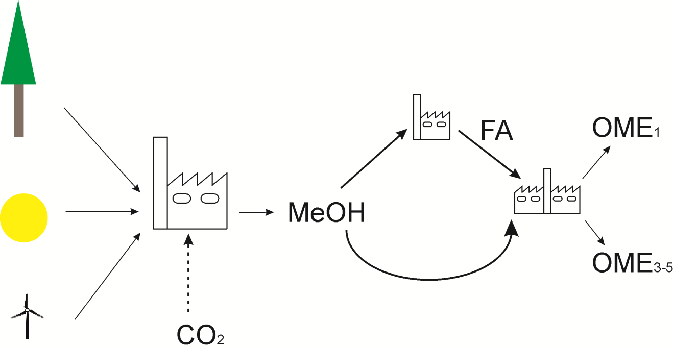
Optimal integrated facility for OME’s production from methanol .
Mariano Martínª, Judit Redondoª, Ignacio E. Grossmann^{b}

OME’s production, OME₁ and OME₃₋₅, from renewable based methanol from different resources is evaluated

Corresponding Author. M Martín: mariano.m3@usal.es
Corresponding Author. M Martín: mariano.m3@usal.es

