Fourth graders’ expression of the general case
Cristina Ayala-Altamirano¹, Marta Molina² and Rebecca Ambrose³
¹University of Almería, Spain, ²University of Salamanca, Spain, ³University of California, USA

Abstract
This study forms part of a classroom teaching experiment (CTE) on the development of a group of 25 9-10 years old students’ algebraic thinking. More specifically, it explores their reasoning while solving word problems built around functional relationships to determine how they generalize through questions posed using natural language, drawn figures or the keyword “many”. Their written and oral answers to those questions are qualitatively analyzed to determine which approach most effectively supports the expression of their generalization. The results reveal the benefits of posing questions about the general case in different ways while teaching students to use conventional algebraic representations. According to these findings, representing indeterminate quantities with the keyword “many” induces generalization more successfully than representing them with letters. The use of letters prompts students to seek meaning for the letters, either conventionally, as an unknown or variable quantity, or otherwise, as a label or specific values assigned according to their own criteria. Identifying the most effective procedures may help teachers and curriculum designers formulate mathematical tasks that encourage students to express the generality they perceive in particular cases. Determining the communication demands of each approach is likewise highly useful.
Keywords: Early algebra, functional thinking, generalization, representation, variable.

Introduction
An understanding of children’s algebraic thinking as it evolves in classrooms has important implications for curricular design. While no consensus has been reached in the scientific community on its definition (Kaput 2008), most agree algebraic thinking involves not only symbols but ways of thinking (Kieran 2004). In this study students were engaged in a number of algebraic thinking activities related to functions including: reference to the analytical use of indeterminate quantities, i.e., operating with them as if they were known (Radford 2018); recognition of the underlying algebraic structure and the inter-quantity relationships in a situation (Kieran 2004); and expressing and working with generality (Mason 2017). Students were invited to interpret arithmetic operations as functions and, through problem-solving, treat functions as variations in everyday contexts (Carraher & Schliemann 2015).
Pivotal to algebraic thinking are generalization, representation and justification (Kaput 2008). Generalizing patterns and functional relationships comprise three stages: (a) to identify elements common to all cases, (b) to extend reasoning further than the original range, and (c) to derive wider results than the particular cases and (d) to provide a direct expression so that any term can be determined (Ellis 2007; Strachota et al. 2018). This study focuses on the third stage, specifically how students refer to indeterminate quantities when justifying their answers. Evidence suggests that justification plays a significant role in learning as students express generalization in more and more sophisticated ways (Stephens et al. 2017). In addition, when teachers assess students’ mathematical knowledge by analyzing what they say or how they use signs (Morgan et al. 2014) they can make instructional decisions to advance students’ algebraic understanding.
While researchers have identified a significant distinction between perceiving and expressing generality leading them to conclude students’ difficulties may be related to a lack of the type of language needed to convey the idea and not necessarily to their failure to identify a regularity (Cooper & Warren 2008; Radford 2003), their views on the use of language to express generality vary. Some stress the importance of considering personal forms of expression in the transition to conventional notation and support the use of natural language over notation (Cooper & Warren 2008; Mason 2017; Radford 2018; Ursini 2001), whereas others propose introducing conventional notation from the earliest grades (Blanton et al. 2019; Kaput 2008).
Mason et al. (1985) contend that students are naturally able to generalize and express generality. While they use a variety of cultural tools, language is their primary resource (Mason et al. 2005). When learning, students transition across enactive, iconic and symbolic representations depending on what they are doing. Ursini (2001) proposes that, before being introduced to conventional algebraic notation, students should be given the opportunity to express general ideas verbally, to use numbers as examples of a class of numbers and to apply non-algebraic symbols. Radford (2018), in turn, claims that as students learn and understand algebraic ideas, their acts are mediated by the cultural tools at their disposal. They imbue mathematical objects with meaning by deploying semiotic means such as objects, artifacts, tools, gestures, drawings and natural language, among others. Caspi and Sfard (2012) distinguish between informal algebraic discourse and formal algebraic discourse, which, although mutually independent, influence each other. They propose that formal discourse can grow from informal talk, i.e. from the students' spontaneous discourse. This approach guarantees continuity between the students' discourse and the new discourse they have not yet acquired. As an open line of research, they highlight the importance of investigating the means of expression that students use in algebra classes in order to close the gap between the formal and the informal.
Blanton and her co-authors defend the importance of introducing letters as algebraic notation from the earliest grades through significant classroom experiences (Blanton et al. 2017). They argue that the early use of such symbols affords more cognitive space to assimilate more complex mathematical ideas and abstractions in the later grades (Blanton & Kaput 2011). Acknowledging that debate among scholars regarding the ages students should first receive instruction on conventional algebraic notation, Blanton et al. (2019) highlight the need for further study that entails more than mere descriptions of students’ thought processes. In addition, Kieran and co-authors (2016) point out the need for in-depth study on the tasks and activities that foster early algebraic thinking.
Based on the background described above, we seek to relate task characteristics to the expression of generality. In that vein, the present study analyzes the extent to which the ways variables are represented (i.e., the keyword “many”, drawings or letters) in problems about the general case support fourth-graders’ abilities to express generalization. By including informal and formal modes of expression in the tasks our goal is to contribute to the understanding of students' means of expression in order to increase the likelihood that students connect their intuitive understandings to formal algebra. The focus on how questions on variables are posed supplements earlier studies that associated task characteristics with students’ performance and ability to think functionally (Ayala-Altamirano & Molina 2021, Ramírez et al. 2020). Identifying the characteristics of tasks that support algebraic thinking provides teachers with grounds for planning teaching and formulating tasks that encourage students to develop algebraic skills.

2. Variables in the literature
In this paper we study the variable in the context of solving problems involving a function, therefore the associated meaning will be a quantity that varies (Usiskin, 1988).

2.1. Representing variables
Variables have been represented in many ways. In school curricula, textbooks and research on algebraic thinking they are represented primarily in natural language, drawings / geometric shapes and letters / algebraic symbolism (Figure 1).
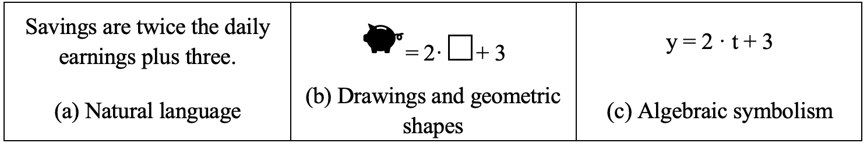
Fig. 1 Examples of representation of expressions including variables
Spoken or written natural language represents variables through expressions allusive to the context of the word problem. For example, in the sentence in Figure 1a, the unknown could be considered the “daily earnings.” This type of representation tends to be accessible for expressing generalization (English & Warren 1998) because the meaning of the unknown is explicit (Molina 2014).
Drawings or geometric shapes (Figure 1b) are usually found in textbooks and curricula. Mason et al. (2005) noted that the use of drawings is a tool for transitioning from the informality of natural language to the formality of letters. In that vein Carraher and Schliemann (2010) stressed the importance of distinguishing between when students’ drawings represent a variable (i.e., a wallet to mean an amount of money) and when they are literal depictions.
The use of letters (Figure 1c) is a modern mathematical convention. Compared to natural language, symbols are artificial and must be learned, so it is important to negotiate their algebraic meaning and the generality attributed to them (Dörfler 2008).

2.2. Ways to ask about variables
Most studies on generalization in elementary school adopt an inductive approach to task design. In other words, tasks begin with the analysis of particular cases involving small quantities, followed by the use of larger and ultimately indeterminate quantities. While as a rule such research begins by using natural language to refer to variables, the way algebraic symbolism is introduced differs. Some examples are set out below, which were selected taking into account that they involved tasks related to patterns or functions, that were carried out with elementary students, and that their results focused on the students' work when they referred to indeterminate quantities for the first time.
One way of asking about variables is one in which the question does not contain letters to represent variables (e.g., Figure 2). The use of symbolism may emerge when students reflect on their answers. In Radford’s 2018 study, fourth-grade students generalized and in a conversation with the teacher used signs such as “#”, “?” and “__” in their answers. The teacher’s suggestion to use letters instead of the aforementioned symbols prompted students to adopt algebraic symbolism. In Lannin’s 2005 study, students did not use algebraic symbolism but their answer denoted their ability to generalize and justify using numerical examples that could be interpreted as generic examples.
Fig. 2 Phone cost problem
Other researchers have used tasks that ask about the general case by representing the variables with natural language and letters. Figure 3 shows an example from Amit and Neria (2008)’s study with 6th and 7th graders. The authors reported that students’ inability to make sense of letters constituted an obstacle to generalizing. In a series of longitudinal studies, Blanton and her co-authors (2017, 2019) showed that students in different elementary grades were able to use algebraic symbolism in functional contexts when participating in teaching sequences in which symbolic representation was gradually introduced through the use of natural language. Contrary to the subjects in previous studies, these students were more successful in representing the rule governing a function with algebraic symbolism than in their own words (Blanton et al. 2019). The researchers attributed that to the emphasis in the instruction delivered on the use of such representation and its meaning in the contexts presented to students. They also pointed out that their findings questioned the conventional wisdom according to which younger students are unprepared to use algebraic symbolism and should be encouraged to use the type of representation they have mastered (such as natural language or drawing). They added that denying students the opportunity to use letters to represent variables may limit their subsequent academic success (Blanton et al. 2017).
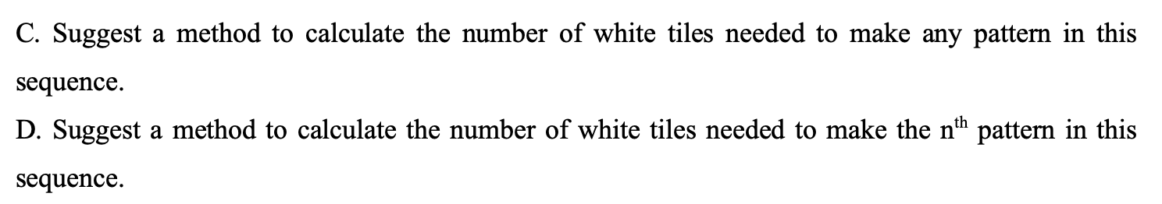Fig. 3 Tiles problem
The research team authoring this study has conducted teaching experiments asking about the general case with natural language and explored the use of letters to represent variables beginning in early elementary school (e.g., Ayala-Altamirano & Molina 2020; Pinto & Cañadas 2021). They concluded that classroom discussion helped students acquire an understanding of letters as a way to symbolize variables, although the meaning they gave letters and the way they represented the functional relationship depended on task characteristics. The true/false statements (e.g. When Carlos sells Z T-shirts, he earns 3XZ euros, ¿true or false?) helped students interpret letters as variables. In the tasks where they were asked to express the functional relationship, the ones they found most difficult, they resorted to other means of representation in their answers.
In light of the existence of various ways to introduce students to variables and their different representations, as well as different responses by students, this study addressed the following research question: What ways of asking about variables (natural language, drawn figures, or the keyword "many") support fourth-grade students’ ability to express functional relationships most effectively?

3. Methodology
This qualitative, exploratory and descriptive study consisted of a classroom teaching experiment (CTE) (Cobb & Gravemeijer 2008) within the research-design paradigm (Bakker 2019).
One of our leading conjectures is that the evolution of the meanings and use of the signs involved in expressing generalization evolves from social interaction according to the demands of communication (Wertsch, 1985/1995). A second conjecture is related to how to ask about the general case. Considering the works mentioned in our literature review, we consider the use of natural language to represent the indeterminate quantities as essential to initially mobilize students' informal discourse. The later introduction of other types of representations such as drawings (Mason et al. 2005) or letters (e.g. Blanton et al. 2019) would lead to a progression to the use of more formal representations.

3.1. Participants
We worked with a group of 25 fourth-grade (9- to 10-year-old) students. They were enrolled in a charter school in southern Spain in a very low-income neighborhood populated by families at risk of social exclusion. We chose to work at the school due to their availability and disposition to participate. Prior to the working sessions, the students had studied addition, subtraction and the basics of multiplication and division and had worked with numbers up to one million. However, although the national guidelines (Ministerio de Educación, Cultura y Deporte 2014) suggest addressing some elements of algebraic thinking, such as describing and analyzing regularities and patterns, the students had received no instruction related to generalization or expressing algebraic ideas. Students’ anonymity in this paper was ensured by assigning each a code: S_{i}, where i = 1 ... 25.
Students’ normal classroom seating arrangement in groups of three or four was retained for the CTE. One researcher played the part of teacher-researcher to better monitor the variables defined in the experimental design (Kelly & Lesh 2000). Her role consisted primarily in encouraging students to participate actively and interact with one another and clarify their doubts about the tasks. Other team members acted as observers or videotaped the sessions.

3.2. Instructional sequence
The study was conducted over 6 months (see Figure 4) and five word-problems (WP) involving different functional relationships were proposed. First of all, the students individually answered a diagnostic questionnaire. Based on the results of this assessment, six students were selected for two individual semi-structured interviews, before and after the instructional sessions. S₉ and S₂₁ did not answer or answered incorrectly almost all of the problems on the questionnaire and were categorized at the low level. S₁₅ and S₁₆ answered some problems correctly but did not show any regularity in their answers and were categorized at the medium level. Finally, S₁₂ and S₂₃ generalized the functional relationship or showed evidence of regularities in their reasoning processes and were categorized at the high level. These interviews were used to corroborate the findings from the class sessions which will be evident when we discuss the findings. We also took into account their teacher’s opinion of their performance in mathematics and made sure to include at least one student in each level of performance.
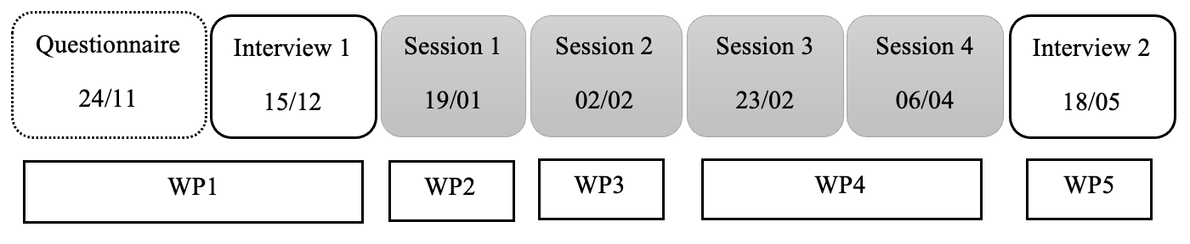
Fig. 4 Organization of sessions
After the diagnostic questionnaire and Interview 1 the whole class participated in four 60-minute classroom sessions. Sessions 1 to 4 included different stages: (a) general introduction of the task by the teacher-researcher; (b) individual or small group-based problem solving with worksheets; and (c) general discussion where students could share their ideas with the rest of the class, ask classmates to explain their thinking, or make suggestions to revise the answers or generalizations proposed. The order of the activities was not strictly linear: after a classroom discussion, the students could return to their working groups or work on a new task. The teacher-researcher did not provide students with any introductory explanation. Instead, she launched the discussions by presenting a set of questions to consider. The organization of instruction is based on the Cognitively Guided Instruction framework (Carpenter & Fennema 1992), in which children are provided with word problems and encouraged to talk about how they solved them. The teacher then probes the child’s thinking if it is unclear and invites other children to comment. The teacher tends not to directly teach things, but rather adjusts future problems to build on the children’s thinking.
The questions for each word-problems were arranged inductively based on the stages of generalization described in earlier studies (Ellis 2007; Strachota et al. 2018). Initially, the questions involved students perceiving regularity: identifying common elements in particular cases involving small quantities and extending reasoning to large quantities. This phase is not the focus of this article. Next, the questions involved students expressing regularity by extending reasoning to general cases, which is the purpose of this article. The general context of each problem and the functional equation involved are given in Figure 5. As an example, Figure 5 shows all the questions asked in the worksheet for session 2 (WP3). For the rest of the sessions only the questions for the general case are shown. The sessions and interviews are described in further detail in Ayala-Altamirano and Molina (2021) and Ramírez et al. (2020).
Three ways of representing the variables were considered in the design of the sessions: natural language, drawing or symbols and letters. The general case in natural language was represented as “many” or another expression proposed by the students. For example, in WP5 the number of guests was represented in natural language as “many guests” or “infinite number of guests” (in WP3).
The use of letters was introduced in WP1 with true/false statements, given that prior experience showed such questions to support the interpretation of letters as variables (Ayala-Altamirano & Molina 2020). This WP was presented in the initial questionnaire. In order to identify the spontaneous ideas of the students, the teacher only told them that the letters represented a quantity that we do not know, as well as the question mark "?". In the next session, in light of the difficulties observed in the questionnaire we decided to reserve the use of letters for the general discussions, where teacher-researcher’ mediation could support students’ understanding. Letters were introduced after discussing the general case in natural language. Students were asked what would happen if the variable at issue were represented by a letter suggested by the research team. Especially in WP4, however, the variable was represented with a letter in the written question on the general case, drawing from earlier research where students were asked to write a note to someone else (as in Radford 2018). They then answered true/false statements containing letters as in WP1.
Alternative written representations for variables were also introduced in WP1 and WP3: a question mark and an inkblot, respectively. We decided to use the character “?” because earlier studies showed that it was one suggested by students before receiving instruction on the use of alphanumerical symbolism (Radford 2018). The use of an inkblot was explored to determine whether it was more accessible than letters. The underlying assumption was that other types of representation would need to be suggested to afford students the opportunity to use the one that made most sense to them.
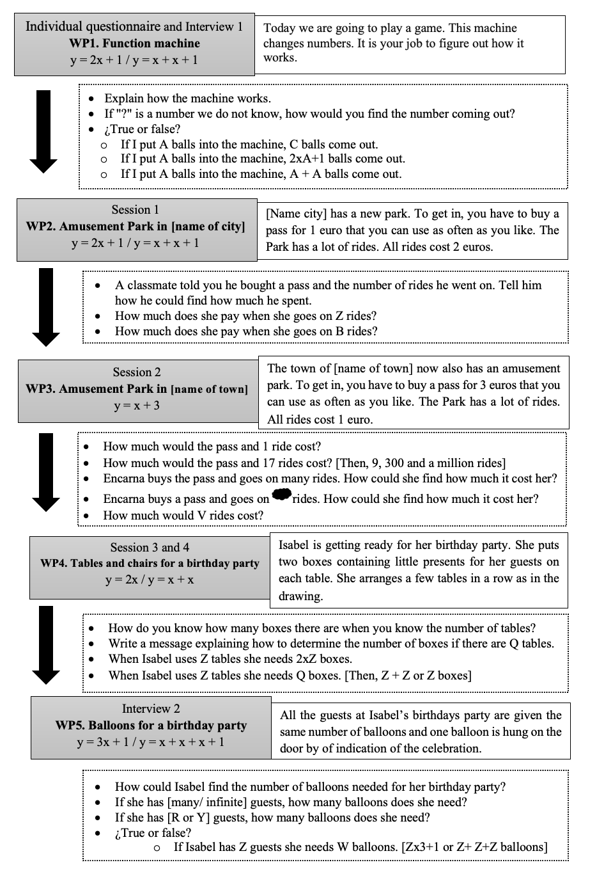
Fig. 5 Background information for Word Problems

3.3. Data collection and analysis
The data analysis conducted was qualitative. Data were collected from three sources: written worksheets, videos of the sessions (with a fixed camera located at the rear of the classroom and with a mobile camera recording students as they worked in small groups) and videos of the interviews.
We first checked the worksheets and selected the written productions of the students who obtained a success percentage of more than 50% in the question about particular cases. Our assumption was that they had perceived a regularity they could apply to questions on general cases. We then carried out an inductive analysis of the written responses of this group of students about general case questions. Based on similarities and differences between student responses, we established six categories to characterize their answers to the general case (Table 1). Only the categories generalization, imprecise generalization and example attested to attempts to express or apply the regularity perceived in the particular cases to the general case.
Table 1 Descriptive categories of students’ answers to general case questions
Category | Description
Generalization | Students describe the mathematical relationship involved and mention indeterminate quantities.
Imprecise generalization | Students describe the mathematical relationship involved mentioning only the arithmetic operation or implicitly expressing the relationship with no mention of the variables.
Example | Students propose a particular numerical case to represent the dependent and independent variables, in an answer consistent with their replies to preceding particular cases.
No regularity observed | The reply contains no indication that students extended the strategy used when replying to the particular cases, nor is it consistent with the answers given to those cases.
No answer | Students fail to answer the general case questions.
Rejection | Students deny the validity of the representation used in the question, contending for instance that letters lacked meaning in the context.

The video recordings of the discussions of each session with the whole class were coded qualitatively. We focused on episodes involving indeterminate quantities and these were coded taking into account the categories previously established (Table 1). The video recordings allowed us to validate the categories and deepen their characterization.
In the individual interviews with six students, we followed a similar process to the written responses. We focused initially on particular cases. With those questions we sought evidence that students had perceived a regularity. Then, the categories listed in Table 1 were used to characterize the arguments about the general case. As mentioned previously, this analysis was used to corroborate the findings from the analysis of the whole class sessions.
The first and second author coded the students’ answers. The third author then checked the codes assigned. To guarantee inter-reliability of the codifications, after first and second author’s coding, we subjected the encodings to a calibration process that included joint coding sessions and discussion of the disagreements.

4. Findings
First, we describe the students’ answers in general, including the information gleaned from their worksheets and the group discussion. The subsequent sub-sections address their replies to each of the three approaches to the general case questions. We comment on the responses in the worksheets, the group discussions, and the responses of the interviewed students who perceived some regularity.

4.1. General results by problem
First, in each WP we focused on the answers given in the questions in which students had to apply the direct relationship in particular cases. According to this, students were grouped according to the percentage of correct answers: (a) students replying correctly to more than 50 % of the questions (r>50%); and (b) those less successful (r≤50 %). For example, in Figure 6, nine students answered more than 50% of the questions correctly referring to particular cases in WP1. Following our research objective, below we focus only on the responses about general cases given by the first group. For each way of representing the variable, the responses were classified considering the categories defined in Table 1.WP4, as indicated above, was worked on in two sessions. In the first the general case questions were posed in natural language only, whereas letters were used in the second. Figure 6 also shows the percentage of students absent in each session.
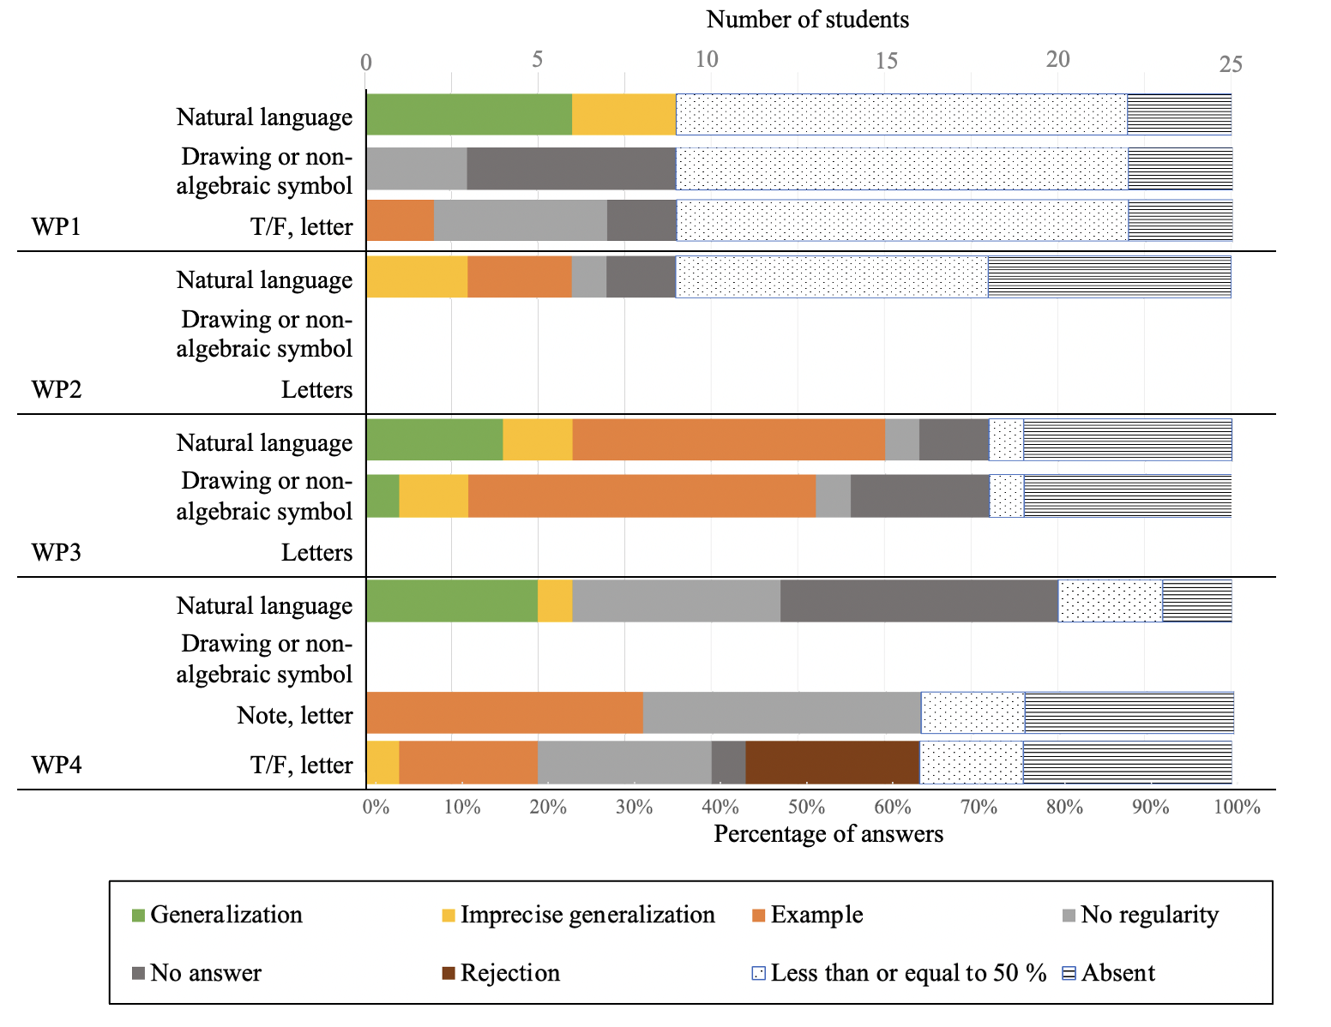
Fig. 6. Answers to written questions on the general case by type of representation

More students attempted to apply the relationship to other cases when the questions were posed in natural language than in either of the other two types of representation. In such questions some students expressed the generality (24% in WP1, 16% in WP3 and 20% in WP4) or attempted to imprecisely (4% to 12% in all the problems). Only one student generalized precisely when another approach was used (in WP3 where is proposed). When asked in writing about the general case in natural language, 60% of the students attempted to apply the regularity more extensively in WP3 (where the indeterminate quantity was referred to as “many rides”) compared to 36% in WP1 and 24% in WP2 and WP4.
When a drawing or non-algebraic symbol (“?” in WP1) was used, students were unable to express the generality they described when asked in natural language. That was not the case in WP3, where 44% of students attempted to apply the relationship more broadly in their written answers, generalizing correctly or imprecisely or giving an example. Nonetheless, that rate was substantially lower than the 60% of students who attempted to extend the relationship in WP3 when asked in natural language. In both cases the use of examples prevailed in their attempts: 36% in response to natural language and 32% to drawing.
Although they attempted to apply the pattern observed, none of the students generalized with letters, but rather with examples involving specific numbers. In WP4 when asked to explain their reasoning around the use of letters more students used an example to do so (32%) where a note was requested than when answering the true/false questions (20%). Figure 6 also shows that letters, used in WP4, were the only type of representation that students rejected.
The replies considered in the group discussion and the interviews were consistent with the classification of the written answers in Figure 6. In the discussions about WP2, WP3 and WP4 a higher percentage of students generalizing when discussing the general case in natural language than when algebraic symbolism was involved. WP3 inspired the most fruitful exchange of views in terms of the generality with which students expressed the relationship perceived, in all three types of representation.

4.2. General case represented in natural language
Table 2 lists the number of each type of reply to the questions posed in natural language by WP on the worksheets. Although more students generalized in WP1 than in the other problems, more students (15) attempted to apply the relationship perceived in the particular cases more extensively in WP3.
Table 2 Type of answers (number) to the question posed in natural language by WP
Type of answer | WP1 | WP2 | WP3 | WP4
Generalization | 6 | 0 | 4 | 5
Imprecise generalization | 3 | 3 | 2 | 1
Example | 0 | 3 | 9 | 0

In WP1 the students who generalized (Table 3) mentioned the mathematical relationship they applied, and some referred explicitly to independent or dependent variables of the function. Those who generalized imprecisely only mentioned the operation they had applied. In this WP none of the students mentioned the problem variables. They used a particularly wide variety of equivalent structures to express the functional relationship.
Table 3 Examples of answers to questions posed in natural language (WP1) on worksheets
Type of answer | Examples | Independent or dependent variables | Mathematical structure | Expression of indeterminate quantities
Generalization | S_{3:} Multiplying by two and adding 1. |  | 2y + 1
 | S_{12:} Adding the next number. For instance, if I have two and three comes after 2, you have to add three and you get five. |  | y + (y + 1) | The next number
 | S_{23:} It works by adding the same number and then one more. |  | (y + y) + 1 | The same number
Imprecise generalization | S_{5:} The machine works by always adding the same.

The same functional equation is involved in WP1 and WP2, although the contexts are different. In WP2 the relationship is explicit in the problem-wording. That information might have conditioned students’ replies, for when generalizing imprecisely they repeated the wording but without mentioning the mathematical relationship or the independent or dependent variable. They also appeared to be repeating the problem-wording. They defined the mathematical relationship incorrectly in both types of replies (Table 4).
Table 4 Examples of answers to questions posed in natural language (WP2) on worksheets
Type of answer | Examples | Independent or dependent variables | Mathematical structure | Expression of indeterminate quantities
Generalization | S_{11:} The pass costs 1 euro and each ride 2 euros. | Rides
 | S_{3:} You have to multiply times 2. |  | 2y
Example | S_{18:} If you have or want to take 11 rides. You multiply 11x2=22 or 2 rides because each one costs 2 euros. It’s simple, multiply and spend. | Rides  Money spent | 2y

Contrary to what was observed for WP1, in WP3 the students who generalized named the independent and dependent variables and the indeterminate quantities and operated with the latter. Examples are given in Table 5, students S₂ and S₁₆. The subjects who generalized imprecisely, while referring to the variable, did not specify how they operated with it. Those who used examples proposed a specific amount for the number of euros spent (S₁) or for the number of rides and wrote in the operations involved (S₂₅).
Table 5 Examples of answers to questions posed in natural language (WP3) on worksheets
Type of answer | Examples | Independent or dependent variables | Mathematical structure | Expression of indeterminate quantities
Generalization | S_{2:} I added the ride to the pass and I found the answer. | Rides | y + 3 | The ride
 | S_{16:} Whatever he says about the rides he has to add 3 euros. | Rides | y + 3 | Whatever he says about the rides
Imprecise generalization | S_{15:} It depends on how many rides he goes on. He pays for that plus for the [pass]. | Rides |  | How many rides he goes on
 | S_{21:} He pays 3 euros and 1 euro for the rides he wants to go on. | Rides |  | Rides he wants to go on
Example | S_{1:} He has to pay 1 000 003. | Spending
 | S_{13:} 3 euros for the pass and 1 000 005 rides makes 1 000 007. I invented it because he didn’t say how many. | Rides

In the group discussion about WP3 students proposed alternative ways to refer to the variable. S₁₇ proposed that “many” could be “infinite and beyond” and would cost four million. In the discussion transcribed below, a number of students debated about “infinite rides”. The research team interpreted the students were using the term infinite to mean a very large number unknown to them and did not interfere.
S₂₁ : Well infinite. Just what I wrote: she spends however much she wants.
I₂ : OK, infinite rides. But how much does it cost her?
S₂₁ : Infinite euros.
S₃ : No, infinity plus three.
I₁ : Why S₃?
S₃ : Because it’s infinite plus three.
I₁ : Does anyone agree with S₃?
S₁₇ : Yes, because if she spends three plus infinite, the answer is infinite plus three.

Questions representing variables as “many” or “infinite” were used in the final interviews (WP5). S₁₅ and S₁₆ applied the relationship through examples. S₂₁ generalized orally and wrote the expression shown in Figure 7. When asked about infinite rides (ideas discussed in WP3), S₂₁ replied that “multiplying three infinite times three is equal to infinity. Infinite balloons plus one is infinite balloons.” In both cases, S₂₁ referred to variables and how to operate with them.
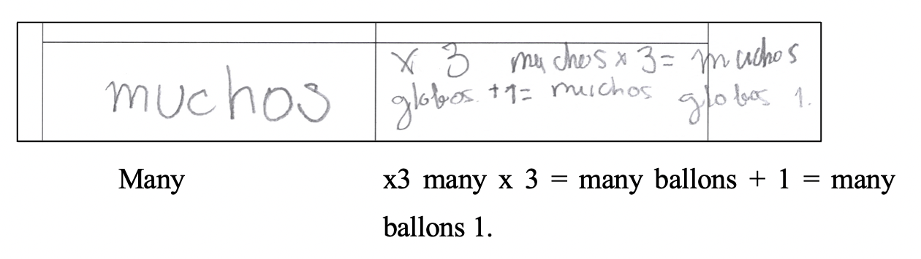
Fig. 7 S₂₁’s reply for many guests
In WP4, the question was posed explicitly mentioning the variables (tables and boxes). Here students replied differently than in the preceding WPs, mentioning the mathematical relationship or the operation used with no reference to the variables (Table 6), either in the worksheets or in the discussion. They agreed they could find the number of boxes by adding two at a time, multiplying times two or calculating double the number of tables. They referred to the variables when prompted by the teacher-researcher, but more often to the operation.
Table 6 Examples of answers to questions posed in natural language (WP4) on worksheets
Type of answer | Examples | Independent or dependent variables | Mathematical structure | Expression of indeterminate quantities
Generalization | S_{1:} I add two at a time or multiply or double. |  | 2 + 2 + … + 2  2y
Imprecise generalization | S₁₂ Adding or multiplying. 20 tables and 40 boxes.

4.3. General case represented with a drawing or non-algebraic symbol
Drawings or non-algebraic symbols were used in WP1 and WP3. Focusing on the worksheets, in WP1 six of nine students who answered the particular cases, when asked what number would come out of the machine when “?” was put in, failed to reply. As the other three only wrote down the answer, we could not determine whether they used the relationship to find it. Fewer students generalized when asked this question in those terms in WP3 than when asked in natural language. Only S₂ generalized on the worksheet, while S₁₉ and S₂₁ generalized imprecisely without explaining how they operated with the variable. Ten students used an example and, as in the natural language question, proposed specific amounts for the number of rides and money spent without necessarily mentioning the mathematical relationship applied (see Table 7).
Table 7 Examples of answers to questions involving a drawing or non-algebraic symbol on worksheets
Type of answer | Examples | Independent or dependent variables | Mathematical structure | Expression of indeterminate quantities
Generalization | S_{2:} I added the ride plus the pass to find the answer. | Rides | x + 3 | The ride
Imprecise generalization | S_{21:} She spends 3 euros and 1 euro for the rides she goes on. | Rides |  | The rides she wants to go on
Example | S_{17:} Encarna gets on 4 000 000 rides and spends 4 000 003. | Rides  Spending

In the discussion the students suggested particular cases they deemed might be hidden underneath the illustration. Only S₂₁ didn’t agree with his classmates, contending: “I used the same answer as before, that she spent three euros plus whatever she spent for the rides. I wasn’t thinking about any number. I erased it and got nothing.” His reply attests to a reference to variables, when he claimed not to have been thinking about any given number, but his generalization was imprecise for he failed to mention how he operated.

4.4. General case represented with letters
Questions involving letters were the ones that students found most difficult to interpret. In their written replies to WP1 two students (S₁₂ and S₁₃) reasoned their answers with examples in which letters were associated with their position in the alphabet: the letter “A” for the number “1”, for instance. In the interviews on that WP, S₁₆ also referred to the alphabet but without associating letters with specific values. As he failed to identify the relationship 2x+1 on his questionnaire, in the interview the problem was adapted, and the function changed to 2x. He applied the function to all the particular cases and attempted to express it using letters, as observed in line 6 of the transcript below.
 | I: | Explain what you mean. If H goes in, what will come out?
 | S₁₆: | Wait… A, B, C, D, E, F, G H…well, I.
 | I: | Why I?
 | S₁₆: | Because it’s the alphabet.
 | I: | But why not T instead of I?
 | S₁₆: | Because then it doesn’t work. You can’t add so many more numbers. It’s like here if with six you get twelve, then H plus H, is I.
 | I: | And here?
 | S₁₆: | A plus A, B.
 | I: | And what Z goes in?
 | S₁₆: | A would come out, because that’s the end of the alphabet.
 | I: | How does this machine work then?
 | S₁₆: | Maybe if there’s a number or a letter, you have to put Z in and [since] that’s the end of the alphabet you have to start with the letter A.

In line 9 S₁₆ is asked about the last letter of the alphabet. In line 12 he says that he used alphabetical order and if all the letters were used he would have to start over with A. Unlike S₁₂ and S₁₃ he never assigned the letters a specific value.
The use of letters to represent variables was discussed in a group session for the first time in WP2. Students were asked how much it would cost to go on B and on Z rides. In keeping with their answers to the particular cases, they multiplied and represented the operation as in Figure 8, failing to indicate the regularity used to reply to the preceding particular cases (saying that one letter represented rides and the other the pass). They associated the letters with their order in the alphabet. S₁₃ for instance said: “The B is the second in alphabetical order so two rides. And A is one, the pass. And you get a lot.”. S₁₆ explained the formula for Z rides also referring to alphabetical order and repeated the argument used in the initial interview: “Z can’t go backward, you need to start all over”, which is why the result is B.
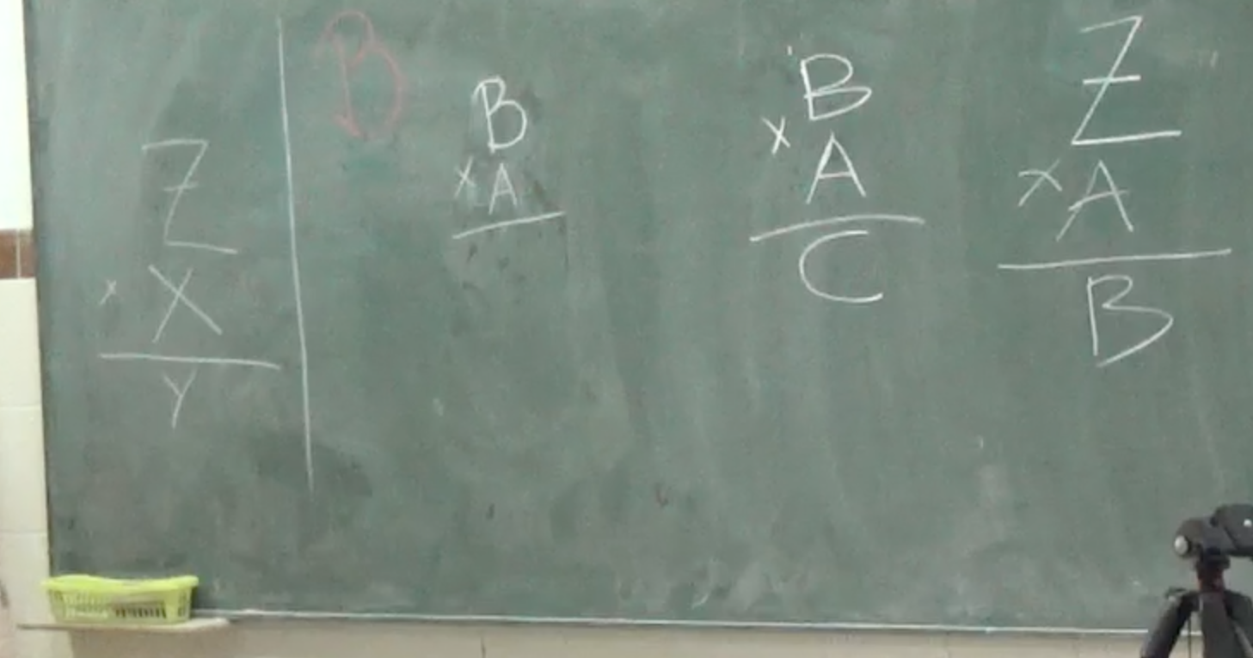
Fig. 8 Answer to the general case represented with letters (WP2)
In the group discussion about WP3, V rides were proposed. As they did when discussing the general case represented with natural language or a drawing, the students proposed specific values for the total spent: 20, 1000000, 2000000, 7 euros. When the researchers then explained that V is a variable number of rides S₁₃ replied: “V three”, in an attempt to express the relationship perceived omitting the plus sign (Figure 9A). S₁ explained that V was the number of rides and 3 the pass. S₁₂ then said that she thought differently and wrote another expression describing the operation performed (Figure 9B). She then wrote as result a number with 3 in the place of the units. The class was dismissed with most of the students agreeing to the latter proposal.
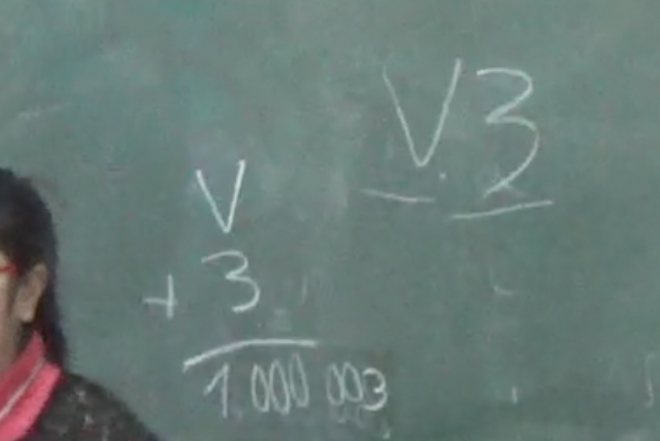
B
A
Fig. 9 Answer to the general case represented with letters (WP3)
In the second session on WP4, in the true/false statements, five students denied the validity of using letters and one generalized imprecisely. More students attempted to broaden the range of the relationship when asked to write a note than when answering the true/false questions. The students used different criteria to explain the letters with examples: they proposed numbers inferred by the first initial (Q for “quince” (15 in Spanish)) or similarity in shape (Z as 2 or 7).
In the group discussion around the 2xZ boxes needed for Z tables, the students recognized multiplication times 2 to be the common element in the particular cases but rejected the use of letters, contending that “Z” could not be a quantity. That rejection was also observed in the final interviews. S₁₆ claimed not to know the answers to those questions and when asked about B guests, S₁₅ associated B with 2 for its position in the alphabet. He later suggested that the value for Z guests would be 27 (the number of letters in the Spanish alphabet) but refused to operate with the letter.
In the final interview S₂₁ generalized when natural language was involved, but when letters were used, he assigned them a value related to their shape (2 and 4 respectively, see Figure 10) and applied the relationship.
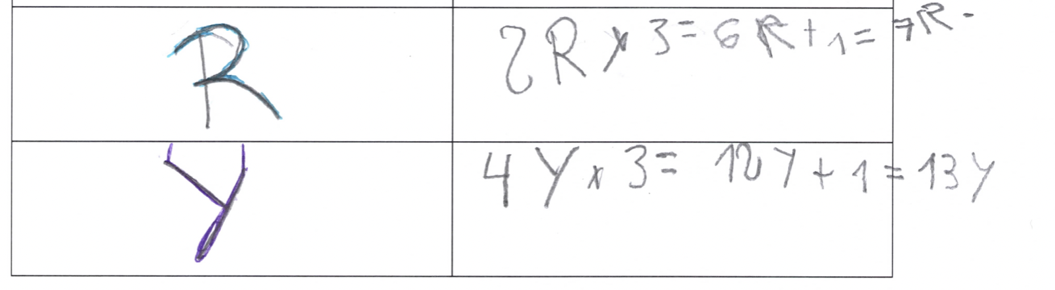
Fig. 10 Answer to the general case represented with letters (S₂₁)

5. Discussion
The findings show that the sophistication exhibited by students in their algebraic thinking varies with the type of task. We provided examples of students’ successfully applying the relationship involved in most of the particular cases, indicating that they apparently perceived regularity. They expressed it differently, however, when replying to the questions on indeterminate quantities when posed using natural language, drawings or letters. Our results support earlier findings (Amit & Neria 2008; Cooper & Warren 2008; Radford 2003) to the effect that while students recognize the relationship, expressing it is challenging for them. The evidence that the manner in which general case questions are posed carries significant weight in the assessment of the expression of generality contributes to the field’s understanding of early algebra and is discussed in greater detail below.

5.1. Use of natural language in general case questions
The present results highlight the prevalence of natural language in the approach to developing our students’ ability to express generalization. In all the WPs, more students attempted to apply the relationship identified when asked about it in natural language than when the questions were posed using other representations.
Questions in which the variable was explicitly mentioned and represented as “many rides” or “many guests” supported discussion of the general case, enabling students to refer to the idea and propose a general expression for the inter-variable relationship. In WP3, during group discussion, they equated “many rides” to “infinite rides” and spontaneously invoked the notion of infinity to refer to and operate with indeterminate quantities analytically. Although the general or indeterminate nature of such expressions might be called into question, we agree with Mason’s (1996) premise that what may be symbolic and abstract for one may be specific for another.
Natural language was also the type of representation used most frequently by students to express generalization, irrespective of how the question was posed on worksheets or in group discussions. Initially students’ explanations were fairly imprecise, omitting the variables to which they referred or failing to explicitly mention variables. Natural language helped them furnish more detailed explanations and express the generalization inherent in functional relationships. That spotlights a pathway for students to acquire competence in verbal mathematical language.
Here we stress the need to work explicitly on developing linguistic skills in mathematics classrooms and help students express themselves more precisely. Unlike algebraic symbolism, this type of representation enables students to keep their generalization in context, which may prove useful when formulating their reasoning in words. In addition, more precise use of verbal language may contribute to the ability to express generalization symbolically considering the succinct, precise and decontextualized nature of algebraic symbolism (Molina 2014). These results, although on a smaller scope, are in line with the research of Caspi and Sfard (2012), who emphasize the importance of considering students' informal algebraic discourses, in our case natural language, at the beginning of the study of formal algebraic discourse thus allowing students to express their ideas in a familiar context. We contribute to the understanding of students' means of expression in order to have more possibilities to help students close the gap with formal algebra.
Children often used numerical examples in their written answers. While initially seeming not to imply generalization, this constituted another way to apply regularity. In line with findings reported by Lannin (2005), our students suggested specific, usually very large, numbers to which they applied the regularities perceived.. We believe such answers might be indicative of algebraic thinking, insofar as they can be construed as generic examples (Mason 1996; Ursini 2001). The students recognized they were mere examples, replying that other numbers would be equally valid. Students’ contention that theirs was the sole answer possible may attest to their interpretation of indeterminate quantities as unknowns. Interestingly, students resorted naturally to large numbers to express generalization, a tactic recommended by Zazkis (2001) to express generality through particular cases, capitalizing on the fact that large quantities do not form part of students’ specific experience.

5.2. Use of drawings or non-algebraic characters in general case questions
Earlier research (Mason et al. 2005) suggests that the use of drawings or non-algebraic characters to represent variables may bridge the gap between natural language and algebraic symbols. This claim is not supported by our results. A comparison of the questions posed in natural language to those involving a drawing in WP3 showed that, on the worksheet, fewer students generalized or attempted to apply the regularity detected via imprecise generalization or examples in their replies to the latter. Only one student generalized when drawings were involved. Both on the worksheets and in group discussions, students formulated their answers in natural language and, in contrast to earlier findings (Blanton et al. 2019; Carraher & Schliemann 2010; Radford 2018), none used drawings or symbolic representation when generalizing. Their interpretation of such representations as unknowns was evident in their use of specific values and their accounts of attempting to see what number might be hidden underneath the inkblot. In light of those explanations, we believe this type of representation may be more suitable in other contexts where its meaning is not a quantity variable but an unknown.

5.3. Use of letters in general case questions
When the general case question was posed using letters, the students exhibited difficulty in expressing their replies in those same terms. Although they attempted to apply the pattern observed they did so imprecisely or with examples involving specific numbers. More precise generalization was supported by group discussion, due to the fact that the researcher-teacher questioned and encouraged the students to clarify those ideas that seemed to be less precise. In Ayala-Altamirano and Molina (2021) the differences between the written and oral argumentations of this group of students are analyzed in greater depth. In the group discussion about WP3, for instance, students expressed the relationship with letters, although they related the resulting expression to the problem-wording in natural language.
In contrast to the results reported by Blanton et al. (2019), who worked on the understanding and use of algebraic symbolism over a longer time span and more intensely, the present findings denoted no progression in students’ successful use of letters. Here, on the contrary, in the last session students rejected their use, even after having successfully expressed generality with symbols in WP3. Overall, these reactions were similar to those observed by other authors: rejection of letters or assignment to them of values in keeping with their position in the alphabet, their resemblance to a number or their status as the first initial of the verbal expression of a number (e.g., Amit & Neria 2008). In the discussions, the researcher-teacher posed questions that allowed the students to reflect on the tasks and their answers and evaluate if they were correct or not. However, our intervention was not getting a correct answer, but rather sharing different verbalizations about the general case. The meanings given to the letters by the students would depend on their own understanding and how the discussion would develop. The students in this study focused more on detecting meaning in this type of representation than on expressing the relationship perceived. We would highlight a few cases, however, where students applied letters to express the relationship: for example, “H plus H” to represent 2x, and “V+3” or V 3 as equivalent. The students gave an answer in both cases, although one persisted in the use of letters, while the other resorted to a number. The latter would suggest non-acceptance of the lack of closure of these expressions (unlike what students are used to in arithmetic contexts).

6. Conclusions
With a view to identifying how the approach used in questions about indeterminate quantities supports students’ ability to express generalization in functional relationships, this study characterized the written and oral answers given by a group of fourth-graders when asked about the general case in natural language, using drawings or with algebraic symbols. We share the idea that educational phenomena are context sensitive, therefore, our aim is that these real references guide future action through reflection without pretending to be directly generalizable to other contexts (Ayala-Altamirano & Molina 2021).
More specifically, the answers provided by students who attempted to apply the regularity perceived in specific cases (generalizing, generalizing imprecisely or giving examples) revealed that natural language was the approach that supported the expression of generalization most effectively. We also found that most students preferred to express themselves verbally, irrespective of whether the question posed included a drawing or symbol. When the indeterminate quantity was represented as a drawing or non-algebraic symbol, students interpreted it to be an unknown and responded with numerical examples. When conventional algebraic symbolism was used they focused on trying to find a meaning for the letters, interpreting them as unknowns or something else (as an initial or a specific value further to some other criterion), ignoring the functional relationship.
This study has a number of implications for research teaching and learning. We agree with researchers (Caspi & Sfard, 2012; Cooper & Warren 2008; Mason 2017; Radford 2018) who stress the importance of natural language and informal algebraic discourses in the process of learning to express generalization. It has been found to be the most effective short-term approach, for it enables teachers to identify the mathematical elements applied and interrelated by students in their replies. We likewise support Blanton and co-authors’ (2019) contention that the introduction of algebraic symbolism in the elementary grades can save students some of the difficulties observed in secondary education. Nonetheless, given that learning conventional representation takes time, as students seek its meaning other types of expression should be deployed to afford them the confidence needed to express algebraic ideas. That is where natural language plays a significant role: it enables students to associate context with the mathematical expressions they use to solve word problems. Like Stephens et al. (2017) and Caspi and Sfard (2012), we deem that allowing students sufficient time and space to discuss algebraic ideas and processes intuitively, drawing from their informal knowledge, is imperative to the inclusion of algebra in elementary school.
Natural language enables students to progress in the study of functions, broaching relevant ideas such as variable, domain and codomain. Algebraic competence need not necessarily be developed in parallel with the acceptance and use of algebraic symbolism. Students’ ability to generalize and express generalization with natural language may support understanding and could be separate from distinguishing the many meanings of letters and for learning to use algebraic symbolism in general. We also believe that the potential of natural language for developing and expressing generalization is highly relevant in secondary education, particularly in the context of solving mathematical problems that can be modeled with algebraic equations.
Lastly, comments on the limitations of this study serve to identify further lines of research on the expression of generality. The findings need to be contrasted with data on how the approach adopted to pose questions impacts students of other ages, over longer periods of time, above all, a greater variety of instances need to be offered to students to observe patterns in their thinking on more than one task. Ways to represent indeterminate quantities in other contexts could also be tested to determine whether the answers vary when the indeterminate quantities refer to unknowns or the generalization of geometric properties or formulas, for instance.
Acknowledgement(s) This work has been developed within the projects EDU2016-75771-P and PID2020-113601GB-I00, financed by the Spanish State Research Agency.
References
Amit, M., & Neria, D. (2008). “Rising to the challenge”: Using generalization in pattern problems to unearth the algebraic skills of talented pre-algebra students. ZDM, 40(1), 111-129. https://doi.org/10.1007/s11858-007-0069-5
Ayala-Altamirano, C., & Molina, M. (2020). Meanings Attributed to Letters in Functional Contexts by Primary School Students. International Journal of Science and Mathematics Education, 18, 1271-1291. https://doi.org/10.1007/s10763-019-10012-5
Ayala-Altamirano, C., & Molina, M. (2021). Fourth-graders’ justifications in early algebra tasks involving a functional relationship. Educational Studies in Mathematics, 107(2), 359-382. https://doi.org/10.1007/s10649-021-10036-1
Bakker, A. (2019). Design research in education. Routledge.
Blanton, M. L., Brizuela, B. M., Gardiner, A. M., Sawrey, K., & Newman-Owens, A. (2017). A progression in first-grade children’s thinking about variable and variable notation in functional relationships. Educational Studies in Mathematics, 95(2), 181-202. https://doi.org/10.1007/s10649-016-9745-0
Blanton, M. L., Isler-Baykal, I., Stroud, R., Stephens, A., Knuth, E., & Gardiner, A. M. (2019). Growth in children’s understanding of generalizing and representing mathematical structure and relationships. Educational Studies in Mathematics, 102(2),193–219. https://doi.org/10.1007/s10649-019-09894-7
Blanton, M. L., & Kaput, J. J. (2011). Functional Thinking as a Route Into Algebra in the Elementary Grades. In J. Cai & E. Knuth (Eds.), Early Algebraization. Advances in Mathematics Education (pp. 5-23). Springer.
Carpenter, T. P., & Fennema, E. (1992). Cognitively guided instruction: Building on the knowledge of students and teachers. International Journal of Educational Research, 17(5), 457-470.
Carraher, D. W., & Schliemann, A. D. (2010). Algebraic reasoning in elementary school classrooms. In D. Lambdin & F. K. Lester, Teaching and learning mathematics: Translating research to the classroom (pp. 23-29). NCTM.
Carraher, D. W., & Schliemann, A. D. (2015). Powerful ideas in elementary school mathematics. H. In L. D. English & D. Kirshner (Eds.), Handbook of international research in mathematics education (pp. 191-208). Routledge.
Caspi, S., & Sfard, A. (2012). Spontaneous meta-arithmetic as a first step toward school algebra. International Journal of Educational Research, 51–52, 45–65. https://doi.org/10.1016/j.ijer.2011.12.006
Cobb, P., & Gravemeijer, K. (2008). Experimenting to support and understand learning processes. In A. E. Kelly, R. A. Lesh, & J. Y. Baek (Eds.), Handbook of design research methods in education: Innovations in science, technology, engineering, and mathematics learning and teaching (pp. 68-95). LEA.
Cooper, T. J., & Warren, E. (2008). The effect of different representations on Years 3 to 5 students’ ability to generalize. ZDM, 40(1), 23-37. https://doi.org/10.1007/s11858-007-0066-8
Dörfler, W. (2008). En route from patterns to algebra: Comments and reflections. ZDM, 40(1), 143-160. https://doi.org/10.1007/s11858-007-0071-y
Ellis, A. B. (2007). Connections between Generalizing and Justifying: Students’ Reasoning with Linear Relationships. Journal for Research in Mathematics Education, 38(3), 194-229. https://doi.org/10.2307/30034866
English, L. D., & Warren, E. A. (1998). Introducing the variable through pattern exploration. The Mathematics Teacher, 91(2), 166-170.
Kaput, J. J. (2008). What Is Algebra? What Is Algebraic Reasoning? In J. J. Kaput, D. W. Carraher, & M. L. Blanton (Eds.), Algebra in the early grades (pp. 5-17). LEA. https://doi.org/10.4324/9781315097435-11
Kelly, A. E., & Lesh, R. A. (2000). Handbook of Research Design in Mathematics and Science Education. LEA.
Kieran, C. (2004). Algebraic thinking in the early grades: What is it? The Mathematics Educator, 8(1), 139-151.
Kieran, C., Pang, J., Schifter, D., & Fong Ng, S. (2016). Early Algebra: Research into its Nature, its Learning, its Teaching. Springer. https://doi.org/10.1007/978-3-319-32258-2
Lannin, J. K. (2005). Generalization and Justification: The Challenge of Introducing Algebraic Reasoning Through Patterning Activities. Mathematical Thinking and Learning, 7(3), 231-258. https://doi.org/10.1207/s15327833mtl0703_3
Mason, J. (1996). Expressing generality and roots of algebra. In N. Bernarz, C. Kieran, & L. Lee (Eds.), Approaches to algebra (pp. 65–86). Springer.
Mason, J. (2017). Overcoming the Algebra Barrier: Being Particular About the General, and Generally Looking Beyond the Particular, in Homage to Mary Boole. In S. Stewart (Ed.), And the Rest is Just Algebra (pp. 97-117). Springer. https://doi.org/10.1007/978-3-319-45053-7_6
Mason, J., Graham, A., & Johnston-Wilder, S. (2005). Developing thinking in algebra. Open University and Sage Publications.
Mason, J., Graham, A., Pimm, D., & Gowar, N. (1985). Routes to algebra, roots of algebra. Open University.
Ministerio de Educación, Cultura y Deporte. (2014). Real Decreto 126/2014 de 28 de febrero, por el que se establece el currículo básico de la Educación Primaria [Royal Decree 126/2014 of February 28, which establishes the basic curriculum of primary education]. BOE, 52, 19349–19420
Molina, M. (2014). Traducción del simbolismo algebraico al lenguaje verbal: Indagando en la comprensión de estudiantes de diferentes niveles educativos [Translation fo algebraic symbolism to verbal language: inquiring into diferente educative levels students’ understanding]. La Gaceta de la RSME, 17(3), 559-579.
Morgan, C., Craig, T., Schuette, M., & Wagner, D. (2014). Language and communication in mathematics education: An overview of research in the field. ZDM, 46(6), 843-853.
Pinto, E., & Cañadas, M. C. (2021). Generalizations of third and fifth graders within a functional approach to early algebra. Mathematics Education Research Journal. 33(1),113–134. https://doi.org/10.1007/s13394-019-00300-2
Radford, L. (2003). Gestures, Speech, and the Sprouting of Signs: A Semiotic-Cultural Approach to Students’ Types of Generalization. Mathematical Thinking and Learning, 5(1), 37-70. https://doi.org/10.1207/S15327833MTL0501_02
Radford, L. (2018). The Emergence of Symbolic Algebraic Thinking in Primary School. In C. Kieran (Ed.), Teaching and Learning Algebraic Thinking with 5- to 12-Year-Olds (pp. 3-25). Springer.
Ramírez, R., Brizuela, B. M., & Ayala-Altamirano, C. (2020). Word problems associated with the use of functional strategies among grade 4 students. Mathematics Education Research Journal, 33(1), 1-25. https://doi.org/10.1007/s13394-020-00346-7
Stephens, A., Ellis, A., Blanton, M. L., & Brizuela, B. M. (2017). Algebraic Thinking in the Elementary and Middle Grades. In J. Cai (Ed.), Compendium for Research in Mathematics Education. Third handbook of research in mathematics education. (pp. 386-420). NCTM.
Strachota, S., Knuth, E., & Blanton, M. L. (2018). Cycles of Generalizing Activities in the Classroom. In C. Kieran (Ed.), Teaching and Learning Algebraic Thinking with 5- to 12-Year-Olds (pp. 351-378). Springer.
Usiskin, Z. (1988). Conceptions of school algebra and uses of variables. In A. Coxford (Ed.), The ideas of algebra K–12 (pp. 8–19). NCTM.
Ursini, S. (2001). General Methods: A Way of Entering the World of Algebra. In R. Sutherland, T. Rojano, A. Bell, & R. Lins (Eds.), Perspectives on School Algebra (Vol. 22, pp. 209-229). Kluwer.
Wertsch, J. V. (1995). Vygotsky and the social formation of mind (J. Zanón & M. Cortés, Trans.; 2nd ed.). Barcelona, Spain: Ediciones Paidós. (Original work published 1985).
Zazkis, R (2001). From arithmetic to algebra via big numbers. In H. Chick, K. Stacey, J. Vincent, & J. Vincent (Eds.), Proceedings of the 12th ICMI study conference: the future of the teaching and learning of algebra (Vol. 2, pp. 676−681). University of Melbourne.

Variables and indeterminate quantities are used indistinctly as synonyms in this article.

