**A multiscale analysis approach for the**

**valorisation of sludge and MSW via co-incineration.**

**Sofía González-Núñez, Lidia S. Guerras, Mariano Martín[1]**

Department of Chemical Engineering. University of Salamanca. Plz. Caídos 1-5. 37008. Salamanca (Spain)

**Abstract**

The use of municipal solid waste and sludge within the waste to power initiative is evaluated following a multiscale approach. A techno-economic analysis is performed following a systematic procedure to determine the optimal operating conditions and to estimate the production and investment cost of the facilities as a function of the waste processing capacity. The facility consists of the boiler, the flue gas treatment chain, the turbine, and the cooling tower. Experimental data and first principles are used to model the boiler and the pollutant abatement technologies, while detailed thermodynamics and transport phenomena are used to model the turbine and the cooling tower to optimize the process using an equation-based approach. For the facility to produce power at a competitive price, 0.06 €/kWh, it has to process the waste generated at cities above 250 k habitants. The investment cost is beyond 30 M€ where gas treatment represents around 19%, with the turbine and the boiler representing 37% and 31% respectively. The rest corresponds to the cooling system. Next, at country level, a multiobjective facility location problem is formulated. From an economic point of view, only the largest cities would be selected. However, aiming at a social objective, power at a competitive price can be produced by selecting the appropriate locations for a budget available. The water - energy nexus is also evaluated for the facilities installed.

Keywords: Waste incineration, waste to power, water consumption, water – energy nexus, circular economy

**1.-Introduction**

Waste is a major issue of our society not only because of the amount generated annually but also the challenge its management represents [1]. It was estimated that by 2021, 6.1 million tons per day will be generated in urban areas [2]. The most common management technologies applied to [municipal solid waste](https://www.sciencedirect.com/topics/earth-and-planetary-sciences/municipal-solid-waste) (MSW) are recycling, landfilling [3], anaerobic digestion and incineration [4]. Anaerobic digestion has previously been evaluated in terms of yields towards biogas and fertilizers so that, for a particular case study, it was possible to produce the natural gas required by the region several times [5]. However, the economy of such a facility relies on the possibility of selling the digestate as fertilizer, with no market established as of today. Alternatively, incineration plants can be considered due to the high yield to power [6]. In a direct comparison among thermochemical processes for valorization of municipal solid waste, authors in reference [7] showed that incineration presented high potential for electricity generation using a Rankine cycle since the yield of thermal power plants can reach 40% in energy production versus the 12% that electric power generation presents [8]. The incineration of MSW can play a role in reducing the share of fossil fuels towards the production of power. As a result, for the last decade there has been an increase in the installation of such facilities [1]. In addition to MSW, dried sludge that reaches a production of 13 Mt in 2020 in the EU [9], can also be used as a resource [10]. Sludge can be used within the cement industry after dewatering, used as a fertilizer or incinerated. Incineration is the second-best alternative in the EU after its use as fertilizers. The ashes, if rich in P, can still be used as fertilizers, else they can be used in the construction of roads, the production of cement or disposed in a landfill [11]. In addition, it is also possible to gasify the dewatered sludge [12]. Sludge has similar energy content as woody biomass but higher ash content [11]. Therefore, co-combustion of MSW and sludge is the most common processing technology [13] to deal with the water content of the sludge in an integrated treatment [14]. Alternatively, gasification can be used [15]. However, the water content provides unique challenges in their operation [16] and co-gasification of other biomass and coal is more common [17].

The body of literature is detailed evaluating the power island to compute the energy produced from incineration. Different approaches have been used, for example, the use of simulation packages for the entire power island in steady state such as the process simulator W2E [18], as well as integrated systems that include logistics [19]. In addition, some groups have focused on the analysis of the incinerator [20] evaluating circulating beds using population balances [21] as well as different fixed bed reactors [22] using DEM [23] developing surrogate models for the emissions of the combustion [24], as well as studying the dynamics [25], with no details on the removal of dioxins and the co-incineration of sludge and MSW [26]. However, while most of the process studies focus on the thermodynamic yield, a facility that processes MSW requires a flue gas treatment to avoid emitting NOx, SO2 [27] but above all, heavy metals, dioxins, and furans [28]. Pollution control systems have been implemented over the years so that current facilities require such systems in operation [1]. The studies that include the analysis of flue gas treatment, present either phenomenological models for the flue gas treatment stages [29] or simple models within ASPEN plus where the models for the removal of pollutants were developed using basic modules based on stoichiometric combined with custom models to represent particle removal, NOx control at the combustion chamber and SO2 abatement [30] or even HCl [31]. The typical analysis does not consider technologies for heavy metals, dioxins, and furans [32]. In addition, no process optimization of such facilities has been addressed. Guerras et al. developed detailed surrogate models to evaluate the performance of the flue gas treatment technologies for NOx, SO2 removal in the case of coal-based facilities [33], but the power island and the cooling system were not included. Therefore, the systematic process design and economic evaluation of a facility including power island, with high- medium- and low- pressure turbine, the design of a cooling tower, and pollution abatement process has not yet been addressed.

Once the facility is analyzed at process scale, the study of the exploitation or use of waste as a resource requires an analysis at a larger scale. A macro scale evaluation of the availability of the resources and the installation of the processing facilities is needed. It can be considered as an extended facility location problem [34] to select the size and location of the facilities to process waste towards the production of power for a certain budget and electricity cost. Several studies apply this type of formulations to waste management. The particular focus is the collection of the waste. Some are devoted to the analysis of the mathematical issues of the problem as a robust optimization one [35], the challenges that they present [36] or the use of swarm optimization to solve the problem [37]. Most of them consider economic objective functions for the selection of landfill sitting [38] or the selection of the collection planning [39]. The ones using a multi objective approach consider cost and the negative impact the distance to the container has on the population for the location of recycling containers across cities [40], combine environmental issues with social concerns related to the health-related problem of dealing with hazardous waste [41], the use of GIS and multicriteria decision making using a fuzzy analytic process considering sizing, location and economic assessment [42] as well as considering environmental, economic and socio-cultural dimensions where the social dimension is related to the desirability of the location [43]. However, the effect on the wealth and social benefits generated by the installation of large waste treatment facilities on the region have not been addressed. The management and use of waste within the waste to energy initiative [44] represents an opportunity to increase the GDP of the region by creating wealth and jobs at the same time of processing the waste generated by society. The facility location problem must consider social parameters [45] together with the economic ones. The Water-Energy (WE) nexus of the resulting infrastructure for waste processing is also an important criterion to assess the sustainability of the growth of society due to the current concerns on water availability [46].

This work presents a multiscale analysis, from the process to the facility location problem, for the optimal waste management. At process scale, it focuses on the design of co-incineration facilities for MSW and sludge evaluating the effect of the scale. A mathematical optimization approach is used for the optimal design of integrated facilities including the furnace, the gas treatment chain, the power island, and the cooling system. After the techno-economic analysis, the economies of scale are evaluated, developing surrogate models to estimate the investment required as well as the power production cost as a function of the waste processed that will allow formulating the facility location problem. This macro-scale problem aims at deciding where to install this kind of facilities at different cities across a country using the available sludge and MSW within range. The analysis at this scale allows evaluating the fraction of power that can be achieved from these residues, the share of the waste used and the budget that these facilities may require.

**2.- Methodology**

The methodology comprises the analysis at two scale levels. At process level, the transformation of waste, MSW and sludge, into power is analyzed developing an optimal process including the incineration of waste, the treatment of the flue gas, the production of power and the cooling system. The technical and economic aspects are to be determined to formulate the facility location problem where that information is required for the exploitation of the waste at country level. A scale-up evaluation study is required as a bridge between both problems, the process design, and the facility location one.

*2.1.-Process synthesis and optimization*

The process consists of four sections: the boiler, the flue gas treatment chain, the Rankine cycle, and the cooling system. Each one of the units is modelled using first principles (mass and energy balances), detailed thermodynamics, rules of thumb and industrial data. The boiler processes the mix of wastes, municipal solid wastes (MSW) and sludge, in a composition that can be managed by the boiler, below 10% sludge, to avoid issues due to the concentration of water. The model of the boiler provides the energy generated as well as the composition of the flue gas, validated using literature data. The flue gas is processed to remove NOx, SO2, as well as particles, dioxins, furans and heavy metals. Selective catalytic reduction, SRC, (R-02) is used to remove the NOx, dioxins, and furans by atomizing ammonia (AT01). Next, an electrostatic precipitator (PE01) removes particles. Subsequently, a Lime Dry Spray process (LSD) system is used (R04) for the removal of SO2. A filter (FM01) is located downstream the flue gas treatment chain before the adsorption tower (T01) that removes heavy metals. The energy produced by the incineration of wastes is used to produce overheated steam. A Rankine cycle with regeneration and reheating is considered. The steam turbine is modelled considering high, medium and low-pressure stages. The high-pressure stream is expanded at T1 and recycled to be heated up it the boiler to be overheated. In Figure 2 no specific HX is presented for this stage because it is part of the boiler design. The overheating stage is modelled as if an additional HX is within the boiler, see HX4 in the supplementary materials for the details of the model. Next, it is expanded in the medium pressure turbine. An extraction from T2 is used to represent the regeneration stage of the cycle. The Rankine cycle considered only one turbine extraction, instead of the multiple one’s typical schemes used. It is a simplification for optimization purposes. HX6 reheats the condensate to be fed to the boiler. Note that it is a simplification of the typical 7 extractions that are used in an industrial Rankine cycle. The rest of the steam is expanded below atmosphere in the low-pressure turbine. A natural draft cooling tower is used to cooldown the water used in condensing the exhaust steam determining the water consumption of the system. Figure 1 presents the flowsheet of incineration facility. The models are described in section 3.1.

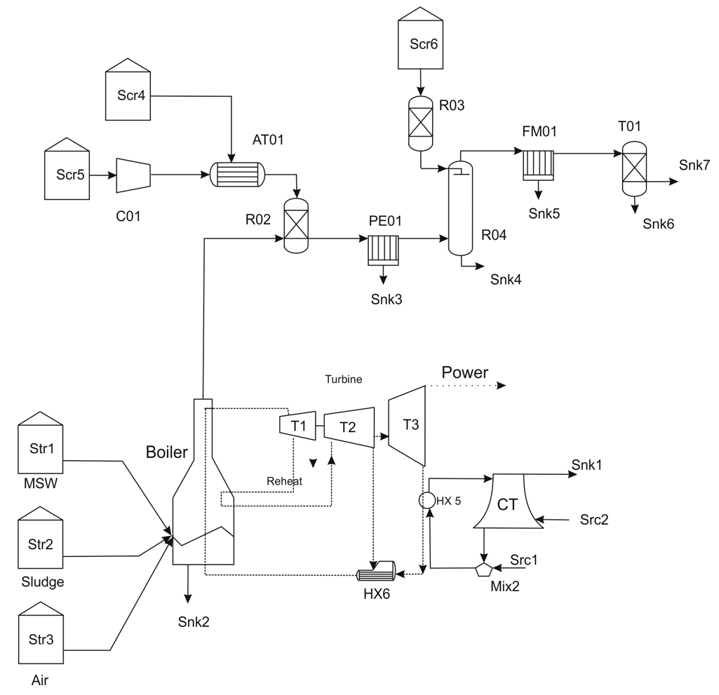

Figure 1.-Flowsheet for the waste treatment facility

*2.2.-Techno-economic analysis*

The investment cost is computed using the widely accepted factorial method [47]. First, the major units are sized including the steam turbine, cooling tower, boiler, LSD, SCR, electrostatic precipitator, adsorption tower based on mass and energy balances. Their investment costs are estimated using correlations from the literature [48-50].

On top of the units’ cost, the estimation of the investment cost of the facility is computed by estimating the costs related to piping (20%), isolation (15%), instrumentation (20%), and utilities (10%) as a fraction of the units’ cost. It is assumed that the land and buildings cost add up to 8 M€. The same distribution of costs as presented in previous work dealing with a concentrated solar power plant [51] is used to establish a comparison. In addition, the fees (3% of the fix cost), overheads, administrative expenses and the plant layout represent 10% of the direct costs (fees plus fix capital) and 5% of the fix cost respectively. The plant start-up cost is assumed to represent 15% of the investment.

Apart from the investment cost, the production cost of electricity is also estimated. The items considered are the labour costs (0.5% of investment), amortization (linear with time in 20 years), equipment maintenance (2.5% of fix costs), overheads (1% investment), taxes (1% investment), and administration (5% of labour, equipment maintenance, amortization, taxes, and overheads) [51]. It is assumed that the collection of waste is already in place in major cities and does not correspond to the production costs of this facility.

*2.3.-Scale-up*

To scale-up or down the investment cost as a function of the processing capacity, the capital costs must be correlated as a function of a characteristic variable, scaling variable, such as the power production of a turbine, the area of a heat exchanger or the flow rate of gas processed at the selective catalytic reduction and the electrostatic precipitator. The scaling variable is directly linked to the mass or energy flows within the unit. The factorial method is used including this issue. In addition, the size of standard units is limited. Therefore, if the processing capacity is exceeded, additional units in parallel must be purchased [52].

*2.4.-Macro analysis: Potential of co-incineration of MSW and Sludge*

The power production and investment costs involved in the processing of waste within the waste to power initiative are to be included in the analysis. Country scale is evaluated where the larger cities/urban areas, responsible for generating most of the waste, are considered as potential locations for the installation of these kind of facilities. The size of the facility depends on the population that it serves. The water consumption of the cooling tower is estimated from the surrogate models developed in previous work as a function of the climate characteristics of the location [53]. A facility location problem is formulated to select the size and location of the incinerator plants towards the waste treatment and the social impact for a certain budget availability and targeting a certain electricity cost, see section 3.2.

**3. Modelling**

This section describes the main assumptions used to model the incineration process including the various sections and the facility location problem. It is divided into the model of the process and that of the facility location problem.

*3.1.-Process modelling*

This section presents the modelling principles of the four different sections of the facility such as the boiler, the flue gas treatment chain, the power island, and the cooling tower.

*3.1.1- Boiler*

The composition of the feed, the municipal solid waste, and the sludge, to the boiler is taken from the literature, see Table 1

Table 1.-Waste composition [54].

|  |  |  |
| --- | --- | --- |
| Ultimate Analysis/Waste | MSW | Wet sludge |
| C | 57.62 | 36.42 |
| H | 8.45 | 7.38 |
| O | 31.5 | 39.77 |
| N | 0.24 | 4.55 |
| S | 0.47 | 11.82 |
| Cl | 1.72 | 0.06 |
| Total moisture (%) | 50 | 83.18 |

The reactions taking place are complex, some of the most important are shown below, eq. (1):

 (1)

To match the experimental composition, data from the literature is used [55]. The CO2 to CO ratio is taken to be 1.24 [56]. The NOx produced are assumed to be 500 mg NOx/Nm3 with a composition of 95% NO and 5% NO2. Finally, the mass flow rate of PCDD/Fs is 0.9 ng TEQ/Nm3 [57]. Both will be removed simultaneously [58].

The energy produced out of the combustion of each residue depends on the composition. For the low heating value, LHV, of the MSW we use eq. (2)

 (2)

While for the case of the sludge a value of 1734.3 kJ/kg (414.9 kcal/kg [59]) is used. An adiabatic energy balance is formulated to the furnace to compute the energy that is absorbed to generate steam. The flue gas exit temperature is assumed to be 493 K based on literature data [60]. The high moisture content of the sludge limits the blending with MSW to 10 wt. % at the most [54].

*3.1.2.-Rankine cycle analysis*

The Rankine cycle consists of a high, medium, and low-pressure turbine, steam condensation, the reheating , and the regeneration stages. Each one is modeled unit by unit using mass and energy balances and detailed thermodynamics. To include the thermodynamics, correlations for the enthalpy and entropy of the streams as a function of the pressure and temperature are used [61].

The mix of wastes is burned generating steam. A regenerative Rankine cycle with reheating is considered for the facility. The overheated steam is fed to the high-pressure turbine. An operating range for the feed pressure of 90-125 bar is considered [62-63]. The steam is expanded down to a pressure within the range from 11 to 35 bar [62-64] and sent back to the boiler for the reheating before feeding the medium pressure turbine where it is further expanded. This stream is split in two. An extraction from the turbine preheats the condensed steam, regenerative section of the cycle, and the rest is fed to the low-pressure turbine for its further expansion. The exhaust pressure is assumed to be within the range of 0.05 bar to 0.31 bar [64-65] and is also an optimization variable. The exhaust steam can contain up to 8% of moisture. Each expansion is modelled assuming a non-ideal isentropic expansion with an isentropic efficiency of 0.85 [66]. See the supplementary material for further details. No additional mechanical constraints have been added to this model, but it is flexible enough to include them. The estimation of the cost of the turbine is carried out using the same correlation as in previous work that relies only on the power production capacity [51].

*3.1.3.-Flue gas treatment*

Gas emissions represent a challenge in the valorization of waste via incineration. They require the removal of chlorine compounds as well as SO2, NOx, particle matter, heavy metals, dioxins, and furans. A flue gas treatment chain is set up to purify the gas within legal regulations.

(NOX), dioxins and furans (PCDD/Fs): Selective catalytic reduction (SCR) is used for the removal of both, NOx and PCDD/Fs [67].The reactions that take place use NH3 as presented in eq. (3)-(4) and oxygen as in eq. (5). Seveso dioxin is considered to represent them all, so that n is equal to 4 in eq. (5).

 (3)-(4)

 (5)

Ammonia 99.5%, with air as impurity, is fed at 423 K [68] in a 5 % excess with respect to the stoichiometric [69]. In addition, oxygen is added in the form of atmospheric humid air. The ratio air to ammonia is fixed to 20, working below flamability limits [70]. The removal yield of NOx is assumed to be above 90%. This technology is also capable of removing 95-99% of polychlorinated dibenzo-p-dioxins (PCDD) and polychlorinated dibenzofurans (PCDF). A removal rate of 97.24% for PCDD/Fs is assumed [53].

The SCR unit model comprises the stoichiometry of the reactions, the conversion for the NOx and the experimental removal ratio for the PCDD/Fs, a mass balance to compute the feed of NH3 and air, and an adiabatic energy balance. For the cost estimation, the unit is over designed to assume 100% removal of the NOx. A correlation from [48] eq. (6), is used where mNOx is tons processed in a year of NOx:

 (6)

**Electrostatic precipitator (EP):** The EP charges the particles in suspension generating an electric field to remove them by attracting them to the walls. The maximum particle concentration allowed is 50 mg /Nm3 [71]. The EP is simulated considering a mass balance, a removal ratio for the solids, and an energy balance. The typical exit temperature is around 423 K [72].

 (7)

The removal yield, , is a function of the particle size, d. The particle size distribution is discretized into 7 sizes, eq. (8), to determine the removal ratios per bin. Industrial data point out that most of the particles are of 10 m [72]. The matrixes in eq. (8) are developed using literature data [73] to model the removal performance. The average efficiency of the EP is computed as in eq. (9) The cost of the EP is estimated using eq. (10) developed from matche.com

 (8)

 (9)

 (10)

Removal of sour gases (SO2, HCl & HF): Two technologies dominate the market, dry (LSD) or wet (LFSO) removal [33]. Among the two, dry removal is cheaper and capable of dealing with low concentrations of sulfur as in the case of waste incineration. Dry removal feeds the spray tower using a slurry of CaO with 35% of water. The temperature of the gases before entering the LSD is to be adjusted between 393 K and 448 K. The removal of the gases takes place following the reaction mechanism presented in eq. (11) [74].

 (11)

Typically, a molar ratio CaSO3 to CaSO4 of 9:1 is achieved because of the absence of forced oxidation [75]. The removal ratio of SO2 is a function of the S in the raw material and the molar ratio between Ca and [53] developed a model for a flue gas generated by burning coal that is assumed to be acceptable in this case due to the lack of studies for other flue gases, eq. (12)

 (12)

The unit model considered a mass balance to the species involved, as presented by eq. (11), the removal efficiency, eq. (12), and an energy balance assuming adiabatic operation. The flue gas is saturated with water at 65ºC. The moisture in the exiting gas is computed using Antoine’s correlation. The investment cost of the entire LSD section is estimated using eq. (13) as a function of the SO2 processed in t/y [48].

 (13)

**Filter:** The subsequent flue gas treatment stage is the use of a filter to remove the remaining solids before the adsorption of heavy metals. The filter sizing depends on the air to cloth ratio, ac, considered to be 5 based on literature (powderprocess.net) and a correlation is developed for its cost as a function of the area from Matche, eq. (14).

 (14)

Where the area of the filter is computed as in eq. (15) as a function of the air-to-cloth ratio, ac, and the gas density

 (15)

Heavy metals: To remove the heavy metals it is important to highlight the fact that they volatize in the combustion so that no solid removal unit is efficient. It is possible to use adsorbent beds for such operation. The removal rate depends on the adsorption capacity of the bed, typically activated carbon to remove species such as Hg⁰(g), or its oxidized forms (Hg2+X(g)) and Hg atoms linked to particles (Hg(p)). The *adsorbent beds* are cost estimated using the price of the adsorbent and vertical vessels, eq (16). 100 % removal is assumed. Two beds are needed to ensure continuous operation. An over-design factor of 10% is used for safety reasons.

 (16)

W is the weight of the vessel in kg. The weight of steel is estimated as a function of the diameter and thickness of the vessels. The diameter of the vessels is calculated considering spherical heads for the vessels as well as a length L = 4Dc, see [59]. The volume of the bed is calculated as a function of bed mass required to capture the heavy metals and the bulk density, 400 kg/m3 [76]. The bed size depends on the adsorption capacity of mercury and the amount of mercury in the flue gas. In this type of bed, the adsorption capacity of mercury is 75.56 milligram per gram of active carbon [77].

*3.1.4.-Cooling tower design*

The model of the cooling tower [78] is based on the literature [79] and has already been presented in previous work [53], see also the supplementary material. The packing height is computed using eq. (17) [80]:

 (17)

The mass transfer coefficient, ky, is estimated using correlations from the literature [81] eq. (18). The fillings contact area is assumed to be 250 m2/m3

 (18)

In eq. (17) S is the specific contact area and Gflux and Lflux correspond to the cross-sectional flows. The flow of water, fWa, is determined by the energy balance to HX 5 and it is allowed to be heated up 8-10 ºC [82] while the flow of air, fair, is determined in the optimization. The water is cooled by evaporation, representing the water loses, computed as in eq. (19) [82].

 (19)

The tower structure aims at providing the driving force to the air , and corresponds to the buoyancy, eq. (20).

 (20)

This pressure drop generated should be enough to overcome the pressure losses across the support of the tower, the contraction, the tower packing, the pressure drop generated by the spray of water and the one due to the mist eliminator [81].

The cooling tower geometry is a hyperboloid [83] whose characteristic dimensions, are optimized. To guarantee a stable design, geometrical constraints based on rules of thumb are imposed [84] as shown in eq. (21) [85].

 (21)

To prevent cold inflow a diameter ratioaround 0.58 is recommended [86]. The cost for the cooling tower, CT, can be estimated from eq. (22) as a function of the cooling load, Cload, developed from Matche.com.

 (22)

The water consumption of the system corresponds to the evaporation loses, FE, and the blow down, FB. It is assumed that the drift is negligible. The recycle ratio, given by the cycles of concentration (COC), relate both, eq. (23). Values from 3 to 7 are typically used in industry [87]. Thus, COC equal to 6 is assumed.

 (23)

The total consumption of waster is computed by eq. (24)

 (24)

The problem is formulated in general form as in eq. (25)

 (25)

Where h represents the equality constraints (mass and energy balances, thermodynamics of the turbine, design correlations for the cooling tower, etc.) and g corresponds to the inequality constraints (limits to temperatures, pressures, sizes of the cooling tower, etc.). See further details in the supplementary material. The model for the facility is an NLP consisting of 968 equations and 1241 variables optimizing the power produced by the facility. It is written in GAMS and solved using a multistart optimization approach.

*3.2.- Process evaluation and facility location.*

The selection of the location of the incinerator plants is a facility location problem [88]. The idea is, on the one hand, to be able to produce power at a competitive price, using the budget allocated, while, on the other hand, make the most of the opportunity to create wealth and jobs in regions that are suffering underpopulation issues or/and underdeveloped with respect to others in their surroundings. For that the social indexes presented in [45] are going to be used within a mathematical optimization formulation to develop a social objective function to determine the location of the facilities.

The three indexes are:

-The **Relative unemployment ratio** with reference to the minimum unemployment ratio across the region under study, defined by eq. (26)

 (26)

**- Human well-being**, thatconsiders the GDPi of any region i, relative to the maximum within the territory under study to help promote investments in that region, Eq. (27) defines this index:

 (27)

**-**The **population density:** Unemployment does not capture the reality of society since if there are not job opportunities people migrate. Therefore, a relative population index of a region i, DHi, is defined to favour the generation of jobs in regions with lower population density rinhab, with respect to the maximum population density, Maxrinhab ,within the studied region (28)

 (28)

The jobs created in a region are a function of the investment. 0.57 jobs per million invested are created directly while a job multiplier of 7.5 is used for the chemical and energy industry [45].

The extended facility location problem is formulated as follows, eq. (29)

 (29)

The model in an MINLP consisting of 65 binary variables, corresponding to all province capitals and cities/towns over 100k habitants of mainland Spain, 394 continuous variables and 396 equations written in GAMS and solved using BARON.

**4.-Results**

This section is divided into presenting the main operating conditions of the facility, the economics of the facilities located at different cities, and the evaluation of the possibility of using the waste generated not only at city level but in the entire province. Next, the scale up correlations are developed to formulate the facility location problem that is presented in the last subsection.

*4.1.- Process yields*

Due to the amount of water in the sludge, up to 10% can be mixed with MSW for the incineration. Based on current availability, that is possible in all regions under study within Spain. Table 2 shows the major operating parameters of the facility. Note that water consumption is a function of the location and therefore it is not detailed in this table, but in the particular cases and the facility location problem, sections 4.2 and 4.3. The results of the operating pressures of the turbine are similar to the actual values of typical Rankine cycles [89,90]. While the first expansion shows a small ratio, it is due to the lack of additional constraints to the pressure. An additional study has been reported in the supplementary material to evaluate that with a limited effect in the yield to power. In particular, note that the high-pressure steam as well as the extractions of the T2 and T3 are similar to the values of the detailed simulation reported in [78]. That work represents a fully detailed regenerative Rankine cycle with reheating. Note that this work does not evaluate the same cycle even if it shares some features. The optimization of the model presented in this work shows that 16% of the steam is used in the regeneration section of the cycle. Figure 2 shows the Sankey diagram of the operation of the facility where only 21% of the energy within the resources result in the production of power. Note also the important loses within the flue gas as well as the energy discharged with the cooling water and the importance of the water – energy nexus. Please note that the problem is highly non-linear and non-convex. Alternative yield results, not far from the ones shown in Table 2, could be achieved if additional constraints, operational or mechanical, are added to limit the pressure ratio at the first expansion or the steam temperature, the operation of the turbine or the boiler, see the supplementary material for the additional example. The results obtained in Table 2 in terms of power and cooling load are within 3% of the ones shown in the supplementary material. Therefore, the values reported in Table 2 are considered robust enough to develop the surrogate models for macroscopic analysis.

Table 2.- Summary of performance values for the operation of the facilities.

|  |  |
| --- | --- |
| **Variable** | **Value** |
| *Boiler* |  |
| Flue-gas (kg/kg MSW) | 23.2 |
| Ashes (kg/kg MSW) | 0.10 |
| Tin (ºC) | 158 |
| Tout (ºC) | 783 |
| *Turbine* |  |
| W1/W2/W3 (kJ/kg MSW) | 619.6/178;538,1 |
| P1/P2/P3/P4 (bar) | 154/11/5.8/0.08 |
| Fraction extracted | 0.16 |
| P(kJ/kg MSW) | 1336 |
| *Cooling cycle* |  |
| Cooling (kJ/kg MSW) | 1579 |
| Water | Location dependent |

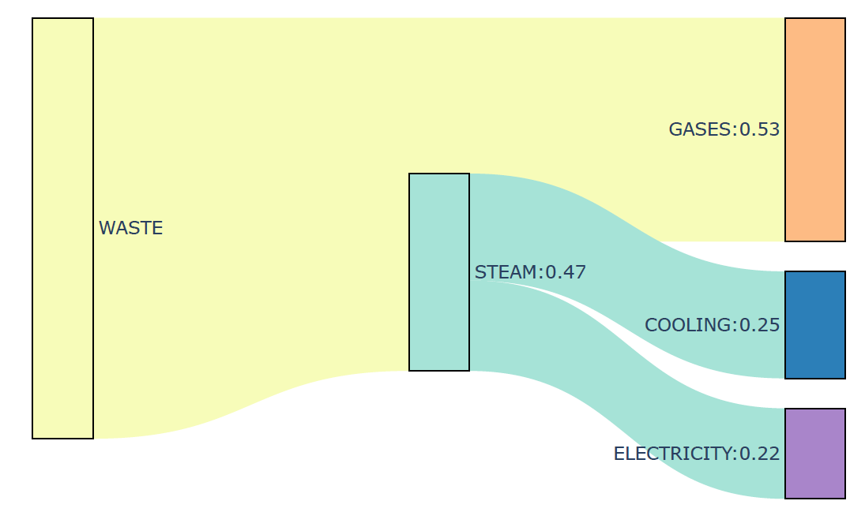

Figure 2.- Sankey diagram of the facility

*4.2.- Economic evaluation and scale-up*

Instead of evaluating a general facility**,** 9 different cities well known to the international public (Madrid, Barcelona, Santiago de Compostela, Valencia, Seville, Gijón, Granada, Pamplona and Salamanca) have been selected to cover a wide range of population sizes and locations. The availability of waste comes from the national institute for statistics [91]. From the household residues, only the combustible fraction is considered assuming the average composition of the waste fraction, around 90% [92]. The data available correspond to the autonomous regions and it is assigned to the provinces and cities by the number of habitants.

*4.2.1.-Economic evaluation*

Table 3 shows the major economic results, investment costs for the facilities to process the waste generated at those places as well as the electricity costs. The investment ranges from 23 M€ for a 100 k habitants city, producing 1.3 MW out of the waste, to the 67 M€ of the country’s capital, with a production capacity of 39.2 MW. Previous analyzed CSP facilities produced an average of 18 MW, similar tot the case of the facilty to be located in Barcelona. Considering this case, not only the investment, 5 times lower, but also the production costs, almost one order of magnitud lower [51], are in favor of using waste. However, note that the waste resources are limited. Smaller facilites can create up to 111 jobs, including indirect ones, while larger ones can generated over 325 total jobs. The production costs range within an order of magnitude from 0.013 €/kWh to 0.11 €/kWh, without considering the cost of the waste collection since it is assumed that the recollection infrastructure is already in place and these facilities only chage the end of use, from landfil to incineration. The power produced is relatively low, with production capacities that are not comparable with previous power facilites based on fossil fuels. The water consumption from the different facilities range from 1.45 L/kWh in Salamanca, to 1.72 L/kWh in Seville, due to the average weather conditions. Cooler locations require less water. Water issues can also affect the selection of the plant location.

If it would be possible to make use of the entire amount of residues generated per province, that includes the supply chain from every small village to a processing facility, the production capacity can rise. While the production costs in the table decreases, the cost for the shipping of all the material is not included yet as the supply chain is out of the scope of this work, see Table 3.

Table 3.-Summary of economic parameters of facilites in different places

|  |  |  |  |  |  |  |  |  |  |
| --- | --- | --- | --- | --- | --- | --- | --- | --- | --- |
| City | Madrid | Barcelona | Valencia | Sevilla | Gijon | Granada | Pamplona | Salamanca | Santiago |
| Habs (khabs) | 3266 | 1637 | 794 | 689 | 270 | 232 | 201 | 144 | 96 |
| P(MW) | 39.2 | 18.8 | 12.6 | 11.8 | 3.8 | 4.0 | 1.9 | 2.0 | 1.3 |
| I (M€) | 67.3 | 46.6 | 39.0 | 37.9 | 27.1 | 26.9 | 23.7 | 24.0 | 22.8 |
| CE(€/kWh) | 0.013 | 0.018 | 0.023 | 0.025 | 0.049 | 0.05 | 0.086 | 0.08 | 0.112 |
| Water(L/kWh) | 1.55 | 1.59 | 1.67 | 1.72 | 1.50 | 1.56 | 1.47 | 1.45 | 1.51 |
| Jobs | 325 | 227 | 189 | 184 | 130 | 131 | 115 | 117 | 111 |
| Province |  |  |  |  |  |  |  |  |  |
| Habs (khabs) | 6377 | 5427 | 2528 | 1941 | 1042 | 917 | 637 | 342 | 1129 |
| P(MW) | 76.6 | 62.4 | 40.2 | 33.3 | 14.9 | 8.9 | 5.9 | 4.89 | 14.9 |
| I (M€) | 99.9 | 88.7 | 68.3 | 63.3 | 41.1 | 35.1 | 30.4 | 29.1 | 41.1 |
| CE(€/kWh) | 0.007 | 0.008 | 0.011 | 0.012 | 0.021 | 0.030 | 0.039 | 0.045 | 0.021 |
| Water(L/kWh) | 1.55 | 1.59 | 1.67 | 1.72 | 1.50 | 1.56 | 1.47 | 1.45 | 1.51 |
| Jobs | 485 | 430 | 332 | 298 | 200 | 166 | 148 | 126 | 200 |

Figure 3 shows the distribution of the different sections of the facility to the total investment cost. The contribution of the cooling section increases as the facility is smaller, while that of the gas treatment or the boiler decreases. The contribution of the turbine is always within 15%

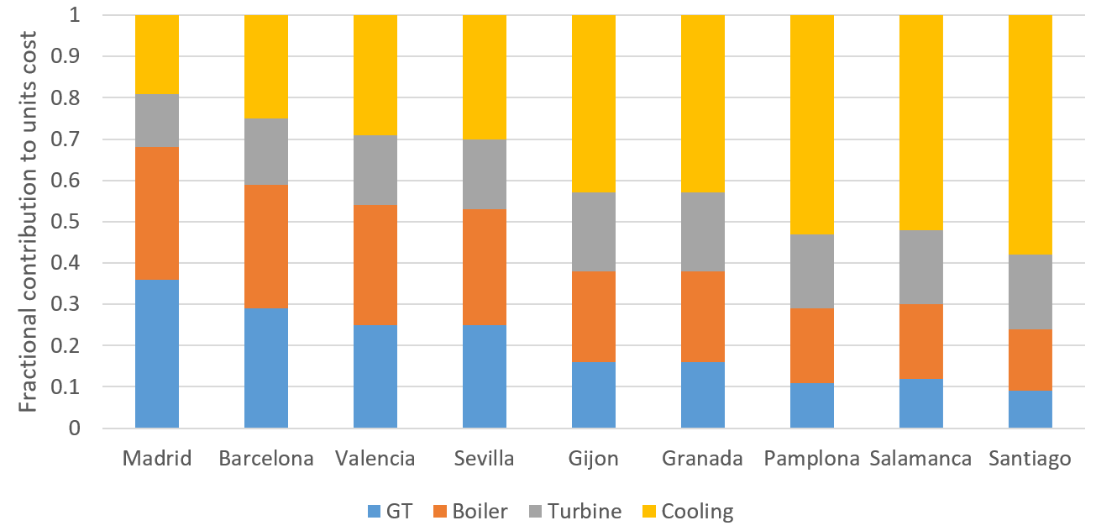

Figure 3.-Effect of the facility size on the contributtion of the plant sections on its cost.

Considering all province capitals and major cities, over 100 k habs, it is possible to produce up to 234 MW of power at an average cost of 0.05 €/kWh, assuming no waste collection costs. The total investment to build all the facilites adds up to 1690 M€. A total of 8225 jobs (999 direct) can be generated by installing all the facilities. However, the amount of residues produced in the country is far larger. It is possible to evaluate the yield to power assuming that its is possible to process it all. Under this scenario, the total power produced reaches three times the previous value, 605 MW at an investment cost just slighly larger, 1790 M€, for a production cost of electricity of 0.021 €/kWh. This is due to the economies of scale of the facilities. However, note that collecting waste from smaller cities, towns and villages to feed a larger facility per province would represent a large supply chain cost and an additional impact in CO2 emissions due to the transportation.

*4.2.2.-Scale-up economics.*

The scale-up of the process allows computing the investment and production costs as a function of the waste processing capacity. Those results are important for the formulation towards the best usage of the residues across a particular region. Following the procedure presented in section 2.3, the investment as well as the electricity costs as a function of the processing capacity are evaluated. The results are correlated as follows for the investment cost (Ii (M€)) as a function of the waste processed, eq. (30)

 (30)

the power production, Pi, eq. (31)

 (31)

and the electricity, CE,i, and total production costs, Cp,i, of a facility as a function of its size is given by eq. (32)

 (32)

*4.3.-Production of power from waste across a country.*

The base case for the study consists of the optimization of an economic objective function, for a budget of 250 M€. Under this scenario, only large cities are selected (Madrid, Barcelona, Valencia, Seville, Malaga and Albacete to cover the budget), for a power production of 92 MW and a cost of electricity of 0.019 €/kWh. For a larger budget, the selection of smaller cities increases the production cost to 0.026 €/kWh, adding to the list of possible locations medium cities over 200k habitants and a power production of 139 MW. Finally for 1000 M€ the electricity cost increases to 0.037 €/kWh, for a total production capacity of 192 MW using cities above 150 khab.

The next stage is the evaluation of the potential that the waste to power initiative has to help create wealth. The variable composition of the MSW can make a difference from one location to another. To avoid this uncertainty average values are used. In addition, the availability of the MSW has become a variable detailed collected by governmental databases. For a fixed budget and imposing electricity prices below 0.06 €/kWh [93] the installation of the facilities is evaluated. The facility location problem requires an objective function that considers the social implications of the installation of the facility in a particular region. Jobs and GDP are to be considered. However, two of the social indicators are related to the generation of Jobs at the location, Ji. Thus, two different objective functions are considered, one using population density as the weight for the contribution of the jobs to generate wealth, eq. (33), and another one that averages the contribution DH and the relative unemployment in the weight to the generation of jobs, eq. (33).

The first objective function for the facility location problem, eq. (29), is given by eq. (33).

 (33)

The problem takes over 2 h and 30 min to reach each of the solutions and increases up to 3 h 20 min for the case of an electricity cost of 0.04 €/kWh. The reason is the close values obtained from different solutions requiring a high number of iterations within the global optimization problem. The solution aims at regions with lower population density and GDP’s using larger cities to adjust the price of the electricity to the target. Figure 4a shows the locations and sizes of the facilities for 0.06 €/kWh. 27.7 MW are produced from cities selected that are within the radius of Madrid. This result can be interpreted by the fact that over the last years people has moved to Madrid looking for job opportunities at the expense of depopulating some of these areas. However, for the power production cost to be competitive it is necessary to use a larger city, Zaragoza, to produce there 9.4 MW, and a number of medium size cities and facilities are built in Córdoba, 5.6 MW, and smaller cities and facilities of around 2-3 MW in Badajoz, Caceres, Burgos, and Albacete so as to average the cost to 0.06 €/kWh. The facilities use the entire amount of waste available in the city. The water consumption is around 1.611 L/kWh, which is a competitive value with thermal based power plants [53]. A total of 1211 jobs are generated. It can be seen that a number of small facilities are built for the social purpose of generating jobs and processing waste more than for the profit.

As the targeted price of electricity decreases, the number of larges facilities also increase, Figure 4b. Three larger facilities are suggested to be installed in cities like Zaragoza, Seville and Valladolid, as well as a number of really small facilities, aiming at just generating jobs due to the fixed costs associated with the installation of the facilities. The reason behind can also be presented based on the fact that larger cities use the entire availability of waste and the rest just a fraction. The water consumption increases to 1.654 L/kWh but the total power produced is similar, 28.3 MW. The total number of jobs remains constant since it is a function of the investment, and it is fully used. If the cost of electricity is targeted to be 0.04 kWh, Figure 4c, the number of medium and larger size cities involved increases including Seville, Zaragoza, Murcia and to a lesser extent Cordoba (5.6 MW) that make use of the entire availability of waste while the rest of the smaller cities and towns build smaller facilities. The total power produced reaches 39.8 MW and the consumption of water is 1.677 L/kWh. It can be seen that in all cases a number of provinces are always selected in the west, but avoiding the coast, as well as in the central part and the south of Spain, towards the generation of wealth and jobs in regions that have suffered to depopulation. Using larger budgets, the number of alternatives increases, and the problem takes more than 10 h. The reason again is the small differences in the indexes that provide the weights to the selection of the facility location

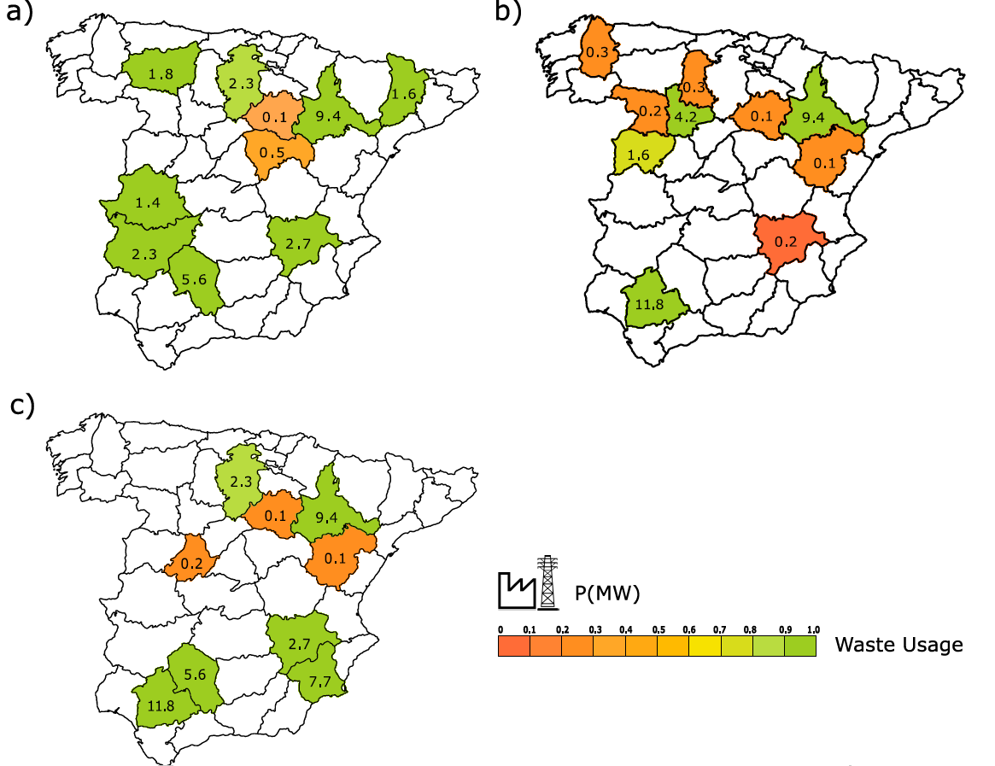

Figure 4.- Facility location as a function of the target cost of electricity. Budget of 250 M€ a) 0.06 €/kWh; b) 0.05 €/kWh; c) 0.04 €/kWh

A second objective function, eq. (34), is evaluated. To avoid double counting the contribution of jobs in the objective function, the RU is normalized with the maximum value.

 (34)

Budgets from 250, 500 and 1000 M€ and targeted electricity prices from 0.04-0.06 €/kWh are evaluated. Using this new objective function, the selection of the locations goes south, where the unemployment is larger. Figure 5a shows the case of a budget of 250 M€ and a targeted electricity cost of 0.06 €/kWh. For this scenario, most of the locations make full use of the waste, but the largest city selected, Seville, that only processes 83% of the waste for a power production of 9.8 MW. There are places with just 25% usage whose selection is related to the social benefit of creating jobs, i.e. Toledo and Almería. The water consumption of the system is 1.673 L/kWh and the production capacity reaches 27 MW. When the electricity cost is targeted at 0.05 €/kWh, and still the budget available is 250 M€, all locations make full use of the waste while larger cities such as Seville, Malaga or Granada are selected so that economies of scale help reduce the production costs. The water consumption remains similar at 1.669 L/kWh. As a result of targeting a lower electricity cost, the production capacity increases to 41 MW, almost 50% higher than in the previous case. If the electricity cost is expected to be even lower, 0.04 €/kWh and the budget available remains at 250 M€, only medium to large cities are selected to the south and others towards the north such as Valladolid, producing 4.2 MW, Murcia, with 7.7 MW, or Zaragoza, with 9.4 MW, join Seville and Cordoba. Still smaller places are selected to improve the social indexes with a use of waste below the availability. Water consumption is 1.682 L/kWh for this system. The total power production is 42 MW, almost the same as when the electricity price target was 0.05 €/kWh. As the budget available increases to 500 M€, Figure 5d, a larger number of locations was selected to the north, most of them in autonomous regions of Castile la Mancha and Castile and Leon, due to the depopulation suffered over the last years and the combination with lower GDP. Most of the same ones already chosen for the lower budget and the same targeted electricity price, Figure 5a, remain but the processing capacity of the facility increases such as in the case of Seville, while Murcia and Cartagena were selected within the region of Murcia. The power production reaches 55 MW while the water consumption decreases to 1.649 L/kWh, compared with the case of the 250 M€ budget. The larger budget provides more flexibility in the selection of the locations. If the budget available reaches 1000 M€, Figures 5d&e, not only the water consumption decreases to 1.613 L/kWh but the production capacity reaches 107 MW. Most of the regions across the county are selected, but for those with the higher GDP such as Madrid, Barcelona, The Basque Country, Valencia or Alicante. Thus, the social objective function achieves its purpose, the generation of jobs and wealth. By comparing the three budgets it can be seen that if the money is not available at once or planned over a number of years there may be decisions on the size of some facilities that would result in suboptimal investments.

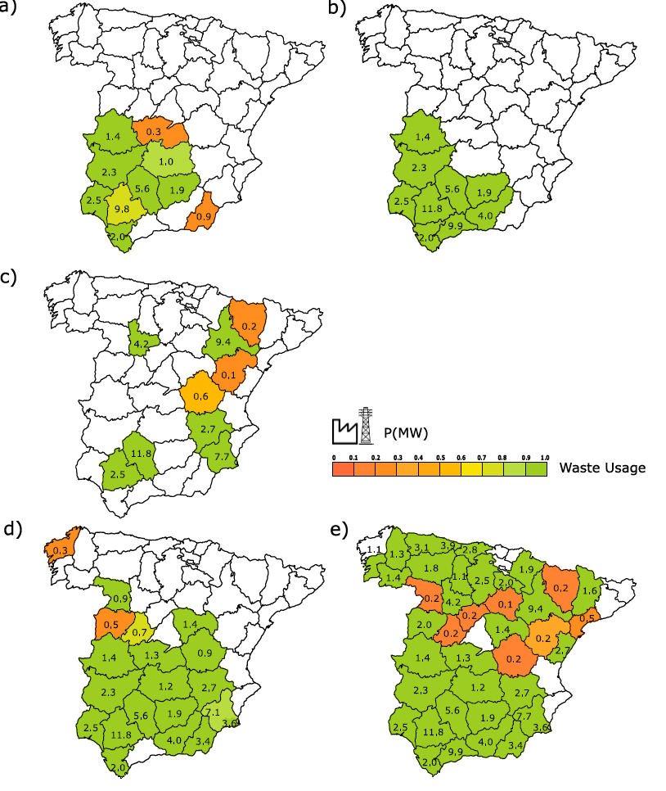

Figure 5.- Facility location as a function of target cost of electricity and budget. A) I=250 M€;0.06 €/kWh; b) I=250 M€; 0.05 €/kWh; c) I=250 M€; 0.04 €/kWh; d) 500 M€; 0.06 €/kWh; e) 1000 M€; 0.06 €/kWh

**5.- Conclusions**

A multiscale approach is presented for the valorization of urban waste within the waste-to-power initiative. At process scale, the systematic techno-economic evaluation of the facility shows that 1.336 MW/kg of mixed waste can be produced. For the facility to produce power at a competitive price, it has to process the waste generated at cities above 200 k habitants. The investment cost is beyond 25 M€ where gas treatment represents around 16%, with the turbine and the boiler representing 19% and 22% respectively. The rest is the cooling. Economies of scale favor the larger facilities where gas treatment reaches 36% of the investment costs.

At country level, for the major cities in Spain (over 65 across the mainland) it would be possible to produce 235 MW from the waste generated at them with a production cost of 0.05 €/kWh and a total investment of 1700 M€. While the average costs are competitive, at regional level, some regions would produce at a high cost and only the national strategy would justify the use of waste at smaller cities. The total waste availability could produce up to 605 MW with an investment of 1800 M€ and a reduced production cost of 0.021 €/kWh, but the collection and transportation of waste from the smallest village to a centralized facility is to be further studied. While the economic solution selects only larger cities, due to the economies of scale, the social aspect is to be evaluated. An optimization formulation is developed for the selection of facility location and size across the territory evaluating budget available and targeted electricity cost. Larger cities are selected as the electricity cost is targeted to be lower, but major capitals are never selected based on social indexes. The larger is the budget available, the locations cover from south to north based on the current unemployment and GDP ratios. Water issues can be further evaluated since most of the locations selected at low budget available are currently under water stress

**Acknowledgments**

The authors would like to acknowledge MICIN, PID2019-105434RB-C31. S.G. acknowledges the Undergraduate research fellowship from MEFP

**6.-Nomenclature**

A: Cooling tower cross sectional Area (m2)

AFilter: Filter area (m2)

ac: air cloth ratio “(1)”

Budget: Available investment (M€)

Ci: Cost of i (€/unit)

Ce production cost of electricity (€/kWh)

CE,i production cost of electricity of facility i (€/kWh)

CL Cooling load (kW)

Cp: Heat capacity (kcal/kg ºC)

Cpi: production cost of electricity at facility in location i (M€/y)

CT: Cost of cooling tower system (€).

C(%) Percentage of carbon in the waste

Dbase: Diameter of the base of the tower (m)

DHi: Relative population index in location i. “(1)”

DRi: Development ratio in location i. “(1)”

GIS Geographical information systems

GDPi: Gross domestic product of region i (€/hab)

Ji: Jobs generated at location i by per investment or size (Number of jobs)

MaxGPD: Maximum gross production (€/hab)

MinU: Minimum unemployment ratio.

UR: Unemployment ratio.

fair: Air flow (kg/s)

fWa: Water flow for cooling (kg/s)

FB Cooling tower blowdown flow (kg/s)

FE Cooling tower evaporation flow (kg/s)

FM Cooling tower make-up flow (kg/s)

Fgas Gas flow rate (Nm3/s)

g: Gravity (m/s2)

Gflux: Air flow per unit area (kg/m2s)

hL : Heat transfer resistance (kcal/m2·s)

hliquid: Liquid enthalpy (kcal/kg)

h: Humid air enthalpy (kJ/kg)

Hm: Air Humidity (kJ/kg)

H(%) Percentage of hydrogen in the waste

Ii: Investment in location i (M€)

ky : Mass transfer resistance (kg /m2s)

Lflux: Water flow per unit area (kg/m2s)

LHV: the low heating value (kcal/kg)

mi mass flow of species i in a year (t/y) i={NOx, SO2}

N(%) Percentage of nitrogen in the waste

O(%) Percentage of oxygen in the waste

p: Pressure (bar)

PHeight: Height of the cooling tower packed section (m)

Pi: Power generated at location i (MW)

Q(unit) Energy at unit (kW)

rt:  Minimum radius of the hyperboloid of the cooling tower (m)

rH:  Top radius of the hyperboloid of the cooling tower (m)

S: Specific contact area of the packing of the cooling tower (m-1)

S(%) Percentage of sulfur in the waste

tL Temperature of the water flow (ºC)

T: Ambient temperature (ºC)

T(unit) Stream temperature (ºC)

THeight: Cooling tower height (m)

Wi: Flow of MSW processed (kg/s)

W: Weight of the vessel (kg)

Wateri: Consumption of water of a facility in location i (L/kWh)

yi Binary variable to select the location of the facilities.

Y, Air moisture (kg moisture per kg dry air)

ZH: Height of the section H of the tower (m)

Zu: Height of the section u of the tower (m)

PGenerated : Driving force for the pressure (Pa)

Symbols

gas: Air density (kg/m3)

rinhab, Population density (hab/m2)

h: yield “(1)”

Units:

AT: Atomizer

Bed Adsorbent bed

Boiler Boiler

C Compressor

CT Cooling tower

HX Heat exchanger

FM Filter.

MS Molecular sieve

PE Electrostatic precipitator

Snk Sink

Spl Splitter

Src: Source

Str: Storage

R: Reactor

T. Packed tower.

Turbine Steam Turbine

**7.-References.**

[1] Makarichi L, Jutidamrongphan W, Techato, K. (2018) The evolution of waste-to-energy incineration: A review Renewable and Sustainable Energy Reviews, 91, 812-821

[2] World Bank. (2012) What a waste: a global review of solid waste management; RL<〈http://siteresources.worldbank.org/INTURBANDEVELOPMENT/Resources/336387-1334852610766/Chap3.pdf〉>

# [3] Di Maria A, Eyckmans J, Van Acker K. (2018) Downcycling versus recycling of construction and demolition waste: Combining LCA and LCC to support sustainable policy making. Waste Manage, 75, 3-21.

[4] Moya D, Aldás C, Jaramillo D, Játiva E, Kaparaju P. (2017) [Waste-To-Energy Technologies: an opportunity of energy recovery from Municipal Solid Waste, using Quito - Ecuador as case study](https://www.sciencedirect.com/science/article/pii/S1876610217346660). Energy Procedia, 134, 327-336

[5] Taifouris, M., Martín, M. (2018) Multiscale scheme for the optimal use of residues for the production of biogas across Castile and Leon. J. Clean. Prod 2018; 185: 239-251.

[6] Damgaard A, Riber C, Fruergaard T, Hulgaard T, Christensen TH. (2010) Life-cycle-assessment of the historical development of air pollution control and energy recovery in waste incineration Waste Manage, 30 (7), 1244-1250

[7] Bosmans A, Vanderreydt I, Geysen D, Helsen L. (2013) The crucial role of waste-to-energy technologies in enhanced landfill mining: a technology review J. Clean. Prod, 55, 10-23

[8] Sun L, Fujii M, Tasaki T, Dong H, Ohnishi S. (2018). Improving waste to energy rate by promoting an integrated municipal solid-waste management system Resour. Conserv. Recyc,136, 289-296

[9] European Commission. (2008) Environmental, Economic and Social Impacts of the Use of Sewage Sludge on Land, Part I: Overview Report; European Commission: Brussels, Belgium,

[10] Tyagi VK, Lo SL. (2016) Chapter 10 - Energy and Resource Recovery From Sludge: Full-Scale Experiences

In. [Environmental Materials and Waste](https://www.sciencedirect.com/science/book/9780128038376) Resource Recovery and Pollution Prevention. Elsevier. 221-244

[11] Đurđevic, D., Blecich, P., Juric, Z. (2019) Energy Recovery from Sewage Sludge: The Case Study of Croatia. Energies, 12, 1927; doi:10.3390/en12101927

[12] Ruijter JA. (2018). Dutch Experience of sludge management and P-recovery pathways

<https://www.nweurope.eu/media/3386/1_p4y_environ2018_hvc-snb_ruijter.pdf>

[13] Werther J, Ogada, T. (1999) [Sewage Sludge Combustion](https://www.sciencedirect.com/science/article/pii/S0360128598000203) Prog. Energy Combust. Sci; 25, 55-116.

[14] Chem G, Wang X, Li J, Yan B, Wang Y, Wu X, Velichkova R, Cheng Z, Ma W (2019) Environmental, energy, and economic analysis of integrated treatment of municipal solid waste and sewage sludge: A case study in China Sci Total Environ, 647, 1433-1443

# [15] Sun Y, Qin Z, Tang Y, Huang T, Ding S, Ma X (2021) Techno-environmental-economic evaluation on municipal solid waste (MSW) to power/fuel by gasification-based and incineration-based routes J Environ. Chem Eng. 9(5), 106108

[16] Ciferno JP, Marano JJ. (2002) Benchmarking Biomass Gasification Technologies for Fuels, Chemicals and Hydrogen Production. U.S. Department of Energy National Energy Technology Laboratory

[17] Masnadi MS, Grace JR., Bi XT, Ellis N, Lim J, Butler J. (2015) Biomass/coal steam co-gasification integrated with in-situ CO2 capture. Energy. 83, 326-336

[18] Hussain HJ, Sebzali MJ. (2016) Modeling of Municipal Solid Waste Incineration Plant for Electricity Generation in Kuwait Int. J. of Sustainable Water & Environ. Sys, 8(2), 65-69

[19] Straka M, Rosova A, Malindzakova M, Khouri S, Culkova K. (2018) Evaluating the Waste Incineration Process for Sustainable Development through Modelling, Logistics, and Simulation Pol. J. Environ. Stud, 27(6), 2739-2748

[20] Jiang M, Lai ACH, Wing-Keung Law, A. (2020) Solid Waste Incineration Modelling for Advanced Moving Grate Incinerators. Sustainability; 12, 8007; doi:10.3390/su12198007

[21] Wang, Q, Luo, Z, Ni, M, Cen, K. (2003) Particle population balance model for a circulating fluidized bed boiler. Chem Eng. J. 93, 2, 121-133

[22] Chen C, JIn Y-Q, Yan JH, Chi Y. (2013) Simulation of municipal solid waste gasification in two different types of fixed bed reactors [Fuel](https://www.scopus.com/sourceid/16313), 103, 58 – 63.

[23] Brosch B, Schrer V, Wirtz S. (2014) Simulation of municipal solid waste incineration in grate firing system with a particle based Discrete Element method. VGB PowerTech, 75-83

[24] Vamvuka D, Alezandrakis S, Galetakis M. (2019) Combustion Performance of Sludge From a Wastewater Treatment Plant in Fluidized Bed. Factorial Modeling and Optimization of Emissions Front. Energy Res. <https://doi.org/10.3389/fenrg.2019.00043>

[25] Magnanelli E., Tranas OL, Carlsson P, Mosby J, Becidan M (2020) Dynamic modeling of municipal solid waste incineration. 209, 118426.

[26] Wang H, Liao Y, Ma X, Zeng X. (2020) Numerical simulation of co-incineration of sewage sludge and municipal solid waste in municipal solid waste incinerator E3S Web of Conferences, 194, 04019

[27] Panepinto D., Zanetti MC. (2018) Municipal solid waste incineration plant: A multi-step approach to the evaluation of an energy-recovery configuration Waste Manage 73,332–341

[28] Hübner C, Boos R, Bohlmann J, Burtscher K, Wiesenberger H. (2000) State-of-the-Art Measures for Dioxin Reduction in Austria. Viena, Austria.

[29] Barbam D, Brandani F, Capocelli M, Luberti M, Zizza A. (2015) Process analysis of an industrial waste-to-energy plant: Theory and experiments. Proces. Saf Environ. Prot, 96, 61–73

[30] Cimici S, Prisciandaro M, Barba D. (2005) Simulation of a waste incineration process with flue-gas cleaning and heat recovery sections using Aspen Plus Waste Manage, 25, 171–175

[31] Jannelli E, Minutillo M. (2007) Simulation of the flue gas cleaning system of an RDF incineration power plant.

Waste Manage, 27, 684-690.

[32] Fodor Z, Klemes JJ. (2012) Waste as alternative fuel – Minimising emissions and effluents by advanced design. Proc. Saf Environ Prot, 90, 263-284

[33] Guerras LS, Martín M (2019) Optimal gas treatment and coal blending for reduced emissions in power plants: A case study in Northwest Spain. Energy, 169, 739-749.

[34] Babinski ML. (1965) Integer Programming: Methods, uses, computations. Manage Sci, 12, 253-313

[35] Baron O, Milner J, Naseraldin H. (2011) Facility Location: A Robust Optimization Approach. Prods Oper Manag. 20(5), 772–785

# [36] Adeleke OJ, Olukanni DO. (2020) Facility Location Problems: Models, Techniques, and Applications. Waste Manage Recy, 5(2), 10; <https://doi.org/10.3390/recycling5020010>

# [37] Jian S, Li Z, Gao G (2022) Study on site selection of municipal solid waste incineration plant based on swarm optimization algorithm Waste Management & Research, 40(2), 205-217.

[38] Eiselt HA, Marianov V. (2015) Location modeling for municipal solid waste facilities. Comput. Oper. Res,  62, 305–315

[39] Ghiani G, Manni A, Manni E, Toraldo, M. (2014) The impact of an efficient collection site location on the zoning phase in municipal solid waste management. Waste Manag, 34, 1949–1956.

[40] Tralhão L, Coutinho-Rodrigues J, Alçada-Almeida L. (2010) A multiobjective modeling approach to locate multi-compartment containers for urban-sorted waste. Waste Manage,30, 2418–2429

[41] Wichapa N, Khokhajaikia P. (2017) Solving multi-objective facility location problem using the fuzzy analytical hierarchy process and goal programming: A case study on infectious waste disposal centers. Oper. Res. Perspect, 4, 39–48.

[42] Yalcinkaya S, Kirtiloglu OS (2021) Application of a geographic information system-based fuzzy analytic hierarchy process model to locate potential municipal solid waste incineration plant sites: A case study of Izmir Metropolitan Municipality Waste Management & Research, 39(1), 174 –184

# [43] Feyzi S, Khanmohammadi M, Abedinzadeh A, Aalipour M (2019) Multi- criteria decision analysis FANP based on GIS for siting municipal solid waste incineration power plant in the north of Iran. Sust Cities Soc. 47, 101513

[44] Energy Information Administration. (2020) Biomass explained, Waste-to-energy (Municipal Solid Waste). <https://www.eia.gov/energyexplained/biomass/waste-to-energy-in-depth.php>

[45] Heras J, Martín M. (2020) Social issues in the energy transition: Effect on the design of the new power system. Appl. Energy, 278, 115654.

[46] Tsolas SD, Karim MN, Faruque Hasan, MM. (2018) Optimization of water energy nexus: A network representation-based graphical approach. Appl. Energy, 224, 230-250 .

[47] Sinnott R, Towler G. Chemical Engineering Design. (2019) Principles, practice and economics of plant and process design. 2ª ed. Elsevier Butterworth-Heinemann, Oxford.

[48] Miller BG. (2015) Fossil Fuel Emissions Control Technologies. Stationary Heat and Power Systems. Editorial: Elsevier, ISBN: 978-0-12-801566-7

<http://manager.redsauce.net/AppController/commands_RSM/api/api_getFile.php?itemID=203&propertyID=20&RStoken=59e8ac1045d03e2ff6564c0638315f38> Last accessed March 2018

[49] Martín M, Grossmann IE. Chapter 2. (2021) Sustainable design for renewable processes. In Sustainable Design for renewable processes. Elsevier. Oxford.

[50] Almena A, Martín, M. (2016) Techno-economic analysis of the production of epichlorohydrin from glycerol. Ind. Eng. Chem. Res, 55 (12), 3226-3238

[51] Martín L, Martín M. (2013) Optimal year-round operation of a Concentrated Solar Energy Plant in the South of Europe Appl Therm Eng, 59, 627-633.

[52] Sánchez A, Martín M. (2018) Scale up and Scale down issues of renewable Ammonia plants: Towards modular design. Sust. Prod. Consump, 16, 176-192 <https://doi.org/10.1016/j.spc.2018.08.001>,

[53] Guerras LS, Martín M. (2020) On the water footprint in power production: Sustainable design of wet cooling towers. Appli. Energy, 263, 114620, <https://doi.org/10.1016/j.apenergy.2020.114620>

[54] Lin, H., Ma, X. (2012) Simulation of co-incineration of sewage sludge with municipal solid waste in a grate furnace incinerator /Waste Manage,32, 561–567

[55] Eduljee G. (1994) Organic micro pollutants emissions from waste incineration. In Hester RE, Harrison RM (ed.) Waste incineration and the environment, Royal Society of Chemistry, London.

[56] Govardhana R, Saxena SC. (1993) Prediction of Flue Gas Composition of an Incinerator Based on a Nonequilibrium-Reaction Approach, Air & Waste, 43(5), 745-752, doi: [10.1080/1073161X.1993.10467156](https://doi.org/10.1080/1073161X.1993.10467156)

[57] Quina MJ, Bordado JCM, Quinta-Ferreira RM. (2011) Air Pollution Control in Municipal Solid Waste Incinerators. In: Khallaf, M. (ed.). The impact of Air pollution on Health, Economy, Environment and Agricultural Sources. <https://core.ac.uk/download/pdf/19133574.pdf>

[58] Goemans M, Clarysse P, Joannes J, De Clercq P, Lenaerts S, Matthys K, Boels K. (2004) Catalytic NOx reduction with simultaneous dioxin and furan oxidation. Chemosphere, 54, 1357-1365. doi: 10.1016/S0045-6535(03)00255-8

[59] Rafie SAA, Haider N, Islam N, Badruzzaman ABM. (2016) Assessing the Energy Values of Sewage Sludge from Pagla Sewage Treatment Plant BUET-ANWAR ISPAT 1st Bangladesh Civil Engineering SUMMIT BUET, Dhaka, Bangladesh [www.cesummitbd.com](http://www.cesummitbd.com),

[60] Servicio de Incineración de Residuos Urbanos SIRUSA. (2019) <http://www.sirusa.es/actividades/descripcion-del-proceso>

[61] León E, Martín M. (2016) Optimal production of power in a combined cycle from manure based biogas Energy Convers Manage, 114, 89–99

[62] Xu C, Wang Z, Li X, Sun F. (2011) Energy and exergy analysis of solar power tower plants. Appl. Therm. Eng, 31(17-18), 3904-3913.

[63] Ghobeity A, Noone CJ, Papanicolas CN, Mitsos A. (2011) Optimal time-invariant operation of a power a water cogeneration solar-thermal plant. Solar Energy, 85 (9),2295-2320.

[64] Morin G, Richter P, Nitz P. (2012) New method and software for multi-variable techno-economic design optimization of CSF plants. www.mathcces.rwth-aachen.de/_media/5people/richter/pascalrichter-2010-solarpaces.pdf [accessed December 2012]

[65] Palenzuela P, Zaragoza G, Alarcón-Padilla DC, Guillén E, Ibarra M, Blanco J. (2011) Assessment of different configurations for combined parabolic-trough (PT) solar power and desalination plants in arid regions. Energy; 36 (8): 4950-4958.

[66] Walas SM. (1990) Chemical process equipment. Selection and Design. Butherworth Heinemann. Newton MA.

# [67] Mussatti DC, Vatavuk WM, Klotz WL, Stallings RL, Srivastava R, Hemmer PM, Straight R, Turner JH, McKenna JD, Mycock JC, Nunn AB, Lawless PA, Tamamoto T, Coy DW, Greiner GP. (2017) Air pollution control cost manual. Environmental Protection Agency (EPA). EPA 452/B-02-002

[68] Sorrels JL, Randall DD, Schaffner KS, Richardson Fry C (2016) Chapter 1: Selective Noncatalytic Reduction.

# <https://www3.epa.gov/ttn/ecas/docs/SNCRCostManualchapter7thEdition2016.pdf>

# [69] Rosenberg HS, Oxley JH. (1993) Selective Catalytic Reduction for NOx Control at Coalfired Power Plants. ICAC Forum ‘93, Controlling Air Toxics and NOx Emissions, Baltimore, MD, 24–26.

# [70] Sorrels JL, Randall DD, Schaffner KS, Richardson Fry C (2015) Chapter 2 Selective Catalytic Reduction

# <https://www3.epa.gov/ttnecas1/models/SCRCostManualchapter_Draftforpubliccomment6-5-2015.pdf>

# Last accessed March 2018.

# [71] BOE (2004). Real Decreto 430/2004, BOE 69, de 20 de marzo de 2004, 12292 – 12303.

[72] Gas Natural Fenosa (2015). Central Térmica La Robla. Leaflet.

# [73] Nichols GG, McCain JD. (1975) Particulate Collection Efficiency Measurements on Three Electrostatic Precipitators. EPA Report 60/2-75-056, <https://www3.epa.gov/ttn/catc/cica/files/fwespwpi.pdf>

[74] Hayton J. (2015) Thermal power plant. Editorial: Elsevier, Amsterdam. ISBN: 978-0-12-801575-9.

[75] Farber P. (1986) Production and disposal of wastes from dry and wet flue-gas cleaning systems. Energy,11 (11/12),1347-1356.

[76] <https://www.zuiveringstechnieken.nl/>

[77] Guo X, Li M, Liu A, Jiang M, Niu X, Liu X. (2020) Adsorption Mechanisms and Characteristics of Hg2+ Removal by Different Fractions of Biochar. Water,12 (8), 2105. <https://doi.org/10.3390/w12082105>

[78] Martín M, Martín M. (2017) Cooling limitations in power plants: optimal multiperiod design of natural draft cooling towers. Energy. 135, 625-636.

[79] Cheremisinoff NP, Chremisinoff PN. (1981) Cooling Towers: Selection, design and practice. Ann Arbor, Michigan, Ann Arbor Science Publishers, 347.

[80] Geankoplis CJ. (1993) Transport Processes and Unit Operations. 3rd Edition. Prentice Hall Upper Saddle River, New Jersey. U.S.A.

[81] Coulson J, Richardson J. (1999) Chemical Engineering, Butterworth Heinemann, UK.

[82] Perry RH, Green DW. (1997) Perry’s Chemical Engineer’s Handbook McGraw-Hill: New York. U.S.A.

[83] Dehaghani ST, Ahmadikia H. (2017) Retrofit of a wet cooling tower in order to reduce water and fan power consumption using a wet/dry approach. Appl. Therm. Eng, 125, 1002-1014.

[84] Kloppers JC, Kröger DG. (2004) Cost optimization of cooling tower geometry. Eng. Opt, 36 (5), 575-584

[85] Almási J. (1981) Approximate determination of cooling tower dimensions. Period. Polytech. Civil Eng, 25(1-2), 95-110.

[86] Serna-González M, Ponce-Ortega JM, Jiménez-Gutiérrez A. (2009) MINLP optimization of mechanical draft counter flow wet-cooling towers. Chem Eng Res Des; 88 (5-6), 614-625.

[87] Fatigati M. (2006) Conserving Water in Ethanol Plants. Western Region BBI Biofuels Workshop San Diego CA. http://www.bbibiofuels.com/biofuelsworkshop/2006/docs/speakerpapers/west/bww/BWW06-14-Fatigati.pdf [accessed November 2018]

[88] Grossmann IE (2021) Advanced optimization for Process system engineering. Cambridge Univ. Press. Cambridge. UK.

[89] La Robla staff personal communication. (2019)

[90] García Sánchez-Cervera, I. Energetic Optimization of a Steam Cycle Power Plant for an Efficient Operation of a Post-combustion CO2 Capture Plant. Techniche Universitate Wien 2010, https://e-archivo.uc3m.es/bitstream/handle/10016/9936/PFC_Ignacio_Garcia_SanchezCervera.pdf

[91] INE (2020) Estadísticas sobre recogida y tratamiento de residuos. Residuos urbanos: Serie 2010-2018

[92] Junta de Extremadura. Consejería de Medio Ambiente y Rural, Políticas Agrarias y Territorio. RL <<http://extremambiente.juntaex.es>>.

[93] Center Point Energy. RL <https://www.centerpointenergy.com/en-us/Services/Pages/natural-gas-electricity-cost-comparison.aspx?sa=mn&au=bus>.

1. Corresponding author. Tel.: +34 923294479

   Email address: mariano.m3@usal.es