A Zero CO₂ Emissions Large Ship Fuelled by an Ammonia-Hydrogen Blend: Reaching the Decarbonisation Goals
Antonio Sánchezª, M. A. Martín Rengel^{b**}, Mariano Martín^{a,} **

ªDepartment of Chemical Engineering. University of Salamanca. Plz. Caídos 1-5. 37008. Salamanca (Spain)
^{b}Departament of Materials Science, Universidad Politécnica de Madrid, E.T.S.I. Navales, Avd. de la Memoria 4, 28040 Madrid (Spain)
Abstract
To reach the decarbonisation goals, a zero CO₂ emissions large ship propulsion system is proposed in this work. The ship selected is a large ferry propelled by an internal combustion engine fuelled by an ammonia-hydrogen blend. The only fuel loaded in the vessel will be ammonia. The hydrogen required for the combustion in the engine will be produced onboard employing ammonia decomposition. The heat required for this decomposition section will be supplied by using the hot flue gases of the combustion engine. To address the issues regarding NO_{x} emissions, a selective catalytic reduction (SCR) reactor was designed. The main operating variables for all the equipment were computed for engine load values of 25%, 50%, 75%, and 100%. Considering the lowest SCR removal rate (91% at an engine load of 100%), the NO_{x} emissions of the vessel were less than 0.5 g/kWh, lower than the IMO requirements. An energy analysis of the system proposed to transform ammonia into energy for shipping was conducted. The global energy and exergy efficiencies were 42.4% and 48.1%. In addition, an economic analysis of the system was performed. The total capital cost (CAPEX) for the system can be estimated at 8.66 M€ (784 €/kW) while the operating cost (OPEX) ranges between 210 €/MWh (engine load 100%) and 243 €/MWh (engine load of 25%). Finally, a sensitivity analysis for the price of ammonia was performed resulting in the feasibility of reducing the operating cost to below 150 €/MWh in the near horizon.

Keywords: Ammonia, Decarbonisation, Hydrogen, Internal combustion engine, Ship

1. Introduction
Global warming due to greenhouse gases (GHGs) is one of the main problems nowadays. The most important and extended of these GHGs is CO₂ (Olivier & Peters, 2017). A remarkable part of these emissions is produced by passengers and goods transportation since shipping is the main mean of world trade. Consequently, about 3% of global GHG emissions come from maritime transport (Buhaug et al., 2009; Smith et al., 2015). At this point, the International Maritime Organization (IMO) has set to reduce by 50% GHGs emissions by 2050 compared to 2008. The aim would be to eliminate them by 2100 (IMO, 2018; Joung et al., 2020). Nowadays, Internal Combustion Engines (ICE) are responsible for almost all shipping CO₂ emissions since these use traditional non-renewable energy sources (being Marine Fuel Oil (MFO) and Marine Diesel Oil (MDO) the most widespread marine fuels today). To introduce renewable energy sources in the shipping sector different strategies have been proposed. Direct electrification using batteries (Kersey et al., 2022), the use of H₂ fuel cells (Wu et al., 2022a), or the use of different alternative fuels (Ampah et al., 2021) are among the most promising options.
Several candidates have been proposed among the alternative fuels. Among them, it is possible to stand out hydrogen (H₂) and its derivatives, methanol (CH₃OH) and ammonia (NH₃). The first remarkable feature of these three compounds is their high energy density. In addition, these three chemicals show a high-octane rating, even higher than gasoline in the case of ammonia and hydrogen (Al-Aboosi et al., 2021). The literature is rich in studies focused on the study of ICE fuelled by hydrogen mixed with other compounds (Ryu et al., 2014), but a limited extension is expected for pure hydrogen-fuelled marine ICEs (Atilhan et al., 2021). The main alternative proposed nowadays for hydrogen marine propulsion is the use of fuel cells (Di Micco et al., 2022). However, the storage of hydrogen onboard is not a straightforward issue for several reasons, for instance, its low volumetric energy density. Consequently, extensive storage systems would be required, especially for long voyages. It may reduce, in a remarkable way, the space available onboard. In addition, hydrogen can be explosive, and due to its small molecular size, it is prompt to leak (Mao et al., 2021). Finally, hydrogen storage systems made of metallic alloys may suffer severe embrittlement processes (Findley et al., 2022). An alternative is the storage of liquid hydrogen. By liquefaction, hydrogen energy density is increased up to 2.8 MWh/m³. However, this process demands temperatures between 13.8 and 33.2 K, and it involves an important economic cost. Furthermore, remarkable losses of gas are expected due to the boil-off effect. The cost of storage of liquefied hydrogen in a large ferry is around 1.71 €/kWh (1.29 €/kWh for bulk carriers and container ships). Another hydrogen storage system is the use of metallic hydrides (Tarasov et al., 2021). However, for an effective deployment of this alternative in portable applications, further research is still needed (Rusman & Dahari, 2016). Despite these hydrogen storage drawbacks, H₂ has potential use in future ship transport and has been proposed for certain types of ships, so far with limited operating hours (Di Micco et al., 2022; Atilhan et al., 2021).
To avoid the aforementioned inconveniences for hydrogen storage on board, a promising alternative is the use of different liquid fuels produced from renewable hydrogen. As liquids, these alternatives are easy to store and transport, also increasing the volumetric energy density of the fuel with respect to hydrogen. Methanol arises as one attractive alternative fuel for shipping propulsion. It has already been considered in some industrial projects. One of the main marine ICE manufacturers, MAN, is going to commercialize this kind of engine by 2024 (MAN, 2019). Maersk, one of the principal shipowners, has started its strategy to switch from the use of conventional fuels to methanol in its ships. Methanol is liquid at ambient temperature and pressure, which represents an important advantage for its onboard storage. In this way, the cost of methanol storage onboard may be estimated at 0.14 €/kWh for a large Ferry and 0.12 €/kWh for bulk carriers and container ships (Korberg et al., 2021). In addition, a methanol spill is considerably less hazardous for marine life than a MFO or MDO spill (Anderson & Marquez Salazar, 2015). This is an important factor in the case of fuel leakage. However, this compound is extremely toxic for humans. Another handicap for the use of methanol onboard is that it may be explosive (in a smaller range than hydrogen but higher than MFO or ammonia). There are many paths to produce green methanol (Yousaf et al., 2022; Gautam et al., 2020), being the most extended the hydrogenation of CO₂ using green hydrogen (Martín, 2016). It is very important to underline that, even when the use of green methanol for marine ICE can achieve a neutral CO₂ combustion balance, it is not possible to reach directly zero CO₂ emissions by using methanol as fuel. To minimize them, some CO₂ capture systems must be employed. The installation of this system on the ship could be technically challenging (or even not possible) and the economic performance could be disadvantageous.
In order to achieve a fleet with zero CO₂ emissions and avoid the inconveniences mentioned above of hydrogen as fuel, ammonia also arises as one attractive fuel option for a decarbonized society (Wang et al., 2023b). Similar to the case of methanol, MAN is conducting an important project for the development of marine ammonia-fuelled ICE. This type of marine engine could be developed by 2024 (MAN, 2020b; Juliussen, 2018). Ammonia can be stored in a liquid state at 240 K and atmospheric pressure or at 10 bar at 293 K. For these reasons, the ammonia storage onboard is quite easier than storing hydrogen, even easier than liquefied natural gas (LNG). Thus, the current ammonia storage costs onboard are about 0.29 €/kWh (for large ferries) and 0.23 €/kWh (for bulk carriers and container ships) (Korberg et al., 2021). To produce renewable ammonia different technologies have been assessed. The most extended today is the combination of green hydrogen (from water electrolysis) with nitrogen (from air separation) to synthesize ammonia using the Haber-Bosch process at high temperatures (400-500 °C) and pressures (15-20 MPa) (Palys et al., 2019; Sánchez & Martín, 2018b). Another alternative is to produce green hydrogen from biomass (Sánchez & Martín, 2019). In addition, one of the emerging options is the use of electrochemical methods based on the electroreduction of nitrogen leaving behind the Haber-Bosch synthesis (MacFarlane et al., 2020). Related to its combustion, ammonia is a relatively unreactive fuel due to several factors such as its relatively low flame speed and its high auto-ignition temperature value. Different techniques approaches have been proposed to address this issue (Elbaz et al., 2022). One of the most studied is the introduction of a co-fuel with better combustion features (Nozari & Karabeyoğlu, 2015; Kurien & Mittal, 2022). Several species have been proposed to promote ammonia combustion, i.e.: methane, diesel, gasoline, dimethyl ether, or hydrogen (Liu et al., 2022; Wu et al., 2022b). Among them, hydrogen emerges as one of the most promising. Hydrogen addition in ammonia combustion increases the ammonia flame speed although an increase in the NO_{x} formation could be expected depending on the selected equivalence ratio (Chai et al., 2021). Another important point for using hydrogen as a co-fuel is its carbon-free nature allowing for completely decarbonizing shipping transport (Valera-Medina et al., 2019). In terms of emissions, the combustion of ammonia does not produce CO₂, as a consequence, zero direct CO₂ emissions level can be reached by using this fuel. Nevertheless, ammonia combustion could produce NO_{x}. Therefore, special attention should be paid to control this pollutant. The introduction of a selective catalytic reduction (SCR) unit is proposed as an effective technology to mitigate NO_{x} emissions (Ejder & Arslanoğlu, 2022).
To deploy ammonia as fuel in the shipping sector, intense research is required in different areas. Currently, several investigations are devoted to exploring the possibility of introducing ammonia in the engine from an experimental and theoretical points of view. Most of this research, as mentioned, proposes the use of a co-fuel for ammonia fuel systems. Therefore, the next step is to assess the entire propulsion system from a holistic approach including not only the ammonia engine but also the problems related to the selected co-fuel and, also, those associated with the pollutants in the combustion gases. To the best of the authors’ knowledge, no research about the conceptual design of the entire propulsion system to introduce ammonia in shipping has still been reported.
Thus, in this work, an integrated analysis of the system to use ammonia as fuel in marine transport is presented. A two-stroke ICE fuelled with an ammonia and hydrogen blend is selected as the core unit of the propulsion system. But the analysis is extended to the entire process. An ammonia decomposition reactor is introduced to produce the necessary hydrogen as co-fuel allowing only ammonia to be loaded as the ship's fuel. Ammonia decomposition will take place by using the heat of ICE exhaust gases. In addition, nitrogen oxides can be produced in the combustion chamber, therefore, to abate this pollutant the introduction of an SCR is proposed in this work. By using the SCR system proposed, the most demanding requirements established by IMO, TIER III (Schneiter, 2015; Wik & Niemi, 2016), will be comfortably reached. Through this global analysis, a significant step is taken to introduce ammonia as a fuel in the maritime transport sector allowing for the decarbonisation of this important activity.
2. Ship selection
The type of ship selected in this work is a large ferry with a nominal capacity of propulsion of 11 MW, a typical value for this kind of ship. A ferry is the vessel among the large ships with the smallest utilisation rate, between 1260 and 3780 utilization hours per year. These values are quite smaller than the ones corresponding to a container ship (with annual rates between 4320 and 6000 hours) and, also, smaller than a bulk carrier or a general cargo one (with annual rates, for both, between 3600 and 5820 hours). As it was described in detail in the previous point, to achieve the main target of this work (to propose a propulsion system that allows a large ship with zero CO₂ emissions) two fuels can be used primarily: ammonia and hydrogen. In addition, the total operating costs for the fuel cells are higher than the ones corresponding to the ICEs. This difference is more remarkable in the case of vessels with the smallest utilisation rates: i.e., large ferries (Korberg et al., 2021). For this reason, using an ICE fuelled by ammonia to propel a large ferry is an excellent option. As it was mentioned above, there is not any remarkable project ongoing for the development of a hydrogen-fuelled marine ICE.
3. System description
The entire system for using ammonia as fuel can be divided into three main sections: ammonia decomposition, the internal combustion engine, and the selective catalytic reduction (SCR) unit. A schematic representation of the system is presented in Figure 1.
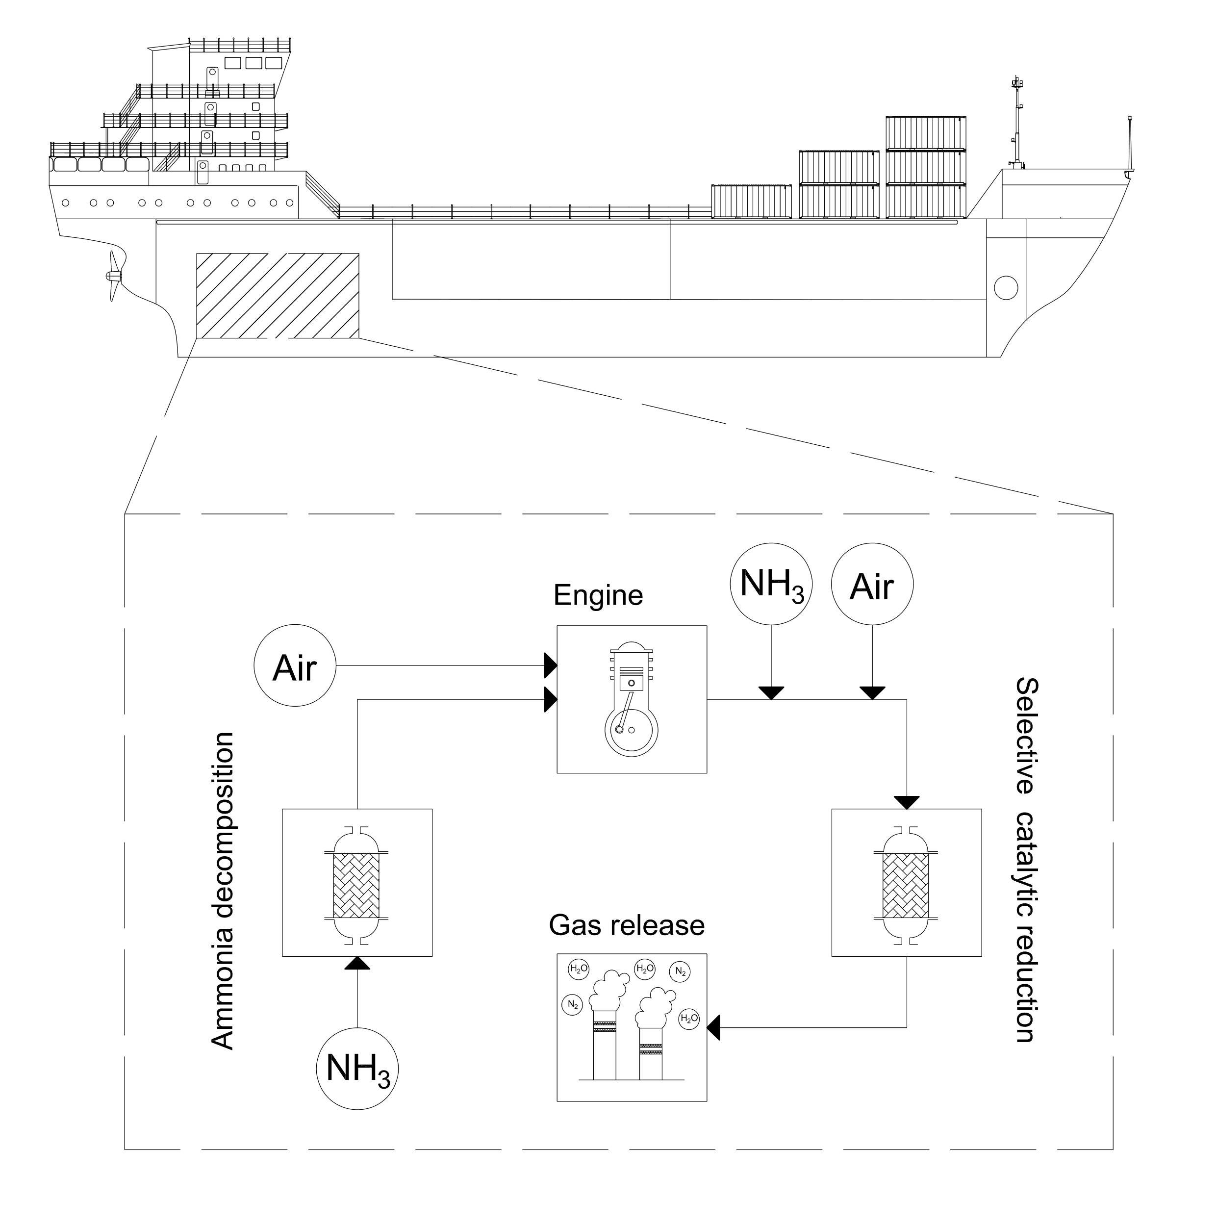
Figure 1: Global overview of the entire system to fuel a ship using ammonia.
Ammonia is fed to a decomposition stage to produce a blend with an ammonia/hydrogen molar proportion of 70/30 (Wang et al., 2021). The objective is to improve the flammability properties of ammonia as feedstock due to its unstable combustion, with the low burning velocity as the major limitation (Li & Li, 2021). The use of hydrogen is widely accepted as a co-fuel for ammonia combustion. The properties of ammonia and hydrogen as fuels are collected in Table 1. To reach the temperature required for ammonia decomposition, a heat exchanger is placed just before the reactor. To provide the necessary heat, the gas stream leaving the turbine after the combustion engine is used, allowing the heat integration of the entire system. The decomposition reaction is highly endothermic; therefore, significant thermal energy must be provided before the reactor since this unit works adiabatically. In the ammonia decomposition reactor, the inlet ammonia is decomposed to form the required mixture (70% NH₃-30%H₂). The reaction is performed in a fixed bed reactor and the stream leaving this unit is the fuel that is fed into the combustion engine section. The temperature of this stream could be adjusted before entering the engine according to the combustion system requirements. The stream that leaves the decomposition is formed by ammonia, hydrogen, and nitrogen. This stream is directly introduced into the internal combustion engine including the produced nitrogen. The presence of this component could modify the combustion process since it is inert. However, nitrogen is also introduced with the inlet air, and the nitrogen from the decomposition only represents around 3% of the total inlet nitrogen into the combustion engine. Therefore, we assume that this additional nitrogen would produce no significant changes.
The second section is the internal combustion engine where the transformation of ammonia into mechanical energy takes place. The first step is the turbocharger which consist of a compressor and a gas turbine where the power required to run the compressor is provided by the gas turbine after the combustion engine (Lu et al., 2022). The feed is compressed up to a given pressure (presented in Table 2) depending on the capacity rate before entering the combustion engine. The temperature of the inlet stream may also be adjusted just before the combustion unit. The two-stroke internal combustion engine is based on a Miller-Sabathe cycle; therefore, the gases are compressed inside the cylinder, the combustion takes place, and finally, the gases are expanded and released. The combustion is carried out with an excess of air to control the maximum temperature inside the engine. The gases that leave the cylinder are introduced in a gas turbine which is the second part of the turbocharger. The gases are expanded to produce the necessary power to run the compressor of the inlet stream. Finally, the gases are cooled in two steps. The first one provides the necessary heat to the ammonia which is fed into the ammonia decomposition reactor. The second heat exchanger could be optional, and it is devoted to adjusting the temperature of the gases to the conditions required in the selective catalytic reduction unit.
Table 1: Properties of ammonia and hydrogen as fuels (Valera-Medina et al., 2018; Wang et al., 2023a; Frigo & Gentili, 2013)
Properties | Ammonia | Hydrogen
Molecular formula | NH₃ | H₂
Density (20ºC) (kg/m³) | 0.77 | 0.089
Gravimetric H₂ density (%w) | 17.8 | 100
Low heating value (MJ/kg) | 18.80 | 120
Flammability limits (%vol) | 15-28 | 4.7-75
Laminar flame velocity (m/s) | 0.015 | 3.51
Auto-ignition temperature (K) | 924 | 844
Adiabatic flame temperature (with air) (K) | 1850 | 2483
Octane number | >130 | >100

The last section of the system is the abatement of the nitric oxide emissions from the exhaust gases. This section is based on the use of a selective catalytic reduction (SCR) reactor where the nitric oxides are catalytically transformed into nitrogen and water (Liang et al., 2019). The reaction is based on the combination of ammonia, oxygen, and nitric oxide, therefore, the two first components must be introduced before the reaction. The SCR reactor is a fixed-bed monolithic unit that operates under adiabatic conditions. For this operation, the removal efficiency is dependent on the initial temperature and ranges from 80% to 100% (Guerras & Martín, 2019). After the catalytic reactor, the outlet stream is cooled to ambient temperature to be released safely into the environment.
4. Modelling approach
In this section, a general description of the modelling issues related to the ammonia fuelled ship is presented. For further details, an extended explanation is shown in the Supplementary Information. The flowsheet considered for the representation of the entire system is shown in Figure 2.
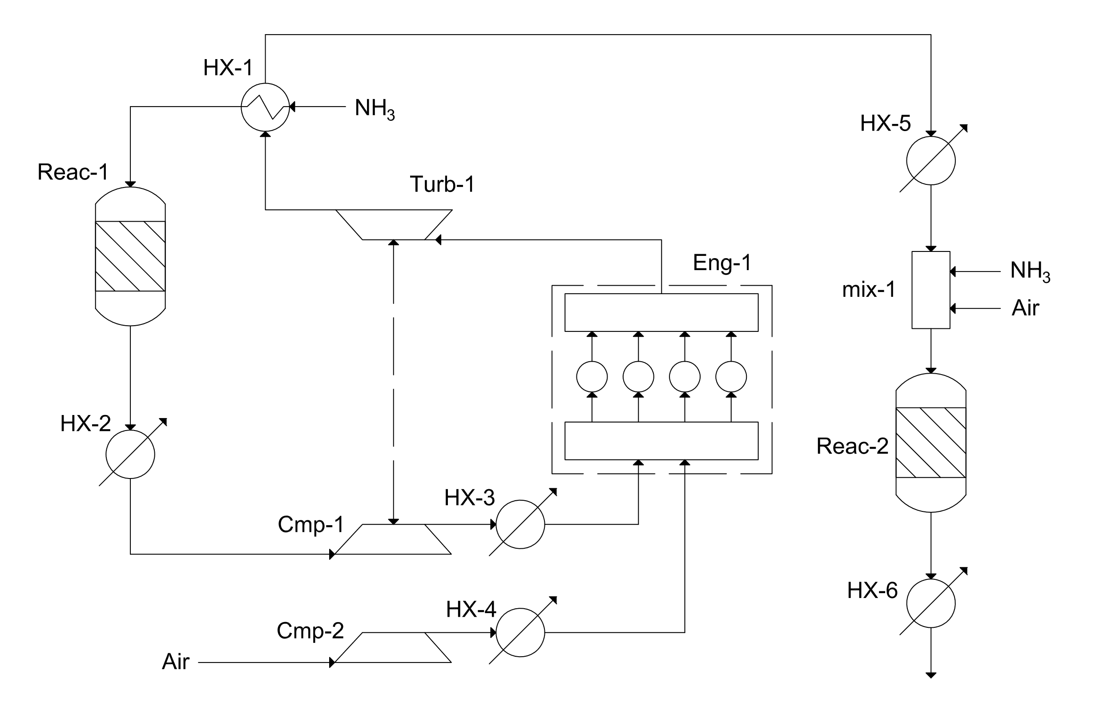
Figure 2: Detailed process diagram of the ammonia fuelled ship including the three main sections: ammonia decomposition, internal combustion engine, and selective catalytic reduction.
4.1. Ammonia decomposition section
The first step in a ship fuelled by ammonia is its decomposition to produce the required mixture of ammonia and hydrogen due to the combustion requirements. The decomposition reactor is based on the following reaction:
$2NH_{3}⇋N_{2}+3H_{2}$ (1)
The decomposition is performed in a fixed bed adiabatic reactor using Ni/Al₂O₃ as catalyst due to the excellent performance in the decomposition reaction and the economic advantages with respect to the ruthenium catalyst (Chiuta et al., 2013). The kinetic expression of ammonia decomposition is as follows (Kim et al, 2018):
$r=3k_{reac}\left[K_{p}^{2}a_{N_{2}}{\left(\frac{a_{H_{2}}^{3}}{a_{NH_{3}}^{2}}\right)}^{α}-{\left(\frac{a_{NH_{3}}^{2}}{a_{H_{2}}^{3}}\right)}^{1-α}\right]ΦΩ$ (2)
In this kinetic expression, $k_{reac}$ is the kinetic constant of the reaction, $K_{p}$ is the equilibrium constant, $a_{i}$ is the activity of the different components, $α$ is a kinetic parameter, $Φ$ is the effectiveness factor and $Ω$ is the catalytic activity.
The reactor is modelled based on a set of differential equations including the mass balances of each component, the energy balance, and the momentum balance to be able to describe the entire performance of the system. The full model of this unit is included in the Supplementary Information. The three main input variables of the detailed model are temperature, pressure, and inlet gas velocity. Based on the dimensions and performance of this reactor, the value of these three variables is determined for each of the scenarios analysed in this work (engine load values of 25%, 50%, 75%, and 100%).
4.2. Ammonia internal combustion engine
Currently, only limited data about marine engines using ammonia as fuel is available. Different research articles have investigated the combustion of ammonia or its use in different combustion devices (Chiong et al., 2021) but a complete analysis of an ammonia maritime engine is not assessed in the literature. For instance, the material selection for these engines is still under development, and further investigation is required to meet the ammonia combustion requirements. From an industrial perspective, MAN adapts the existing engines running on liquid petroleum gas (LPG) or methanol to be used with ammonia as fuel but, due to industrial information restrictions, limited public data is available for this alternative (MAN, 2019). Therefore, to model this unit, a combination of data from the existing maritime engines using different fuels and a process engineering approach are employed in this work.
Two different application technologies have been proposed to use ammonia in engines: spark ignition (SI) and compression ignition (CI). However, due to the large ignition energy required in marine engines, the preferred option in most projects is compression ignition engines, limiting the adoption of spark ignition technology (Liu et al., 2022a). Particularly, a two-stroke compression ignition ICE is employed in this work. In addition, the use of pure ammonia as fuel is limited, as mentioned before, due to its flammability characteristics (Wang et al., 2021). In this work, to avoid carbon components (and, therefore, no carbon dioxide emissions), hydrogen is selected as co-fuel. And, specifically, this hydrogen is produced using ammonia to load only one liquid fuel onboard that is easier to store and transport than hydrogen. Particularly, an ammonia/hydrogen ratio of 70/30 is fixed in this work because a large number of authors have supported this ratio (Mashruk et al., 2022; Wang et al., 2021; Kim et al., 2020). The combustion process could be performed using different amounts of oxygen and, therefore, different equivalence ratios (ER) defined as the relationship between the oxygen that is introduced in the combustion and the stoichiometric one. In this case, to control the temperature of the combustion process inside the cylinder, an ER equal to 0.85 is selected.
Two reactions are involved in the combustion of the ammonia/hydrogen blend:
$H_{2}+\frac{1}{2}O_{2}→H_{2}O$ (3)
$4NH_{3}+3O_{2}→2N_{2}+6H_{2}O$ (4)
In addition, one main pollutant is produced in the ammonia combustion reaction: nitrogen oxide. At this point, it is essential to estimate the emissions of this pollutant in the combustion chamber to select the proper abatement technology and to verify whether the limits established by the legislation are complied with. A NO_{x} concentration in the exhaust gases of 2000 ppm is set according to the previous works for an ammonia/hydrogen CI engine using a NH₃/H₂ ratio of 70/30 (Liu et al., 2022c). It is assumed that only nitric oxide (NO) leaves the combustion chamber since nitric oxide is the main nitrogen pollutant in the exhaust gases from ammonia combustion (Okafor et al., 2020).
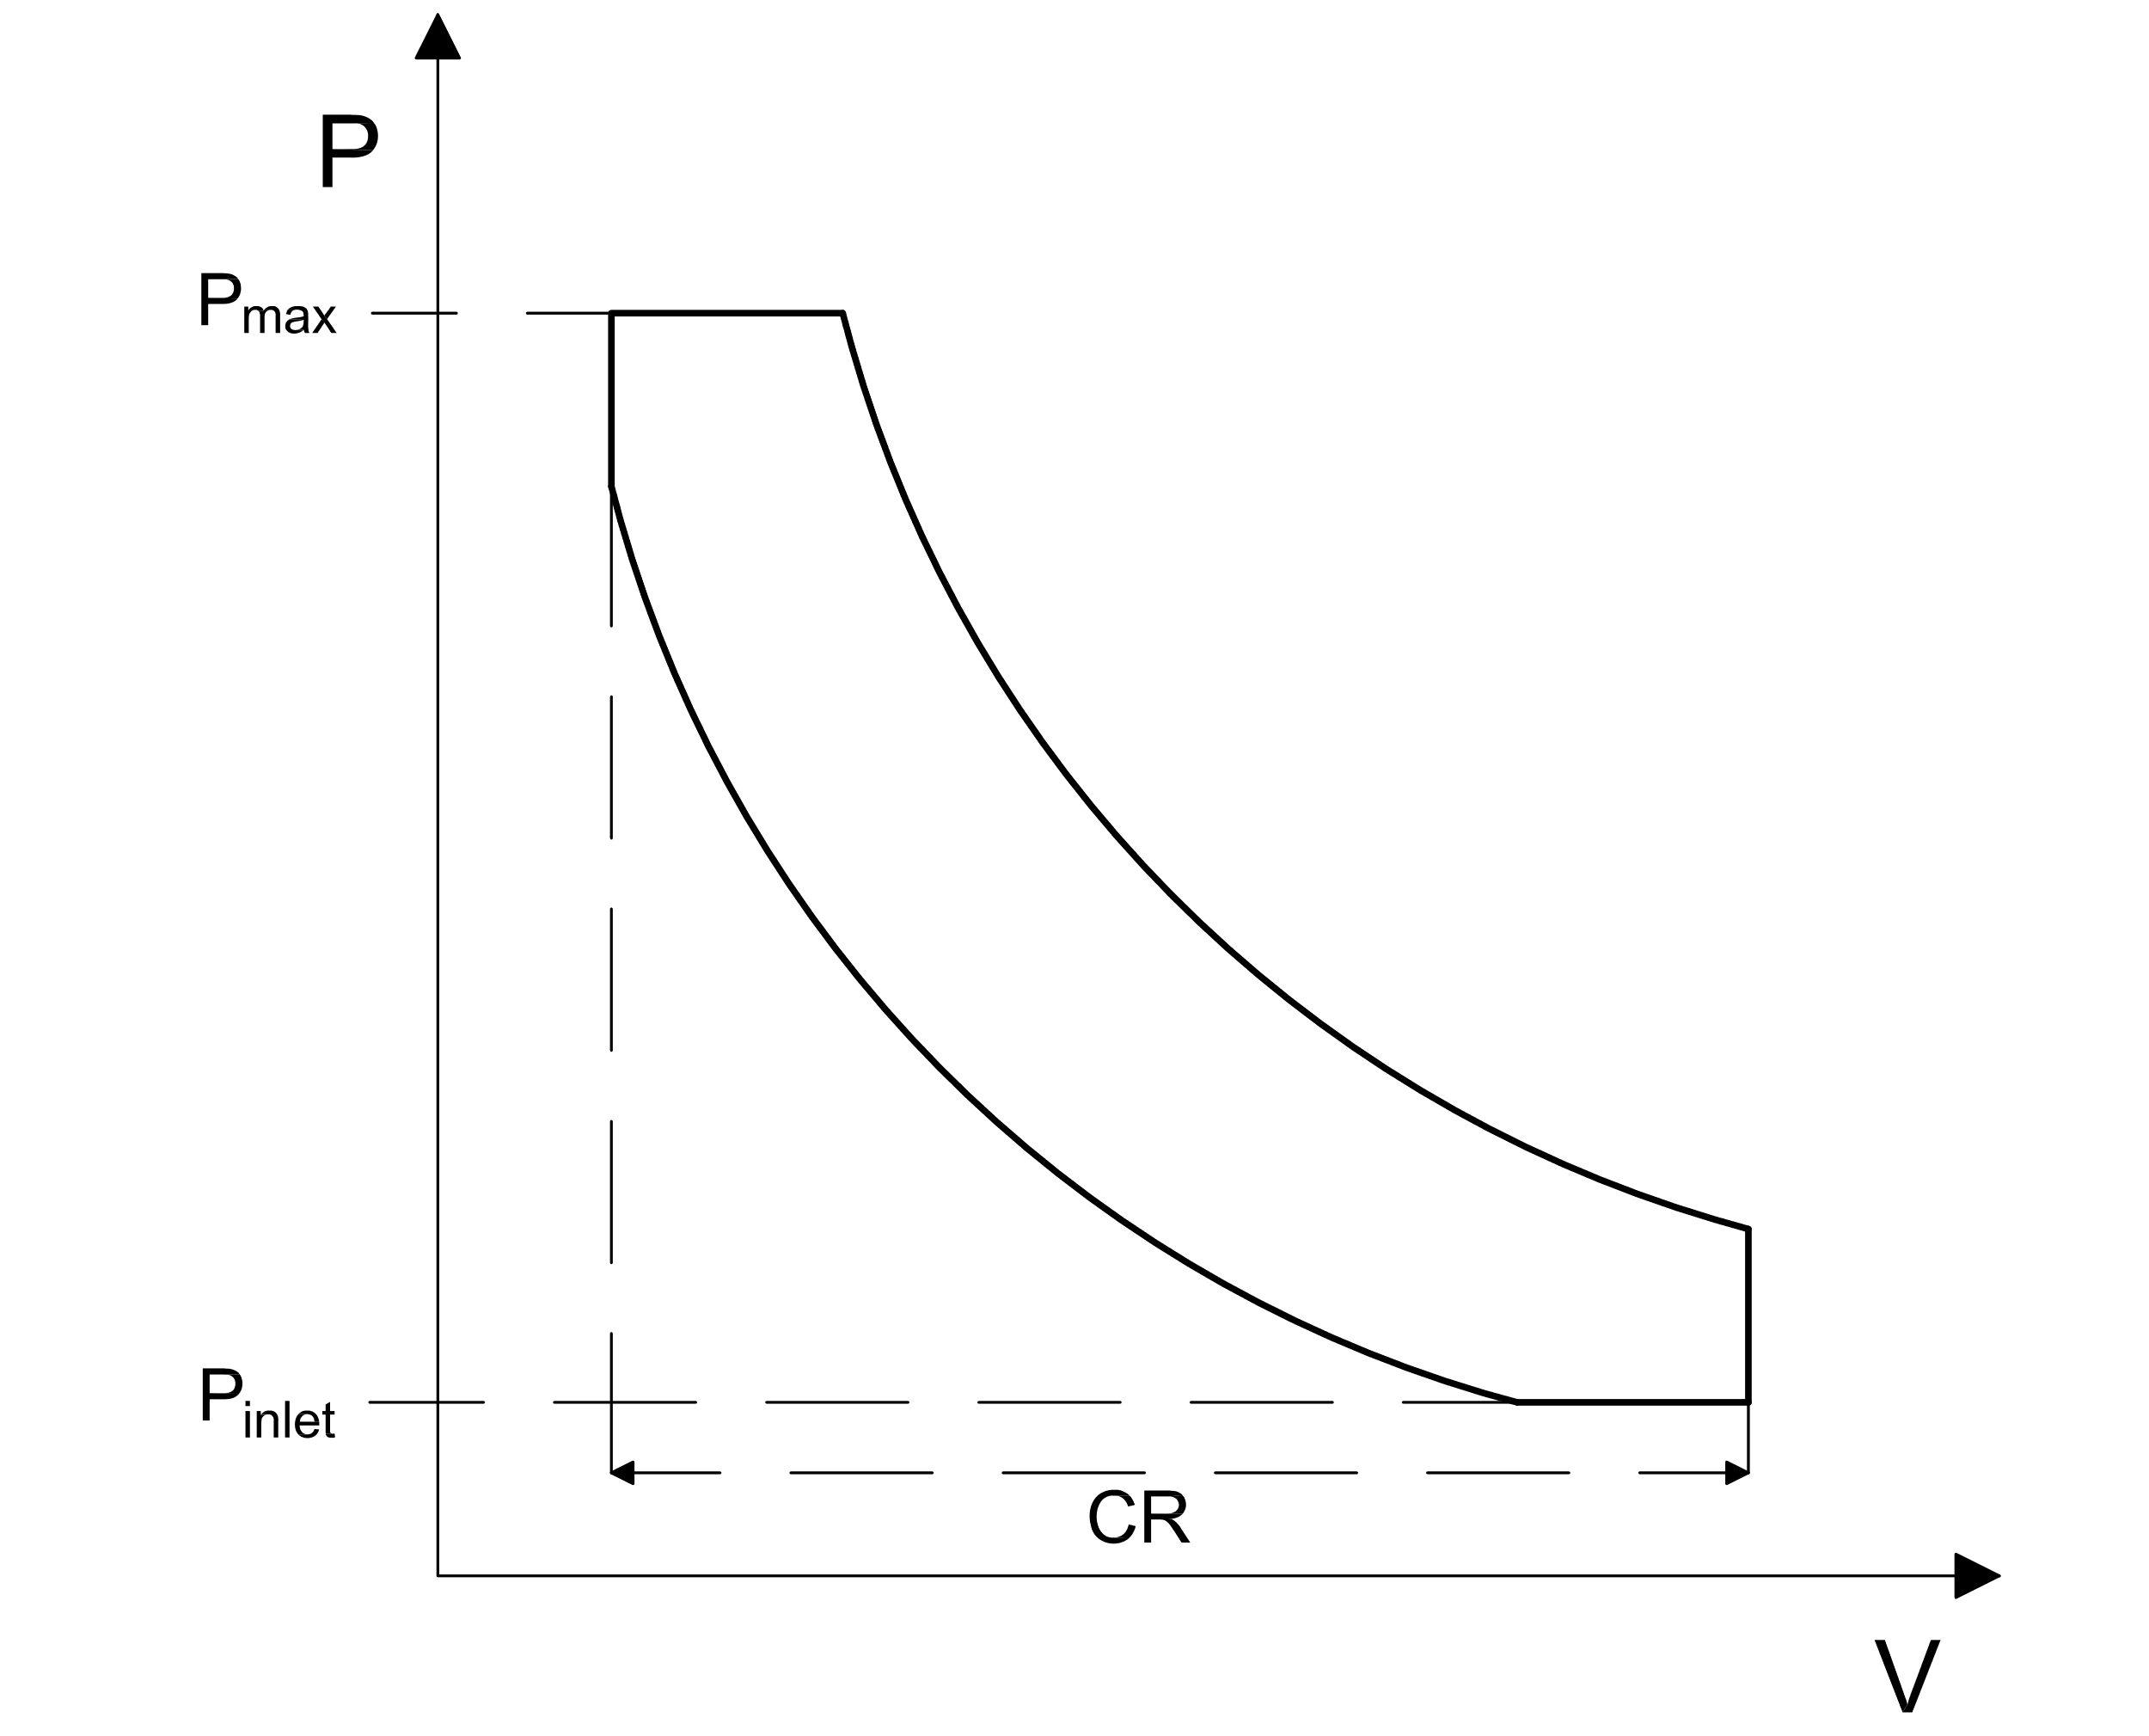
Figure 3: P-V diagram of ideal Miller-Sabathe cycle
The thermodynamics of the system is based on an ideal Miller-Sabathe cycle that is proposed for low-carbon and zero-carbon fuels in marine engines (Liu et al., 2022b). This cycle is based on the following steps: adiabatic compression, constant volume heat addition, constant pressure heat addition, adiabatic expansion, and heat removal. A schematic representation of the cycle performance is presented in Figure 3 including the main design parameters.
To capture the real behaviour of a marine engine, some pressure values in the cycle have been set according to the experimental data from an actual device. In particular, the inlet pressure into the cylinder (after the compression in the turbocharger) and the maximum pressure in the cylinder are fixed. In this work, these pressure values have been taken from Lu et al. (2022) and are collected in Table 2 for the different load values analysed in this work. To reach the inlet pressure required in the engine, a compressor (modelled as polytrophic) is introduced (as a part of the turbocharger). The power required for this unit is produced by expanding the gases that leave the cylinders in a turbine (assuming also a polytrophic expansion). In addition, the compression ratio (CR) is set to 14 for this ammonia-based engine (Wang et al., 2021). This value has been set as an average of the proposed CR in the literature for ammonia/hydrogen compression engines from 12 (Liu et al., 2022a) to 20 (Liu et al., 2022b).
The thermal efficiency of the process can be calculated using the different heat loads and temperatures of the cycle (as presented in the Supplementary Information). However, in this work, the value of the thermal efficiency is set to 50%, the typical value expected for a two-stroke marine engine fuelled by ammonia (Korberg et al., 2021), lower than those calculated using thermodynamics, to consider the real operation of the engine including heat losses or irreversibilities that have been neglected in the thermodynamic calculations.
Table 2: Pressure values fixed in the engine performance based on the results presented by Lu et al. (2022).
 | 100% | 75% | 50% | 25%
Inlet pressure into the cylinder (bar) | 4.0 | 3.2 | 2.2 | 1.3
Maximum pressure (bar) | 180 | 165 | 145 | 110
Compression ratio (CR) | 14 | 14 | 14 | 14

4.3. Selective catalytic reduction (SCR) reactor
The last stage is the selective catalytic reduction (SCR) section. The purpose of this part is to reduce the amount of nitric oxide to release the combustion gases into the atmosphere in a safe and environmentally responsible manner. To abate the nitric oxide concentration, its transformation into nitrogen and water using a catalytic system is used according to the next reaction (Napolitano et al., 2022):
$4NO+4{NH}_{3}+O_{2}→4N_{2}+6H_{2}O$ (5)
A fixed-bed monolithic reactor is used for this reduction reaction (Nakamura et al., 2021). A commercial Cu-zeolite catalyst is selected in this case due to its high-temperature durability and good performance for a wide range of NO_{x} concentrations (Nova et al., 2011; Pant & Schmieg, 2011). The inlet range of temperatures is set between 545K and 750K, the amount of air that is introduced (to supply the oxygen required for the reaction) is based on an air/ammonia ratio of 20, and the amount of ammonia fed to the system is the stoichiometric one (Guerras & Martín, 2019). The reactor operates adiabatically, and the removal efficiency of the reactor is computed as a function of the inlet temperature according to the following expression proposed by Guerras & Martín (2019):
$η=6.6537∙{10}^{-6}T^{3}-1.523{10}^{-2}T^{2}+11.43T-2731.8$ (6)
Where η is the removal efficiency (in %) and T is the inlet temperature (in K). To determine the reactor dimensions, a mechanistic model is used based on the assumption that mass transfer is the limiting step in the reaction system (Rodenhausen, 1999). More details about this model can be found in the Supplementary Information.
4.4. Economic evaluation of the system
With the modelling approach proposed in the previous sections, it is possible to evaluate the economic performance of the ammonia fuelled ship. In this assessment, the capital (CAPEX) and operating (OPEX) costs are estimated using approximate correlations. For the CAPEX, the three main units are the decomposition reactor, the ammonia internal combustion engine, and the SCR reactor. The capital cost of the decomposition reactor is computed using two contributions: the steel vessel and the catalyst, both calculated using the detailed model proposed in Section 4.1. The price of the catalyst (Ni/Al₂O₃) is set at 30 €/kg (Jess & Wasserscheid, 2019). The cost of the engine is calculated based on the cost proposed by Kim et al. (2020) for an ammonia-based engine and is equal to 500 $/kW. The detailed design of the engine is out of the scope of this study. Finally, the capital cost of the SCR reactor is calculated following a similar methodology to the one mentioned in the decomposition reactor. The mechanistic model determines the dimensions of the SCR reactor and then, the two contributions (vessel and catalyst) are included. For this reactor, the cost of the catalyst is set to 4000 $/m³ (Sorrels et al., 2016). For the OPEX, three main items have been considered: the cost of raw materials, the amortization of the capital cost, and the maintenance of the units. The cost of ammonia is set, as a baseline, at 0.5 €/kg; however, this value is largely influenced by the ammonia production technology (Cesaro et al., 2021). To address this point, a sensitivity analysis is performed, although the base case scenario is presented with the mentioned cost. The coefficient for the amortization of the capital cost is fixed at 0.1 of the total investment per year. In the end, the maintenance cost of the system is set to 2% of the total CAPEX per year (Kim et al., 2020). To determine the optimal conditions of the ammonia fuelled ship system (but subject to the restrictions set out above), an optimization approach is followed. A nonlinear programming (NLP) problem is formulated and implemented in GAMS collecting all the models proposed in the previous sections. As objective function, the OPEX of the ship is selected aiming at minimizing the operating cost of the ship’s propulsion system.
5. Results and discussion
5.1 Main Operating Variables
In this section, a brief discussion of the main operating variables of the system is presented. The baseline case has been set to 11 MW of energy produced in the engine and, four different engine load values have been analysed: 100%, 75%, 50%, and 25% of the baseline capacity (as presented in Table 2). The goal is to assess the behaviour of the ship in the different situations where it will be involved and how this affects the main operating conditions of the ammonia combustion system. The first step is the ammonia decomposition section where the necessary hydrogen is produced to prepare the fuel for the engine. The operating conditions of this reactor are highly influenced by the engine load as it is presented in Figure 4. The decomposition reactor is designed for the most stressed scenario, namely, for the maximum load. Therefore, the design variables are fixed (the real reactor dimensions) for all the engine load values and the operating conditions must be changed to be able to produce the required blend of hydrogen and ammonia. Particularly, the inlet temperature of the reactor (controlled in the heat exchanger HX-1) is the main variable that it is possible to modify to be able to produce the desired mixture (70% NH₃-30% H₂). As the decomposition is an endothermic reaction, for a given reactor unit, when the load is reduced the temperature must be decreased to avoid the over-conversion of the reaction. As the temperature decreases, the kinetic rate is reduced, and the final mixture can meet the given requirement (70% NH₃ – 30% H₂). For the current propulsion system that produces 11 MW, a reactor length of 5.4 m and a cross-sectional area of 2.6 m² are required. As shown in Figure 4, the maximum inlet temperature is 750K when the load is equal to 100%. This is one of the most critical points of the system due to the high endothermicity of the ammonia decomposition reaction. For the design of an autonomous process, as intended in this work, the energy to heat up the feed of ammonia is to be provided from the outlet gases of the combustion allowing also for the heat integration of the system. However, the maximum temperature of the combustion gases is limited by the performance of the engine and the turbocharger system. Thus, the maximum temperature of these gases is around 790K, setting for the proposed system 750K as a reasonable value for the maximum temperature in the inlet feed to the decomposition reactor. If the maximum temperature of the combustion gases could be increased, the decomposition reactor size could be reduced minimizing the capital cost of the system. When the load is decreased, it is possible to reduce the inlet temperature since the reactor is oversized for the analysed flow rate. Another important operating variable affected by the change in the engine load is the inlet gas velocity. Since the area of the reactor is fixed, the inlet gas velocity decreases with decreasing load, affecting the phenomena of mass transfer inside the reactor (as shown in Figure 4).
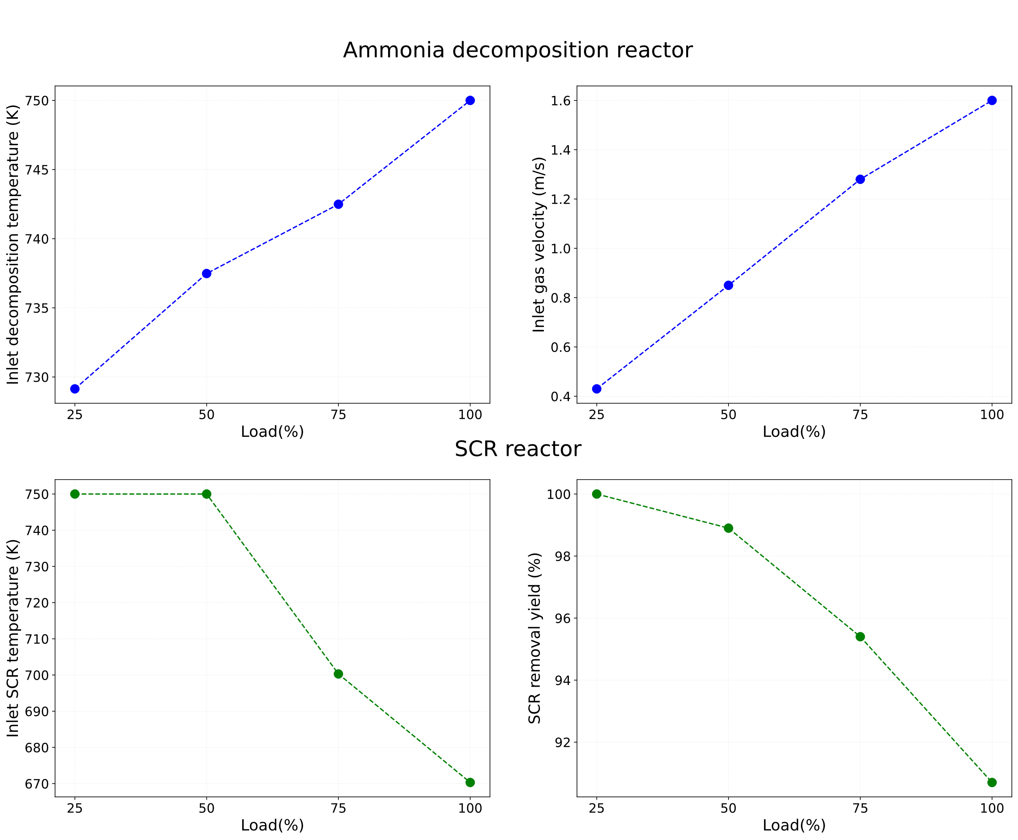
Figure 4: Main operating conditions in ammonia decomposition and selective catalytic removal reactors (a – inlet decomposition temperature; b -inlet gas velocity in the decomposition reactor; c- inlet SCR temperature; d- SCR removal yield)
The performance of the ammonia engine is determined by the parameters presented in Table 2 and some of the most important results are presented in Table 3. The maximum temperature in the combustion zone is around 2500 K (as presented in Table 3) controlling it through the equivalence ratio (varying the excess of air introduced in the unit). The required amounts of ammonia and air for the engine operation are presented in Table 3 ranging the inlet ammonia from 0.25 kg/s to 1.25 kg/s for the different load ratios. The thermal efficiency of the engine could be calculated from a thermodynamic theoretical calculation using the inlet and outlet heats of the cycle (as presented in the Supporting Information). With this approach, the thermal efficiency reaches values in the range of 60%-70%. However, to be more realistic and consider irreversibilities and losses (that can be not included in the thermodynamic model), the value of thermal efficiency has been set to 50% (the typical value expected for a two-stroke marine engine fuelled by ammonia). The gases from the engine are introduced into the gas turbine (included inside the turbocharger) to produce the necessary power to run the compressor of the engine inlet gases. Table 3 collects the energy involved in the turbocharger operation. At this point, a trade-off arises between the power that can be produced in this turbine and the outlet temperature of the gases from this unit. If the power production is maximized, the temperature of the outlet gases of the turbine limits the thermal energy available to heat up the inlet gases to the ammonia decomposition reactor. However, if the temperature of the outlet gases is maximized (to reduce the capital cost of the reactor), the power produced is minimized and may not produce enough power to supply the compressor. Therefore, the minimum power required to run the compressor is obtained in the optimization procedure presented in Section 4.4 allowing the maximum feasible temperature for heating the inlet ammonia since this is one of the main critical points of the system.
Table 3: Results for the proposed propulsion system under different load ratios
 | 25% | 50% | 75% | 100%
Inlet NH₃ (kg/s) | 0.29 | 0.58 | 0.87 | 1.16
Inlet air (kg/s) | 2.07 | 4.13 | 6.20 | 8.26
Turbocharger power (kW) | 62.7 | 407.2 | 952.9 | 1566.5
Maximum engine temperature (K) | 2504.8 | 2477.1 | 2463.9 | 2463.9
Energy to propulsion (MW) | 2.8 | 5.5 | 8.3 | 11.0
Exhaust gases temperature after cooling (K) | 758.9 | 758.9 | 708.4 | 677.8

In the combustion of ammonia, a non-negligible amount of nitrogen oxides is produced. To reduce the concentration of this pollutant, a selective catalytic reduction (SCR) unit is installed. The performance of the SCR reactor is also highly influenced by the engine load as it is presented in Figure 4. Analogous to the decomposition reactor, the SCR unit is designed for the wort case scenario that is 100% of the load. Then, the operation for different loads is explored based on the design for the full capacity. For the proposed system, the dimensions of the SCR reactor are 3.9 m in length and 0.5 m² in cross-sectional area. When the load is reduced, the temperature of the inlet gases to the SCR can be increased due to the lower heat requirements of the heat exchanger before the ammonia decomposition reactor. This temperature increase benefits the performance of the SCR reactor, that together with a lower flowrate of gases to be treated in a unit designed for the maximum load improve the removal yield. Therefore, the removal yield can be increased from around 90%, when the full capacity is analysed, to almost 100% for a load of 25%. This improvement in the NO_{x} abatement is reflected in the exhaust gases concentration as is presented in Figure 5.
After the combustion, the concentration of NO_{x} in the combustion gases is in the range of 1000-1500 mg/Nm³ in all the cases. This concentration corresponds to values of emissions per energy produced in the range of 3.5-4 g/kWh (as shown in Figure 5). These values are around double the target NO_{x} emissions proposed by the International Maritime Organization in TIER III (Schneiter, 2015; Wik & Niemi, 2016). It sets the goal of reducing emissions to below 2 g/kWh for the engines subject to the highest requirements. For a further improvement related to NO_{x} and aiming to achieve the most demanding emission targets, the SCR unit is included allowing for a reduction in the emissions in the range of 90%-100%. This translates into emission values per energy consumed of less than 0.5 g/kWh. Therefore, when the SCR unit is included in the propulsion system, the introduction of ammonia as fuel in shipping is highly beneficial in terms of CO₂ emissions since ammonia is a carbon-free fuel but also in terms of NO_{x} releases meeting the current most demanding requirements.
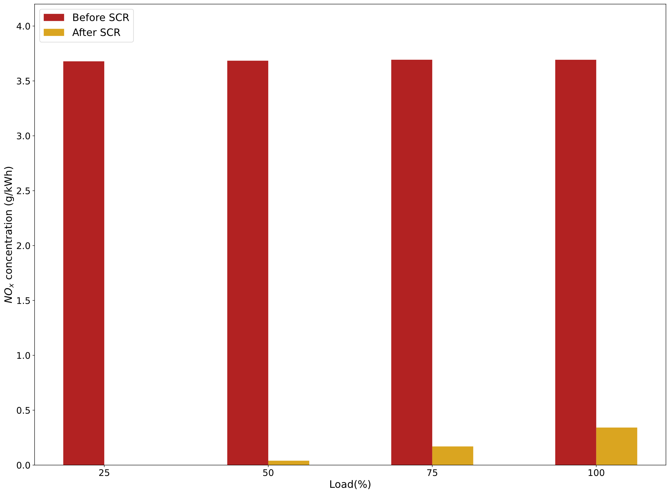
Figure 5: NO_{x} concentration after and before the SCR unit
The proposed results are based on the stationary state for each of the analysed loads. However, the cold start of the system could introduce some difficulties in the operation of the propulsion system. When the engine is stopped, and the feed system is started, there is not enough energy to perform the decomposition process. The energy for this ammonia decomposition is provided by the exhaust stream from the engine, and no gases are available during the cold start. Different solutions can be explored to mitigate this problem. The most promising alternative, at first sight, could be the use of a small hydrogen tank to provide the necessary hydrogen for the initial start of the engine or in the stressed transition for the ammonia decomposition reactor. Then, the produced exhaust gases can be introduced to start hydrogen production in situ by decomposing the stored ammonia. Another alternative is to store a fraction of the mixture of ammonia/hydrogen/nitrogen that is produced during the operation of the engine. This fraction could be produced during the less stressed situation for the decomposition section using it during the cold start process. This option could be more challenging for its actual deployment in the ship. The solution should be adapted to the particular use of the propulsion system allowing for the effective deployment of the ammonia/hydrogen propulsion system in real applications.
5.2 Energy analysis
In this section, an energy analysis of the system proposed to transform ammonia into energy for shipping is performed. The different energy flows are present in Figure 6 using a Sankey diagram for the full capacity case (100%). For other engine load values, similar results can be obtained.
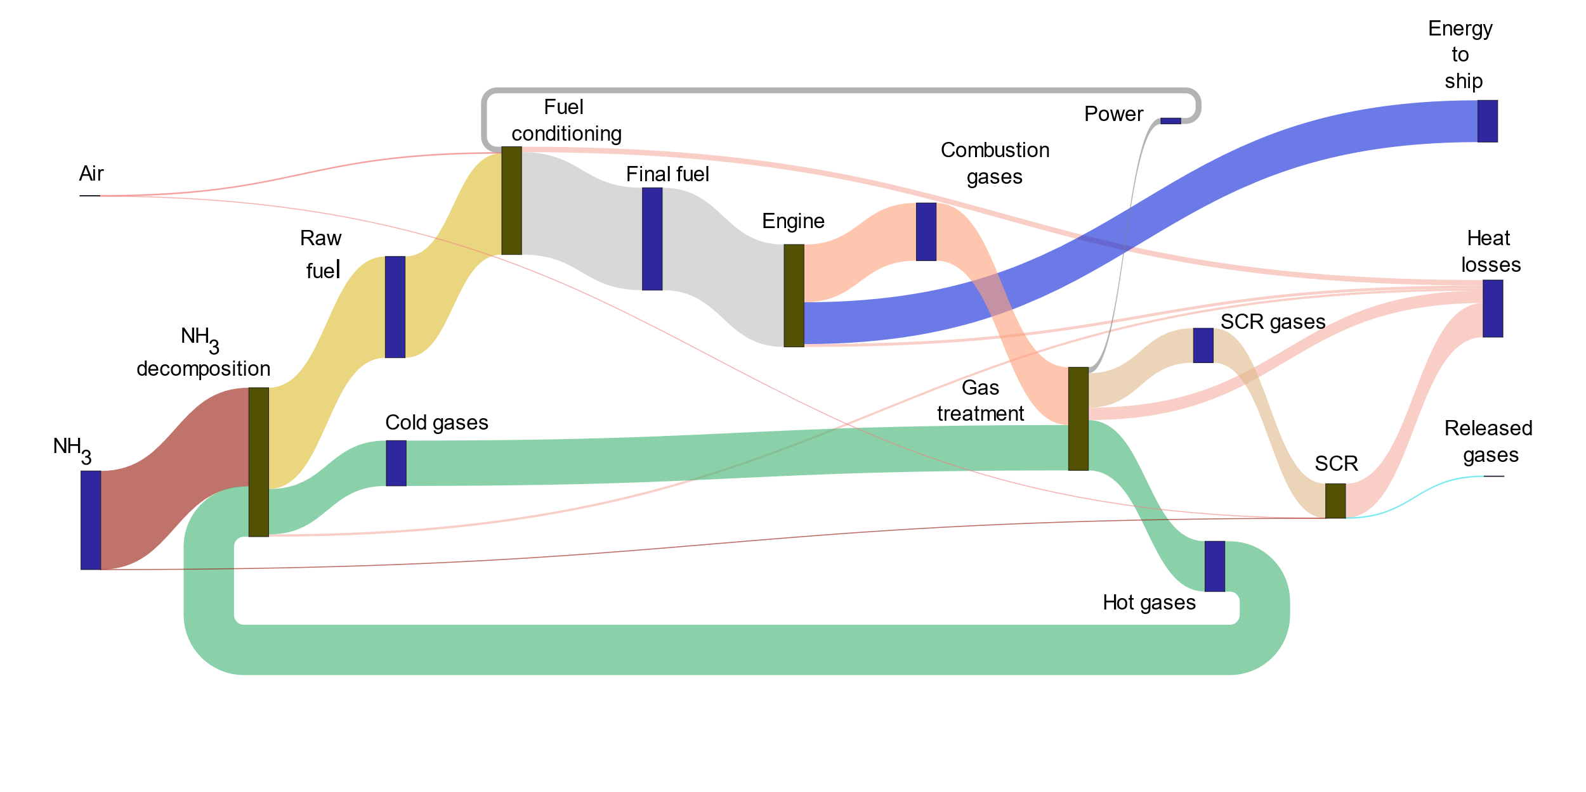
Figure 6: Sankey diagram with the main energy input of the propulsion system. The blue boxes represent the main products of the process and the green ones the total energy involved in the main sections of the system.
There are two raw materials for the process: ammonia and air, and ammonia is clearly the main energy input of the facility. In the first stage, the inlet ammonia is introduced into the decomposition section to produce the blend of ammonia/hydrogen. The gases from the combustion are recycled to use their thermal energy to heat up the feed of ammonia up to the inlet decomposition temperature. However, as it is shown in Figure 6, only a small fraction of the energy of the gases is used and the outlet gases still contain around 90% of the inlet energy. The main limitation in the heat transfer is the temperature gradient since the gases have enough energy but the gradient makes energy transfer impossible. If this energy integration could be improved, the inlet temperature of the decomposition reactor could rise improving the operation of this unit. The raw fuel prepared in the decomposition has an energy content similar to the initial ammonia (only an increase of around 3% is observed). This raw fuel, after some adjustments in pressure and temperature, is fed to the engine. For the adjustment in terms of pressure, a turbocharger is used. Therefore, the power generated by the exhaust gases of the engine is reused for the decomposition section. This power represents a minor contribution versus, for example, the energy content of the fuel blend. Air is also introduced in the engine at this step with a small energy share. As mentioned in the process description, 50% of the inlet energy of the fuel is transformed into mechanical energy to be used in the propulsion of this ship. The rest of the energy is mainly in the exhaust combustion gases. These gases produced power in a gas turbine as a part of the turbocharger and then, reduce their temperature in a first step to provide energy to the decomposition section and, in a second one, to adjust the temperature for the SCR reactor. This final adjustment is only required when the load is 25% or 50% since the operation at higher capacities required more energy in the decomposition section making this final temperature reduction unnecessary. Therefore, the worst-case scenario for the design of this unit is not the full capacity, but 25% of the load (with the associated design considerations). After gas pre-treatment, the final section is the SCR in which the NO_{x} concentration is highly reduced. In this stage, a small amount of energy is also added to the inlet ammonia and air required for the NO_{x} reduction reaction. Finally, the gases are cooled down to release them where a significant amount of energy is lost. To improve the energy efficiency of the entire ship, this energy could be integrated into other auxiliary processes. To summarize, there are two energy inputs in the system, air and, mainly, ammonia, and, three energy outlets, the mechanical energy for propulsion (around 50% of the inlet energy), heat losses (another 50%), and a small amount of energy with the released gases. Thus, the energy efficiency of the propulsion system (based on the generated energy and the energy of the inlet fuel) is equal to 42.4%.
Table 4: Exergy efficiencies for the different sections of the ammonia system
Section | Exergy efficiency (%)
NH₃ decomposition | 97.2
Fuel conditioning | 97.3
Engine | 35.5
Gas treatment | 87.7
SCR | 53.2

In addition, an exergy analysis is presented for the proposed ammonia propulsion system. The details about the calculation of exergy can be found in the Supplementary Information. In Table 4, the exergy efficiency (calculated as the total exergy leaving the section versus the total exergy entering it) is presented. The main exergy destruction of the entire system is found in the engine at the combustion of the fuel. The chemical reaction and the heat losses in this unit are primarily responsible for exergy losses. Other authors have analysed different combustion processes to produce energy also highlighting the combustion chamber as the unit with higher exergy destruction (Ameri et al., 2008). Caton (2012) mentioned the equivalence ratio, exhaust gas recirculation, and inlet oxygen concentration as the three main factors affecting the engine in terms of exergy losses. Another unit with high exergy destruction is the SCR, with an exergy efficiency of around 50%. In this section, a chemical reaction is also involved, and, in addition, the flue gases are cooled to be released at ambient temperature. These conditions are translated into low exergy efficiency. Finally, the remaining three sections, NH₃ decomposition, fuel conditioning, and gas treatment have higher exergy efficiencies of around 90%. With these data, the global exergy efficiency (computed as the total exergy leaving the system versus the total exergy entering the system) is 61.5% and, if only the energy produced in the system (and devoted to the ship propulsion) is considered as output, the exergy efficiency of the overall process is reduced down to 48.1%.
5.3 Economic Assessment
In this section, the economic performance of a ship propulsion system based on ammonia as fuel is analysed. First, the total investment required to install the propulsion system based on ammonia is estimated. The total capital cost (CAPEX) required is about 8.66 M€ for a system with a maximum energy production of 11 MW. The total investment is distributed according to the breakdown presented in Figure 7. The major contributor to the total cost is the engine with around 65% of the entire investment. This unit is the core of the propulsion system with the higher technical complexity and, as expected, represents the largest cost. The cost of the engine is estimated based on preliminary results from the literature for an ammonia-based engine, however, a moderate uncertainty is expected in this value because marine ammonia internal combustion engines are currently under development and no commercial units are currently available. In addition, future improvements may result in reducing the capital cost of the unit. This reduction would have a significant impact on the total capital cost of the ammonia system. The cost of the decomposition reactor is also an important item of the investment with around 5% and represents a higher share versus the other reactor in the system, the SCR one. This last unit only accounts for around 0.2% of the total capital cost. The smaller size of the unit and the different catalyst type (and its associated cost) determines the different capital cost of the two reaction units. The reduced cost of the SCR unit compared to the other sections involved will favour its implementation within maritime systems to improve the level of NO_{x} emissions. In the proposed system, if the SCR is not included, the level of NO_{x} is above the limit proposed by the International Maritime Organization. However, with a small increase in the investment for the capital cost, a significant improvement in terms of NO_{x} emissions can be obtained. Furthermore, heat exchangers and compressors used across the process also represent an important fraction of the total capital cost with around 30% of the total share. A comparison with respect to other propulsion systems based on different fuels can be made to put into perspective the proposed propulsion system with a specific investment of 784 €/kW. Horvath et al. (2018) assessed four different fuels for the decarbonization of the shipping sector: marine gas oil, liquefied natural gas, methanol, and hydrogen. Using an internal combustion engine, the capital cost is estimated around 530 €/kW for marine gas oil, 780 €/kW for liquefied natural gas, 550 €/kW for methanol, and 780 €/kW for hydrogen. In the case of methanol, this fuel is fed as such without a co-fuel to overcome the combustion problems as has been proposed in some studies (Gong et al., 2020). The use of a co-fuel (as proposed in this work) can increase the capital cost of the system but it is necessary for the proper operation of the engine. Wang & Wright (2021) also evaluated the capital cost using simplified calculations for different marine fuels. For an internal combustion engine, when biodiesel is used as fuel a capital cost of 460 US$/kW is presented, 505 US$/kW for methanol, or 850 US$/kW for hydrogen. Some studies have provided an investment cost for ammonia systems based on rough approximations; therefore, limited accuracy is expected for these data. Ejder & Arslanoğlu (2022) calculated a capital cost for an ammonia ship of 630 US$/kW or Wang & Wright (2021) around 600 US$/kW. However, these analyses are mainly focused on the engine performance leaving behind the design and operation of other essential parts of the system. Thus, if the detailed design of the entire system including the ammonia decomposition reactor, the engine with turbocharger, and the SCR unit is included a slight increase in the capital cost is expected to the values obtained in this work. Therefore, the results obtained are in line with the previous results from the literature showing a promising scenario for the deployment of ammonia as a green fuel in the shipping sector.
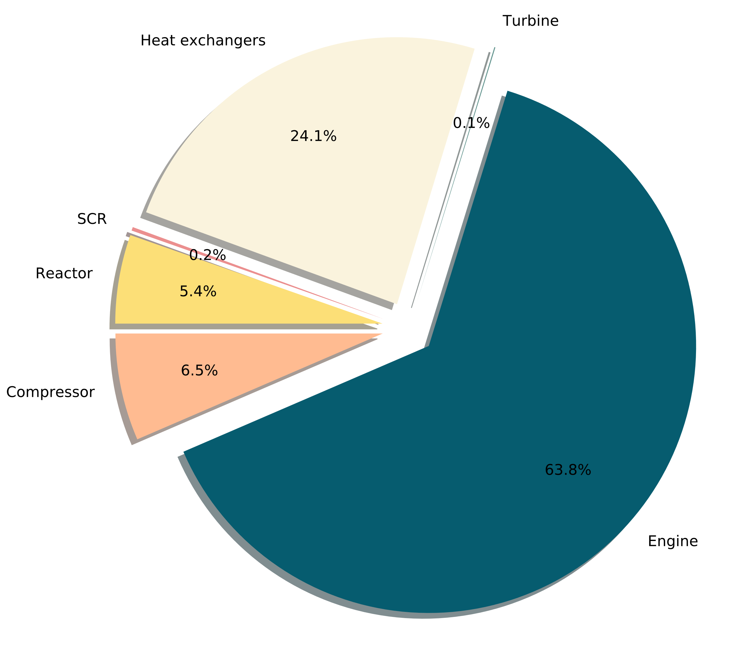
Figure 7: Breakdown of the investment cost for the ammonia propulsion system
The operating cost (OPEX) of the ammonia system is also analysed in this work. This cost is based on three main items: the cost of the fuel (ammonia for this system), the amortization cost (directly related to the total capital cost of the system), and the maintenance cost (calculated as a fraction of the investment). The operating cost of the ammonia propulsion system is equal to 210 €/MWh for the full load, 214 €/MWh for 75%, 221 €/MWh for 50%, and, finally, 243 €/MWh for 25%. The distribution of the operating cost of each of the analysed loads is shown in Figure 8. The cost of the fuel is clearly the major contributor to the total operating cost of the system with around 80% of the total cost at 25% of the load but with more than 90% if the full capacity is evaluated. The cost associated with the amortization and maintenance is constant for the different loads since the system is built for the maximum capacity (11 MW). Therefore, as the cost of ammonia is reduced as the load decreases, the percentage associated with other costs increases. Consequently, the cost of ammonia is a crucial factor in the profitability of the ammonia ship propulsion.
These values of operating cost can be compared with other fuels analysed in the literature. Cheliotis et al. (2021) estimated the cost of using current diesel engines around 120 €/MWh with a stable cost over time. Zincir et al. (2019) analysed the performance of two different marine fuels: low sulphur marine gas oil (LSMGO) and methanol. The operating cost of LSMGO is in the range of 150-190 US$/MWh and, in the case of methanol, around 140-180 US$/MWh. In that study, the results are obtained by analysing only the engine unit with no regard for pre-treatment or combustion gas-related operations. Therefore, these values can increase if the entire system is considered. Korberg et al. (2021) evaluated different alternative marine fuels using a simplified performance-based procedure without going into the operation of the system. For marine gas oil (MGO), the established non-renewable technology, the reduced cost is obtained at about 58 €/MWh. Different renewable fuels produced from biomass have been evaluated such as DME, methanol, or biodiesel with a range of cost between 137 €/MWh and 188 €/MWh. Alternatively, different e-fuels have been also assessed yielding a range of cost of 233-312 €/MWh (Korberg et al., 2021). Therefore, the current production costs of electrochemical fuels are higher than biofuels leading to higher propulsion costs. An alternative to using ammonia or other fuels in marine systems is the introduction of fuel cells to produce the electricity required. This is a novel approach and, therefore, more limited technical and economic data are available. For example, Korberg et al. (2021) estimated the operating cost of a fuel cell system using e-methanol and e-ammonia resulting in a cost of 248 €/MWh and 255 €/MWh respectively. In all cases, the use of fuel cell technology increases the operating cost of the propulsion systems, therefore, further research is required to improve the efficiency of these devices to be able to deploy them at an industrial scale. In sum, in the light of the presented results, the costs of using ammonia as fuel are higher than the current non-sustainable fuels such as marine gas oil. This is a logical situation due to the disruption between a scenario dominated by carbon sources and the new sustainability paradigm. However, the results obtained are similar to other studies reported by different authors. Therefore, it is emerging a promising scenario for the implementation of ammonia as fuel, and the expected improvement in this technology (in terms of yield conversion and capital cost) will allow for a reduction in the operating cost making it possible to bridge the gap between new technologies and established ones. Additional restrictions to the emission of CO₂ in the shipping transport will favour the implementation of this ammonia-based systems. As Figure 8 shows, the cost of fuel has a paramount impact on the operating cost and, its influence will be addressed in the next section. But the calculated costs are in line with the estimations presented in the literature. However, the main differences between the results presented in this study and the results from the literature are the base data to develop the economic assessment and the extension of the process analysis. Previous works use a very simplified process design approach focusing essentially on the engine for the cost calculation (Korberg et al., 2021; Kim et al., 2020). In contrast, the operating costs presented are based on a conceptual design of the propulsion system as explained in the previous sections. And an integrated and global assessment of the system is performed including not only the engine but also the feedstock preparation and the gas treatment, both essential in the operation of a ship based on ammonia. Therefore, more accurate results are expected from the approach presented.
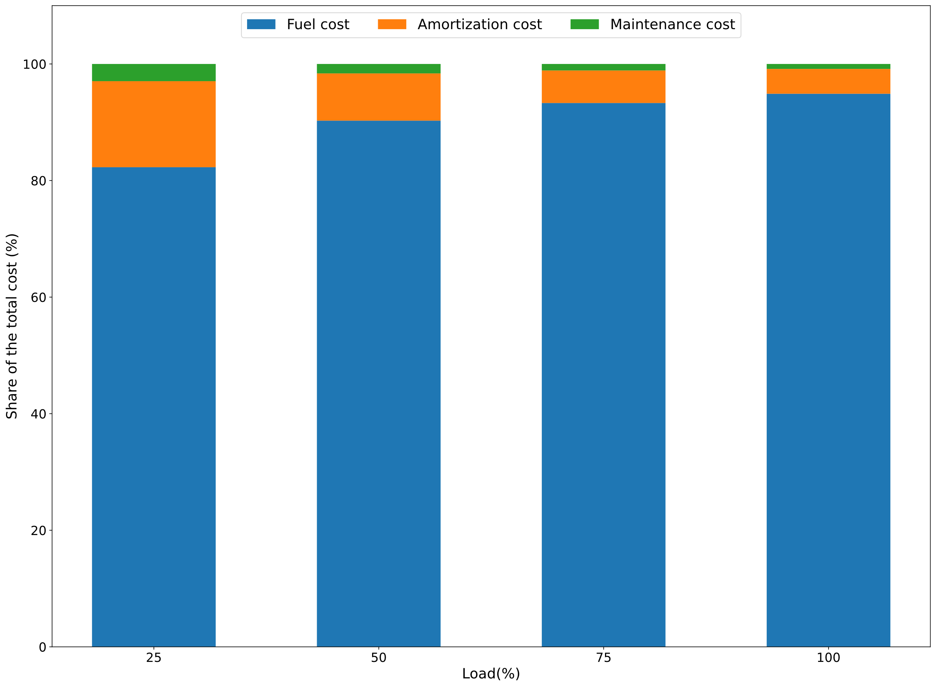
Figure 8: Division of the operating cost (OPEX) for the different load

5.4 Sensitivity analysis
As it is presented in the previous section, the cost of the fuel has a high influence on the operating cost of the ammonia-based ship propulsion system with a share of more than 80% in all cases. Therefore, in this section, an evaluation of the performance of the system proposed for different ammonia prices is presented. The cost of green ammonia is mainly affected by the production method. Three different alternatives have been proposed for sustainable ammonia. The first one is the combination of water electrolysis with air separation units and, finally, produces ammonia using the Haber-Bosch synthesis. For this alternative, Cesaro et al. (2021) calculated the cost of ammonia yielding values of around 800 US$/t, however, this value is significantly affected by the cost of renewable electricity (Sánchez & Martín., 2018). The electrochemical production of ammonia is the second production alternative with the goal of leaving behind the traditional Haber-Bosch process. The cost of this alternative is currently higher than the previous one at around 1800 US$/t (Gomez et al., 2020). Finally, ammonia can be produced using biomass as feedstock. This technology can reduce the cost of green ammonia to values around 400 €/t, however, there are CO₂-associated emissions with the process (Sánchez et al., 2019). In the future, current predictions forecast an average cost for green ammonia between 370-450 €/t by 2030 and, in 2050, 285-350 €/t (Fasihi et al., 2021).
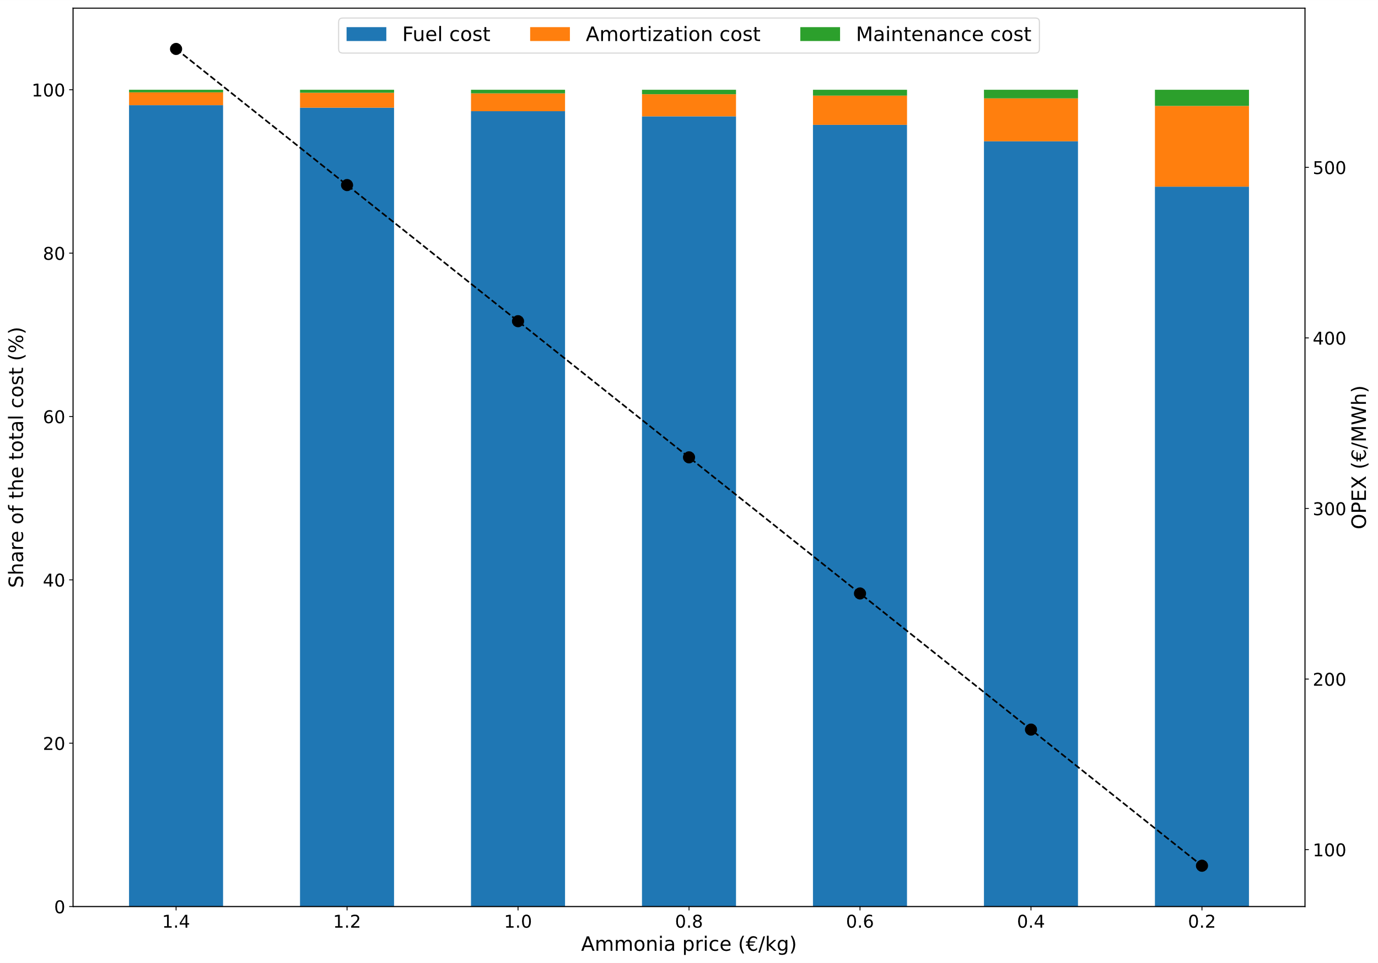
Figure 9: Operating cost of the propulsion system as a function of the ammonia price for the full analysed capacity (the black line represents the OPEX and the columns the share of the total cost)
In this work, a wide range of ammonia prices has been considered to cover all the possible production alternatives mentioned before. For the different ammonia prices, the ship is designed, and the economic evaluation is performed as presented in Section 4.4 and in the Supporting Information. The same procedure is applied for all cases allowing for a fair comparison. In Figure 9, the OPEX and its distribution (raw material, maintenance, and amortization) are presented for different ammonia prices between 0.2 €/kg and 1.4 €/kg. All the information is for the full capacity of the propulsion system. Similar results can be obtained for other capacity cases. With the current renewable ammonia prices, the cost of the fuel system is around 200-300 €/MWh. If current predictions come true, the cost could drop significantly by up to 150 €/MWh. In the operating cost of the propulsion system, the cost of fuel represents the highest share. Therefore, to be able to introduce ammonia as fuel in the marine sector, a major effort should be made to reduce the cost of the fuel since the cost related to the capital cost only accounts for around 10% of the total operating cost in the scenario with the reduced ammonia prices. Future improvements in terms of electrolyzer performance and the reduction in the cost of renewable electricity can potentially reduce the ammonia price allowing for the effective integration of ammonia as fuel in the shipping sector. This step is essential due to the future decarbonization objectives since ammonia is a carbon-free fuel with no direct CO₂ emissions.
6. Conclusions
The conceptual design of a propulsion system to fuel a ship (particularly a large ferry) using ammonia is proposed aiming for a complete decarbonisation of the shipping sector. This ferry will be propelled by an ICE fuelled by an ammonia-hydrogen blend. The hydrogen required for the combustion reactions will be produced onboard by means of the ammonia decomposition reactor. In this way, the important inconveniences that involve the hydrogen storage onboard are avoided. For ammonia decomposition, a fixed bed adiabatic reactor was designed. The energy required to heat up the inlet ammonia to this equipment can be supplied by using the outlet gases of the combustion engine. This allows the heat integration of the system for all the proposed engine loads. In order to reduce the NO_{x} emissions, a selective catalytic reduction unit was designed. The highest vessel emission value, around 0.5 g/kWh, is lower than the one required by the IMO rules.
On the basis of the energy analysis carried out, it is possible to conclude that the global exergy efficiency for the system proposed for this type of ship can be established at 61.5% (if this efficiency is defined as the total exergy leaving the system in relationship with the total exergy entering the system). This value is reduced down to reach 48.1% if only the energy produced in the system (and devoted to the ship propulsion) is considered as output.
Regarding the economic assessment, the total capital cost (CAPEX) for the system can be established at 8.66 M€ (784 €/kW). 63.8% of the total investment corresponds to the engine. It is important to highlight that the capital cost associated with the SCR represents only 0.2%. For this reason, including this equipment in the system is highly advisable. It produces a remarkable environmental benefit with a moderate increase in cost. The operating cost (OPEX) for the system proposed for this kind of ship oscillates between 210 €/MWh (engine load of 100%) and 243 €/MWh (engine load of 25%). From the sensitivity analysis performed, it is possible to expect a reduction in the cost of fuelling a ship with ammonia due to the predicted decrease in the green ammonia cost in the coming years. Conclusively, the economic results show ammonia-based ships as a competitive alternative to be used in the next future to decarbonise maritime transportation.
Nomenclature
$a_{i}$ activity of the different components
$ER$ equivalence ratio
$k_{reac}$ kinetic constant
$K_{p}$ equilibrium constant
$r$ kinetic rate
$T$ temperature
$y_{NO}$ molar concentration of NO
$α$ kinetic parameter
$Φ$ effectiveness factor
$Ω$ catalytic activity
$η$ removal efficiency
Acknowledgments
This work was supported by the Regional Government of Castilla y León (Junta de Castilla y León) and by the Ministry of Science and Innovation MICIN and the European Union NextGenerationEU / PRTR (H₂MetAmo project - C17.I01.P01.S21).
References
Al-Aboosi FY, El-Halwagi MM, Moore M, Nielsen RB. Renewable ammonia as an alternative fuel for the shipping industry. Curr. Opin. Chem. Eng. 2021; 31:100670. DOI: https://doi.org/10.1016/j.coche.2021.100670
Ameri M, Ahmadi P, Khanmohammadi, S. Exergy analysis of a 420 MW combined cycle power plant. Int. J. Energy Res. 2008; 32: 175-183. DOI: https://doi.org/10.1002/er.1351
Ampah, JD, Yusuf AA, Afrane S, Jin C, Liu H. Reviewing two decades of cleaner alternative marine fuels: Towards IMO's decarbonization of the maritime transport sector. J. Clean. Prod. 2021; 320: 128871. DOI: https://doi.org/10.1016/j.jclepro.2021.128871
Anderson K, Marquez Salazar C. Methanol as a marine fuel report. Methanol institute, FCBI Energy 2015. URL: https://www.methanol.org/wp-content/uploads/2018/03/FCBI-Methanol-Marine-Fuel-Report-Final-English.pdf
Atilhan S, Park S, El-Halwagi MM, Atilhan M, Moore M, Nielsen RB. Green hydrogen as an alternative fuel for the shipping industry. Curr. Opin. Chem. Eng. 2021; 31: 100668. DOI: https://doi.org/10.1016/j.coche.2020.100668
Buhaug Ø, Corbett JJ, Endresen Ø, Eyring V, Faber J, Hanayama S, Lee D., Lee D, Lindstad H, Markowska AZ, Mjelde A, Nelissen D, Nilsen J, Pålsson C, Winebrake JJ, Wu W, Yoshida K. Second IMO GHG study 2009. 2009. London.
Caton JA. Exergy destruction during the combustion process as functions of operating and design parameters for a spark-ignition engine. Int. J. Energy Res. 2012; 36: 368-384. DOI: https://doi.org/10.1002/er.1807
Cesaro Z, Ives M, Nayak-Luke R, Mason M, Bañares-Alcántara R. Ammonia to power: Forecasting the levelized cost of electricity from green ammonia in large-scale power plants. Appl. Energy 2021; 282: 116009. DOI: https://doi.org/10.1016/j.apenergy.2020.116009
Chai WS, Bao Y, Jin P, Tang G, Zhou L. A review on ammonia, ammonia-hydrogen and ammonia-methane fuels. Renewable Sustainable Energy Rev. 2021; 147: 111254. DOI: https://doi.org/10.1016/j.rser.2021.111254
Cheliotis M, Boulougouris E, Trivyza NL, Theotokatos G, Livanos G, Mantalos G, Stubos A, Stamatakis E, Venetsanos A. Review on the safe use of ammonia fuel cells in the maritime industry. Energies 2021; 14(11): 3023. DOI: https://doi.org/10.3390/en14113023
Chiong MC, Chong CT, Ng JH, Mashruk S, Chong WWF, Samiran NA, Mong GR, Valera-Medina A. Advancements of combustion technologies in the ammonia-fuelled engines. Energy Convers. Manag. 2021; 244: 114460. DOI: https://doi.org/10.1016/j.enconman.2021.114460.
Chiuta S, Everson RC, Neomagus HWJP, van der Gryp P, Bessarabov DG. Reactor technology options for distributed hydrogen generation via ammonia decomposition: A review. Int. J. Hydrog. Energy 2013; 38(35): 14968-14991. DOI: https://doi.org/10.1016/j.ijhydene.2013.09.067
Di Micco S, Mastropasqua L, Cigolotti V, Minutillo M, Brouwer J. A framework for the replacement analysis of a hydrogen-based polymer electrolyte membrane fuel cell technology on board ships: A step towards decarbonization in the maritime sector. Energy Convers. Manag. 2022; 267: 115893. DOI: https://doi.org/10.1016/j.enconman.2022.115893
Ejder E, Arslanoğlu Y. Evaluation of ammonia fueled engine for a bulk carrier in marine decarbonization pathways. J. Clean. Prod. 2022; 379: 134688. DOI: https://doi.org/10.1016/j.jclepro.2022.134688
Elbaz AM, Wang S, Guiberti TF, Roberts WL. Review on the recent advances on ammonia combustion from the fundamentals to the applications. Fuel Communications 2022; 10: 100053. DOI: https://doi.org/10.1016/j.jfueco.2022.100053.
Fasihi M, Weiss R, Savolainen J, Breyer C. Global potential of green ammonia based on hybrid PV-wind power plants. Appl. Energy 2021; 294: 116170. DOI: https://doi.org/10.1016/j.apenergy.2020.116170
Findley KO, Lawrence SK, O’Brien MK. Engineering challenges associated with hydrogen embrittlement in steels. Encycl. Mater. Met. Alloy 2022; 2: 235-249.
Frigo S, Gentili R. Analysis of the behaviour of a 4-stroke Si engine fuelled with ammonia and hydrogen. Int. J. Hydrog. Energy 2013; 38(3): 1607-1615. DOI: https://doi.org/10.1016/j.ijhydene.2012.10.114
Gautam P, Upadhyay SN, Dubey SK. Bio-methanol as a renewable fuel from waste biomass: Current trends and future perspective. Fuel 2020; 273: 117783. DOI: https://doi.org/10.1016/j.fuel.2020.117783
Gomez JR, Baca J, Garzon F. Techno-economic analysis and life cycle assessment for electrochemical ammonia production using proton conducting membrane. Int. J. Hydrog. Energy 2020; 45(1): 721-737. DOI: https://doi.org/10.1016/j.ijhydene.2019.10.174
Gong C, Li Z, Yi L, Huang K, Liu F. Research on the performance of a hydrogen/methanol dual-injection assisted spark-ignition engine using late-injection strategy for methanol. Fuel 2020; 260: 116403. DOI: https://doi.org/10.1016/j.fuel.2019.116403
Guerras LS, Martín M. Optimal gas treatment and coal blending for reduced emissions in power plants: A case study in Northwest Spain. Energy 2019; 169: 739-749. DOI: https://doi.org/10.1016/j.energy.2018.12.089
Horvath S, Fasihi M, Breyer C. Techno-economic analysis of a decarbonized shipping sector: Technology suggestions for a fleet in 2030 and 2040. Energy Convers. Manag. 2018; 164: 230-241. DOI: https://doi.org/10.1016/j.enconman.2018.02.098
IMO. Adoption of the Initial Strategy on Reduction of GHG Emissions from Ships and Existing Activity Related to Reducing GHG Emissions in the Shipping Sector. London, UK: International Maritime Organization; 2018,1-27.
Jess A, Wasserscheid P. Chemical Technology: From Principles to Products. John Wiley & Sons; 2019. ISBN: 978-3527344215
Joung TH, Kang SG, Lee JK, Ahn J.The IMO initial strategy for reducing Greenhouse Gas (GHG) emissions, and its follow-up actions towards 2050. J. Int. Marit. Saf. Environ. Aff. Shipp. 2020; 4:1-7
Juliussen LR. Ship operation using LPG and ammonia as fuel on MAN B&W dual fuel ME-LGIP Engines. Using low carbón ammonia fuel. Man energy solutions: Copenhagen, Denmark; 2018.
Kersey J, Popovich ND, Phadke AA. Rapid battery cost declines accelerate the prospects of all-electric interregional container shipping. Nat. Energy 2022; 7: 664-674. DOI: https://doi.org/10.5281/zenodo.6594089.
Kim K, Roh G, Kim W, Chun K. A Preliminary Study on an Alternative Ship Propulsion System Fueled by Ammonia: Environmental and Economic Assessments. J. Mar. Sci. Eng. 2020; 8(3): 183. DOI: https://doi.org/10.3390/jmse8030183
Kim S, Song J, Lim H. Conceptual feasibility studies of a COX-free hydrogen production from ammonia decomposition in a membrane reactor for PEM fuel cells. Korean J. Chem. Eng. 2018; 35: 1509-1516. DOI: https://doi.org/10.1007/s11814-018-0037-5
Korberg AD, Brynolf S, Grahn M, Skov IR. Techno-economic assessment of advanced fuels and propulsion systems in future fossil-free ships. Renewable Sustainable Energy Rev. 2021; 142: 110861. DOI: https://doi.org/10.1016/j.rser.2021.110861
Kurien C, Mittal M. Review on the production and utilization of green ammonia as an alternate fuel in dual-fuel compression ignition engines. Energy Convers. Manag. 2022; 251:114990. DOI: https://doi.org/10.1016/j.enconman.2021.114990
Li Z, Li S. Kinetics modeling of NOx emissions characteristics of a NH₃/H₂ fueled gas turbine combustor. Int. J. Hydrog. Energy 2021; 45(5): 4526-4537. DOI: https://doi.org/10.1016/j.ijhydene.2020.11.024
Liang X, Zhao B, Zhang F, Liu Q. Compact research for maritime selective catalytic reduction reactor based on response surface methodology. Appl. Energy 2019; 254: 113702. DOI: https://doi.org/10.1016/j.apenergy.2019.113702
Liu L, Wu Y, Wang Y. Numerical investigation on the combustion and emission characteristics of ammonia in a low-speed two-stroke marine engine. Fuel 2022a; 314: 122727. DOI: https://doi.org/10.1016/j.fuel.2021.122727
Liu L, Tang Y, Liu D. Investigation of future low-carbon and zero-carbon fuels for marine engines from the view of thermal efficiency. Energy Rep. 2022b; 8: 6150-6160. DOI: https://doi.org/10.1016/j.egyr.2022.04.058
Liu L, Tan F, Wu Z, Wang Y, Liu H. Comparison of the combustion and emission characteristics of NH₃/NH₄NO₂ and NH₃/H₂ in a two-stroke low speed marine engine. Int. J. Hydrog. Energy 2022c; 47(40): 17778-17787. DOI: https://doi.org/10.1016/j.ijhydene.2022.03.239
Lu D, Theotokatos G, Zhang J, Zeng H, Cui K. Parametric investigation of a large marine two-stroke diesel engine equipped with exhaust gas recirculation and turbocharger cut out systems. Appl. Therm. Eng. 2022; 200:117654. DOI: https://doi.org/10.1016/j.applthermaleng.2021.117654
MacFarlane DR, Cherepanov PV, Choi J, Suryanto BHR, Hodgetts RY, Bakker JM, Vallana FMF, Simonov AN. A Roadmap to the Ammonia Economy. Joule 2020; 4(6): 1186-1205. DOI: https://doi.org/10.1016/j.joule.2020.04.004
MAN. Methanol in shipping, MAN energy solutions: Copenhagen, Denmark, 2019.
MAN. MAN B&W two-stroke engine operating on ammonia. 2020. URL: https://www.man-es.com/docs/default-source/document-sync/man-b-w-two-stroke-engine-operating-on-ammonia-eng.pdf?sfvrsn=c4bb6fea_0 [accessed 13 December 2022]
MAN, MAN B&W Ammonia fueled engine development status, Man energy solutions: Copenhagen, Denmark; 2020b.
Martin M, Methodology for solar and wind energy chemical storage facilities design under uncertainty: Methanol production from CO₂ and hydrogen. Computers & Chemical Engineering 2016; 92: 43-54. DOI: https://doi.org/10.1016/j.compchemeng.2016.05.001
Mao X, Ying R, Yuan Y, Li F, Shen B. Simulation and analysis of hydrogen leakage and explosion behaviors in various compartments on a hydrogen fuel cell ship. Int. J. Hydrog. Energy 2021; 46(9): 6857-6872. DOI: https://doi.org/10.1016/j.ijhydene.2020.11.158
Mashruk S, Zitouni SE, Brequigny P, Mounaim-Rousselle C, Valera-Medina A. Combustion performances of premixed ammonia/hydrogen/air laminar and swirling flames for a wide range of equivalence ratios. Int. J. Hydrog. Energy 2022; 47(97): 41170-41182. DOI: https://doi.org/10.1016/j.ijhydene.2022.09.165
Nakamura K, Muramatsu T, Ogawa T, Nkagaki T. Prediction of de-NOx performance using monolithic SCR catalyst under load following operation of natural gas-fired combined cycle power plants. Energy 2021; 227: 120383. DOI: https://doi.org/10.1016/j.energy.2021.120383
Napolitano P, Liotta LF, Guido C, Tornatore C, Pantaleo G, La Parola V, Beatrice C. Insights of Selective Catalytic Reduction Technology for Nitrogen Oxides Control in Marine Engine Applications. Catalyst 2022; 12(10): 1191. DOI: https://doi.org/10.3390/catal12101191
Nozari H, Karabeyoğlu A. Numerical study of combustion characteristics of ammonia as a renewable fuel and establishment of reduced reaction mechanisms. Fuel 2015; 159: 223-233. DOI: https://doi.org/10.1016/j.fuel.2015.06.075
Nova I, Bounechada D, Maestri R, Tronconi E. Influence of the Substrate Properties on the Performances of NH₃ -SCR Monolithic Catalysts for the Aftertreatment of Diesel Exhaust: An Experimental and Modeling Study. Ind. Eng. Chem. Res. 2011; 50: 299–309. DOI: https://doi.org/10.1021/ie1015409
Okafor EC, Somarathne KDKA, Ratthanan R, Hayakawa A, Kudo T, Kurata O, Iki N, Tsujimura T, Furutani H, Kobayashi H. Control of NO_{x} and other emissions in micro gas turbine combustors fuelled with mixtures of methane and ammonia. Combustion and Flame 2020; 211: 406-416. DOI: https://doi.org/10.1016/j.combustflame.2019.10.012
Olivier JG, Peters JA. Trends in global CO₂ and total greenhouse gas emissions: 2017 report. Pbl Netherlands: Enviroment Assessment Agency. The Hage; 2017.
Otomo J, Koshi M, Mitsumori T, Iwasaki H, Yamada K. Chemical kinetic modeling of ammonia oxidation with improved reaction mechanism for ammonia/air and ammonia/hydrogen/air combustion. Int. J. Hydrog. Energy 2018; 43(5): 3004-3014. DOI: https://doi.org/10.1016/j.ijhydene.2017.12.066
Palys MJ, Allman A, Daoutidis P. Exploring the Benefits of Modular Renewable-Powered Ammonia Production: A Supply Chain Optimization Study. Ind. Eng. Chem. Res. 2019; 58 (15): 5898–5908. DOI: https://doi.org/10.1021/acs.iecr.8b04189
Pant A, Schmieg SJ. Kinetic Model of NOx SCR Using Urea on Commercial Cu-Zeolite Catalyst. Ind. Eng. Chem. Res. 2011; 50: 5490-5498. DOI: https://doi.org/10.1021/ie200060s
Rodenhausen, R. Case study: choosing selective catalytic reduction as a preferred technology for the destruction of NO_{x}. Environ. Prog. 1999; 18(4): 260-266. DOI: https://doi.org/10.1002/ep.670180412
Rusman, NAA, Dahari, M. A review on the current progress of metal hydrides material for solid-state hydrogen storage applications. Int. J. Hydrog. Energy 2016; 41(28): 12108-12126. DOI: https://doi.org/10.1016/j.ijhydene.2016.05.244
Ryu K, Zacharakis-Jutz GE, Kong SC. Performance enhancement of ammonia-fueled engine by using dissociation catalyst for hydrogen generation. Int. J. Hydrog. Energy 2014; 39: 2390-2398. DOI: https://doi.org/10.1016/j.ijhydene.2013.11.098
Sánchez A, Martín M, Vega P. Biomass Based Sustainable Ammonia Production: Digestion vs Gasification. ACS Sustain. Chem. Eng. 2019; 7(11): 9995-10007. DOI: https://doi.org/10.1021/acssuschemeng.9b01158
Sánchez A, Martín M. Optimal renewable production of ammonia from water and air. J. Clean. Prod. 2018; 178: 325-342. DOI: https://doi.org/10.1016/j.jclepro.2017.12.279
Sánchez A, Martín M. Scale up and scale down issues of renewable ammonia plants: Towards modular design. Sustain. Prod. Consum. 2018b; 16:176-192. DOI: https://doi.org/10.1016/j.spc.2018.08.001
Schneiter D. Tier III programme status and Outlook, Winterthur Gas & Diesel; 2015.
Smith TWP, Jalkanen JP, Anderson BA, Corbett JJ, Faber J, Hanayama S, O’Keeffe E, Parker S, Johansson l, Aldous l, Raucci C, Traut M, Ettinger S, Nelissen D, Lee DS, Ng S, Agrawal A, Winebrake JJ, Hoen M, Chesworth S, Pandey A. Third IMO GHG study 2014. 2015. London.
Sorrels JL, Randall DD, Schaffner KS, Fry CR. Selective catalytic reduction. In EPA Air Pollution Control Cost Manual 2016; 7. ISBN: 978-1296051327
Tarasov BP, Fursikov PV, Volodin AA, Bocharnikov MS, Shimkus YY, Kashin AM, Yartys VA, Chidziva S, Pasupathi S, Lototskyy MV. Metal hydride hydrogen storage and compression systems for energy storage technologies. Int. J. Hydrog. Energy 2021; 46(25): 13647-13657. DOI: https://doi.org/10.1016/j.ijhydene.2020.07.085
Valera-Medina A, Gutesa M, Xiao H, Pugh D, Giles A, Goktepe B, Marsh R, Bowen P. Valera-Medina, A., Gutesa, M., Xiao, H., Pugh, D., Giles, A., Goktepe, B. Premixed ammonia/hydrogen swirl combustion under rich fuel conditions for gas turbines operation. Int J Hydrogen Energy 2019; 44(16): 8615-8626. DOI: https://doi.org/10.1016/j.ijhydene.2019.02.041
Valera-Medina A, Xiao H, Owen-Jones M, David WIF, Bowen PJ. Ammonia for power. Prog. Energy Combust. Sci. 2018; 69: 63-102. DOI: https://doi.org/10.1016/j.pecs.2018.07.001
Wang B, Yang C, Wang H, Hu D, Wang Y. Effect of Diesel-Ignited Ammonia/Hydrogen mixture fuel combustion on engine combustion and emission performance. Fuel 2023a; 331: 125865. DOI: https://doi.org/10.1016/j.fuel.2022.125865
Wang H, Daoutidis P, Zhang Q. Ammonia-based green corridors for sustainable maritime transportation. Digital Chemical Engineering 2023b; 6: 100082. DOI: https://doi.org/10.1016/j.dche.2022.100082
Wang Y, Zhou Z, Liu L. Theoretical investigation of the combustion performance of ammonia/hydrogen mixtures on a marine diesel engine. Int. J. Hydrog. Energy 2021; 46(27): 14805-14812. DOI: https://doi.org/10.1016/j.ijhydene.2021.01.233
Wang Y, Wright LA. A Comparative Review of Alternative Fuels for the Maritime Sector: Economic, Technology, and Policy Challenges for Clean Energy Implementation. World 2021; 2(4): 456-481. DOI: https://doi.org/10.3390/world2040029
Wik C, Niemi S. Low emission engine technologies for future tier 3 legislations-options and case studies. J. Ship. Trade 2016; 1(1): 1-22. DOI: https://doi.org/10.1186/s41072-016-0009-z
Wu S, Salmon N, Li MMJ, Bañares-Alcántara R, Tsang SCE. Energy decarbonization via green H₂ or NH₃?. ACS Energy Lett. 2022a; 7(3): 1021-1033. DOI: https://doi.org/10.1021/acsenergylett.1c02816
Wu X, Feng Y, Xu G, Zhu Y, Ming P, Dai L. Numerical investigations on charge motion and combustion of natural gas-enhanced ammonia in marine pre-chamber lean-burn engine with dual-fuel combustion system. Int. J. Hydrog. Energy; 2022b: in press.
Yousaf M, Mahmood A, Elkamel A, Rizwan M, Zaman M. Techno-economic analysis of integrated hydrogen and methanol production process by CO₂ hydrogenation. Int. J. Greenh. Gas Control. 2022; 115: 103615. DOI: https://doi.org/10.1016/j.ijggc.2022.103615
Zincir B, Deniz C, Tuner M. Investigation of environmental, operational and economic performance of methanol partially premixed combustion at slow speed operation of a marine engine. J. Clean. Prod. 2019; 235: 1006-1019. DOI: https://doi.org/10.1016/j.jclepro.2019.07.044

Corresponding author. Email address: mariano.m3@usal.es
** The two authors have the same contribution to this study.

