Appendix

List of countries
Austria, Belgium, Bulgaria, Croatia, Czech Republic, Egypt, Estonia, France, Germany, Greece, Hungary, Israel, Italy, Jordan, South Korea, Lithuania, Poland, Romania, Russia, Slovakia, South Africa, Spain, Taiwan, Turkey, Ukraine, United Kingdom.

Relapse criteria (as developed by Csernansky et al, 2002)
Defined by any of the following: psychiatric hospitalization; an increase in the level of psychiatric care (e.g. significant crisis intervention needed to avert hospitalization, clinically notable increases in the frequency or intensity of patient contact required to maintain outpatient status) and an increase of 25% from baseline in the Positive and Negative Syndrome Scale total score (or an increase of 10 points if the baseline score was ≤40); deliberate self-injury; suicidal or homicidal ideation that was clinically significant in the investigator’s judgment; violent behavior resulting in clinically significant injury to another person or property damage; substantial clinical deterioration, defined as a change score of 6 (‘much worse’) or 7 (‘very much worse’) on the Clinical Global Impression-Change scale; the required dose of antipsychotic exceeds the maximum approved dose.

Deaths during study
On Day 493 of the study a 49 year old male, receiving paliperidone palmitate died of cardiac arrest. The subject had reportedly shown symptoms of abdominal pain the day he died. No relevant test or laboratory data were reported. It was not reported if an autopsy was performed. This death was considered unrelated to study drug.
On Day 614 of the study, a 36 year old male, receiving oral olanzapine was found dead in his bed in the morning. The subject was asymptomatic without any signs and symptoms of any somatic condition. The cause of death was initially reported as cardiorespiratory arrest. An autopsy was performed and the pathologist classified it as sudden death. This death was considered doubtfully related to study drug.

Supplementary tables and figures

Supplementary Table 1
Type of anti-psychotic medication just before entering the initial acute oral treatment phase
ATC Term/Preferred Term | Paliperidone palmitate (n=352) | Oral antipsychotics  (n=363) | Total number of subjects (n=715)
Number of subjects with at least one antipsychotic medication just before entering the initial acute oral treatment phase | 217 (61.6) | 221 (60.9) | 438 (61.3)
Benzamides | 15 (4.3) | 15 (4.1) | 30 (4.2)
Amisulpride | 15 (4.3) | 13 (3.6) | 28 (3.9)
Tiapride | 0 | 2 (0.6) | 2 (0.3)
Butyrophenone derivatives | 43 (12.2) | 42 (11.6) | 85 (11.9)
Haloperidol | 43 (12.2) | 42 (11.6) | 85 (11.9)
Diazepines, oxazepines, thiazepines and oxepines | 55 (15.6) | 49 (13.5) | 104 (14.5)
Clozapine | 0 | 1 (0.3) | 1 (0.1)
Loxapine | 3 (0.9) | 1 (0.3) | 4 (0.6)
Olanzapine | 36 (10.2) | 21 (5.8) | 57 (8.0)
Quetiapine | 8 (2.3) | 16 (4.4) | 24 (3.4)
Quetiapine fumarate | 11 (3.1) | 10 (2.8) | 21 (2.9)
Indole derivatives | 4 (1.1) | 8 (2.2) | 12 (1.7)
Sertindole | 2 (0.6) | 2 (0.6) | 4 (0.6)
Ziprasidone | 2 (0.6) | 2 (0.6) | 4 (0.6)
Ziprasidone hydrochloride | 0 | 4 (1.1) | 4 (0.6)
Lithium | 4 (1.1) | 3 (0.8) | 7 (1.0)
Lithium | 0 | 1 (0.3) | 1 (0.1)
Lithium carbonate | 4 (1.1) | 2 (0.6) | 6 (0.8)
Other antipsychotics | 83 (23.6) | 82 (22.6) | 165 (23.1)
Aripiprazole | 15 (4.3) | 12 (3.3) | 27 (3.8)
Paliperidone | 11 (3.1) | 9 (2.5) | 20 (2.8)
Risperidone | 62 (17.6) | 64 (17.6) | 126 (17.6)
Phenothiazines with aliphatic side-chain | 26 (7.4) | 24 (6.6) | 50 (7.0)
Chlorpromazine | 17 (4.8) | 10 (2.8) | 27 (3.8)
Chlorpromazine hydrochloride | 6 (1.7) | 6 (1.7) | 12 (1.7)
Cyamemazine | 1 (0.3) | 0 | 1 (0.1)
Levomepromazine | 3 (0.9) | 3 (0.8) | 6 (0.8)
Levomepromazine maleate | 1 (0.3) | 3 (0.8) | 4 (0.6)
Promazine hydrochloride | 0 | 2 (0.6) | 2 (0.3)
Phenothiazines with piperazine structure | 18 (5.1) | 30 (8.3) | 48 (6.7)
Fluphenazine hydrochloride | 2 (0.6) | 2 (0.6) | 4 (0.6)
Perphenazine | 2 (0.6) | 2 (0.6) | 4 (0.6)
Trifluoperazine | 13 (3.7) | 25 (6.9) | 38 (5.3)
Trifluoperazine hydrochloride | 1 (0.3) | 1 (0.3) | 2 (0.3)
Phenothiazines with piperidine structure | 5 (1.4) | 3 (0.8) | 8 (1.1)
Periciazine | 1 (0.3) | 0 | 1 (0.1)
Thioridazine | 2 (0.6) | 0 | 2 (0.3)
Thioridazine hydrochloride | 2 (0.6) | 3 (0.8) | 5 (0.7)
Thioxanthene derivatives | 25 (7.1) | 28 (7.7) | 53 (7.4)
Chlorprothixene | 3 (0.9) | 9 (2.5) | 12 (1.7)
Chlorprothixene hydrochloride | 5 (1.4) | 2 (0.6) | 7 (1.0)
Flupentixol | 3 (0.9) | 2 (0.6) | 5 (0.7)
Flupentixol decanoate | 2 (0.6) | 1 (0.3) | 3 (0.4)
Flupentixol dihydrochloride | 3 (0.9) | 5 (1.4) | 8 (1.1)
Zuclopenthixol | 6 (1.7) | 6 (1.7) | 12 (1.7)
Zuclopenthixol acetate | 2 (0.6) | 1 (0.3) | 3 (0.4)
Zuclopenthixol decanoate | 1 (0.3) | 0 | 1 (0.1)
Zuclopenthixol hydrochloride | 4 (1.1) | 4 (1.1) | 8 (1.1)

Supplementary Table 2
Secondary outcomes.
Measure | Mean (SD) baseline value | Mean (SD) LOCF endpoint value | Mean (SD) change from baseline to LOCF endpoint | 95% CI | Within group  P value* | Between group  P value†
PANSS
PANSS total score
Paliperidone palmitate (n = 350) | 82.5 (12.0) | 65.9 (22.1) | -16.6 (21.4) | -18.8, -14.3 | <0.0001 | 0.0745
Oral antipsychotics (n = 360) | 81.5 (11.7) | 67.3 (22.4) | -14.1 (21.3) | -16.3, -11.9 | <0.0001 | 0.0745
PANSS positive subscale
Paliperidone palmitate (n = 350) | 18.4 (4.0) | 14.1 (6.6) | -4.4 (6.6) | -5.1, -3.7 | <0.0001 | 0.2383
Oral antipsychotics (n = 360) | 18.3 (4.0) | 14.5 (6.9) | -3.8 (6.7) | -4.5, -3.1 | <0.0001 | 0.2383
PANSS negative subscale
Paliperidone palmitate (n = 350) | 22.6 (4.6) | 18.6 (6.1) | -4.1 (6.1) | -4.7, -3.4 | <0.0001 | 0.2586
Oral antipsychotics (n = 360) | 22.3 (4.6) | 18.6 (5.9) | -3.7 (5.8) | -4.3, -3.1 | <0.0001 | 0.2586
PANSS general psychopathology subscale
Paliperidone palmitate (n = 350) | 41.4 (6.7) | 33.3 (11.2) | -8.1 (11.0) | -9.3, -7.0 | <0.0001 | 0.0447
Oral antipsychotics (n = 360) | 40.8 (6.6) | 34.2 (11.7) | -6.7 (11.1) | -7.8, -5.5 | <0.0001 | 0.0447
PANSS Marder Factor Scores
Positive symptoms factor score
Paliperidone palmitate (n = 350) | 22.9 (4.3) | 17.9 (7.3) | -5.0 (6.7) | -5.7, -4.3 | <0.0001 | 0.2869
Oral antipsychotics (n = 360) | 22.5 (4.4) | 17.9 (7.3) | -4.7 (6.8) | -5.4, -4.0 | <0.0001 | 0.2869
Negative symptoms factor score
Paliperidone palmitate (n = 350) | 22.0 (4.7) | 17.7 (6.1) | -4.3 (6.3) | -5.0, -3.6 | <0.0001 | 0.1355
Oral antipsychotics (n = 360) | 21.5 (5.0) | 17.7 (5.7) | -3.8 (6.1) | -4.4, -3.1 | <0.0001 | 0.1355
Disorganized thoughts factor score
Paliperidone palmitate (n = 350) | 19.5 (3.5) | 15.9 (5.3) | -3.7 (5.0) | -4.2, -3.1 | <0.0001 | 0.2093
Oral antipsychotics (n = 360) | 19.4 (3.4) | 16.2 (5.3) | -3.2 (5.2) | -3.7, -2.7 | <0.0001 | 0.2093
Uncontrolled hostility/excitement factor score
Paliperidone palmitate (n = 350) | 8.4 (2.7) | 6.9 (3.5) | -1.5 (3.8) | -1.9, -1.1 | <0.0001 | 0.0077
Oral antipsychotics (n = 360) | 8.3 (2.6) | 7.5 (3.9) | -0.8 (3.9) | -1.2, -0.4 | <0.0001 | 0.0077
Anxiety/depression factor score
Paliperidone palmitate (n = 350) | 9.7 (2.7) | 7.6 (3.4) | -2.1 (3.5) | -2.5, -1.7 | <0.0001 | 0.2795
Oral antipsychotics (n = 360) | 9.8 (2.9) | 8.0 (3.7) | -1.8 (3.5) | -2.1, -1.4 | <0.0001 | 0.2795
CGI-S score
Paliperidone palmitate (n = 350) | 3.9 (0.4) | 3.2 (1.2) | -0.7 (1.1) | -0.8, -0.5 | <0.0001 | 0.4837
Oral antipsychotics (n = 360) | 3.8 (0.4) | 3.2 (1.1) | -0.6 (1.1) | -0.7, -0.5 | <0.0001 | 0.4837
PSP
PSP total score
Paliperidone palmitate (n = 346) | 55.3 (11.3) | 65.0 (15.0) | 9.8 (15.4) | 8.1, 11.4 | <0.0001 | 0.2831
Oral antipsychotics (n = 355) | 55.3 (11.1) | 64.0 (14.7) | 8.7 (14.9) | 7.2, 10.3 | <0.0001 | 0.2831
Socially useful activities
Paliperidone palmitate (n = 346) | 3.6 (0.9) | 2.8 (1.1) | -0.7 (1.1) | -0.8, -0.6 | <0.0001 | 0.4568
Oral antipsychotics (n = 355) | 3.6 (0.8) | 2.9 (1.1) | -0.7 (1.1) | -0.8, -0.6 | <0.0001 | 0.4568
Personal and social relationships
Paliperidone palmitate (n = 346) | 3.3 (0.8) | 2.7 (1.0) | -0.7 (1.1) | -0.8, -0.6 | <0.0001 | 0.6136
Oral antipsychotics (n = 355) | 3.3 (0.8) | 2.6 (1.0) | -0.6 (1.0) | -0.7, -0.5 | <0.0001 | 0.6136
Self care
Paliperidone palmitate (n = 346) | 2.3 (0.9) | 1.9 (1.0) | -0.4 (0.9) | -0.5, -0.3 | <0.0001 | 0.6532
Oral antipsychotics (n = 355) | 2.2 (0.9) | 1.8 (0.9) | -0.4 (1.0) | -0.5, -0.3 | <0.0001 | 0.6532
Disturbing and aggressive behaviors
Paliperidone palmitate (n = 346) | 1.5 (0.8) | 1.4 (0.8) | -0.1 (0.9) | -0.2, -0.0 | 0.0006 | 0.6989
Oral antipsychotics (n = 355) | 1.6 (0.8) | 1.5 (0.9) | -0.1 (0.9) | -0.2, -0.0 | 0.0059 | 0.6989
SF-36
Physical functioning – scale score
Paliperidone palmitate (n = 324) | 78.8 (21.0) | 84.6 (19.9) | 5.8 (23.0) | 3.3, 8.3 | <0.0001 | 0.6578
Oral antipsychotics (n = 340) | 78.1 (21.5) | 84.0 (21.2) | 5.8 (21.3) | 3.6, 8.1 | <0.0001 | 0.6578
Role limitations – physical –scale score
Paliperidone palmitate (n = 324) | 56.0 (27.9) | 68.8 (25.4) | 12.7 (29.7) | 9.5, 16.0 | <0.0001 | 0.5986
Oral antipsychotics (n = 340) | 55.9 (28.5) | 67.5 (25.5) | 11.6 (29.4) | 8.4, 14.7 | <0.0001 | 0.5986
Bodily pain – scale score
Paliperidone palmitate (n = 324) | 79.7 (24.9) | 84.6 (23.1) | 4.9 (26.5) | 2.0, 7.8 | 0.0004 | 0.1835
Oral antipsychotics (n = 340) | 81.4 (25.1) | 84.9 (23.4) | 3.5 (25.5) | 0.8, 6.2 | 0.0086 | 0.1835
General health – scale score
Paliperidone palmitate (n = 324) | 49.2 (20.4) | 58.9 (20.5) | 9.8 (22.4) | 7.3, 12.2 | <0.0001 | 0.4432
Oral antipsychotics (n = 340) | 49.5 (20.0) | 58.3 (19.0) | 8.8 (21.3) | 6.5, 11.1 | <0.0001 | 0.4432
Vitality – scale score
Paliperidone palmitate (n = 324) | 45.8 (21.8) | 57.9 (19.8) | 12.2 (24.2) | 9.5, 14.8 | <0.0001 | 0.5675
Oral antipsychotics (n = 340) | 45.5 (20.1) | 57.0 (18.6) | 11.5 (22.8) | 9.1, 13.9 | <0.0001 | 0.5675
Social functioning – scale score
Paliperidone palmitate (n = 324) | 50.0 (26.3) | 69.8 (24.8) | 19.8 (31.7) | 16.4, 23.3 | <0.0001 | 0.5728
Oral antipsychotics (n = 340) | 48.6 (26.8) | 67.6 (24.6) | 19.0 (28.7) | 15.9, 22.1 | <0.0001 | 0.5728
Role limitations – emotional – scale score
Paliperidone palmitate (n = 324) | 49.5 (27.7) | 65.5 (27.0) | 16.0 (32.8) | 12.4, 19.6 | <0.0001 | 0.9556
Oral antipsychotics (n = 340) | 48.2 (27.1) | 64.6 (26.6) | 16.4 (31.6) | 13.1, 19.8 | <0.0001 | 0.9556
Mental health – scale score
Paliperidone palmitate (n = 324) | 52.0 (20.4) | 64.5 (19.7) | 12.5 (23.2) | 9.9, 15.0 | <0.0001 | 0.4221
Oral antipsychotics (n = 340) | 51.4 (20.4) | 62.9 (19.4) | 11.4 (23.3) | 9.0, 13.9 | <0.0001 | 0.4221
Physical component – scale score
Paliperidone palmitate (n = 324) | 50.3 (8.0) | 52.0 (7.3) | 1.7 (8.5) | 0.8, 2.7 | <0.0001 | 0.4427
Oral antipsychotics (n = 340) | 50.6 (7.8) | 52.0 (7.0) | 1.4 (7.4) | 0.6, 2.1 | 0.0002 | 0.4427
Mental component – scale score
Paliperidone palmitate (n = 324) | 32.1 (12.6) | 41.0 (12.2) | 9.0 (15.0) | 7.3, 10.6 | <0.0001 | 0.6276
Oral antipsychotics (n = 340) | 31.4 (12.9) | 40.2 (12.0) | 8.7 (14.4) | 7.2, 10.2 | <0.0001 | 0.6276
EQ-5D VAS
Paliperidone palmitate (n = 325) | 57.5 (20.9) | 70.5 (20.3) | 13.0 (22.9) | 10.5, 15.5 | <0.0001 | 0.4153
Oral antipsychotics (n = 339) | 57.6 (20.4) | 69.6 (19.5) | 11.9 (21.5) | 9.6, 14.2 | <0.0001 | 0.4153
EQ-5D Index score
Paliperidone palmitate (n = 324) | 0.80 (0.2) | 0.86 (0.2) | 0.06 (0.2) | 0.03, 0.08 | <0.0001 | 0.3667
Oral antipsychotics (n = 339) | 0.78 (0.2) | 0.86 (0.2) | 0.08 (0.2) | 0.06, 0.1 | <0.0001
SWN-S
SWN-S total score
Paliperidone palmitate (n = 325) | 76.5 (17.0) | 86.2 (17.3) | 9.7 (19.2) | 7.6, 11.8 | <0.0001 | 0.2262
Oral antipsychotics (n = 339) | 76.7 (17.1) | 85.0 (16.8) | 8.3 (17.6) | 6.5, 10.2 | <0.0001 | 0.2262
Mental functioning
Paliperidone palmitate (n = 325) | 14.3 (4.3) | 16.5 (3.8) | 2.2 (4.4) | 1.8, 2.7 | <0.0001 | 0.2952
Oral antipsychotics (n = 339) | 14.1 (4.3) | 16.0 (4.0) | 1.9 (4.4) | 1.4, 2.3 | <0.0001
Self control
Paliperidone palmitate (n = 325) | 15.9 (3.4) | 17.6 (3.6) | 1.7 (4.0) | 1.3, 2.2 | <0.0001 | 0.3474
Oral antipsychotics (n = 339) | 16.1 (3.3) | 17.5 (3.6) | 1.5 (3.7) | 1.1, 1.9 | <0.0001 | 0.3474
Emotional regulation
Paliperidone palmitate (n = 325) | 15.6 (4.0) | 17.8 (3.8) | 2.2 (4.3) | 1.7, 2.6 | <0.0001 | 0.1003
Oral antipsychotics (n = 339) | 15.9 (4.0) | 17.4 (4.0) | 1.5 (4.4) | 1.0, 2.0 | <0.0001 | 0.1003
Physical functioning
Paliperidone palmitate (n = 325) | 16.3 (4.1) | 18.0 (4.3) | 1.7 (4.9) | 1.2, 2.2 | <0.0001 | 0.2586
Oral antipsychotics (n = 339) | 16.2 (4.0) | 17.7 (4.0) | 1.5 (4.2) | 1.0, 1.9 | <0.0001 | 0.2586
Social integration
Paliperidone palmitate (n = 325) | 14.5 (4.4) | 16.5 (3.8) | 2.0 (4.8) | 1.5, 2.6 | <0.0001 | 0.7269
Oral antipsychotics (n = 339) | 14.4 (4.3) | 16.4 (3.9) | 2.0 (4.1) | 1.6, 2.4 | <0.0001 | 0.7269
Treatment Satisfaction Questionnaire for Medication
Effectiveness
Paliperidone palmitate (n = 314) | 61.9 (17.0) | 65.7 (22.1) | 3.8 (23.5) | 1.2, 6.4 | 0.0027 | 0.4358
Oral antipsychotics (n = 328) | 59.5 (16.8) | 64.0 (21.8) | 4.5 (25.3) | 1.8, 7.3 | <0.0001 | 0.4358
Side effects
Paliperidone palmitate (n = 313) | 91.3 (19.7) | 89.9 (22.5) | -1.4 (25.6) | -4.2, 1.5 | 0.4347 | 0.2125
Oral antipsychotics (n = 327) | 87.3 (23.4) | 88.0 (23.0) | 0.7 (28.2) | -2.4, 3.8 | 0.6268 | 0.2125
Convenience
Paliperidone palmitate (n = 314) | 67.1 (16.7) | 74.5 (17.9) | 7.4 (21.2) | 5.0, 9.8 | <0.0001 | <0.0001
Oral antipsychotics (n = 328) | 68.4 (16.5) | 68.7 (18.3) | 0.3 (21.7) | -2.0, 2.7 | 0.4249 | <0.0001
Global satisfaction
Paliperidone palmitate (n = 313) | 64.0 (18.1) | 67.0 (23.9) | 3.0 (25.0) | 0.2, 5.8 | 0.0222 | 0.3509
Oral antipsychotics (n = 328) | 62.8 (18.3) | 63.8 (24.2) | 1.0 (26.8) | -1.9, 3.9 | 0.2230 | 0.3509
Physician’s treatment satisfaction
Efficacy
Paliperidone palmitate (n = 325) | 2.7 (0.8) | 2.6 (1.3) | -0.2 (1.5) | -0.3, -0.0 | 0.0082 | 0.1129
Oral antipsychotics (n = 339) | 2.8 (0.8) | 2.8 (1.3) | 0.0 (1.4) | -0.1, 0.2 | 0.8664 | 0.1129
Safety
Paliperidone palmitate (n = 325) | 2.4 (0.8) | 2.3 (1.0) | -0.2 (1.2) | -0.3, -0.1 | 0.0007 | 0.0893
Oral antipsychotics (n = 339) | 2.6 (0.8) | 2.5 (1.1) | -0.0 (1.2) | -0.1, 0.1 | 0.4072 | 0.0893
Mode of administration
Paliperidone palmitate (n = 325) | 2.6 (0.9) | 2.0 (0.9) | -0.5 (1.2) | -0.6, -0.4 | <0.0001 | <0.0001
Oral antipsychotics (n = 339) | 2.6 (0.8) | 2.6 (1.0) | 0.0 (1.0) | -0.1, 0.1 | 0.9673 | <0.0001
Overall satisfaction^{ǂ}
Paliperidone palmitate (n = 325) | 2.6 (0.8) | 2.4 (1.1) | -0.2 (1.3) | -0.3, -0.1 | 0.0026 | 0.0023
Oral antipsychotics (n = 339) | 2.7 (0.7) | 2.8 (1.1) | 0.1 (1.2) | -0.0, 0.2 | 0.2200 | 0.0023
*Within-group comparison, Wilcoxon signed-rank test.
†Between-group comparison, Wilcoxon two-sample test.
^{ǂ}At LOCF endpoint, higher proportions of patients receiving paliperidone palmitate than oral antipsychotics were ‘extremely satisfied’ (14.8% vs 5.0%) or ‘very satisfied’ (53.8% vs 43.7%) according to the physician treatment overall satisfaction subscale score.
CGI-S = Clinical Global Impression – Severity, CI = confidence interval, LOCF = last observation carried forward, PANSS = Positive and Negative Syndrome Scale, PSP = Personal and Social Performance, SD = standard deviation, SF-36 = Short Form (36) Health Survey.

Supplementary Table 3
Frequency of reported combinations of hyperprolactinemia and potentially prolactin-related TEAEs.
(Combinations of) Preferred terms | Paliperidone palmitate (n = 352) | Oral antipsychotics (n = 363)
 | n (%) | n (%)
Total number of patients with a TEAE of hyperprolactinemia and/or at least 1 potentially prolactin-related TEAE | 22 (6.3) | 18 (5.0)
Amenorrhoea | 7 (2.0) | 6 (1.7)
Amenorrhoea, blood prolactin increased | 0 (0.0) | 1 (0.3)
Amenorrhoea, galactorrhoea | 1 (0.3) | 0 (0.0)
Amenorrhoea, galactorrhoea, menstruation irregular | 1 (0.3) | 0 (0.0)
Amenorrhea, hyperprolactinemia | 1 (0.3) | 0 (0.0)
Amenorrhea, libido decreased | 1 (0.3) | 0 (0.0)
Anorgasmia, ejaculation disorder, gynecomastia | 0 (0.0) | 1 (0.3)
Blood prolactin increased | 0 (0.0) | 2 (0.6)
Breast discharge | 1 (0.3) | 0 (0.0)
Ejaculation disorder | 0 (0.0) | 1 (0.3)
Erectile dysfunction | 3 (0.9) | 2 (0.6)
Erectile dysfunction, sexual dysfunction | 0 (0.0) | 1 (0.3)
Galactorrhea | 4 (1.1) | 1 (0.3)
Hyperprolactinemia | 1 (0.3) | 1 (0.3)
Libido decreased | 1 (0.3) | 1 (0.3)
Menstruation irregular | 1 (0.3) | 0 (0.0)
Orgasm abnormal | 0 (0.0) | 1 (0.3)

Supplementary Fig. 1. Mean PANSS total score over time.
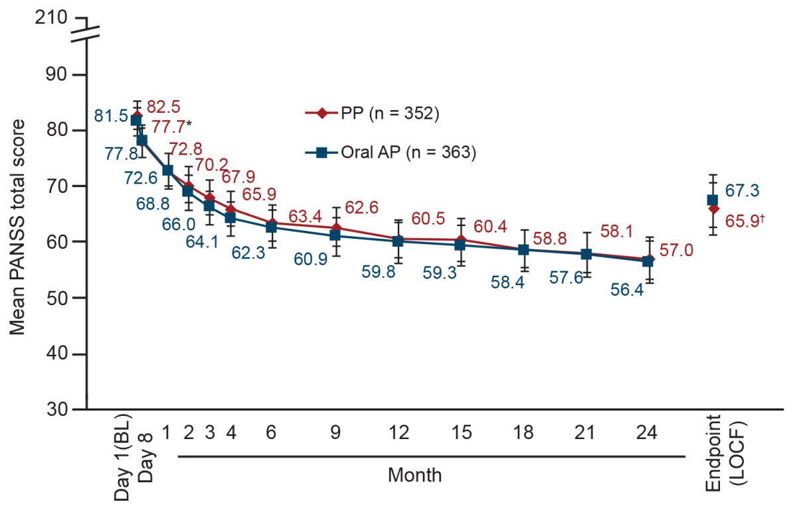
Error bars represent 95% confidence intervals.
*P=0.0213 between the PP and oral AP groups (Wilcoxon two-sample test).
†P=0.0745 between PP and oral AP groups (Wilcoxon two-sample test).
AP = antipsychotic, BL = baseline, CGI-S = Clinical Global Impression-Severity, LOCF = last observation carried forward, PP = paliperidone palmitate, PANSS = Positive and Negative Syndrome Scale.

Supplementary Fig. 2. Frequency distribution of Clinical Global Impression-Severity (CGI-S) scores over time.
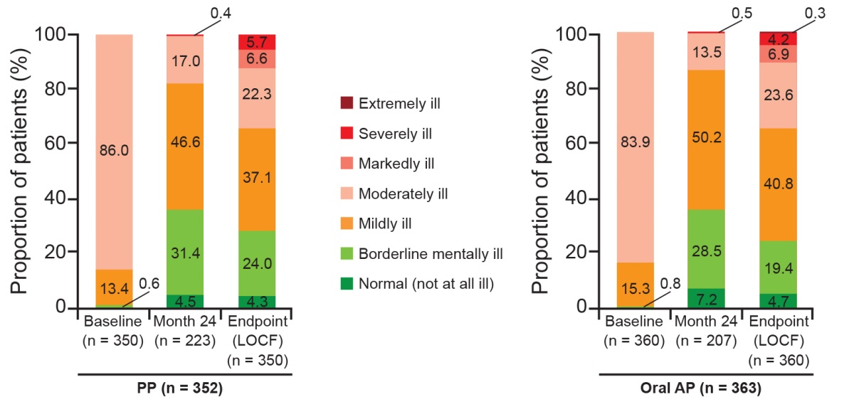
AP = antipsychotic, CGI-S = Clinical Global Impression – Severity, LOCF = last observation carried forward, PP = paliperidone palmitate.

Supplementary Fig. 3. Frequency distribution of PSP total score for PP (A) and oral APs (B).
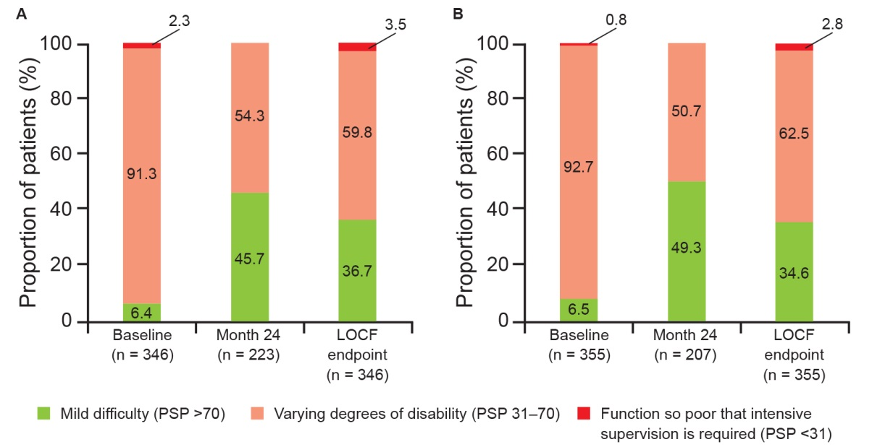
AP = antipsychotic, LOCF = last observation carried forward, PP = paliperidone palmitate, PSP = Personal and Social Performance.

