Supplementary material.
Table S1. MS/MS parameters obtained for a standard solution of isoflavones at 1000 μgL⁻¹. Optimized conditions: capillary voltage: 3500 V, nebulizer pressure: 35 psi, drying gas flow rate: 12 L min-1, temperature of the gas: 350ºC. ESI-MS spectra were acquired in positive-ion MRM mode.
Analtyte | Precursor ion (m/z) | Product ions (m/z) | Fragmentor (V) | Collision energy (V)
Daidzin | 417.1 | 255.1* | 110 | 12
Glycitin | 447.1 | 285.1*/270.1 | 90 | 8/40
Genistin | 433.1 | 271.1* | 90 | 16
Daidzein | 255.1 | 137*/199.1/91 | 150 | 28/24/40
Glycitein | 285.1 | 270*/242 | 150 | 24/32
Genistein | 271.1 | 153*/91.1 | 150 | 28/40
Formononetin | 269.1 | 197.1*/253 | 150 | 40/28
Biochanin A | 285.1 | 152*/213 | 150 | 24/40
*These product ions were used for the quantification; the rest of the product ions were used for confirmatory analysis

Table S2. Box-Behnken experimental design matrix. The letters A to E correspond to the factors in Table S2.

Experiment | A | B | C | D | E
1 | 0 | 0 | 0 | -1 | -1
2 | 0 | 0 | 0 | 1 | -1
3 | 0 | 0 | 0 | -1 | 1
4 | 0 | 0 | 0 | 1 | 1
5 | 0 | -1 | -1 | 0 | 0
6 | 0 | 1 | -1 | 0 | 0
7 | 0 | -1 | 1 | 0 | 0
8 | 0 | 1 | 1 | 0 | 0
9 | -1 | 0 | 0 | -1 | 0
10 | 1 | 0 | 0 | -1 | 0
11 | -1 | 0 | 0 | 1 | 0
12 | 1 | 0 | 0 | 1 | 0
13 | 0 | 0 | -1 | 0 | -1
14 | 0 | 0 | 1 | 0 | -1
15 | 0 | 0 | -1 | 0 | 1
16 | 0 | 0 | 1 | 0 | 1
17 | -1 | -1 | 0 | 0 | 0
18 | 1 | -1 | 0 | 0 | 0
19 | -1 | 1 | 0 | 0 | 0
20 | 1 | 1 | 0 | 0 | 0
21 | 0 | 0 | -1 | -1 | 0
22 | 0 | 0 | 1 | -1 | 0
23 | 0 | 0 | -1 | 1 | 0
24 | 0 | 0 | 1 | 1 | 0
25 | 0 | -1 | 0 | 0 | -1
26 | 0 | 1 | 0 | 0 | -1
27 | 0 | -1 | 0 | 0 | 1
28 | 0 | 1 | 0 | 0 | 1
29 | -1 | 0 | -1 | 0 | 0
30 | 1 | 0 | -1 | 0 | 0
31 | -1 | 0 | 1 | 0 | 0
32 | 1 | 0 | 1 | 0 | 0
33 | -1 | 0 | 0 | 0 | -1
34 | 1 | 0 | 0 | 0 | -1
35 | -1 | 0 | 0 | 0 | 1
36 | 1 | 0 | 0 | 0 | 1
37 | 0 | -1 | 0 | -1 | 0
38 | 0 | 1 | 0 | -1 | 0
39 | 0 | -1 | 0 | 1 | 0
40 | 0 | 1 | 0 | 1 | 0
41 | 0 | 0 | 0 | 0 | 0
42 | 0 | 0 | 0 | 0 | 0
43 | 0 | 0 | 0 | 0 | 0

Table S3: Coefficients of the factors in the selected model for each analyte together with their corresponding p-value.

Analyte |  | Factors in the selected model
Analyte |  | A | B | C | D | E | A² | B² | C² | D² | E²
Daidzin | Coefficient | 16.05 | -4.69 | 6.49 | -11.59 | 0.75
Daidzin | p-value | 0.0001 | 0.2167 | 0.0908 | 0.0037 | 0.8411
Glycitin | Coefficient | 10.61 | -2.90 | 5.11 | -0.93 | 3.31
Glycitin | p-value | 0.0016 | 0.3597 | 0.1107 | 0.7686 | 0.2969
Genistin | Coefficient | 3.96 | -0.46 | 4.47 | 5.38 | -1.95 | -15.75 | -8.10 | -10.28 | 3.18 | -10.42
Genistin | p-value | 0.1321 | 0.8589 | 0.0903 | 0.0436 | 0.4507 | 0.0016 | 0.0851 | 0.0311 | 0.4904 | 0.0290
Daidzein | Coefficient | 4.51 | -1.33 | 7.09 | 4.56 | 1.75
Daidzein | p-value | 0.1150 | 0.6374 | 0.0155 | 0.1112 | 0.5357
Glycitein | Coefficient | 5.29 | -1.18 | 5.65 | 5.75 | 2.25
Glycitein | p-value | 0.0476 | 0.6497 | 0.0351 | 0.0321 | 0.3890
Genistein | Coefficient | - | - | - | - | - | - | - | - | - | -
Genistein | p-value | - | - | - | - | - | - | - | - | - | -
Formononetin | Coefficient | 2.35 | -0.92 | 5.98 | 7.45 | 1.10
Formononetin | p-value | 0.3957 | 0.7372 | 0.0348 | 0.0097 | 0.6901
Biochanin A | Coefficient | -0.81 | 0.43 | 4.79 | 11.12 | 1.21
Biochanin A | p-value | 0.7912 | 0.8893 | 0.1229 | 0.0008 | 0.6913
A: Amount of sorbent (mg); B: extraction time (min); C: Desorption time (min); D: Volume of the desorption solvent (mL); E: pH of the desorption solvent

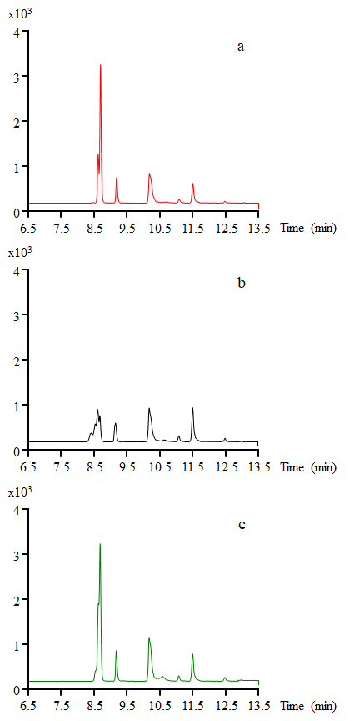
Figure S1. Influence of desorption solvent: a) MeOH, b) MeCN, c) MeCN:MeOH 1:2 (v/v).

