Uncertainty analysis of a multi-product solar grade silicon refinery: considering environmental and economic metrics
César Eduardo Cortés-Estrada¹, César Ramírez-Márquez^{1*}, José María Ponce-Ortega¹, Juan Gabriel Segovia-Hernández², Mariano Martín³
¹ Departamento de Ingeniería Química, Universidad Michoacana de San Nicolás de Hidalgo, Morelia, Mich, 58060, Mexico.
² Departamento de Ingeniería Química, Universidad de Guanajuato, Noria Alta s/n, Guanajuato, Gto., 36050, Mexico.
³ Departamento de Ingeniería Química, Universidad de Salamanca, Plza. Caídos 1-5, Salamanca 37008, España.

Abstract
Today, one of the main lines of solar energy development is the creation of environmentally friendly, waste-free and inexpensive solar grade silicon production technologies. Presently, the main solar grade silicon production technologies are based on the reduction of silicon hydrogen chloride compounds (trichlorosilane, tetrachlorosilane and silane). These technologies use environmentally hazardous compounds, such as tetrachlorosilane and silane, and compounds not resistant to high temperatures such as dichlorosilane. These production levels can only be profitable at high volumes, i.e. more than 5000 tons per year. This paper will examine the results of the optimization of a multi-product silicon refinery, where the objective functions are Profit and Eco-indicator99. The best scenario (S4) showed a tendency to maintain a balance between Profit (98.66 M$/y) and the environmental indicator Eco99 (6.04 MP/y). Similarly, an uncertainty study was carried out by varying the market prices of each of the products obtained (solar grade silicon, TEOS at different purities, and chlorosilanes) with an increase of 10% and a decrease of 10%, resulting in multiple production scenarios depending on what the market dictates. By increasing the cost of solar grade silicon by 10%, the multi-product refinery achieves the highest profit (151.84 [M$/y] with an environmental impact of 9.8 [MP/y]), and by decreasing the cost of the same silicon by 10%, the lowest environmental impact is achieved (36 [M$/y] with an environmental impact of 3 [MP/y]). Making it clear that solar grade silicon is the governing compound in the multi-product refinery.
Keywords: Solar grade silicon refinery; Uncertainty; Eco Indicator 99; Profit.
- Introduction
Pollution problems and global warming are today's challenging issues. It is because of these issues that the development of renewable energy sources is of great importance. Within the variety of renewable energies, photovoltaic (PV) power generation is considered the most promising, due to its large installation capacity and its enormous potential to reduce energy consumption which does not generate large amounts of pollutants.¹ The PV industry has been growing steadily since the end of the 20th century.² Global market demand, the Asian market growth, each country’s own regulations and international energy policies have triggered an exponential growth of the PV industry.³ According to IRENA, China's installed solar energy capacity in 2021 was 254,355 MWp, which represents 35.6% of the world's total, making it the largest market in the world.⁴ The rapid growth of the PV industry and the market is giving rise to key technologies in the energy sector ⁵, and the ratio of energy production and consumption per kilogram of solar grade silicon (Si_{SG}) has been reduced significantly, as well as the costs per PV module.⁶
However, there is a controversy about the generation of energy produced by PV since solar cells are not able to compensate for the energy consumption in their production compared to the energy consumption that they provide in their lifetime. Another debate states that PV energy is not a green nor a clean energy source due to the high energy consumption in the manufacture of each component of solar modules, especially in the production of solar grade silicon, and due to the large amount of pollutants produced during the manufacture of silicon (tetrachlorosilane, dichlorosilane, etc.).⁷ The truth is that PV system operation is almost maintenance-free and completely clean, and the problem most likely lies in the fact that the processes for obtaining solar grade silicon are designed without taking into account the environmental impact that this process could represent and only considering the economic aspect of the factory. When thinking about the environmental impact of PV power generation, one must consider quartz extraction, metallurgical silicon production, solar grade silicon production, energy consumption and pollutant emissions.⁸ It is, therefore, a priority to quantify the energy consumption and environmental impact of PV power generation to define whether PV technology is an environmentally friendly renewable energy.
Some studies have evaluated the environmental impact of PV energy. Peng & Yang⁹ examined the sustainability and environmental impact of PV-based electricity generation systems through a comprehensive review of life cycle assessment (LCA) studies of common PV systems. Peng & Yang estimated that the environmental impact of PV technologies continues to improve in the near future. Fthenakis & Kim ¹⁰ analyzed the life-cycle environmental metrics of a PV system and evaluated some life-cycle risk indicators for photovoltaics, i.e., fatalities, injuries, and peak consequences in a comparative context with other electricity generation pathways. However, these studies neither examined the environmental impact in the production of solar grade silicon nor examined the design stage of a silicon refinery. Ramírez-Márquez et al.¹¹ presented a preliminary stage of the integration of environmental metrics in the optimization of the design of a solar grade silicon plant. The limitation of the work that they presented refers to the reaction equipment, which is practically fixed at one conversion.
The aforementioned literature reviews show limited results in the design of solar grade silicon production plants. There are few works that examine the environmental impact of solar grade silicon production issues.⁹⁻¹¹ The novelty of this work is to present the integration of environmental metrics (Ecoindicator99) in the design and optimization not only of a single-product solar grade silicon plant but also in a multi-product solar grade silicon refinery. The best scenario of the multi-product refinery that not only meets the best profit, but also balances the environmental impact derived from producing each of the products of the refinery (solar grade silicon, TEOS 99.5, TEOS 99, TEOS 98.5, silane, dichlorosilane, and monochlorosilane) will be suggested. Various cases of uncertainty in the market prices of each product were studied, raising and lowering their cost by 10%. There is no work in the literature that shows an uncertainty study in this type of multi-product plant and even less in a silicon refinery. This was done to promote economically viable and environmentally friendly designs. The uncertainty analysis will aid in the understanding of market projections in the face of cost oscillations and will also help select the best plant design scenario. The following sections will show the methodology and an in-depth analysis of the results in the selection of the best design.
- Methodology
2.1 Case Study
The present work was applied to a case study of a refinery in the production of solar grade silicon by a hybrid process studied, designed and modeled in the General Algebraic Modeling System (GAMS) by Ramírez-Márquez et al. ¹² An average production capacity of 15,000 metric tons per year of polycrystalline silicon was considered.¹³ In the Supporting Information section, the subrogated models of each of the refinery sections are presented. This hybrid process takes the better part of two processes in the obtainment of solar grade silicon: The Siemens Process and the FBR Union Carbide process, as shown in Figure 1.
The hybrid process requires a higher energy demand in the production of 1 kg of solar grade silicon for its use in PV applications, and a reduction of energy consumption of the process is needed. It is essential to maintain a sustainable energy consumption in the processes so that current generations can meet their daily needs without compromising future generations. As is known, high energy consumption generates damaging effects, such as greenhouse gases, water/land/atmosphere contamination, and global warming, in our environment.
Figure 1. Process diagram of the solar grade silicon multiproduct refinery.
To evaluate and make decisions about the optimal production of the main product (Si_{SG}) and other byproducts of higher added value to the refinery, we will be taking into account two indexes (the economic profit and the Eco-Indicator99 (Eco99)) that will help us analyze the economic and environmental aspects of the process. The importance of the evaluation of these criteria is to make a reflective analysis about the profitability for the existence of the refinery and the process design involved. Both of these indexes are used not only for their importance but also because they are accessible when measuring and quantifying the economic and the environmental impact respectively.
In the next section, these indexes will be defined using the environmental and economic aspects and their objective function respectively, to implement the multi-objective optimization problem.
2.1.1 Objective function for the Economic Aspect (Profit)
This represents the economic profit of the process; the proposed objective function represents the profit of selling the solar grade silicon and the high valuable byproducts as TEOS 98.5, TEOS 99, TEOS 99.5, silane (SiH₄), dichlorosilane (SiH₂Cl₂), monochlorosilane (SiH₃Cl), where the production costs and the obtention of raw materials are taken into account.
The objective function for the economic profit is defined by the next equation:
$$maxProfit=P_{SiSG}+C_{SP}-C_{RM}-C_{Elec}-C_{Vap}-C_{Ref} (1)$$
Where $P_{SiSG}$ is the price of solar grade silicon, $C_{SP}$ is the price of the high added value products, $C_{RM}$ is the cost of raw material and the variables $C_{Elec}$, $C_{vap}$, $C_{ref}$ represent the cost of the electricity, steam and refrigerant used in the process for the production of Si_{SG} respectively, and in different energy requirements to satisfy the quantity of yielded products. A detailed economic evaluation based on the procedure proposed by Turton et al. ¹⁴ was carried out, estimating the equipment cost, production cost, maintenance, administration and manpower. This problem aims to maximize the objective function over the economic profit ($/year).
2.1.2 Objective function for the Environmental Impact (Eco-Indicator99)
For the environmental impact analysis, the environmental impact will be quantified using an Eco-Indicator. This indicator represents a measure of the environmental impact of a process, a material, or a simple activity through the life cycle analysis techniques; here, the Eco-Indicator99 methodology of Goedkoop & Spriensma will be used.¹⁵ This methodology takes into account three categories of environmental damage that are caused when an activity, a process or usage of a material is being carried out. These categories are: damage to ecosystem quality, damage to human health and damage to natural resources. All of these categories affect the environment. The extent to which an effect contributes to a category of damage is classified from 1 to 11 and a score is assigned to each one. The process units are shown in Table 1 (with a respective score assigned for the steam used in heating and the electricity consumed in refrigeration). The score of this eco-indicator is known as the Eco-Indicator Point (Pt) or Eco-Point; the scale of these points is chosen in such a way that the value of 1 Pt is representative for one thousandth of the yearly environmental load of one average European inhabitant.
Table 1. Eco-Indicador99 values for each category damage for the environment.¹⁵
It can be observed that the Eco-Indicator99 methodology is an integral approach since it takes into account eleven damage categories. This is of great importance to the chemical industry as it will aid us in the evaluation and analysis of environmental impacts caused by a process. Carbon footprint is another method that can be used to evaluate an environmental impact.
The EI99 is defined in the following equation:
$EI99 = \sum_{b}{\sum_{d}{\sum_{k∈K}{δ_{d}ω_{d}β_{b}α_{b,k}}}}$ (2)
where, $δ_{d}$is the normalization factor for damage of category d, $ω_{d}$is the weighting factor for the damage of category d, $β_{b}$ represents the total amount of chemical product b released per unit of reference flow due to direct emissions, $α_{b,k}$ is the damage caused in category k per unit of chemical product b released to the environment.
For the objective function of the environmental impact, following the Eco-Indicator99 methodology, where only the energy consumption in the hybrid process of the refinery for solar grade silicon is taken into account, is as follows:
$$\left\{\begin{matrix}Electity \\ Steam \\ Refrigeration\end{matrix}\right\}Energy consumptions (3)$$
Within the electricity consumption, according to the model of the designed process by Ramírez-Márquez et al.,¹² the amounts of the electrical energy that requires the following process units were taken into account. These are the carboreduction reactor and the deposition reactor, since these reactors require a large amount of electrical energy for their operation.
For the steam consumption, the following process units were included: the conventional distillation columns and the reactive distillation columns. These were included in the operation of their reboilers and the heat exchangers since these process units have a high energy consumption.
The objective function of the Eco-Indicator99 that measures the environmental impact is defined by:
$$minEco99=\sum_{i}{\sum_{j}{H_{steam,i} EI_{steam,j}}}+\sum_{i}{\sum_{j}{H_{Elect,i} EI_{Elect,j}}}+\sum_{i}{\sum_{j}{H_{Ref,i} EI_{Ref,j}}} (4)$$
Where $H_{steam}$ is the vapor amount used for the process units aforesaid (i) that require steam used for heating [kg/year], $EI_{steam}$ is the value of the Eco-Indicator99 for each energy category taken in this study (j), by Eco-Points per kilogram of steam [Pt/kg] as shown in Table 1 for the specific case of the steam. $H_{Elect}$ represents the amount of electrical energy used in the different process units (i) in [kW/year], whereas $EI_{Elect}$ is the value of the Eco-Indicator99 for each damage category (j) in Eco-Points per kilowatt [Pt/kW], as shown in Table 1. The term for the refrigeration energy consumption, $H_{Ref}$, represents the amount of the electrical energy used for the refrigeration (taking into account that the energy efficiency of a refrigeration system is about 70% of the process units that are required for a refrigeration utility (i) in Eco-Points per kilowatt [Pt/kW]). The term $EI_{Ref}$, represents the value of the Eco-Indicator99 for each damage category (j) used for electricity. The optimization aims to minimize the objective function for the environmental impact [Pt/year].
2.2 Multiobjective Optimization
The optimization problem was formulated as a mathematical problem that seeks to maximize the annual economic profit and simultaneously minimize the environmental impact. In the Supporting Information section, the subrogated models of each of the refinery sections are presented. The aforesaid makes a multiobjective problem. This problem will be solved applying the epsilon-constraint method, based on the solving of the original problem, and taking one of the two objective functions as the main objective function, which is subject to different lower limit values for the other objective functions. In this case study, the objective function for the economic profit of the process (1) was to take as the main objective function subject the environmental impact objective function, whereas the last objective function will be assigned different lower limit values ($δ)$ for each optimal scenario where the profit will be maximized to obtain the Pareto front with their optimal solutions. The multiobjective optimization formulation is defined by:
$$Objective function: Max Profit$$
$$Subject to: Eco99≤δ (5)$$
For the epsilon-constraint ($ε$) method, the extreme points will be first defined. The first point is the minimizing of the Eco99 function (2) without considering the economic profit, in contrast, the opposite extreme point is to maximize the profit (1) without taking into account the environmental impact. With the obtained data, the Pareto front has the upper and lower limits. It is worth noting that the underlying problem of the chemical industries lies in their pursuit to maximize their economic profit without taking into account the environmental impact and the effects that their actions can create.
The next step is to solve the optimization approach and to obtain a maximum profit taking into account an Eco-Indicator99 limit value, here, five limit values $δ$ were established with different intervals and each optimization generates a different scenario to build the Pareto front.
2.3 Uncertainty
For this study, we will take into account the uncertainty of the Si_{SG} and the optimal byproducts prices (see Table 2), within a 10% increase and 10% decrease interval. Taking this into account will help us make decisions, and to have a future projection in the different cases that the prices of the products offered by the biorefinery under study increase or decrease.
Table 2. Price of each Product.
Thus, for each one of the upper and lower limits (10% increase, 10% decrease) of the optimal byproduct prices, and taking into account the uncertainty of the prices, a new Pareto front will be built, with seven optimal scenarios, one minimizing the Eco-Indicator99, one maximizing the profit and the others subject to a different limit value for the Eco99. Therefore, for one value of the Eco-Indicator99, there will be several profit values. In this study, a mean profit will be calculated, and the models will be compared to reach a conclusion. A percentage of 10% upward and downward was decided, due to the variations of the real market in the last decade. ²³
A tool that will allow us to make a deep analysis of this study is the calculation of the standard deviation for each one of the optimal scenarios shown in the Pareto front. Moreover, the epsilon-constraint method tells us that, of the different optimal solutions, the one closest to the utopian point should be the best one. It is at this point where the minimum environmental impact and the maximum economic profit simultaneously take place.
For each upper and lower limit (10% up, 10% down) of the prices of the optimal products of the refinery, a Pareto front will be made with seven different scenarios, the first one where Eco-Indicator99 is minimized, the second one where profit is maximized and the remaining scenarios will be subject to different Eco-Indicator99 limit values, so there will be a different Pareto front for the different optimal products and their price uncertainties, but by having a variety of Pareto fronts and looking for the behavior of the analyzed variables under uncertainty it is necessary to obtain an average value, this to establish a deep and clearer analysis, since for a fixed value of Eco-Indicator99 there will be different profit values due to the analysis of the uncertainties of the products, an average of those values will be obtained and compared with the Pareto front of the original scenarios to be able to obtain conclusions. To obtain the mean of the different profits, EcoIndicator99 values were established in a range of 3 to 11 MP/y, with a scale of 0.5, in which, for each value, its corresponding profit value was noted in the different uncertainties of each optimum product, these obtained values were added and an average was obtained, this result corresponds to its corresponding EcoIndicator99 value, and so on, the obtained values were plotted to build the Pareto front of the average profit values where the uncertainty is already contemplated and to contrast it with the original curve.
3. Results and discussion
3.1 Pareto front
As mentioned above, the Pareto front for the proposed optimization model was obtained where the optimization of the economic profit for different limit values of the Eco-Indicator99 was optimized on the GAMS software. The code that contains the model of the refinery for the production of solar grade silicon has around 2,789 equations and 3,743 variables, and it is solved with the solver CONOPT. All the trials to carry out the optimization were performed, and each one of the trials takes a computing time to obtain the optimal solutions, which is around 1,200 seconds (20 minutes) using a computer with an AMD ryzen 7 CPU at 2.3 GHz and 8.00 GB RAM. Seven were the total scenarios for the optimization process. Table 3 shows the results of the values for the Eco-Indicator99 (millions of Eco-Points per year) and the profit (millions of dollars per year) for each one of the proposed scenarios.
Table 3. Optimal solutions obtained taking into count the environmental and the economic objective functions.
Taking the data obtained from Table 3, the Pareto front was built as it is shown in Figure 2. It is important to note the structure of the Pareto front performed for this study. Scenario 1 (S1) represents the minimum value of the environmental impact of the process, on the contrary, Scenario 7 (S7) represents the maximum economic profit, and the other scenarios between S1 and S7 correspond to different optimal scenarios. This means that the Pareto front contains an optimal solution for the process, subject to a different limit, and an attractive solution as well.
The area under the curve represents only suboptimal solutions, whereas the area above the curve represents infeasible solutions. This is because it makes no sense to obtain a higher profit with a lower environmental impact. However, in the Pareto front, we found the utopian point which can be used as a standard idea for the criterion values to find the best solution from the Pareto front optimal set. The minimum environmental impact has an Eco-Indicator99 value of 3.06 MP/y, whereas the maximum economic profit has a value of 138.18 M$/y.
To implement the discussion of the different optimal solutions obtained from the optimization of the model, which will allow us to make better decisions about the refinery production, a trade-off between the economic and the environmental aspect must be taken into account. Here, a criterion of the Pareto front will be considered, where the best scenario or the most optimal solution is the one that is closest to the utopian point.
Figure 2. Pareto front for environmental and economic aspects.
It can be observed in Figure 2 that the profit in each one of the scenarios is increasing at an interval of 20 M$/y approximately. In the regions that include S5, S6, and S7, there is a significant increase in terms of environmental impact. Since there is no significant increase in the economic profit among these scenarios, a choice for the best solution among these three scenarios cannot be made, as these have 10% standard deviation among them in terms of the economic profit. On the contrary, among scenarios S2, S3, S4 and S5, a significant increase in the function of profit among them can be observed, so the choice for the best solution can be discussed as there is not a great difference among them in the value of the environmental impact function, which is about 20-30% of deviation among these scenarios.
Table 4. Percentage of deviation between the different scenarios and the utopian point.
A tool that will allow us to make a deep analysis in the decision-making of this study is the percentage of deviation for each one of the optimal solutions shown in the Pareto front concerning the utopian point, as is shown in Table 4. Here, it is established how far each scenario is concerning the utopian point. In other words, how far each optimal solution is to the minimum environmental impact as well as to the maximum economic profit. Out of all these optimal scenarios, the one that most compensates environmental and economic aspects is Scenario 4 (S4), with an Eco-Indicator99 value of 6.0355 MP/y and a profit value of 98.66 M$/y. Scenario (S4) is the closest to the utopian point and it is chosen as the optimal solution.
Figure 3. Production of silicon and products of high added value in each scenario.
An optimal amount of Si_{SG} production is determined through the optimization of each scenario. An optimal production of the byproducts of high added value that are considered in the refinery is also calculated. All the products taken into account are: Solar grade silicon (Si_{SG}), TEOS at 98.5, 99 and 99.5% purity, silane, monochlorosilane and dichlorosilane. For each one of the optimal scenarios, there is an amount of production of these lists of products (see Figure 3). It was observed in different scenarios, like the production of a certain amount of any product in the refinery, for example, that the process will stop producing others, and the energy demand for steam, refrigeration and electricity for the different scenarios will vary depending on the products to be produced. Since different amounts of energy will be required for different scenarios, thus, the energy requirements will change and the operating conditions of the processes will change as well.
The highest profit has the highest amount of solar grade silicon production, the highest amount of dichlorosilane production, and a small amount of TEOS 99% purity and monochlorosilane to cause the minimum environmental impact. It is the refinery that tends to produce around 5,000 ton/y of Si_{SG} and 8,000 ton/y of dichlorosilane. For this reason, other byproducts, like the ones mentioned above, would stop being produced.
It is important to note that in all the proposed scenarios, the production of dichlorosilane and Si_{SG} is active. This is evident since the Si_{SG} guarantees the profitability of the refinery. In this study, the minimum environmental impact is not a zero in the Eco-Indicator99 because the model optimized was always pursuing an optimal profit in the production of the Si_{SG} and dichlorosilane. If we desired to obtain a zero environmental impact, then nothing would be produced, which means that refineries would not exist.
An attractive option as the best optimal solution is Scenario 5 (S5). It is important to note that S5 has a disadvantage since this scenario produces higher amounts of TEOS in its different purities (98.5, 99 and 99,5). This implies a higher energy consumption that translates to a higher value of environmental impact. However, this aspect is still an attractive solution since this scenario has a deviation of 15% concerning the maximum economic benefit that can be obtained in the process.
With regards to the scenario chosen as the optimal solution (S4), there is an optimal and balanced production between the different byproducts, which guarantees the profitability of the process. Here, only the production of TEOS 99.5% purity is excluded. In other words, the higher the required purity, the higher the environmental impact of the refinery is. This scenario has a deviation of 49.3% concerning the minimum Eco-Indicator99 that the process may have. It also has a deviation of 40% from the maximum economic benefit that can be obtained. A midpoint or a trade-off between the economic and environmental aspects can be observed. In this scenario, the production of solar grade silicon is about 10,880 ton/year, 149 ton/year of TEOS 98.5, 15 ton/year of TEOS 99, 0.5 ton/year of silane, 1382 ton/year of dichlorosilane and 16 ton/year of monochlorosilane.
It is interesting to note that the higher the purity requirement is, the greater the energy consumption in the process equipment is too, such as in the conventional and reactive distillation columns. This can be observed in Figure 4. For a higher reboiler duty, the environmental impact value will be greater in the graphs, as it must meet a higher energy demand for the global process. This is because the distillation operation also involves considerable cooling and energy needs. Therefore, by reducing byproducts of high added value, utility consumption will be reduced as well.
Figure 4 describes the contribution of the three different utilities (electricity, steam and refrigerant) to the total environmental impact quantified on each scenario. It is important to note that the energy used for refrigeration has a greater impact on the environment than the other two. Used steam does not significantly impact the environment as it would be expected due to the higher temperatures of the process. The energy consumption of the scenarios with minimum Eco-Indicator99 values (S1, S2, S3) is lower and their use of electrical energy is higher which represents 20-30% of the total environmental impact of each scenario. In the scenarios where the Eco-Indicator99 value is given greater flexibility, more refrigerant is commonly used, which means that most of its negative environmental impact is caused by the use of refrigeration in the process.
From the analysis of the design and operating conditions presented in Table 5, it is apparent that each operating unit requires different conditions to meet production, profit and environmental care requirements. Depending on the production demand, the equipment will require a greater or lesser amount of energy. The more energy that is used, the greater the environmental impact will be. In S4, Table 4 shows an increase in both the carboreduction reactor temperature (2676 K) and in the deposition (1434 K), combined with a low value of H₂/SiCl₄ (1.54). This combination of operating conditions generates a medium production scenario of both trichlorosilane and tetrachlorosilane, which is mandatory since the system is forced to produce a considerable amount of solar grade silicon and a large amount of TEOS 99, TEOS 98.5, silane, dichlorosilane, and monochlorosilane, in order to obtain the highest possible profit. The results show that it is the process with the highest production of TEOS 98.5 (149.21 ton/y), which is reflected in high profit and low environmental impact.
Figure 4. Influence to the Eco-Indicator99 of the energy consumption in each scenario.
Table 5. Operating conditions of each scenario.
3.2 Uncertainty analysis
If we asked the question, what would happen if the selling prices of the solar grade silicon and the products of high added value increased or decreased by 10%? An answer could be given or explained by the uncertainty. Figure 5 shows a comparison between the Pareto front of the original model and the Pareto front under each uncertainty of the sale prices of the products. Figure 5 shows how Profit and Eco-indicator99 move depending on the demand of the product to be manufactured. It is evident that by increasing prices by 10%, the model tends to produce the component of interest. However, this has an impact on Eco-indicator99, an example is given in high purity products such as TEOS 99.5. When they require a high reboiler duty, Eco-indicator99 shoots up. A similar phenomenon happens when reducing prices by 10%, the model tends to the production of other components of interest to raise the profit, compromising the environmental impact. However, there are also balanced solutions to obtain an adequate profit without compromising the environment.
Multiple scenarios can be inferred from Figure 5. The first and most important is the large influence of the price of solar grade silicon. By increasing its price by 10%, the profit rises by 54.91% (higher profit case) with respect to the original Pareto scenario S4. At the same time, decreasing the price of silicon by 10% in the lower environmental impact scenario reduces it by 49.75% with respect to the original Pareto S4. This means that the price of silicon in the multi-product refinery has the greatest impact on both economic and environmental metrics. Among the other products, there are two that have a favorable trend in terms of price variation. Such is the case of monochlorosilane and TEOS 99.0, both with a 10% price increase. The effect of both products is seen in their proximity to the utopian point. In this scenario, the multiproduct refinery gives a profit of 101.66 [M$/y] and an environmental impact of 4.77 [MP/y] with the uncertainty of TEOS 99. And with the uncertainty in monochlorosilane the refinery gives a scenario with a profit of 81.19 [M$/y] and an environmental impact of 3.51 [MP/y]. All this means that the multi-product refinery design can have variants as the market dictates. This is not convenient in terms of design, so it is important to visualize the behavior of the multi-product refinery by having an "average" Pareto front of the uncertainties presented.
Figure 6 shows a plot of the mean values obtained from the uncertainty plots. Considering the uncertainty of the prices, the values of the objective functions show a better estimate for case studies in the future and decision making becomes a trade-off between an increase and a decrease in prices since an average economic benefit is being considered.
It is important to note that the original model fits great with the model under uncertainty. It can be observed that the solar grade silicon production governs the model under uncertainty. This means that in order to have the minimum environmental impact, only solar grade silicon and dichlorosilane should be produced, (because they are the main contributors to economic profit) but this, by itself, would not be profitable. The greater the number of byproducts of higher added value that are produced, the greater the environmental impact of the refinery will be. The higher the purity of the byproducts is, the greater the energy demand is as well.
For Eco-Indicator99 values from 4 to 6 MP/y, it is observed that in the model under uncertainty, the economic profit increases significantly over the original Pareto front because in these scenarios the production of the different high added value byproducts predominates, while, in other values of environmental impact and economic profit, the scenario does not change significantly from the original model.
Figure 5. Pareto front of each model in the face of uncertainties in selling prices by 10% upward and 10% downward.
Figure 6. Pareto front of the original model and the model under uncertainty.
4 Conclusions
To reduce emissions and move towards a complete economy with a low environmental impact, green technologies must be promoted. However, many critical elements are needed to manufacture green technologies and, as discussed in the article, the availability of optimizing a design under environmental and economic metrics can produce constraints and bottlenecks that must be avoided. Knowing what to produce and how much of it to produce combined with the best design of a green multiproduct silicon refinery can be critical from a supply-demand point of view and can favor the promotion of policies related to equipment design, substitution and efficiency, capable of avoiding these bottlenecks. In the scenario analysis of the selected multi-product solar grade silicon refineries, different constraints in terms of product demand, profit, and environmental impact have been identified. The best scenario (S4) showed a tendency to maintain a balance between Profit (98.66 M$/y) and the environmental Eco-indicator99 (6.04 MP/y). It should be noted that not all commercially available products have the same impact on the environment. For example, TEOS 99.5, the permanent energy demand is higher than in the case of TEOS 99 or TEOS 98.5. This issue must be analyzed in-depth in order to define adequate design strategies to avoid the non-production of any component that the market demands. It is because of this reason that the optimization and design methodology under economic and environmental impact metrics shown in this work are so useful, and could become generalized methodologies for other types of multi-product industrial factories. In combination, the uncertainty study helped to envision the possible scenarios of profit and environmental impact of the multi-product solar grade silicon refinery designs, under the perspective of current market oscillation. Among all the uncertainty scenarios presented, the case of a 10% increase and decrease in the price of solar grade silicon is the most significant, predicting a 54.91% increase in profit in the best scenario and a 49.75% decrease in environmental impact in the lowest impact scenario.
5 Acknowledgements
The authors acknowledge CONACyT (Mexico).
6 Abbreviations
$/kg Dollars per kilogram.
$C_{Elec}$ Cost of the electricity.
$C_{RM}$ Cost of raw material.
$C_{SP}$ Price of the high added-value products.
$C_{ref}$ Cost of the refrigerant.
$C_{vap}$ Cost of the steam.
$H_{Elect}$ Amount of electrical energy.
$H_{Ref}$ Amount of the electrical energy used for the refrigeration.
$H_{steam}$ Vapor amount (i).
$P_{SiSG}$ Price of solar grade silicon.
$α_{b,k}$ Damage caused in category k per unit of chemical product b released to the environment.
$β_{b}$ Represents the total amount of chemical product b released per unit of reference flow due to direct emissions.
$δ_{d}$ Normalization factor for damage of category d.
$ω_{d}$ Weighting factor for the damage of category d.
b Unit cost of each raw material.
c Cost of each utility E.
C1 Column 1.
C2 Column 2.
Col RD Reactive distillation Column.
DFR Distillate to feed ratio.
E Utility.
FR Feed ratio.
Hy Hydrochlorination reactor.
kg/h kilogram per hour.
kg/year Kilogram per year.
M$/y Millions of dollars per year.
N/A Not apply.
NLP Nonlinear programming.
P Pressure.
Pt/kg Eco-Points per kilogram of steam.
RM Raw material.
RR Reflux ratio.
SiH₂Cl₂ Dichlorosilane.
SiH₃Cl Monochlorosilane.
SiH₄ Silane.
Si_{SG} Solar grade silicon.
T Temperature.
T_{Ca} Thermal carboreduction.
TEOS Tetraethoxysilane.
ε Epsilon-constraint.
$EI_{Elect}$ Value of the Eco-Indicator99 for each damage category (j).
$EI_{Ref}$ Value of the Eco-Indicator99 for each damage category (j) used for electricity.
$EI_{steam}$ Value of the Eco-Indicator99 for each energy category (j).
7 References
(1) Lips, D.; Schuurmans, J. M.; Dos Santos, F. B.; & Hellingwerf, K. J. Many ways towards ‘solar fuel’: quantitative analysis of the most promising strategies and the main challenges during scale-up. Energy Environ. Sci., 2018, 11(1), 10-22. DOI:10.1039/C7EE02212C
(2) Zou, C.; Zhao, Q.; Zhang, G.; & Xiong, B. Energy revolution: From a fossil energy era to a new energy era. Nat. Gas Ind. B, 2016, 3(1), 1-11. https://doi.org/10.1016/j.ngib.2016.02.001
(3) de Souza, L. E. V.; & Cavalcante, A. M. G. Towards a sociology of energy and globalization: Interconnectedness, capital, and knowledge in the Brazilian solar photovoltaic industry. Energy Res. Soc. Sci., 2016, 21, 145-154. https://doi.org/10.1016/j.erss.2016.07.004
(4) Tu, Q.; Mo, J., Liu, Z.; Gong, C.; & Fan, Y. Using green finance to counteract the adverse effects of COVID-19 pandemic on renewable energy investment-The case of offshore wind power in China. Energy Policy, 2021, 158, 112542. https://doi.org/10.1016/j.enpol.2021.112542
(5) Ha, Y. H.; & Byrne, J. The rise and fall of green growth: Korea's energy sector experiment and its lessons for sustainable energy policy. Wiley Interdiscip. Rev.: Energy Environ., 2019, 8(4), e335. https://doi.org/10.1002/wene.335
(6) Hou, G.; Sun, H.; Jiang, Z.; Pan, Z.; Wang, Y.; Zhang, X.; ... & Yao, Q. Life cycle assessment of grid-connected photovoltaic power generation from crystalline silicon solar modules in China. Appl. Energy, 2016, 164, 882-890. https://doi.org/10.1016/j.apenergy.2015.11.023
(7) Monteiro Lunardi, M.; Wing Yi Ho‐Baillie, A.; Alvarez‐Gaitan, J. P.; Moore, S.; & Corkish, R. A life cycle assessment of perovskite/silicon tandem solar cells. Prog. Photovolt.: Res. Appl.., 2017, 25(8), 679-695. https://doi.org/10.1002/pip.2877
(8) Pacca, S.; Sivaraman, D.; & Keoleian, G. A. Parameters affecting the life cycle performance of PV technologies and systems. Energy Policy, 2007, 35(6), 3316-3326. https://doi.org/10.1016/j.enpol.2006.10.003
(9) Peng, J.; Lu, L.; & Yang, H. Review on life cycle assessment of energy payback and greenhouse gas emission of solar photovoltaic systems. Renew. Sust. Energ. Rev., 2013, 19, 255-274. https://doi.org/10.1016/j.rser.2012.11.035
(10) Fthenakis, V. M.; & Kim, H. C. Photovoltaics: Life-cycle analyses. Sol Energy, 2011, 85(8), 1609-1628. https://doi.org/10.1016/j.solener.2009.10.002
(11) Ramirez-Marquez, C.; Contreras-Zarazúa, G.; Martín, M.; & Segovia-Hernández, J. G. Safety, economic, and environmental optimization applied to three processes for the production of solar-grade silicon. ACS Sustain. Chem. Eng., 2019, 7(5), 5355-5366. https://doi.org/10.1021/acssuschemeng.8b06375
(12) Ramírez-Márquez, C.; Martín-Hernández, E.; Martín, M.; & Segovia-Hernández, J. G. Optimal portfolio of products in a polycrystalline silicon refinery. Ind. Eng. Chem. Res., 2020, 59(22), 10552-10567. https://doi.org/10.1021/acs.iecr.0c01006
(13) Rubber & Plastics News Report, Wacker to build silica plant in Tenn. https://www.rubbernews.com/article/20161214/NEWS/161219980/wacker-to-build-silica-plant-intenn, 2016.
(14) Turton R.; Bailie R. C.; Whiting W.B.; Shaeiwitz J.A.; Bhattacharyya D. Analysis, synthesis and design of chemical processes. Pearson Education, 2012.
(15) Goedkoop, M.; & Spriensma, L. Eco-Indicator 99: Manual for designers, a damage oriented method for life cycle impact assessment. Methodology Report, 2000.
(16) PVinsights, PVinsights Grid the world. United States of America Publishing. Recovered from http://pvinsights.com/, 2021.
(17) Alibaba, Product Listing Policy. https://www.alibaba.com/product-detail/REACH-verified-producer-supply-High Quality_60719460163.html?spm=a2700.7724857.normalList.2.2d6a243cK662pK&bypass=true, 2021.
(18) Alibaba, Product Listing Policy. https://www.alibaba.com/product-detail/Tetraethyl-orthosilicate-TEOS-CAS-78-10_1299681072.html?spm=a2700.7724857.normalList.2.12192296hSVZQb&s=p, 2021.
(19) Alibaba, Product Listing Policy. https://spanish.alibaba.com/product-detail/cas-78-10-4-super-low-price-tetraethylsilane-tetraethyl-orthosilicate-60813279070.html?spm=a2700.8699010.normalList.29.1eac341fplwUSq, 2021.
(20) Focus Technology Co., Made-in-China Connecting Buyers with Chinese Suppliers. https://dswgascylinder.en.made-in-china.com/product/pCAmYNLFhuhl/China-99-9999-Sih4-Silane.html, 2021.
(21) American Elements. American Elements, Dichlorosilane. https://www.americanelements.com/dichlorosilane-4109-96-0, 2021.
(22) Zibo Hangyu Import&Export Co., Ltd, Chlorosilane. https://hangyuchemical.lookchem.com/products/CasNo-13465-78-6-Chlorosilane-23107353.html, 2021.
(23) Bernreuter Research Polysilicon Markets Reposts, Polysilicon Price Trend. https://www.bernreuter.com/polysilicon/price-trend/, 2021.

Table 1. Eco-Indicador99 values for each category damage for the environment.¹⁵
Damage category | Steam (Eco-Points/kg) |  | Electricity (Eco-Points/kWh)
Carcinogenic effects |  | $$1.18×{10}^{-4}$$ |  | $$4.360×{10}^{-4}$$
Climate change |  | $$1.27×{10}^{-3}$$ |  | $$4.07×{10}^{-3}$$
Ionizing radiation |  | $$1.91×{10}^{-6}$$ |  | $$8.94×{10}^{-5}$$
Ozone layer depletion |  | $$7.78×{10}^{-7}$$ |  | $$5.41×{10}^{-7}$$
Respiratory effects |  | $$1.56×{10}^{-3}$$ |  | $$1.01×{10}^{-5}$$
Acidification |  | $$1.21×{10}^{-4}$$ |  | $$9.88×{10}^{-4}$$
Ecotoxicity |  | $$2.85×{10}^{-4}$$ |  | $$2.14×{10}^{-4}$$
Land-use |  | $$8.60×{10}^{-5}$$ |  | $$4.64×{10}^{-4}$$
Fossil resources |  | $$1.24×{10}^{-2}$$ |  | $$1.01×{10}^{-2}$$
Mineral extraction |  | 8.87$×{10}^{-6}$ |  | $$5.85×{10}^{-5}$$

Table 2. Price of each Product.
 | Original | 10% up | 10% down
Price of Polycrystalline Silicon [$/kg] | 6.86 ¹⁶ | 7.54 | 6.17
Price of TEOS 99.5 [$/kg] | 3.75 ¹⁷ | 4.12 | 3.37
Price of TEOS 99.0 [$/kg] | 2.50 ¹⁸ | 2.75 | 2.25
Price of TEOS 98.5 [$/kg] | 1.50 ¹⁹ | 1.65 | 1.35
Price of SiH₄ [$/kg] | 88.44 ²⁰ | 97.28 | 79.59
Price of SiH₂Cl₂ [$/kg] | 3.67 ²¹ | 4.03 | 3.30
Price of SiH₃Cl [$/kg] | 3.0 ²² | 3.30 | 2.70

Table 3. Optimal solutions obtained taking into count the environmental and the economic objective functions.
Escenario | Eco99 [MP/y] | Profit [M$/y]
Minimum Eco99: S1 | 3.06 | 48.4
S2 | 4.4557 | 58.39
S3 | 5.6486 | 81.19
S4 | 6.0355 | 98.66
S5 | 6.9055 | 119.18
S6 | 9 | 132.1
Maximum Profit: S7 | 10.81 | 138.18

Table 4. Percentage of deviation between the different scenarios and the utopian point.
Optimal scenario | % Deviation Min Eco99 | % Deviation Max Profit
S2 | 31.32% | 136.65%
S3 | 45.83% | 70.19%
S4 | 49.30% | 40.06%
S5 | 55.69% | 15.94%
S6 | 66.00% | 4.60%

Table 5. Operating conditions of each scenario.
 | TCa | Hy |  |  | Separation |  |  |  | Col RD TEOS |  |  |  |  |  | Col RD SiH₄ – SiH₂Cl₂- SiH₃Cl |  |  |  |  |  | Siemens
 |  |  |  |  | C1 |  | C2 |  | 98.5 |  | 99.0 |  | 99.5 |  | SiH₄ |  | SiH₂Cl₂ |  | SiH₃Cl
 | T [K] | T [K] | P [kPa] | H₂/SiCl₄ | FR | RR | FR | RR | RR | P [kPa] | RR | P [kPa] | RR | P [kPa] | DFR | RR | DFR | RR | DFR | RR | T [K]
S1 | 2600 | 515.2 | 2026.5 | 1.45 | 2.17 | 14.94 | 7.24 | 59.99 | N/A | N/A | N/A | N/A | N/A | N/A | N/A | N/A | N/A | N/A | N/A | N/A | 1372
S2 | 2608 | 552.2 | 2002.9 | 1.68 | 2.16 | 31.81 | 7.11 | 66.26 | 1.90 | 101.32 | 1.37 | 101.32 | 1.21 | 101.32 | 0.25 | 61.2 | 0.50 | 25.8 | N/A | N/A | 1497
S3 | 2600 | 373.2 | 2026.5 | 1.04 | 2.17 | 46.01 | 7.55 | 73.17 | 1.90 | 101.32 | 1.37 | 101.32 | 1.21 | 101.32 | N/A | N/A | 0.50 | 25.8 | 0.33 | 24.3 | 1491
S4 | 2676 | 373.1 | 2026.5 | 1.54 | 2.17 | 46.01 | 7.55 | 73.17 | 1.90 | 101.32 | 1.37 | 101.32 | N/A | N/A | 0.25 | 61.2 | 0.50 | 25.8 | 0.33 | 24.3 | 1434
S5 | 2701 | 573.1 | 1736.3 | 5.00 | 2.09 | 14.66 | 5.74 | 73.75 | 1.90 | 101.32 | 1.37 | 101.32 | 1.21 | 101.32 | 0.25 | 61.2 | 0.50 | 25.8 | 0.33 | 24.3 | 1494
S6 | 2998 | 373.1 | 2026.5 | 1.04 | 2.17 | 74.18 | 7.55 | 90.01 | N/A | N/A | N/A | N/A | N/A | N/A | N/A | N/A | N/A | N/A | N/A | N/A | 1500
S7 | 2780 | 373.1 | 2026.5 | 2.28 | 2.12 | 80.00 | 7.30 | 59.99 | N/A | N/A | 1.37 | 101.32 | N/A | N/A | N/A | N/A | N/A | N/A | 0.33 | 24.3 | 1500
* TCa=Thermal Carboreduction; Hy=Hydrochlorination Reactor; C1= Column 1; C2= Column 2; Col RD= Reactive distillation Column; T= Temperature; P=Pressure; FR= Feed Ratio; RR= Reflux Ratio; DFR=Distillate to feed ratio; N/A=Not apply.

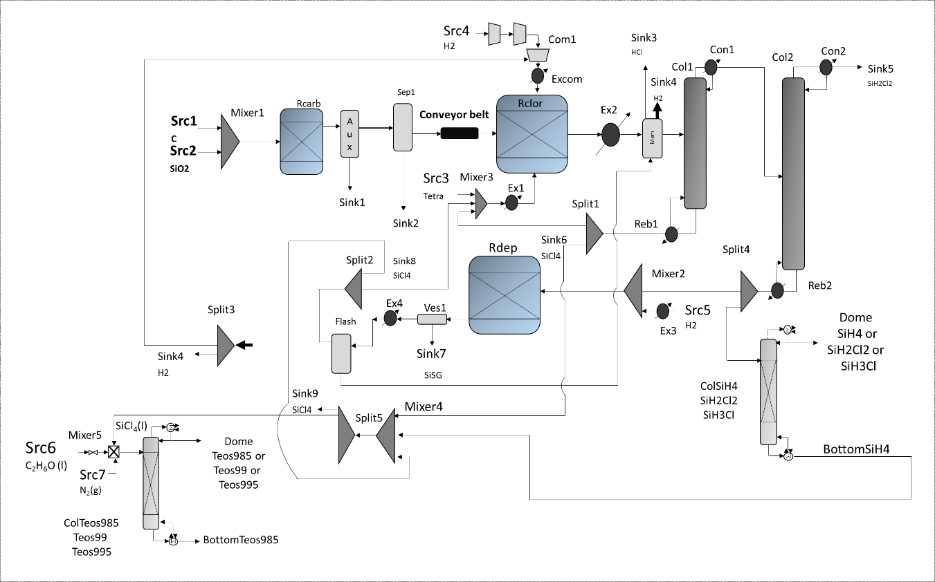
Figure 1. Process diagram of the solar grade silicon multiproduct refinery.
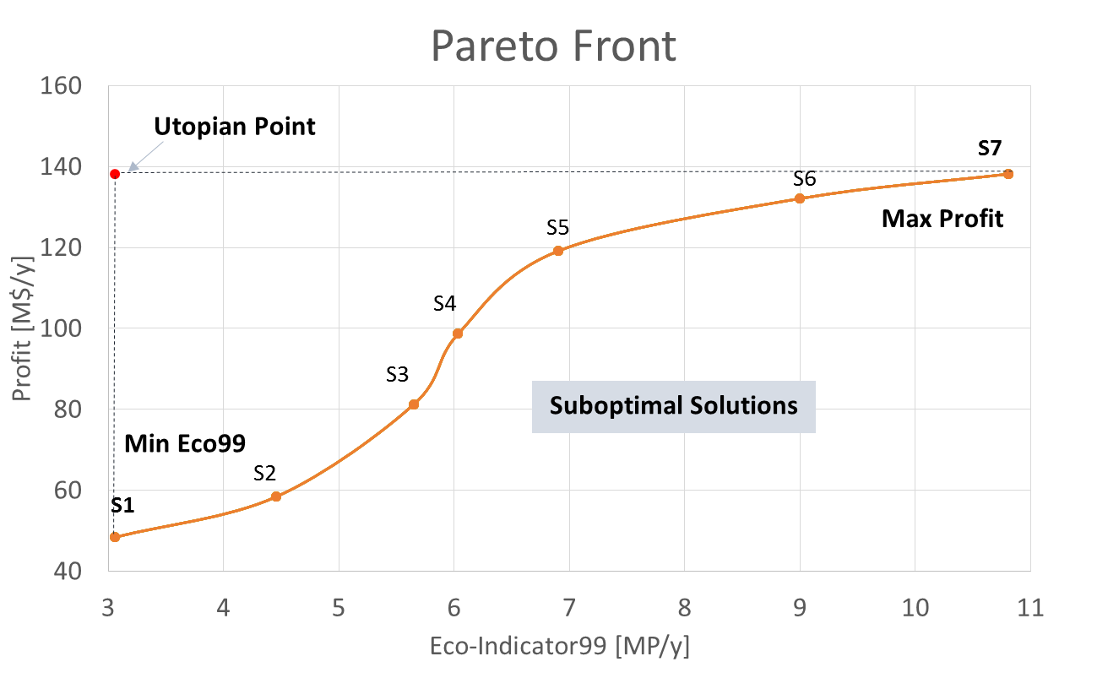
Figure 2. Pareto front for the environmental and economic aspects.
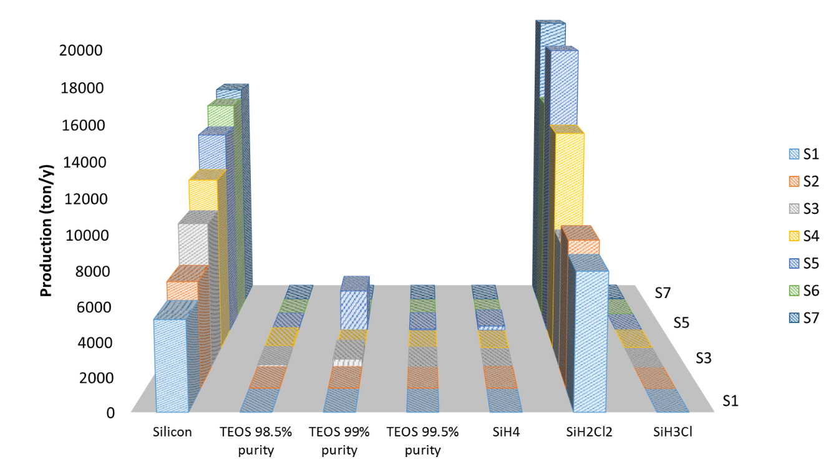
Figure 3. Production of silicon and products of high added value in ecah scenario.
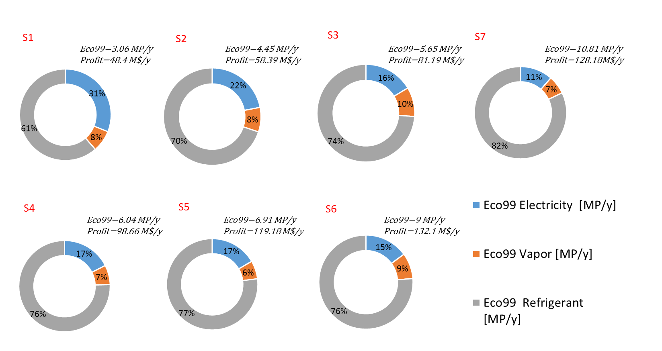
Figure 4. Influence to the Eco-Indicator99 of the energy consumption in each scenario.

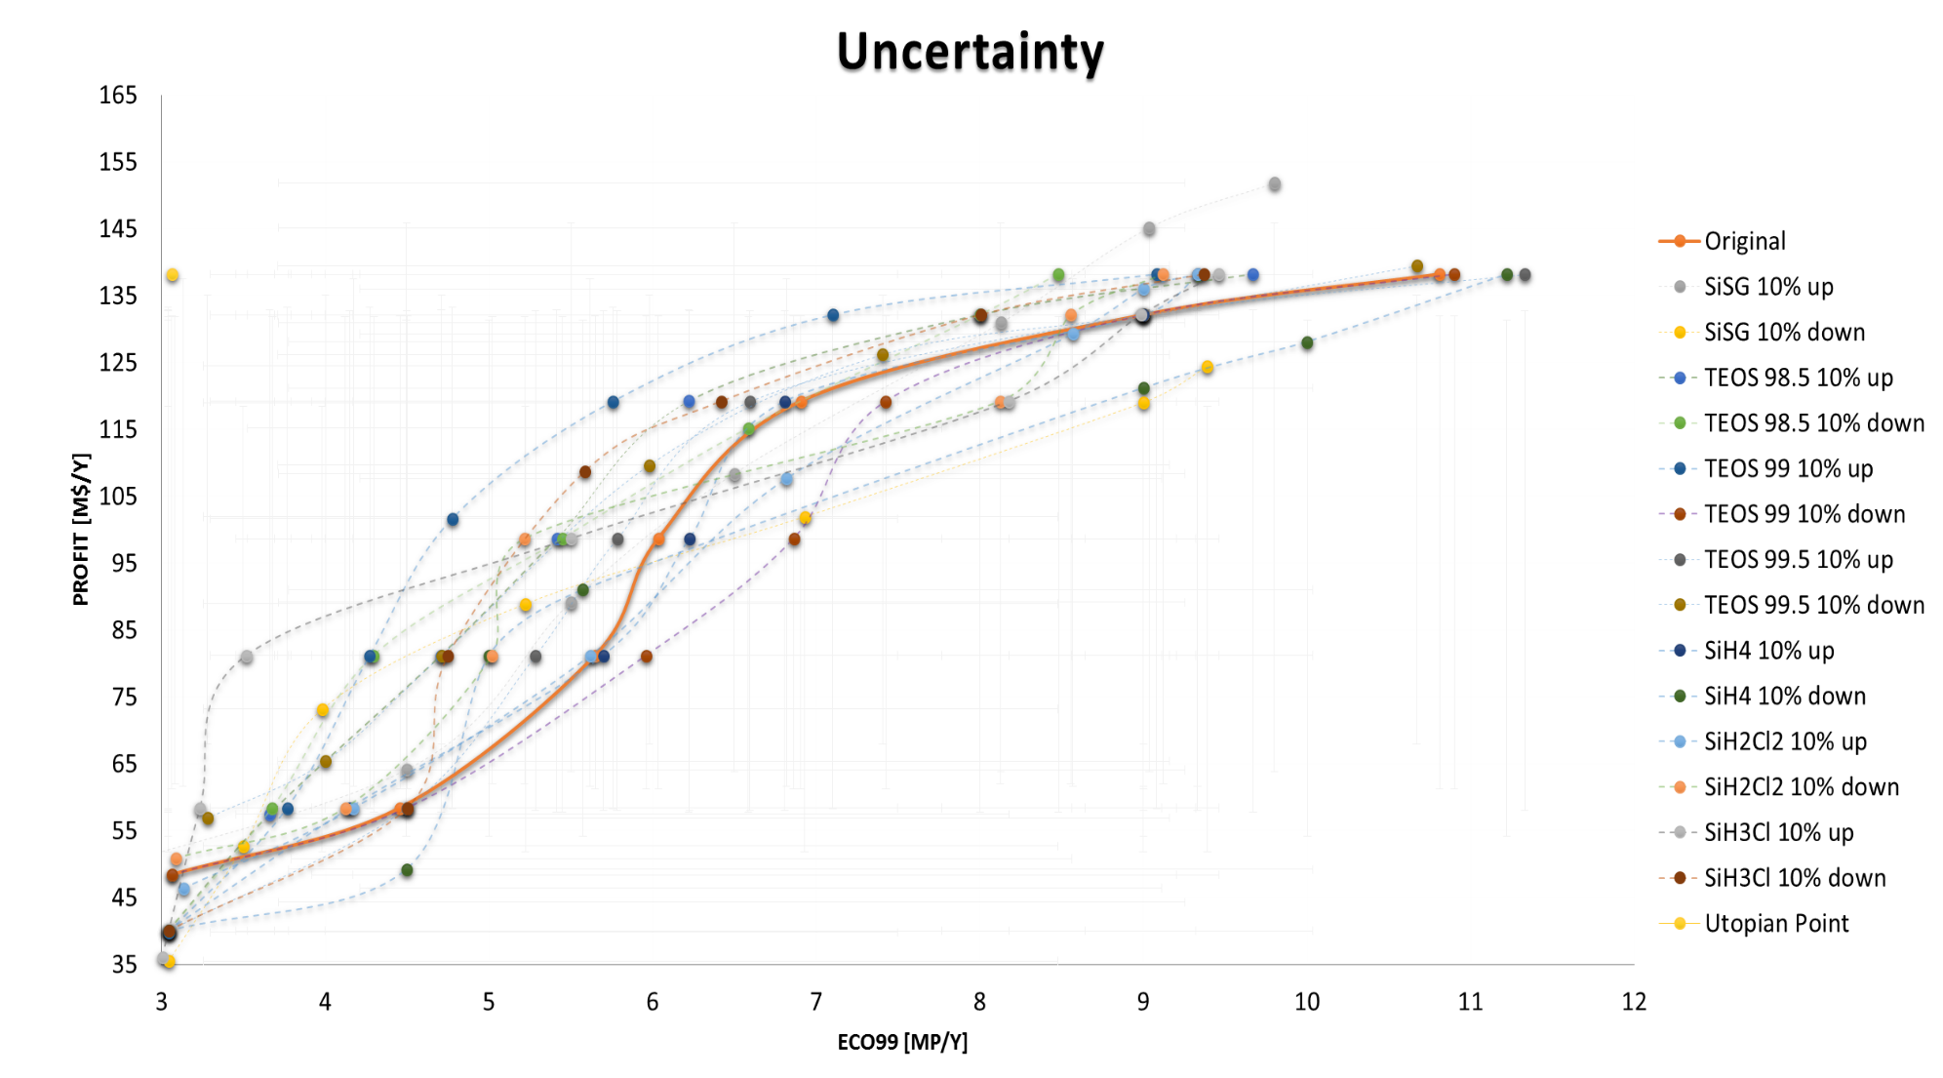
Figure 5. Pareto front of each model in the face of uncertainties in selling prices by 10% upward and 10% downward.
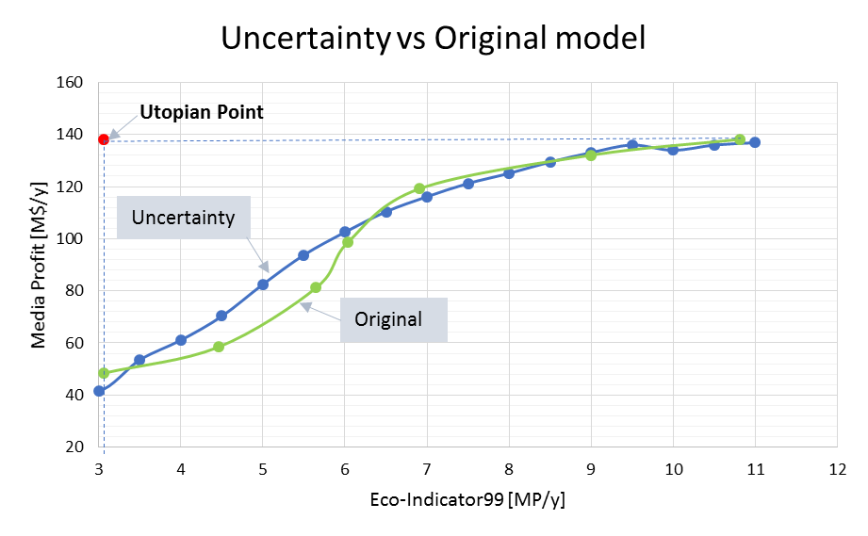
Figure 6. Pareto front of the original model and the model under uncertainty.

For table of contents only
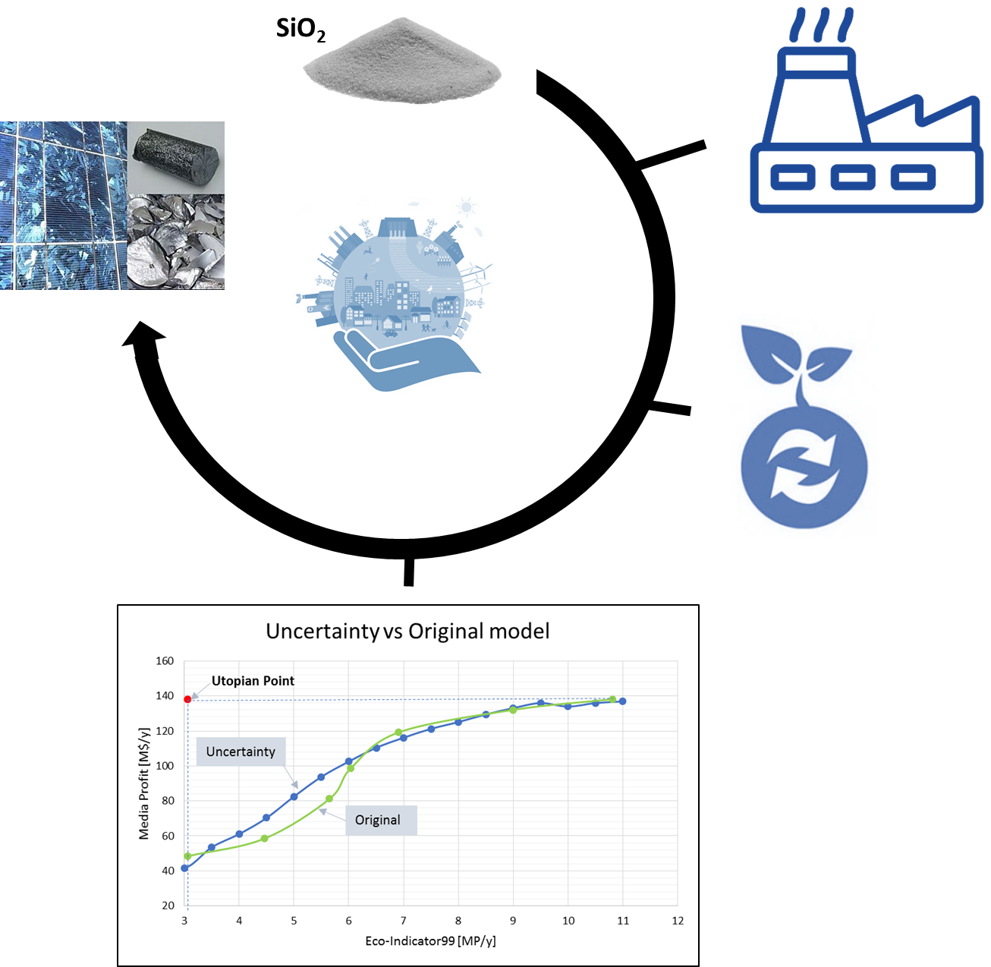

Uncertainty analysis of a multi-product solar grade silicon refinery: considering environmental and economic metrics

