Generation of a Surrogate Compartment Model for Counter-Current Spray Dryer. Fluxes and Momentum Modeling.

Borja Hernández^{1,2}, Mark A. Pinto¹, Mariano Martín^{2*}

1 Corporate Functions, Research and Development, Newcastle Innovation Centre, Procter & Gamble, Newcastle upon Tyne, NE12 9BZ, United Kingdom.
2 Department of Chemical Engineering, Salamanca, Plza. Caídos, 1-5, 37008, Salamanca, Spain.
*Corresponding Author: mariano.m3@usal.es
Abstract
This work presents the development of a reduced order compartment model for a counter-current spray dryer. The compartment model is formulated using adaptable compartments and introducing the use of correlations based on dimensionless groups. These correlations can capture the mean residence time they but are unable to reproduce the variance of the entire residence time distribution (RTD). Limitations are also observed in the evaluation of internal fluxes. The application of these correlations to a specific zone requires the inclusion the geometrical modifications in any part of the unit. A small internal modification in one geometry not only modifies a zone, but also influences the remaining regions so that the zones cannot be independently scaled-up. The methodology is complemented with an analysis of the RTD showing that most of the dispersion generated takes place in the bottom cone.

Highlights:
- Compartments are adapted to different operating conditions by means of reduced models.
- A general description of the system can be carried out with dimensionless groups.
- The zones of the dryer cannot be independently scale-up.
- Statistical methods are still needed to increase the accuracy of the model.
- The equivalent type of reactor is identified within each region for a counter-current spray dryer.
Keywords: Compartment modeling, CFD-DPM, scale-up, spray drying.
- INTRODUCTION.
Computational Fluid Dynamic (CFD) and Discrete Element Method (DEM) models have been widely used for understanding the internal fluxes, momentum and spatial distribution of the properties in unit operations. They have a wide range of applications in process and product design in chemical, pharmaceutical and metallurgical industries. However, these rigorous models involve a high computational cost. One of the alternatives proposed for the reduction of this cost is the use of Compartment Models (Haag et al., 2018). Following the reviews of Haag et al. (2018) and Jourdan et al. (2019) we can classify compartment models into two types of approaches: those based on equivalent reactor networks, namely systemic compartment models, and those based on the topological description within the unit. Each of the approaches is described below and their main characteristics are summarized in Table 1.
The first approach has been extensively used in process modeling to study the system dynamics within the entire unit or in well distinguished phenomenological zones (Haag et al., 2018). This approach, typically used for tracing (Danckwerts, 1953; Levenspiel, 2004; Nauman, 2008), has been applied to a wide range of systems such as water-treatment (Laurent et al., 2015), pharmaceutics (Gernaey et al., 2012; Ierapetritou et al., 2016), bioreactors (Ben Gaida et al., 2012) or particulate processes (Gao et al., 2012). In some cases, the approach has been used to characterize the system dynamics and its stability for a set of experimental trials (Harris et al., 2003; Engisch & Muzzio, 2016; García-Muñoz et al., 2019; Kruisz et al., 2019) and address control strategies (Bhaskar et al., 2017; Su et al., 2019). However, in modeling-focused works the objective has been to determine the residence time distribution (RTD), with RTD parameters fitted as a function of the operating conditions (e.g. material properties (Escotet-Espinoza et al., 2019), rotation rate, loads) from experimental characterization (Gao et al., 2011; Ben Gaida et al., 2012) or simulations based on rigorous models (Dubey et al., 2011). Although the reactor network of these elaborated approaches is flexible, the models still involve errors due to small oscillations that cannot be captured (Haag et al., 2018). Furthermore, they are also limited in their description of the internal distribution of properties. As a result, the remaining mechanisms such as the mass transfer may need to be characterized for every new operating condition to ensure an accurate prediction. This does not allow the reapplication of kinetic models characterized at laboratory scale. In such cases the introduction of an internal description of the properties in the unit cannot be omitted and the use of CFD-based topological method is needed.
The second approach is based on the extraction of the information of the fluxes within the unit to obtain a model based on a network of reactors that are equivalent to the finite volumes of the CFD model. This approach requires an internal experimental characterization of the fluxes or a CFD model as alternative for generating the mapping of the zones and the fluxes between them (Jourdan et al., 2020). Different methodologies have been developed based on this approach from the first work of Bermingham et al. (1998). A slightly more evolved approach was proposed by Bauer and Eigenberger (1999), who introduced an iterative process between the CFD model and the compartment model. This iteration was also considered by Bezzo et al. (2004a), who introduced a new automatic construction method (Bezzo and Macchietto, 2004b) based on aggregating the cells with similar properties. This method has been one of the most extended in the area, using different properties for aggregating the cells such as material concentration (Nauha et al., 2018), velocity (Tajsoleiman et al., 2019) or turbulent components (Le Moullec et al., 2010). As an alternative to the cell aggregation method, Delafosse et al. (2014) proposed the layer-by-layer method that averages the layer values combined with the cell values. Another interesting study in CFD is the hybrid systemic and CFD based compartment approach presented by Alvarado et al., (2012). They used the reactors to reproduce the turbulent kinetic energy. The development of these construction methods for CFD has not been applied to particulate processes since the particles are represented by discrete elements (DEM) or with a representative parcel by discrete parcel method (DPM). The fluxes of these elements/parcels are only extracted by tracking them and in most of the works the approach used for generating the compartments is based on creating a homogeneous structure of cells (Boukouvala et al., 2013; Rogers et al., 2014). Averaging the properties with this homogeneous division of compartments involves a discretization error in each of the cells. This error has been studied in detail for data-driven CFD models. It was found that the most sensitive phenomenon is the kinetic (Guha et al. 2006; Yang et al. 2019). Once the compartments have been generated, a data-driven model is typically built. In some cases, the objective has been to address complex kinetic models (Bezzo et al., 2003; Rehman et al., 2017) while in other cases the data have been used to derive a population balance model (PBM). In the area of particle processing this has been a common technique for those cases where the mass transfer of the particles is not sufficiently high to have a significant impact on the particle dynamics (e.g. mixers (Sen et al., 2012)). In other cases, with changes in the dynamics as a function of the operating conditions (e.g. coaters (Freireich et al., 2011) or fluidized beds (Börner et al., 2013)), the data-driven approach has been combined with more complex models in some regions. This reduces the error but still requires the use of DEM models (Freireich et al., 2011) or experimental analysis (Börner et al., 2013) for every new case study.
These approaches are very useful in the description of single phase (e.g. bioreactors, mixing tanks) or highly dispersed systems where the reaction does not influence the momentum and the geometrical parameters are rarely modified. The CFD model and its compartmentalization only need to be redeveloped when there is a significant change in the fluxes due to a modification of a variables that change the momentum. However, in the case of complex multi-phase or particulate systems with reaction or geometrical parameters influencing the momentum, a rigorous model is required for every new operating condition. The modification of any of the operating conditions from the discrete (e.g. density, moisture content, shear modulus, etc.) or continuous phase (e.g. temperature, flow rate, agitation) can have a significant effect on the fluxes and compartments. This makes it necessary to run the CFD or DEM model and generate the compartment for every new case, which is not very practical. As an alternative, the generation of Reduced-Order-Models (ROM) from these CFD or DEM models has received more attention in the last years. The use of ROMs was initially applied in mechanical engineering (Willcox and Peraire, 2002; Lucia et al. 2004) where it has been used to understanding complex systems (Lieu et al., 2006) and performing geometrical optimizations (Iuliano and Quagliarella, 2013; Yao et al. 2020). In chemical engineering, one of the first works was developed by Lang et al. (2009), who generated a ROM for the combustion of natural gas. In a similar way, ROMs have also been applied to particle processes, mainly based on DEM models. A generalized methodology was developed by Boukouvala et al. (2013), dividing the procedure into 4 steps: 1) Definition of variables and generation of a Design of Experiments (DOX), 2) simulation and data extraction from the DEM model, 3) reduction of dimensions and 4) model generation. This generalized methodology has been applied under small modifications to different operations such as blenders (Rogers and Ierapetritou, 2014), mills (Metta et al. 2020) or fluidized beds (Brenner et al. 2012; Zhong et al., 2020). In the generation of these models, authors have paid most of their attention to dimensionality reduction and modeling techniques since, contrary to data-driven approaches where discretization governs, the error is mainly generated by the accuracy of the model. Dimensionality reduction can be carried out by several techniques such as clustering, principal component analysis (PCA), filters based on t-test or Pearson correlation coefficient, and wrapper methods such as the ones based on sequential search or genetic algorithms (Carreira-Perpiñan, 1997; Guyon and Elisseeff, 2003; Mwangi et al. 2014). Among these, the use of orthogonal decomposition methods such as PCA have been the most widely used. As a result, a reduced set of components is obtained. These are complemented by surrogate modeling techniques such as linear or polynomial regressions, kriging models or Artificial Neural Networks (ANN) (Queipo et al. 2005; Bhosekar and Ierapetritou, 2018, Sánchez et al. 2020). These surrogate models can then be used for estimating single or multiple variables addressing them together with other first-principle based models in a final grey-box model that is equivalent to the CFD or DEM model. Large number of cases have been generated by applying ANN to CFD models (Willcox and Peraire, 2002; Lang et al. 2009). In the case of particulate processes, the ANN surrogate model has been used for computing the momentum meanwhile the remaining particle properties (size, mass flows, density) have been typically computed by means of PBM. (Akkisetty et al. 2010; Barraso et al. 2014; Zhong et al. 2020; Metta et al. 2020). As an alternative to ANN, other models have also been used, e.g. kriging (Boukouvala et al. 2013; Rogers et al. 2014), to address the particle momentum. This last approach provides information about the influence of each parameter and may require less computational experiments to have a final ROM. On the positive side, it can address more complex correlations but with a smaller number of parameters/neurons to be fitted.
The objective of this work is to propose and evaluate a methodology for generating robust compartment models based on dimensionless groups for a counter-current spray dryer. The use of dimensionless groups is applicable when there is a high number of similar units since the resultant groups can be reapplied. The use of dimensionless groups is not only applied to compute the momentum of the air and particles in the dryer but is also used for making the phenomenological zones adaptable. These zones can be computed from the resultant momentum equations by means of a sufficiently narrow mesh (Boukouvala et al. 2013). However, the aim here is to first characterize those distributions, generate ROMs to make the zone distribution adaptable, and address it into a final grey-box model with fewer regions. The evaluation of these correlations is applied to a counter-current spray dryer. Spray drying is a complex operation involving a 2-way coupling multiphase system with heat and mass transfer between the two phases, air and droplets. The operation has been widely studied in CFD (e.g. Harvie et al. 2002; Langrish and Fletcher, 2007; Woo, M.W. 2016; Hernández et al. 2018) and, in the case of counter-current contact, reduced models using systemic compartment models in the form of plug-flow reactors (Ali et al. 2016) have been generated. Furthermore, a topological study has also been presented defining a set of possible phenomenological zones. The model used ROMs only for computing a final property, the temperature distribution as a function of the location, instead of using ROMs to estimate the momentum independently from heat and mass transfer (Ali et al. 2020) and make the temperature profiles flexible to the location of the injection or the input properties. In addition, by following their strategy, the model does not distinguish the source of changes and it cannot be then used for addressing the influence of different discrete (i.e. particle size, detergent formulation, injection location, temperature or velocity) or continuous (i.e. flow, temperature or moisture) phase properties since the physics is not decoupled. Another relevant problem is that there is not a distinction of the errors, which can overlap. This also occurs in the CFD model used as the basis and presented by these authors. They were able to predict the temperature distribution (Ali et al. 2016) but they were not able to predict the momentum of the particles (Ali et al. 2017), which suggests an interaction of the errors. As an alternative approach, a step-by-step validation was followed decoupling the physics of the CFD-DPM model. First, the air momentum was modelled and validated under different level of roughness of the wall generated by the deposits (Hernández et al. 2018a). Then, the residence time (RT) of the particles has been modelled by using an effective restitution coefficient (Hernández et al. 2021), see supplementary material for further details of the validation. Finally, the heat and mass transfer model are implemented in the CFD model.
In a similar way to CFD, the generation of the compartment model is divided in two parts: a first study of the momentum and a second study, out of the scope of this work, of the heat and mass transfer mechanisms. This first manuscript focuses on the generation of a surrogate-based compartment model for the momentum and zone distribution independently of the heat and mass transfer mechanisms. The use of a surrogate-based model is proposed instead of the model based on a final CFD with heat and mass transfer of Ali et al. (2020) to reduce the computational cost and address the influence of the changes on discrete phase properties on the continuous phase. Since the system is 2-way coupling, any modification given in the particle properties (i.e., changes by drying, diameters or fluxes of them) have an impact on the air fluxes, see further detail in supplementary material Figure S-20. Thus, the use of surrogate compartment models instead of data-driven compartment models is the only alternative to reduce the computational cost of the CFD. The approaches based on data driven models prior the kinetics used in other works for single phase (Bezzo et al. 2003; Tajsoleiman et al., 2019) or 1 way coupling systems (Rehman et al. 2017) result in significant errors if they are applied here. In these systems, the use of a data-driven compartment model would be only applicable on predicting a final property such as final particle quality attributes due to agglomeration or breakage, but it would not remove the use of a CFD model that is the most computational expensive.
Table 1. Summary of characteristics for each of the compartmental modeling approaches.
Computational cost | Robustness | Accuracy |  | Applications |  | Fundamentals
Computational cost | Robustness | Geometrical  Errors. | Numerical Errors. |  |  | Fundamentals
Low. | Very low (1 model per experiment). | Do not include spatial discretization limiting the modeling of highly detailed phenomena and scalable models. | Limited by system stability. | Final use in process modeling and control. | Tracing, RTD characterization | Equivalent set of reactors is generated in a unit based on residence time distributions. | Data-driven | Systemic approach
Low. | Limited by the momentum and its interactions with subsequent heat and mass transfer. |  | Limited by model accuracy. | Final use in process modeling and control. | Predictive modelling of RTD that it is join with other approaches (e.g. Population Balances, kinetics, etc.). |  | Reduced order based | Systemic approach
Very High. Limited by the CFD model. | Low. It requires the use of a CFD model or internal experimental description per model. | Provides a spatial description of the phenomena allowing the scale-up of heat and mass transfer (e.g. kinetic models). | Governed by the discretization errors. | Addressing complex physics. |  | Data is extracted from CFD for a set of zones. | Data-driven | Topological approach
Low. | High. Provides a geometrical description and it is independent from CFD. |  | Limited by the model accuracy. | Reduction of computational cost for quick decisions and use in control and optimization. |  | Models are generated from the CFD data in each of the zones. | Reduced order based | Topological approach

The remaining parts of this manuscript present the generation of this surrogate compartment model and they are structured as follows: Section 2 provides a description of the unit to be modeled. A description of the methodology followed for generating the compartment model is presented in section 3. Section 4 presents the results and section 5 presents the conclusions of the work.

- DESCRIPTION OF THE UNIT.
The compartment model is developed for the semi-industrial scale counter-current spray dryer sketched in Figure 1, A). This process is based on the drying of droplets to produce powder by contacting them with hot air. Depending on how the contact between the air and the particles takes place, spray dryers are classified as co-current or counter-current. Sensitive materials (e.g. food, pharmaceuticals) requiring a good control of the product temperature are typically processed in co-current mode meanwhile more stable materials such as ceramics or detergents use counter-current operation to improve the heat transfer efficiency (Masters, 1972). Apart from the type of contact, the intensification of spray dryers has led to an improvement in the unit design by adopting, among others, the use of swirl flow patterns (Huntingon, D. 2004). This type of airflow pattern, widely used in other units such as cyclones (Hreiz et al. 2011), increases the RT and subsequently the contact of the air and the particles in the unit, see Figure 1,B). Although the aim of this work is not to characterize the airflow pattern, it is necessary to define the following characteristics that are key in the generation of the model:
- The first characteristic is the swirl intensity number used to quantify the strength of the angular momentum of this type of pattern, see Eq. (1) (Kitoh, 1991). It normalizes the non-dimensional flux of angular momentum by the axial flux of momentum based on superficial velocity, $U_{av}$, and tower radius, R.
$S=2πρ\int_{0}^{R}{\frac{\overline{U} \overline{W}}{ρπ\overline{U_{av}^{2}}R^{3}}r^{2}dr}$ (1)
- The vortex, generated by the tangential arrangement of the inlets at the bottom, shows a decay of the swirl intensity (Francia et al. 2015a). The air flows from the bottom to the top having a significant contact with the wall. As a result, a wall-shear stress is generated and the momentum components tend to homogenize showing a decay of the swirl intensity as described by Eq. (2) (Steenbergen and Voskamp, 1998; Francia et al., 2015b).
$S=S_{ref}∙e^{-λ\left(\frac{z-z_{ref}}{D}\right)}$ (2)
- The angular momentum of this pattern is also responsible of a phenomenon called vortex breakdown (VBD) (Lucca-Negro and O’Doherty, 2001; Rusak, 2017). This phenomenon results in the generation of internal recirculation regions under sufficiently high swirl intensities (S>1).
- The last characteristic is the presence of a precessing vortex core (PVC) (Syred, 2006), where the core of the air-flow pattern rotates around itself due to the forced vortex.
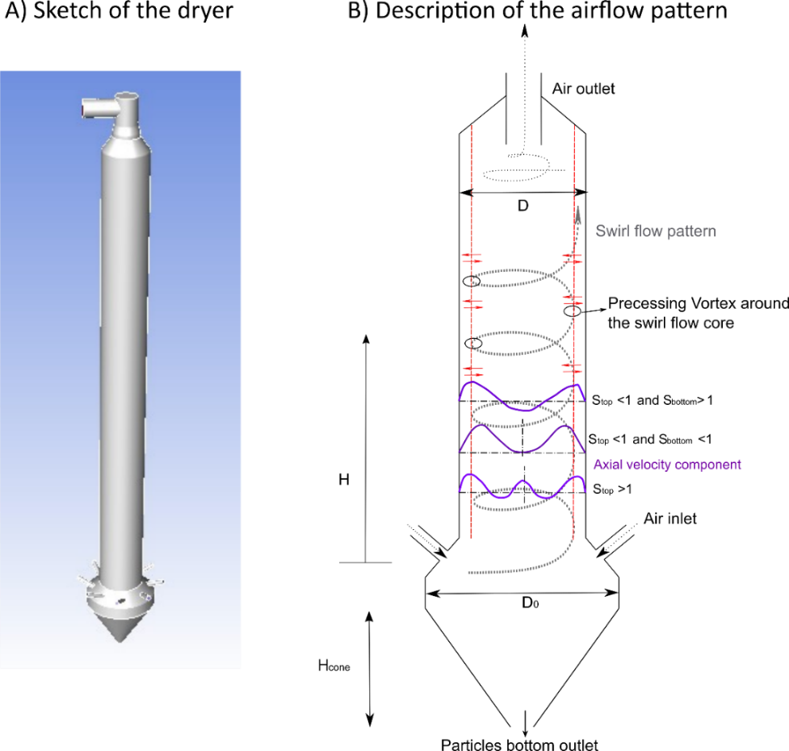
Figure 1. A) Sketch of the dryer and B) description of the airflow pattern.
- METHODOLOGY USED FOR THE DEVELOPMENT OF THE COMPARTMENT MODEL.
The methodology followed for generating the ROMs for the zones, fluxes, momentum and variance of particle residence time is presented in Figure 2. The methodology is divided into four steps that are defined in the following paragraphs. After defining each step, its application to the case study is presented.
3.1 Generation of experiments for process modeling.
In the first stage a design of experiments (DOX) is generated. Although traditional response surface methods such as Central Composite and Box-Behnken designs have been widely used for modeling purposes, alternative fast-flexible filling (Roshan et al. 2015) or space-filling designs (Pronzato et al. 2012; Roshan 2016; Garud et al. 2017) such as Latin hypercubes or sphere-packing are preferred for this task since they allow the generation of a model with higher number of input variables and a smaller number of computational experiments. For this work, the constraints on the inputs were wide and we did not know beforehand which part of the input space would need finer characterization to accurately capture the responses. In this situation, either Latin Hypercube, sphere packing, or fast-flexible filling designs are suitable for generating the initial DOX. However, if further experiments are needed, the fast-flexible filling method is a good option to minimize the variance in outputs with more experiments in the center of a transition. In our case study we have selected the fast-flexible DOX, generated with the statistical software JMP®. The CFD-DPM simulations run in the first DOX are presented in Table S-1 of the supplementary material.
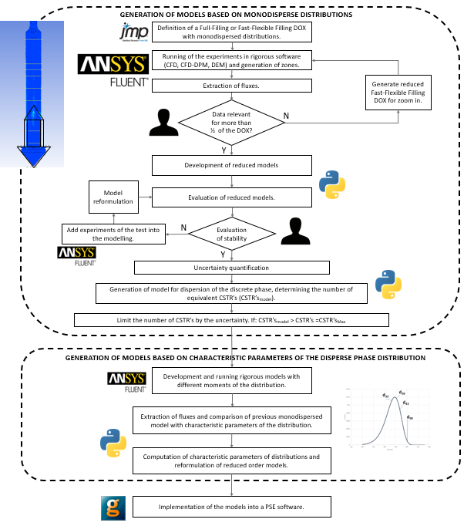
Figure 2. Summary of the methodology followed for generating the ROM based compartment model.
3.2 Simulation of the rigorous model and characterization of the zones.
In the second stage, each of the computational experiments of the DOX are run with the CFD-DPM model developed and validated in previous works (Hernández et al. 2018a; Hernández et al. 2021). In line with the general scheme for a CFD model generation, an independent validation of the momentum before addressing the heat and mass transfer mechanisms to avoid the overlapping of errors was performed. It was carried out by comparing the residence time at the bottom of the dryer for pulses with different particle size distributions and materials. However, these experiments did not cover the entire range of sizes since the feed droplets are smaller than the particles and some of them elutriate. When a CFD-DPM simulation was run in transient mode, it was observed that a fraction of the discrete phase remains suspended in the dryer increasing the computational cost as the simulation progresses. The accumulation can be corrected by generating a User Defined Function (UDF) in Ansys ® Fluent that removes the parcels in the simulation at a certain RT or by implementing an agglomeration mechanism (the second approach is more computationally expensive than removing the parcels at a certain time). However, even with the removal of parcels, the simulation takes 20 days to simulate 130 seconds of operation with a High Processor Computer (HPC) with 4 parallel Inter-Xeon E5-2698 ® processors. Thus, neither approach yields a computationally efficient transient simulation that can be run 20 times or more to generate enough data to create a surrogate model. The approach taken in this study used steady-state simulations, each taking between 70h and 100h on the same HPC. This steady-state approach has been validated with steady-state variables (volume fraction of particles measured near the wall based on the work of (Hassall, 2011)). It allows the tracking of particles to obtain dynamic information. Further details of the validation in steady state are given in the supplementary material.
Once the experiments are simulated, the number of cells in the model are reduced by aggregating them in zones with similar properties. This simplifies the model of the system and reduces its computational cost. This aggregation is straightforward when considering properties that are continuous in the cells, but not for discrete elements (e.g. particles or droplets tracked with DEM or DPM methods). For these elements the properties can often only be read in a certain position in the cell or in its layers, see Rogers and Ierapetritou (2014) as an example. Thus, the procedure followed in this work consists of:
3.2.1) Definition of an approximate zone boundaries based on heuristics and extraction of data by generating a planar mesh within these predefined zones. An estimated value for the boundaries of the zones is known beforehand, and it is not necessary to generate an extensive mesh in all the unit, only a fine mesh near the zones where the transitions are expected. For example, the nozzle region cannot go below the impact of the particle with the wall and is constrained by the location and angle of the injection nozzle. The generation of these zones and the data extraction is performed with a journal file in Ansys Fluent®.
3.2.2) Characterization of the final zone boundaries using the data extracted: This definition is carried out by the user based on a chosen property. The property used for generating the regions is the volume fraction of particles, as in future work on drying of the discrete phase will be considered. The transition between high and low concentration is assumed to occur when a threshold is achieved (at least capturing 90% of the particles in the planar mesh). The final zones obtained in this study are summarized in Figure 3.
3.2.3) After the identification of the zones, a new mesh is generated extracting the mass and property fluxes as follows:
3.2.3.1) The geometry is cut with planes defined by the new known transitions.
3.2.3.2) Fluxes of continuous properties are extracted from the layers generated on the mesh by cutting with planes.
3.2.3.3) Discrete phase fluxes and properties are extracted by tracking the individual parcels and saving the data when the parcels cross the cutting planes. The variables of the particles addressed in the parcels are extracted with a suitable UDF in Fluent®. All this second study is also run with a journal file in Ansys Fluent ®.
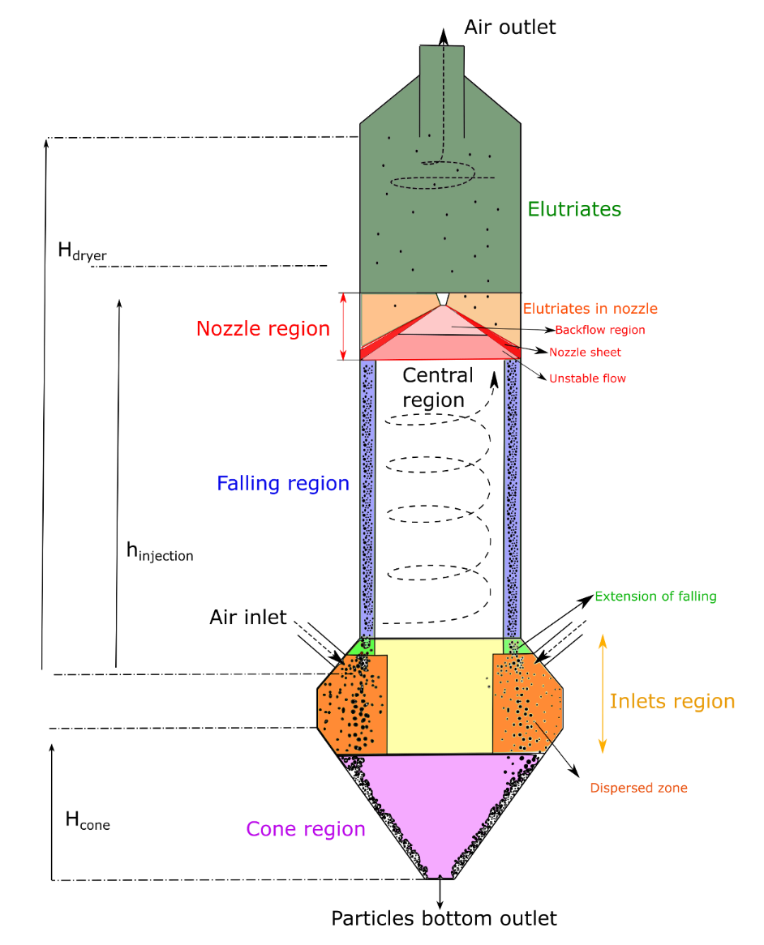
Figure 3. Zones identified in the dryer.

3.3. Generation of reduced order models.
In the following step, ROMs are generated for making the zones flexible and to predict the fluxes and phase properties in the boundaries of the zones. The generation of the models is divided into the following steps:
3.3.1) Post-processing of the data read from the fluxes: The mass fluxes at phase boundaries do not need special treatment. However, the phase properties in each layers are distributed, and it is necessary to compute their mean values and the dispersion.
3.3.2) After post-processing the data, a validation step is carried out to confirm that there is sufficient data to model the desired variables in each of the zones. For example, it is possible that the discrete phase only appears in a zone in one half of the original DOX. In this case, more experiments are required to generate a final model. If this holds true (we assume that at least half of the experiments of the original DOX are required for modeling the variable), the model is validated in the second step. Otherwise, a new DOX is generated to improve the resolution of the operating space. The new DOX is assumed to have half the size of the original.
3.3.3) Identification of the variables that show a higher impact on the fluxes and on the mean values of the distributed properties. The preferred method for this reduction is the minimization of the Bayesian Information Criteria (BIC). This method permits the accounting of the interaction between the models generated from the different variables while reducing the set of variables to only the most relevant ones. In this first step, the minimization of the BIC is only performed with the linear terms to select those variables with the highest influence. In case none of the variables/dimensionless groups are removed, further reduction is generated with user inference methods. A filter based on a Pearson correlation coefficient limiting the maximum number of variables is used.
3.3.4.a) After dimensionality reduction, the next step consists of generating the final ROM to be used. Since the aim of this work is to generate correlations based on dimensionless groups like others used in chemical engineering (e.g. Dittus-Boelter, Ranz-Marshall), the form presented in Eq. (3) is the one used here. It is noted that the user’s knowledge of the phenomena to be modelled is also important and alternative forms can be also adopted.
$y=a·x_{1}^{b}·x_{2}^{c}·…·x_{n}^{d}$ (3)
3.3.4.b) Other approaches for generating the ROMs can be also followed:
  - The first one is a grey box model based on first principles where the data driven from the CFD can be used to estimate some of the embedded parameters of the model by optimization.
  - The second is a pure statistical based approach. The model can be generated by any of the methods previously defined such as BIC minimization, principal component regression (PCR), single value decomposition or kriging. If one exclusively focuses on modeling a single unit, this alternative is recommended since it has been widely validated.
3.3.5) Validation of the models and uncertainty quantification: A validation and an analysis of the stability of the model are carried out. This evaluation is performed selecting one random intermediate experiment and another experiment with values in the bounds of the operating space. Then, the Root Mean Square Error (RMSE) of the new experiments plus the previous ones from the DOX is analyzed. If the RMSE does not suffer a significant increase (we have considered a threshold of 10% of the RMSE of the original DOX) or if it is reduced, the model is assumed to be stable, and is finally implemented in the ROM framework. Otherwise, two new experiments are added for the evaluation.
If this evaluation fails the test again, the model needs to be reformulated. One approach for making the model more stable is to remove the least significant variable based on a statistical parameter (e.g. Pearson coefficient). This often results in a less accurate but more stable model. If the accuracy after removing the variable is still poor or the model is still not stable, a new different expression is evaluated. In case no scalable expression based on dimensionless groups is found, a purely statistical model is generated.
3.3.6) Generation of models for the variance of the RT: After generating the models for the geometries, fluxes and mean values, the next step is the generation of models for the variance of the residence time. This variance, or a dimensionless representation of it, is modeled following the procedures presented in section 3.3.4. The models for representing the variance are limited by the confidence intervals obtained for the model that predicts the mean values in previous step.
A good example to be applied in this work is the RTD. This RTD has been modeled in previous works by a mean RT and an equivalent number of CSTR’s. For very dispersed systems, this type of model can represent the RTD curve. However, in systems with low dispersion, ahigh number of CSTR’s is needed. This number limits the accuracy that can be achieved in reproducing the mean RT. Thus, the definition of the variance in terms of time (dispersion modeled with equivalent reactors) is constrained by the accuracy in reproducing the mean RT. Apart from this limitation, it is also important to note that this approach (CSTR equivalent network) is only necessary in those cases where the zones generated cover a high percentage of volume within the units. On the contrary, in case a very high number of small zones are used such as in other works (Boukouvala et al. (2013)) the equivalent CSTR model cannot be used since the number of tanks will grow exponentially (dispersion is smaller for small regions requiring more CSTR’s).
3.3.7) Correction for systems with discrete phase. Characterization of the particle/droplet/bubble size distribution parameter with lowest error: The methodology defined so far only considers mono-dispersed distributions of the discrete phase. To quantify the effect that one distributed property has on another (e.g. the PSD of the particles on the fluxes of air) it is necessary to determine the characteristic statistical parameter of the distribution to model the effect (e.g. mean or median based on mass, volume or area of the discrete phase). Thus, a new set of experiments is run addressing different distributions of the system for this characterization. After that, the data is extracted as in the case for the monodispersed distributions. Then, the variables (either alone or in dimensionless groups) that have a property distribution are substituted by the characteristic parameter of the distribution (e.g. median diameter or Sauter diameter in a distribution). Finally, the accuracy of the models with each characteristic parameter is compared, the one that shows the lowest RMSE is selected.
Application to the spray dryer.
The description of the generation of the ROMs is divided into different parts according to the zones of Figure 3. In each of the zones, the ROMs generated for the geometries are presented first, then the fluxes of air are analyzed, then the momentum of the particles and, finally, the variance of the RTD.
Nozzle region
The nozzle region is characterized by a zone with a higher concentration of discrete phase that corresponds to the nozzle sheet and two other regions with lower concentration of particles. A sketch of the characteristic dimensions and zones in the nozzle region is provided in Figure 4,A). The dimension of the nozzle sheet in the axial axis has not been separately modeled with dimensionless groups since the same nozzles are used in larger scales by increasing their number. The characteristic groups included involve numbers such as the Reynolds number for the flow of air, the Froude number or the Stokes number. To determine the adaption of the geometries of Figure 4,A) to the operating conditions, the procedures defined in sections 3.3.3) and 3.3.4.a) have been followed. The necessary dimensionless groups are reduced first by a BIC minimization with linear terms. Then, a parameter estimation is carried out in a power form as shown in Eq. (3).
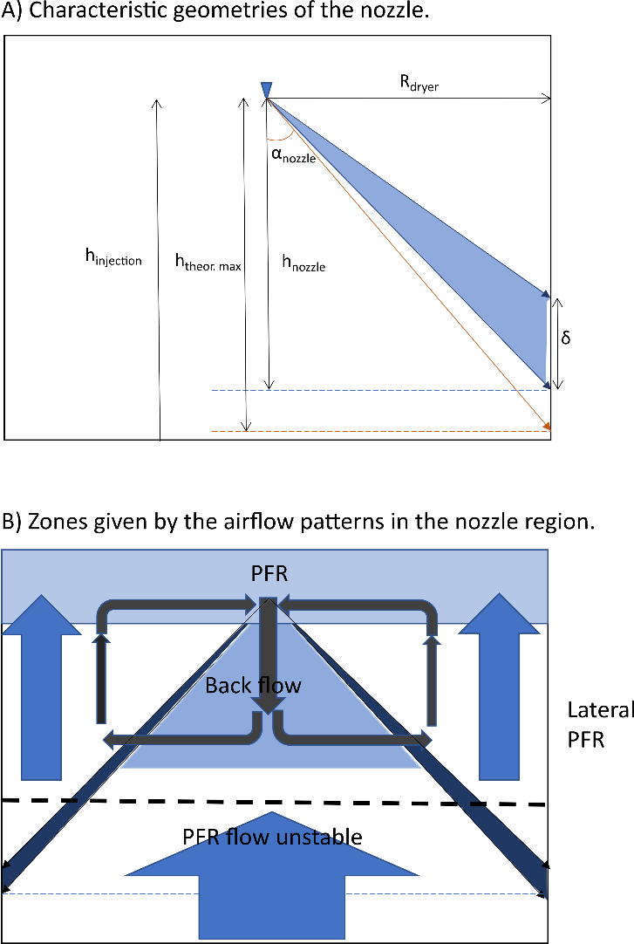
Figure 4. A) Characteristic geometries of the nozzle. B) Airflow regions in the nozzle region. Note that the nozzle angle, α_{nozzle}, is the original without the contact with the air.
The air in the nozzle region is divided into three zones based on the predominant axial velocity pattern: bottom part, top central recirculation, and top external zone, see Figure 4, B). At the bottom part of the nozzle the air is highly unstable since the characteristic vortex of the swirl flow pattern is broken by the drag of the particles. Under this bottom section different shapes and irregular distributions are obtained for each of the cases studied. To model this region, the air is assumed to behave as plug-flow with a homogeneous radial distribution. This region extends until a backflow (negative axial velocity) appears. The height of the backflow region is determined by a surrogate model including dimensionless groups and the nozzle characteristics. In the top part of the nozzle region, two subregions can be distinguished: First, a central region with a backflow in the internal zone left by the nozzle sheet. Second, an external accelerated flow. The mass fraction of air that is recycled to the backflow region is also modeled as defined in section 3.3.4.
After modeling the geometries of the zones and the air fluxes, ROMs are generated for the momentum of the particles. In this region the particles suffer a significant change of velocity and some of them elutriate. To consider the change of velocity within the nozzle, a grey box model is proposed with a drag factor as a function of nozzle properties and dimensionless groups. The procedure for generating the model is summarized in Figure 5. First, the nozzle region is initially sliced by several planes. The RTD is extracted in each of them. From the RTD curve it is possible to identify the mean RT. The velocity in the axial axis is computed with the distance between planes. From these CFD values, the Reynolds number can be computed as in Eq. (4). This Reynolds number refers to the axial direction, but it can be also used to compute the total component as in Eq. (5).
$Re_{py}=\frac{Δy·ρ_{Air}·d_{p}}{Δt·μ}$ (4)
$Re_{p}=\frac{Re_{py CFD}}{{sen(α}_{corr}) }$ (5)
The Reynolds number in the first layer is computed as in Eq. (4). In the second layer, the Reynolds number of the particles requires a correction by the drag factor as defined in Eq. (6). Here $r_{H}$ is the relative height of a layer from the total nozzle height and it is equal to the inverse of the number of layers, see Eq. (7). This definition of Reynolds number is applied to every internal layer.
$Re_{p(n+1)y}=f_{drag}·(1-r_{H})·Re_{pny}$ (6)
$r_{H}=\frac{h_{layer}}{h_{nozzle}}=\frac{1}{N_{layers}}$ (7)
The drag factor in each internal layer needs to be modeled as a function of the dimensionless groups. Not enough experiments from the first DOX were available to model the elutriates (smallest particle sizes). Thus, two further DOXs were generated. After running all the experiments, steps 3.3.3) and 3.3.4.a) are followed proposing a correlation for the drag factor in the form of Eq. (3). This correlation is included within the model and the parameters are estimated by a data-driven optimization where all the layers are included and the cumulative square error (CSE) of Eq. (7) is minimized. The number of experiments for defining some regions and the accuracy obtained with a single model is not that good, so that a piecewise model with two transitions based on a discrete phase diameter is used. Apart from modeling the RT, the dispersion could also be added but the velocity is so high that the RT is assumed to follow a plug-flow reactor model.
$CSE=\sum_{n=1}^{n=nexperiment}{\sum_{y=0}^{y=H_{nozzle cone}}{{{\left(Re_{py exp}-Re_{py model}\right)}_{n_{experiment}}}^{2}}}$ (8)
Figure 5. Summary of the procedure followed for generating the ROMs for the particle’s momentum in the nozzle region.
The last ROM developed in this region corresponds to the fraction of particles that is elutriated. This fraction is computed in each layer using the output from the CFD-DPM model. It is determined by formulating a balance with those particles with a non-negative axial velocity. The variables for the ROM are reduced by BIC minimization. Then a parameter estimation is carried out based on an oriented model that considers a balance between the drag, gravity and inertia groups.
Elutriates region
This region extends from the location of the injection to the top exit of the dryer. The particles are highly dispersed within the region without any structured pattern, so that is not possible to distinguish stable zones as in the previous nozzle region. The air, after contacting with the nozzle, has unstable structures but with a predominant plug-flow pattern. Thus, a homogeneous radial distribution of particles is assumed and the only variable modeled is the momentum of the particles. The time that the particles spend in the elutriates region is modelled in a similar way to that in the nozzle, but only considering the RT at the entrance and exit of the zone. An equivalent axial Reynolds number of the particles from the CFD simulation is then computed as in Eq. (4). A BIC minimization is carried out to determine the dimensionless groups with the highest influence. Since BIC minimization did not offer a small number of dimensionless groups, a filter based on the Pearson coefficient has been used. The resultant groups are finally modeled as a power expression in the form of Eq. (3).
The variance of the RTD in this region is modelled as a set of equivalent CSTR’s per unit length. The CSTR’s are defined per unit length to make the dispersion of the particles independent of the zone size. The number of tanks is finally characterized as a function of dimensionless groups by a filter based on the Pearson coefficient and modeled with Eq. (3).
Falling and central regions
Below the nozzle region, the discrete phase losses the momentum of its injection either by the contact with the airflow or by impact with the wall. The resultant distribution of particles is governed by the momentum distribution of the airflow. This tends to concentrate the particles near the wall region and two regions can be identified: A central region with only air and a falling region where the particles are concentrated. The distinction between both regions is based on the volume fraction of particles the simulations used in the first DOX. Most of the cases show a transition at a relative unit radius of r/R=0.77. Only the cases with small particles show a small fraction of the particles being transported to the center due to the PVC. In these cases, the particles in the center of the unit represent a small fraction of the whole the system, so all the particles are assumed to be in the region with a r/R greater than 0.77. This decision simplifies the generation of models for the air fluxes since less fluxes of the air between the zones need to be determined.
The radial and axial fluxes of air are read at different heights. Since the simulation is carried out in steady state, only the net fluxes are obtained. In the case of the radial fluxes, there is no trend between the bottom and the top of the phenomenological zones. The radial fluxes also do not show any correlation with other dimensionless groups, see Table S-5 in the supplementary for further details. This behavior is due to the PVC phenomena defined in section 3.1 and shown in Figure 1. In transient conditions there is an exchange of flow between both regions but in steady state the flow is balanced.
Apart from the radial fluxes, the axial fluxes are also modeled. The fraction of mass flow in the axial direction, $f_{Air},$ for each of the zones (central and falling) is extracted at different heights and averaged. The mean value is then used to obtain the ROM. It is first necessary to identify the variables and dimensionless groups with the highest influence on $f_{Air}$. In this case, it is necessary to use a filter-based method for dimensionality reduction since BIC minimization does not remove any of the dimensionless groups. Then, $f_{Air}$ is modelled following a power correlation as shown in Eq. (3). After generating the model with dimensionless groups, a comparative analysis is carried out with polydisperse distribution parameters as defined in section 3.3.7. The best result is obtained with the Sauter diameter.
${\dot{m}}_{air axial Total}={\dot{m}}_{airTotal}·f_{Air}+\left(1-f_{Air}\right)·{\dot{m}}_{airTotal}=\dot{m_{air Falling}}\dot{+m_{air Central}}$ (9)
The momentum of the particles is modelled in a similar way to that in the elutriates region. The plane at the bottom layer extracts the RTD. From the RTD, the mean RT is characterized and the Reynolds number of the particles in the axial direction is computed. This Reynolds number is then modeled as a function of dimensionless groups determined by BIC minimization and fitting to Eq. (3). It is important to remark that besides dimensionless groups referring to the entire unit, local groups related to the zone properties are also taken into account (e.g. the Froude number using the velocity of the falling region instead of the entire area (Overcamp and Scarlett, 1993; Hoffman and Stein, 2008)).
This Reynolds number of the particles in the axial direction is exclusively used for computing the mean RT of the particles in the zone. The Reynolds number including the spatial components in the three dimensions and accounting for the tangential component due to the air drag is determined using a different model. The model for the Reynolds number with the all-3D components is determined by averaging the velocity that includes all the components at different heights. The ROM is generated by BIC minimization followed by a fitting to Eq. (3).
Finally, the dispersion is modeled by determining the equivalent number of CSTR’s per meter and generating a function based on dimensionless groups following steps 3.3.3) and 3.3.4.a).
Extension of falling region in the inlets
This region is in the hip of the spray tower (see Figure 3), but with particles not dispersed by the air released tangentially by the inlets, is assumed to behave as the falling region. The same model for the distribution of particles, fluxes and RTD of the particles are used.
Dispersed zone near the inlets
The dimensions of this region are dependent on the operating conditions. For this 2D compartment model, two dimensions are determined for this region: the radial and axial distances at which the particles are concentrated. The generation of the models for the geometries is carried out as presented in previous sections: reducing the sets by BIC minimization and generating a correlation as in Eq. (3).
The modeling of the air fluxes is more complex. By following the streamlines computed in CFD we can check if the air contacts with particles more than once. In this region the airflow first goes down, then impacts with the wall and finally forms the vortex moving upwards. Thus, a complete mixing with the particles is assumed within the region.
The characterization of the RT of the particles is carried out in a similar way to previous zones. A plane is generated at the entrance and exit layers of the zones, and the RTD is extracted. The mean RT is then characterized, and the characteristic dimensionless groups are determined by BIC minimization and a filter based on Pearson coefficient. The model also has a power form as Eq. (3). After that, the dispersion is modeled.
Cone region
This region contains the particles rolling on the bottom cone. The region is divided in two zones with respect to the particle concentration. One zone considers the bed of particles by themselves. Thus, there is no flux of air between the two zones. The height of this bed does not vary much within the zone, except at the top of the cone where there are small changes due to the rebound of particles after their first impact. For homogeneity, the system is assumed to have the height of the bed in the entire region. The RT of the particles and the dispersion of the RTD are modeled as in previous approaches with BIC minimization and a model then generated in power form as in Eq. (3).
3.4 Implementation into a modeling software.
After developing the ROMs, the final compartment model is implemented. The procedure proposed follows a multilevel approach as presented in Figure 6. The first layer contains the phenomenological zones, the “intelligent-core” (IC) model for computing the size of each zone and the number of equivalent reactors within each of them. In the second layer, the equivalent number of CSTR tanks are modelled. The maximum number of tanks is limited by the accuracy in modeling the mean RT in each region. At least one tank is fixed in each region and this tank has a dead-volume factor to model those cases where the number of equivalent CSTR’s is below one (Levenspiel, 2004). Each tank contains the general mass and energy balances for the continuous phase and the PBM for the discrete phase as presented in the Appendix. To address the individual phenomena such as reaction kinetics or drying lower levels are defined within each CSTR. In this study, the models in the third level are the continuous and discrete phase property models and the momentum model. The formulation can be implemented either in equation-oriented modeling tools (e.g. gPROMS® or Modelica) or with sequential programing approaches (e.g. Matlab® or Python).
Application to the case study
The final model is implemented in gPROMS® following the structure presented in Figure 6. A summary of all the models generated in previous steps for each of the phenomenological zones is presented in the Appendix together with the general scheme and CSTR models.
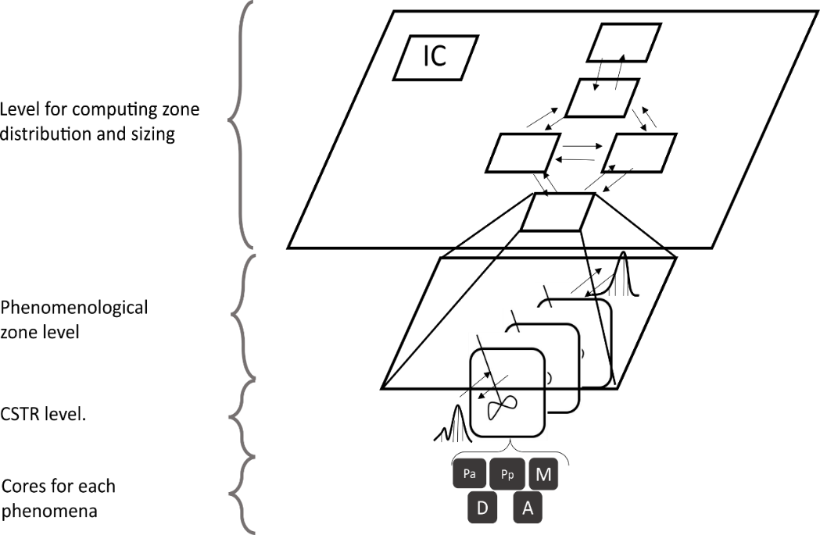
Figure 6. Structure of the compartment model for a 2-way coupling multiphase system.

- RESULTS.
The main result obtained from the final framework composed of ROMs is the reduction of the computational cost compared to the CFD-DPM model. The developed framework can compute the distribution of the volume fraction of particles, the fluxes of air and the momentum of particles in a few dozens of seconds compared to dozens of hours with the CFD-DPM model. Although a high number of initial simulations are required for generating the framework, it can now substitute the CFD-DPM model in a lot of use cases and reduce the time for taking decisions about the operation of the unit, for example with new materials. The reduction in decision time is limited by the errors involved in each of the ROs. These errors are analyzed in the following subsections.
4.1 Evaluation of reduced order models.
In this section we describe the physical meaning of some of the ROMs obtained in this case study, focusing on those that have required further analysis or with a high relevance. Further details of the validation (e.g. Parity plots, RMSE) of each of ROMs with the original CFD-DPM model are given in the supplementary material.
Nozzle region
The first region evaluated is the nozzle region. This region is a bit different from the others since the same type of nozzle considered in the current work is also used in large scale facilities. The scale-up to higher productions is done by introducing more nozzles in the system, see Huntington (2004) for examples of atomization rigs with several nozzles at industrial scale. Thus, the models generated include not only dimensionless groups but also the nozzle properties. The model obtained for the height of the zone has a significant contribution from 2 characteristic dimensionless groups in the modeling of particle-air systems: Archimedes (Ar) and Stokes (St) numbers, see Eq. (10).
$\frac{h_{nozzle}}{h_{nozzle theorical max}}=1.89·{10}^{-4}·Ar_{d90}^{-0.93}·{\ln\left(Ar_{d90}\right)}^{7.555}·\ln\left(St_{d90}^{-0.120}\right)·v_{nozzle}^{0.0489}·α_{nozzle}^{0.0765}$ (10)
For the nozzle sheet, the nozzle angle and the volume fraction of particles are also found to play a critical role, see Eq. (11).
$δ=St_{d50}^{a}·α_{nozzle}^{b}·Ar_{d50}^{c}·Fr^{d}·vf^{e}$ (11)
These nozzle characteristics are also considered in the definition of the region where there is a backflow, see Eq. (12).
$\frac{h_{back flow}}{h_{nozzle}}=0.8179·α_{nozzle}^{0.4585}·vf^{0.282}·{Ar}_{90}^{-0.278398}·St_{90}^{0.3506}·vel_{nozzle}^{0.5483}$ (12)
In fact, the mass fraction of air recycled by the drag generated by the particles is also influenced by the injection characteristics (fraction of particles and injection velocity), see Eq. (13).
$f_{air recycle}=7.5·{10}^{-5}·α_{nozzle}^{2.1628} ·{Ar}_{50}^{0.2341}·vel_{nozzle}^{0.6075}·St_{50}^{-0.52357}$ (13)
The momentum of the discrete phase in this region is modeled by the same three dimensionless groups and the angle of the injection. The model of the drag factor for the particles is divided in two following parts, Eqs. (14) and (15), based on the diameter of the discrete phase:
- For d_{p} > 400 µm:
$f_{drag nozzle}= 0.5617934·Ar^{0.1006754}·St^{-0.107708}·Fr^{0.082514}·α_{nozzle}^{0.0294465}222nd 200 e sizes between 400 r of the nozzle is very small. thusfollows. nozzle ined for the reactor. nd then fore$ (14)
- For d_{p} < 400 µm:
$f_{drag nozzle}= 168486·Ar^{-2.9521}·St^{3.9741}·Fr^{-1.50532}· α_{nozzle}^{-0.8247796}222nd 200 e sizes between 400 r of the nozzle is very small. thusfollows. nozzle ined for the reactor. nd then fore$ (15)
The fraction of elutriated particles in each internal position is computed with two weighted terms: a first term with the gravity (Archimedes); and a second term accounting for the drag forces and represented by the ratio between the Stokes and Reynolds numbers of the particles, see Eq. (16).
$f_{elutriates}=8.2287·{10}^{-5}·Ar-0.909193·\frac{\ln\left(St\right)}{Re_{pin}}$ (16)
Elutriates region
In this region only the RTD of the particles is modelled with surrogates. The three dimensionless groups with higher a contribution to the mean RT correspond to the Archimedes, the Froude and the Stokes numbers. The estimation of the parameters of a power law correlation has not been constrained and shows an Archimedes number with a positive exponential, see Eq. (17). This contradicts physics since one should expect that those particles with higher Archimedes numbers (higher contribution of the gravity force) should move slower. However, the positive power of the Archimedes is balanced with a very large negative exponent for the Stokes number and a positive exponent for the Froude numbers. The Stokes number follows the expected trend since higher values of Stokes number favor inertial forces (mainly gravity) and reduce the possibilities of advection. The Froude number is also expected to have a positive trend since the higher the velocity, the faster the particles move in the region.
$Re_{p}=4.906414·{10}^{-5}·{Ar}^{2.719125}·Fr^{1.84564}·St^{-3.63357}$ (17)
The variance is modeled by means of an equivalent number of CSTR’s per unit length. This number of CSTR’s is also influenced by the Stokes and Archimedes numbers, but withthe Reynolds number of the air instead of the Froude number, see Eq. (18).
$\frac{N_{tanks}}{m}=1.3·{10}^{-8}·Re^{1.6844}·Ar^{-0.324787}·St^{1.195}$ (18)

Central and falling regions
Since the boundary between the two regions has been determined to have a relative radius of r/R=0.77, see section 3.3, the first term modeled is the fraction that separates the axial fluxes of air. The analysis with dimensionless groups shows that $f_{Air}$ is mainly influenced by the level of deposition on the walls. This modifies the decay of the swirl intensity, $\frac{S}{S_{0}}$, and the Stokes number of the characteristic Sauter diameter of the particle size distribution, see Eq. (19). However, the model generated including only the dimensionless groups does not provide a good fit, see Figure 7, A) (RMSE=0.0699). Including the next most significant group, the volume fraction, does not improve the accuracy much (RMSE=0.0675).
$f_{Air}=0.4387639·{\left(\frac{S}{S_{0}}\right)}^{-0.37743536}·{\ln\left(St_{d32}\right)}^{-0.1802539}$ (19)
Due to the low accuracy of these models, an alternative studied is the generation of a model including the dimensionless groups and the geometrical properties of the nozzle. The model suggested includes the angle of the nozzle and the Archimedes number instead of the Stokes number, see Eq. (20) (RMSE=0.0574). This contribution of the angle means that the zone cannot be independently scaled-up to similar units. The relevance of the nozzle is significant since the system is two-way coupled (air and solid influence each other) and a modification in any of the internal parts of dryer changes the entire motion of the system. Furthermore, due to the vortex generated, the air velocity profiles show a radial increase from the center of the dryer to the wall (see Figure S-19 and S-20 in the supplementary material), requiring a model with higher discretization (equal to the number of cells in the mesh) to capture the changes.
$f_{Air}=0.52178·{\left(\frac{S}{S_{0}}\right)}^{-0.498}·{\ln\left({Ar}_{d32}\right)}^{-0.5739}·α_{Nozzle}^{0.2956}$ (20)
The result is not only significant in terms of ROM generation, but also has an impact on the scale-up of the zones. Francia et al. (2015b) demonstrated that the scale-up of the air without a nozzle can be carried out as in Eq. (2). However, in the presence of particles, the airflow is far more unstable and particle characteristics, including injection, turn out to be critical. In particular, the main constraint is given by the impact that the injection has on the flow pattern. The pressure generated by the particles changes the pattern in all the regions since the air is a low viscous fluid and is unable to dissipate the changes of motion. This phenomenon also neglects the scale-up of the internal fluxes because nozzles are not scaled-up maintaining the geometry ratios. Thus, the cross-sectional area covered at larger scales is different and the effect of the air is also modified.
Figure 7. A) Model for the fraction of air in the falling region including only dimensionless groups and B) including dimensionless groups and nozzle variables.
In addition to the model of the air, the RTD of the particles is modeled. The model obtained for the particles selects the Reynolds number based on the terminal velocity, the swirl intensity correction and the Froude number corresponding to the falling region. In the parameter estimation the Reynolds number involving the terminal velocity shows a power of 0.78, see Eq. (21).
$Re_{py}=1.33·Fr_{local falling}^{-0.56}·Re_{pterm}^{0.78}·{\left(\frac{S}{S_{0}}\right)}^{-0.93}$ (21)
Based on this value, the model can be rewritten in the form of a ratio of Reynolds numbers as in Eq. (22) without a significant change in the accuracy of the prediction: the RMSE only increases from 3.634 to 4.921 from Eq. (21) to Eq. (22).
$\frac{Re_{py}}{Re_{pterm}}=0.44·Fr_{local falling}^{-0.66}·{\left(\frac{S}{S_{0}}\right)}^{-1.29}$ (22)
The influence of each group is also in agreement with the expected physics. The Froude number increases with the air velocity and the velocity of the particles is smaller when the air velocity is increased. The swirl ratio captures the effect of fouling. For higher fouling, the swirl intensity decreases, and the rotational movement of the particles is smaller. Thus, the particles spend less time rotating for the same increment of axial length.
The Reynolds number in the axial direction, $Re_{py}$, accounts for the RT of the particles in the zone. However, if we need to include the heat and mass transfer in future work, we will need to use the Reynolds of the particles in 3D,$Re_{p falling}$ . $Re_{p falling}$ is determined from the CFD-DPM simulations by extracting the 3D components of the velocity of the particles at different internal points. Then a model is proposed as previously defined. This new correlation computes $Re_{p falling}$ as a function of $Re_{py}$, the Stokes number, the Reynolds number of the air and the ratio of Swirl intensities groups, see Eq. (23).
$\frac{Re_{py}}{Re_{p3D}}=ratio_{3D}=0.107626·{\left(\frac{S}{S_{0}}\right)}^{0.3843}·St^{-0.4195}·Re^{0.2955}$ (23)
Finally, the dispersion of the RTD is modeled as a function of the Froude number, the ratio of Swirl intensities and Stokes number. However, the quality of the model using dimensionless groups as in Eq. (3) is not that good (RMSE=32.8). The approach followed in the current work is compared with a purely statistical model based on principal component regression (PCR) selecting the 3 most relevant components, see Figure 8 A) and B). The PCR model is expectedly more accurate (RMSE=7.4), however the model is only applicable to the current unit and within the space of operation covered by the DOX. This model obtained by PCR represents at least 90% of the variance and includes the following dimensionless groups in linear form: volume fraction, Archimedes number of particles, Reynolds number, Froude number, Stokes number of particles, Reynolds number of the particles in terminal velocity and ratio of Swirl intensities due to fouling.
Figure 8. Comparison of the modeling of the dispersion of the RTD by equivalent number of tanks with current methodology and PCR for the falling (A & B) and cone regions (C & D).
Dispersed zone in the air inlets region
The first aim at this step-in modeling is to determine the geometries of the zones. In particular, the height of the “dispersed zone” at the inlets plays a critical role since it mainly accounts for the distance covered by the falling particles until they reach the cone. In the cone the particles form a bed reducing the contact area with the air. For confidential reasons, this height is presented in dimensionless form, divided by the cone height. The reduced model for this height is computed as in Eq. (24).
$$if Re_{pterm}<75: \frac{h}{H_{cone}}=6.418·Fr^{0.107}·{\left(\frac{S}{S_{0}}\right)}^{0.658}·Re_{pterm}^{-0.308}$$
$else:\frac{h}{H_{cone}}=0.85$ (24)
The time that the particles spend in the dispersed zone is suggested to be a function of the swirl intensity ratio, the Stokes and Archimedes numbers of the particles and the Reynolds number of air the dryer, see Eq. (25).
$Re_{p}=9.4102·{10}^{-3}·{\left(\frac{S}{S_{0}}\right)}^{0.59164}·Re^{0.245467}·St^{-0.58847}·{Ar}^{0.822044}$ (25)
The Archimedes number shows a positive power, which agrees with physics since a higher Archimedes number accounts for higher contribution of gravity. The Stokes and Reynolds numbers show a different influence than one expects in counter-current operation, so that the RT increases when the air flow is higher, and the Stokes number is smaller. However, these results are still physically reliable since the air partially contacts the dispersed phase in co-current mode, pushing the particles to fall. In fact, a reduction of the dispersion is obtained, making it necessary to model the zone as a PFR instead of a CSTR, see Table S-26 of the supplementary material.
Cone region
The last region corresponds to the bottom cone where zones are fixed by the thickness of the bed of particles and only the RTD of the particles is modelled. By BIC minimization, the mean RT, computed from the Reynolds number, is obtained as a function on the Archimedes and Stokes numbers. However, the influence of the Archimedes number is the only one expected since the movement of the particles in this bottom cone is like the movement of a bed of particles in a silo. The Reynolds number of the particles in silos has been exclusively modeled as a function of the Archimedes number (Muite et al. 2004). An analysis comparing the two models, with and without the Stokes number, is provided in the supplementary material showing that a reduction to only the Archimedes does not change the results significantly: the RMSE only increases from 0.9135 to 1.021. The final model is given in Eq. (26).
$Re_{p}=0.19023·{Ar}^{0.25623}$ (26)
The model of the RTD is completed with a modeling of the dispersion. The current approach is unable to capture the trend (RMSE=34.48) with the 3 most significant terms (the ratio of Swirl numbers, the Archimedes and Froude numbers). As an alternative, the modeling has also been carried out by Principal Component Regression, yielding slightly better accuracy (RMSE=31.09). However, the PCR based model still shows errors near zero in some cases suggesting a negative number of tanks. To avoid negative values, the equivalent number of CSTR’s is limited be above 0.5.
4.2 Model validation with the RTD of the particles.
The model can also be validated by comparing against the RTD. Two sections with significant changes in the dispersion of the discrete phase are selected: at the end of the falling region and at the bottom part of the dryer. The results for two experiments with very different types of RTD curves at these two regions are given in Figure 9. To quantify the accuracy of the prediction through the entire RTD curve, the cumulative error, $ε$, is used. The error is computed as in Eq. (27) with the differences between the mass fraction predicted by the compartment model,$w_{comp}$, and the ones obtained from the CFD-DPM model, $w_{CFD-DPM}$, for intervals of 0.1 s. For the experiments studied, the average value of $ε$ before the particles access the inlets region is 0.2552 and the maximum is $ε$ =0.55. At the bottom of the dryer, this error is reduced to an average value of $ε$ =0.1224 and a maximum of $ε$ =0.2079.
$ε=\sqrt{\sum_{t=0}^{t=t}{{\left(w_{comp}-w_{CFD-DPM}\right)}^{2}}}$ (27)
Analysing Figure 9, the first couple of images are for experiment 1 that corresponds to a case with a high dispersion (the number of tanks required in the falling region is 10 and in the cone region is 1 with an internal dead volume equivalent to 0.6). This experiment is accurately predicted. The other two images correspond to experiment 5, where a low fraction of mass is captured by the RTD of the ROM. Even though the error in the mean RT is below 1 s (the error is 0.67 s), the dispersion of the RTD is very narrow, close to a Dirac delta function, suggesting a PFR. In fact, the zone requires 188 CSTR’s, which can only be reproduced by the model if the variance is below 0.109 s² (RMSE is 0.33 s). This is nearly a third of the RMSE of the model, 0.88 s. This degree of accuracy is obviously very hard to achieved with a ROM. An analysis can be also done from the Principal Components where even after selecting the 4 most relevant components (typically up 3 are selected) it is not possible to describe more than 96% of the variance. Thus, the accuracy required for reproducing the mean RT limits the possibility of using either the equivalent CSTR theory or a PFR with dispersion. The alternatives that can be followed are:
- Assume the zone as to be a PFR without dispersion and only compare the mean RT, which is still accurately reproduced.
- Constrain the maximum number of CSTR’s as proposed in the methodology. As a result, we at least cover a higher fraction of the area, and a part of the mass fraction is captured in cases with a dispersion of the discrete lower than the accuracy of the model for the mean RT.

f_{m} (s⁻¹) | Exp. 1 At the end of falling region.  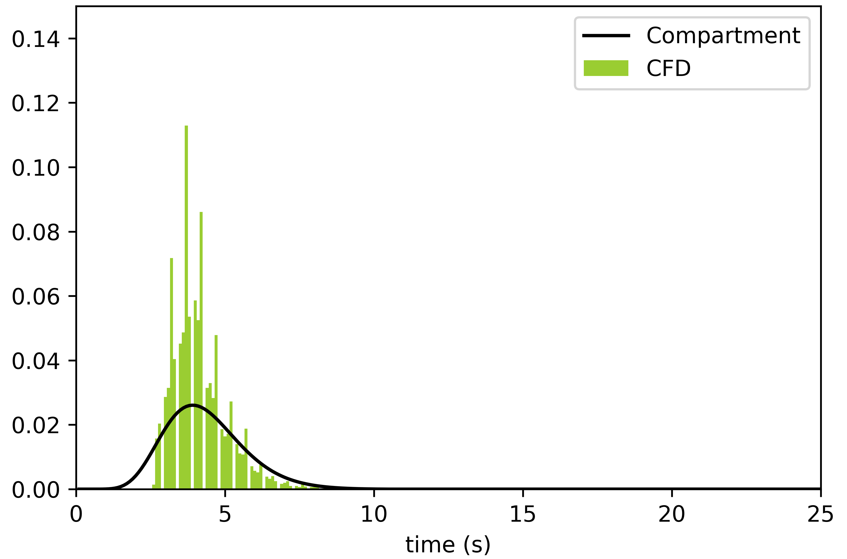 | Exp. 1 At the bottom of the dryer.  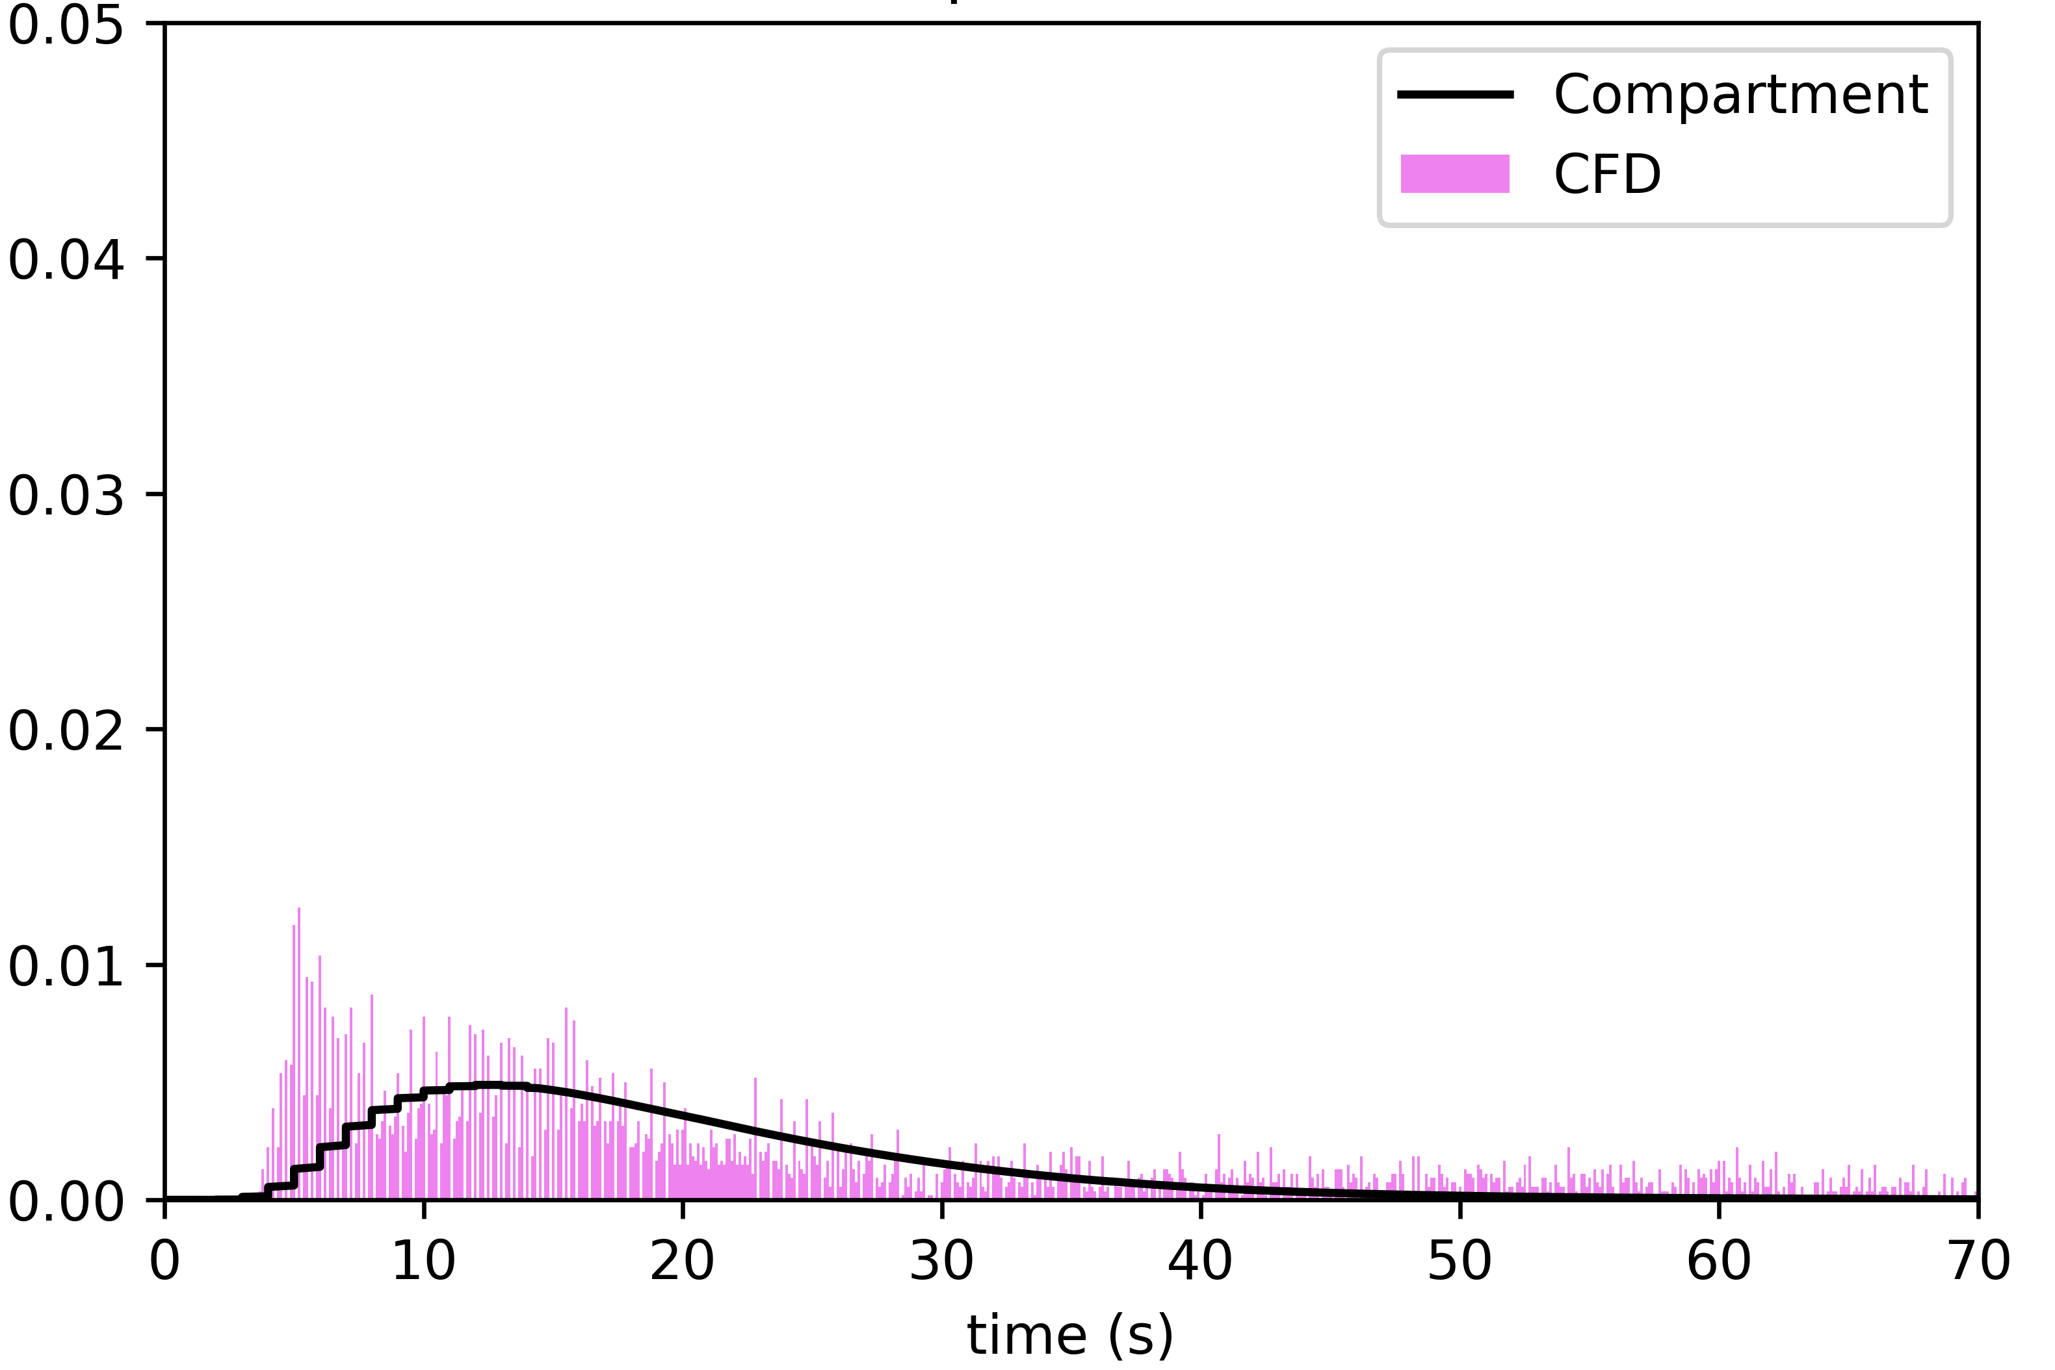
f_{m} (s⁻¹) | Exp. 5. At the end of falling region.  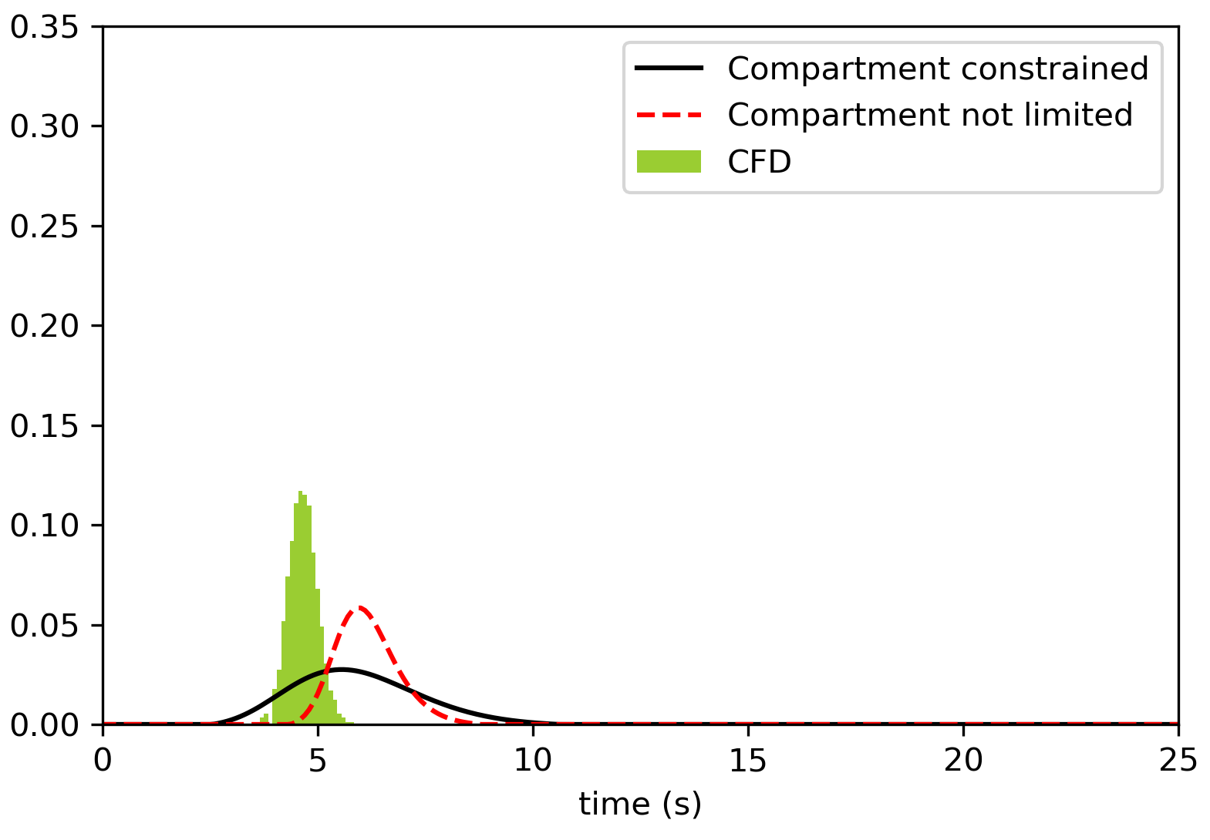 | Exp. 5. At the bottom of the dryer.  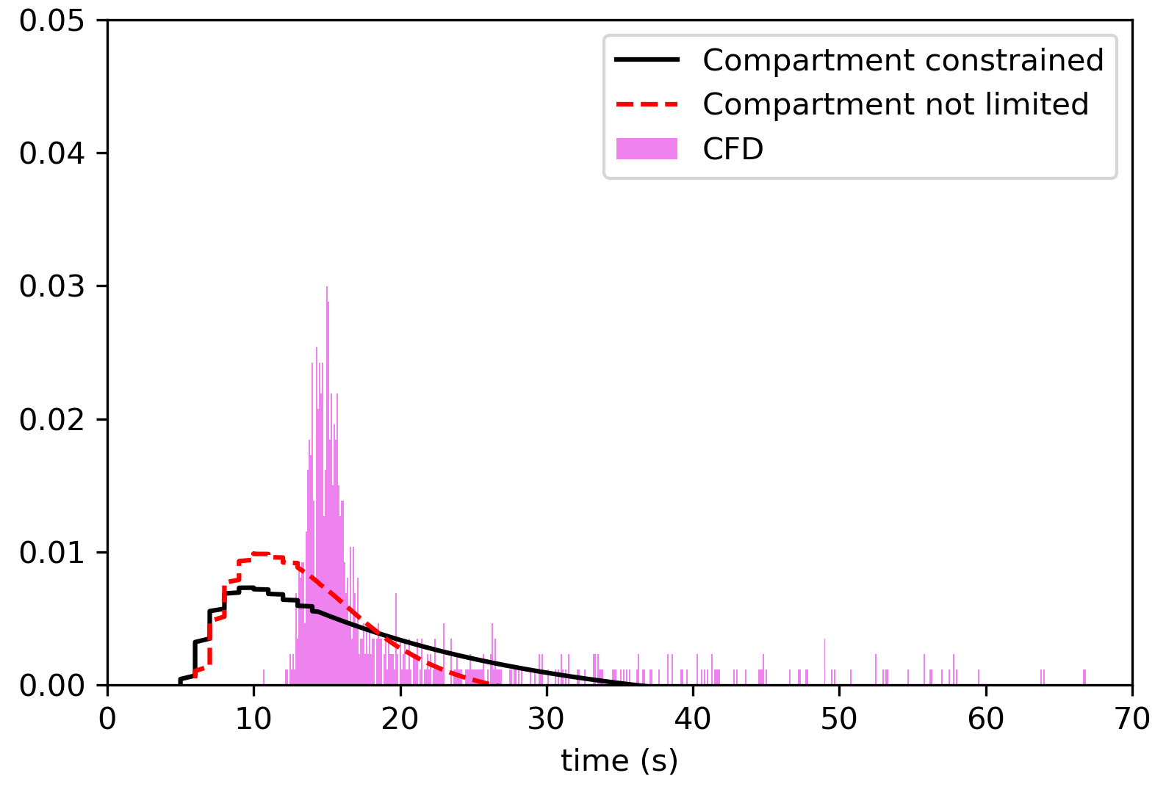
Figure 9. Comparison of the RTD for Experiments 1 and 5.
Contrary to the observations in the previous section, where the zone can be considered as a PFR, the cone zone shows a higher dispersion that needs to be described. This dispersion has been missed in previous works (Ali et al. 2014; Ali et al. 2020) where only the mean RT for each particle size was compared based on a previous CFD model that does not predict the RTD (Ali et al. 2017). However, since most of the drying occurs in the nozzle, falling and inlets regions, the 2D PFR model of Ali et al. (2014) still presents acceptable results for predicting the heat and mass transfer.
The analysis by phenomenological zones also allows identifying the source of the dispersion of the RT observed in previous work (Hernández et al. 2021). In that work, experimental pulses were analysed with 3 systemic compartment models (equivalent CSTR, equivalent PFR and PFR+CSTR). From the three approaches, the use of a PFR plus a CSTR showed the lowest errors. This PFR+CSTR has a physical representation in our case of study. The injection, falling and inlet zones are very narrow in a PFR. Meanwhile the cone is a CSTR or a set of CSTR’s (in some cases low dispersion is observed) since it is the region with highest dispersion.
The results presented in this section, so far only corresponds to monodispersed distributions. A second analysis of the prediction of the mass distribution is also carried out using particle size distributions. In these cases, the error computed by the parameter $ε$ is found to be lower than that with monodispersed distributions, with values up to 21% of $ε$ before the region of the inlets (average of 14.7%) and up to 9% at the bottom of the dryer (average of 7.9%). The lower error obtained is due to a balance of the error between the different particle sizes that overlap each other. Thus, for a rigorous validation of the RTD, the analysis needs to be carried out with monodispersed distributions.
4.3 The role of the number of zones in the momentum prediction.
The compartment models are compared with the simplest case of a systemic compartment model, the modeling of the whole unit as a set of CSTR’s. The resulting model to predict the mean RT by using dimensionless groups is presented in Eq. (28) and the model for predicting the dispersion by means of that approach is presented in Eq. (29). See the parity plots in Figure 10.
$Re_{p}=492.108·Re_{pterm}^{1.4431}·St^{-0.24834}·Ar^{-0.66138}·vf^{0.39659}$ (28)
$\frac{N_{Tanks}}{m}=5.709·{10}^{-10}·Re^{0.668646}·{\left(\frac{S}{S_{0}}\right)}^{0.231}·Ar^{1.058756}·vf^{-0.77156}·St^{-1.241}$ (29)
The model for the mean RT, Figure 10, A) is first compared with a PCR model including the 3 most important components, Figure 10,B) and showing very similar results. On the contrary, the model for the dispersion shows very high errors, is highly non-linear and includes many terms. As occurred in the modeling of the dispersion for each of the zones, the use of dimensionless groups is not useful and it is necessary to use PCR to obtain accurate predictions, see in Figure 10, D).
Figure 10. Validation of models for the Reynolds number (it addresses the mean RT) and the dispersion considering the dryer as a unique system.
The accuracy of a single phenomenological zone is also compared with the compartment model developed in this work. The comparison is carried out using the mean RT at the bottom of the dryer. A lower error is obtained with the compartment model than by considering the entire dryer with a single zone, see Table 2. Increasing the number of zones increases the number of parameters to fit the model and improves the model accuracy. Apart from comparing with the experiments of the first DOX, the models are also compared using the experiments of the second DOX for cross-validation. The comparison is divided into 3 parts to check the stability of both models: First, with one experiment on the bounds (experiment B-5 in the supplementary material) that shows a high RT; then with one of the bounds and 2 central points (experiments B-3 and B-10) and finally with all the experiments in which particles are recovered at the bottom. In all the cases, the compartment model shows smaller error than considering a single zone system. The compartmental approach ensures the model’s stability in the bounds and central points of the operating space. Furthermore, when the number of trials is increased, the RMSE of the model does not increase as much as with a single zone. This also suggests a stable solution. It is possible that using too many zones could lead to more instability problems due to overfitting. To avoid such errors in the surrogate-based compartment models, one suggestion is to limit the number of zones to those that exclusively have phenomenological changes. This also helps to reduce the computational cost. Table 2. Comparison of RMSE for mean RT prediction between compartment model and model with one zone.
Case study | Based on | RMSE (s)
A)  All reactor with 1 model (1 zone) | Experiments of the 1st DOX used for modeling. | 1.837
A)  All reactor with 1 model (1 zone) | Experiments of 1st DOX plus B-5 of the 2nd DOX | 2.454
A)  All reactor with 1 model (1 zone) | Experiments of 1st DOX plus B-3, B-5 and B-10 | 3.716
A)  All reactor with 1 model (1 zone) | Experiments of the 1st DOX plus the 2nd DOX | 4.390
B)  Aggregation of inlets and cone zones | Experiments of the 1st DOX used for modeling. | 1.629
B)  Aggregation of inlets and cone zones | Experiments of 1st DOX plus B-5 of the 2nd DOX | 1.574
B)  Aggregation of inlets and cone zones | Experiments of 1st DOX plus B-3, B-5 and B-10 | 1.979
B)  Aggregation of inlets and cone zones | Experiments of the 1st DOX plus the 2nd DOX | 2.128

- CONCLUSIONS.
This work has presented the generation of a surrogate-based compartment model with adaptable regions for a counter-current spray dryer. These regions are based on the distribution of the discrete phase within the regions. To model the distribution of the zones, the fluxes and the momentum, the use of correlations based on dimensionless groups has been adopted because it permits the possibility to scale-up the zones to geometrically similar units. In this case study, this approach has been able to reproduce the fluxes and distribution of zones with reasonable accuracy, but needs to be complemented with statistical methods for an accurate description. Furthermore, limitations are also observed in the modeling of the air, where geometrical factors are necessary to model the different zones. Each of the zones cannot be independently scaled-up in this case with a low viscous fluid, namely air. These limitations mean that the approach cannot be solely implemented into a reinforcement learning methodology. The only possibility is by a two-step learning process, first evaluating the dimensionless groups and then employing the statistical model.
In the modeling of the momentum, the use of the dimensionless group-based correlations in each of the regions has yielded good performance for the modeling of the mean RT. However, it has failed in the accurate modeling of the variance of the RTD, necessitating the use of pure statistical models to improve the quality of the prediction. An analysis of this variance has been also carried out showing that most of the regions can be modeled as a PFR without dispersion except the elutriates (it contains a small fraction of particles) and the bottom cone (most of the particles here arrived dry). This observation justifies why other works have obtained accurate results with a PFR (Ali et al. 2014) even though they have not been able to reproduce the RTD of the particles in the dryer (Ali et al. 2017). In particular, the analysis of the RTD pays attention to the error involved in narrow curves. It has been observed that the reproduction of the dispersion is limited by the model of the mean RT. The two alternatives are: to use a PFR or to limit the number of equivalent CSTR’s to limit the dispersion. Either approaches can be considered in the nozzle, falling and inlet regions but not for the entire dryer. For the latter, the second approach has been selected. This permits a flexible compartment model that automatically identifies the zone and that can be used in future work including heat and mass transfer with the mass and energy fluxes. These fluxes can be modelled following a similar procedure such as the one described here.
Acknowledgements
Authors acknowledge P&G for funding and software licenses. BH acknowledges Banco Santander for PhD. fellowship.
APENDIX.
Model used for computing the momentum in each of the reactors
The modelling of the discrete phase has been carried out following a CSTR model that every bin of the population balance follows Eq. (A-1).
$\frac{dC_{pi}}{dt}=\frac{1}{V_{T}}\left({\dot{m}}_{in pi}-{\dot{m}}_{out pi}\right)$ (A-1)
The flux of particles leaving the zone is computed dependent on the concentration of particles and it is determined as presented in Eq. (A-2). Eq. (A-2) is for such cases in which the number of tanks is 1 or higher. When the number of tanks is below 1, a CSTR with dead zones is used, see Eq. (A-3). The characteristic RT of each bin in the reactor is computed as function of the Reynolds number and the equivalent height of the reactor. The volume fraction of the particles is computed from the concentration of particles as presented in Eq. (A-4).
${\dot{m}}_{out pi}=\frac{v_{fpi}·ρ_{out pi}·V_{T}}{\overline{t}}$ (A-2)
${\dot{m}}_{out pi}=\frac{v_{fpi}·ρ_{out pi}·V_{T}}{\overline{t}·factor_{DZ}}$ (A-3)
$vf_{pi}=C_{pi}/ρ_{out pi}$ (A-4)
Since the volume of each of the zones remains constant, the volume flowrate coming in is the same that lefts the reactor.
$V_{Pin}+V_{airin}=V_{pout}+V_{airout}$ (A-5)
Where the total volume of particles at the entrance and outlet is the sum of all the bins as Eq. (A-6).
$V_{p}=\sum_{i=1}^{n=bins}{V_{pi}}$ (A-6)

NOMENCLATURE
Dimensionless groups
$Ar=\frac{g·d_{p}^{3}·ρ_{air}·\left(ρ_{p}-ρ_{air}\right)}{μ^{2}}$ Archimedes number of the particles
$Fr=\frac{U_{avg}}{\sqrt{g·D_{dryer}}}$ Froude number of the air
$Re=\frac{ρ_{air}·D_{dryer}·U_{avg}}{μ}$ Reynolds number of the air in the dryer.
$Re_{p}=\frac{ρ_{air}·d_{p}·v_{p}}{μ}$ Reynolds number of the particles
$Re_{pterm}=\frac{ρ_{air}·d_{p}·v_{pterm}}{μ}$ Reynolds number of particles with terminal velocity.
$St=\frac{d_{p}^{2}·ρ_{p}·M_{air}}{μD_{dryer}^{3}ρ_{Air}}$ Stokes number of the particles in the dryer.
$vf=\frac{V_{p}}{V_{air}}$ Volume fraction of particles.
Variables
$C_{pi}$ Concentration of particles in the reactor (kg/m³).
$d_{p}$ Diameter of the particle (m)
$d_{32}$ Sauter diameter of particle size distributions (m).
$d_{50}$ Mean diameter of particle size distributions (m).
$d_{90}$ d₉₀ of particle size distributions (m).
$D_{dryer}$ Diameter of the dryer (m).
$f_{Air}$ Fraction of air sent to the falling region.
$f_{elutriates}$ Mass fraction of elutriated particles.
$f_{drag}$ Drag factor for reducing the velocity in the nozzle.
g Gravity (9.8 m²/s).
$h_{back flow}$ Height of the backflow region in the nozzle (m).
$h_{layer}$ Height of the layers in the nozzle (m).
$h_{nozzle}$ Height of the nozzle (m).
$h_{theor}$ Maximum theoretical height of the nozzle region (m).
$\dot{m}$ Mass flux of air (kg/s).
$N_{layers}$ Number of layers/Cuts in the nozzle region.
$N_{tanks}$ Equivalent number of CSTR’s.
$R_{dryer}$ Radius of the dryer (m)
$r_{H}$ Ratio of layer and nozzle height.
$S$ Swirl intensity of the air in the dryer at z=0.2.
$S_{0}$ Swirl intensity of the air in the dryer at z=0.
t Time (s).
$\overline{t}$ Mean RT of the reactor (s).
$T_{air}$ Air temperature (K).
$U_{avg}$ Average velocity of the air in the zone (m/s).
$v_{p}$ Velocity of the particles (m/s).
$v_{p term}$ Terminal velocity of the particles (m/s).
$v_{py}$ Velocity of the particles in the axial axis (m/s).
${vel}_{nozzle}$ Velocity of the particles at the injection (m/s).
$V_{T}$ Total volume of the reactor (m³).
$V_{p}$ Volume of particles in the reactor.
$w_{CFD-DPM}$ Mass fraction released by the CFD-DPM model.
$w_{comp}$ Mass fraction released by the compartment model.
$α_{Nozzle}$ Angle of the nozzle without dispersion (º)
$σ^{2}$ Variance of the RTD (s²).
$ρ_{air}$ Density of the air (kg/m³).
$ρ_{p}$ Density of the particles (kg/m³).
$μ$ Viscosity of the air (Pa·s).
$θ$ Dimensionless variance of the RT.

Abbreviations
ANN Artificial Neural Network.
CFD Computational Fluid Dynamics.
CSE Cumulative square error.
DEM Distinct or Discrete Element Method.
DOX Design of Experiments.
DPM Discrete Parcel Method.
HPC High-Processing Computer.
PBM Population Balance Model
PCA Principal Component Analysis.
PCR Principal Component Regression.
RMSE Root mean square error.
ROM Reduce Order Model
RT Residence Time.
RTD Residence Time distribution.
UDF User Defined Function.

Subscripts
Cone Referred to the cone region.
air Referred to the air.
i Bins.
p Particles
y Axial axis.

REFERENCES
Ali, M. Mahmud, T. Heggs, P.J. Ghadiri, M. Djurdjevic, D. Ahmadian, H. Martin de Juan, L. Amador, C. Bayly, A. (2014) A one-dimensional plug-flow model of a counter-current spray drying tower. Chemical Engineering Research and Design, 92, 5, 826-841.
Ali, M. Mahmud, T. Heggs, P.J. Ghadiri, M. Bayly, A. Ahmadian, H. de Juan, LM. (2016) CFD modelling of a pilot-scale counter-current spray drying tower for the manufacture of detergent powder. Drying Technology, 281-299.
Ali, M. Mahmud, T. Heggs, P. Ghadiri, M. Bayly, A. Crosby, M. Ahmadian, H. Marindejuan,L. Alam, Z. (2017) Residence time distribution of glass ballotini in isothermal swirling flows in a counter-current spray drying tower. Powder technology, 305, 809-815.
Ali, M. Mahmud, T. Heggs, P.J. Ghadiri, M. (2020) Zonal modelling of a counter-current spray drying tower. Chemical Engineering Research and Design, 155, 180-199.
Akkisetty, P.K. Lee, U. Reklaitis, G.V. Venkatasubramanian, V. (2010) Population Balance Model-Based Hybrid Neural Network for a Pharmaceutical Milling Process. Journal of Pharmaceutical Innovation, 5, 161-168. DOI: 10.1007/s12247-010-9090-2
Alvarado, A. Vedantam, S. Goethals, P. Nopens, I. (2012) A compartmental model to describe hydraulics in a full-scale waste stabilization pond. Water Research, 46 (2), 521-530. DOI: https://doi.org/10.1016/j.watres.2011.11.038
Barraso, D. Tamrakar, A. Ramachandran, R. (2014) A reduced order PBM-ANN model of a multi-scale PBM-DEM description of a wet granulation process. Chemical Engineering Science, 119, 319-329. DOI: https://doi.org/10.1016/j.ces.2014.08.005
Bauer, M. Eigenberger, G. (1999) A concept for multi-scale modeling of bubble columns and loop reactors. Chemical Engineering Science, 54, 21, 5109-5117.
Ben Gaida, L. Andre, C. Bideaux, C. Alfenore, S. Cameleyre, X. Molina-Jouve, C. Fillaudeau, L. (2012) Modelling of hydrodynamic behaviour of a two-stage bioreactor with cell recycling dedicated to intensive microbial production. Chemical Engineering Journal, 183, 222- 230. DOI: https://doi.org/10.1016/j.cej.2011.12.065.
Bermingham, S. Kramer, H.J.M. van Rosmalen, G.M. (1998) Towards on-scale crystallizer design using compartmental models. Computers & Chemical Engineering, 22, S355-S362. DOI: https://doi.org/10.1016/S0098-1354(98)00075-1
Bezzo, F. Macchietto, S. Pantelides, C. C. (2003) General hybrid multizonal/CFD approach for bioreactor modeling. AIChE Journal, 49, 8, 2133-2148. DOI: https://doi.org/10.1002/aic.690490821.
Bezzo, F. Macchietto, S. Pantelides, C. C. (2004a) A general methodology for hybrid mutizonal/CFD models: Part I. Theoretical framework. Computers & Chemical Engineering, 28, 4, 501-511. DOI: https://doi.org/10.1016/j.compchemeng.2003.08.004
Bezzo, F. Macchietto, S. (2004b) A general methodology for hybrid mutizonal/CFD models: Part II. Automatic zoning. Computers & Chemical Engineering, 28, 4, 513-525. DOI: https://doi.org/10.1016/j.compchemeng.2003.08.010.
Bhaskar, A. Barros, F.N. Singh, R. (2017) Development and implementation of an advanced model predictive control system into continuous pharmaceutical tablet compaction process. International Journal of Pharmaceutics, 534(1), 159-178. DOI: https://doi.org/10.1016/j.ijpharm.2017.10.003.
Bhosekar, A. Ierapetritou, M. (2017) Advances in surrogate based modeling, feasibility analysis, and optimization: A review. Computers and Chemical Engineering, 108, 250-267. DOI: https://doi.org/10.1016/j.compchemeng.2017.09.017
Boukouvala, F. Gao, Y. Muzzio, F. Ierapetritou, M.G. (2013) Reduced-order discrete element method modeling. Chemical Engineering Science, 95, 12-26. DOI: https://doi.org/10.1016/j.ces.2013.01.053.
Börner, M. Peglow, M. Tsotsas, E. (2011) Derivation of parameters for a two compartment population balance model of Wurster fluidized bed granulation. Powder Technology, 238, 122-131. DOI: https://doi.org/10.1016/j.powtec.2012.04.014.
Brenner, T.A. Fontenot, R.L. Cizmas, P.G.A. O’Brien, T.J. Breault, R.W. (2012) A reduced-order model for heat transfer in multiphase flow and practical aspects of the proper orthogonal decomposition. Computers & Chemical Engineering, 43, 68-80. DOI: https://doi.org/10.1016/j.compchemeng.2012.04.003.
Carreira-Perpiñan, M.A. (1997) A review of dimension reduction techniques. Technical Report CS-96-09. Available in: http://www.pca.narod.ru/DimensionReductionBrifReview.pdf
Danckwerts, P. (1953) Continuous flow systems: Distribution of residence times. Chemical Engineering Science, 2 (1), 1-13. DOI: https://doi.org/10.1016/0009-2509(53)80001-1.
Delafosse, A. Collignon, M.L. Calvo, S. Delvigne, F. Crine, M. Thonart, P. Toye, D. (2014) CFD-based compartment model for description of mixing in bioreactors. Chemical Engineering Science, 106, 76-85. DOI: https://doi.org/10.1016/j.ces.2013.11.033.
Dubey, A. Sarkar, A. Ierapetritou, M. Wassgren, C.R. Muzzio, F.J. (2011) Computational approaches for studying the granular dynamics of continuous blending processes, 1 – dem based methods. Macromolecular Materials and Engineering, 296 (3-4), 290-307. DOI: https://doi.org/10.1002/mame.201000389.
Engisch, W. Muzzio, F. (2016) Using Residence Time Distributions (RTDs) to Address the Traceability of Raw Materials in Continuous Pharmaceutical Manufacturing. Journal of Pharmaceutical Innovation, 11, 1, 64-81.
Escotet-Espinoza, M.S. Moghtadernejad, S. Oka, S. Wang, Z. Roman-Ospino, A. Schäfer, E. Cappuyns, P. Van Assche, I. Futran, M. Muzzio, F. Ierapetritou, M. (2019) Effect of material properties on the residence time distribution (RTD) characterization of powder blending unit operations. Part II of II: Application of models. Powder Technology, 344, 525-544. DOI: https://doi.org/10.1016/j.powtec.2018.12.051.
Francia, V. Martín, L. Bayly, A.E. Simmons, M.J.H., (2015a). An experimental investigation of the swirling flow in a tall-form counter-current spray dryer. Experimental Thermal and Fluid Science, 65, 52-64.
Francia, V. Martin, L. Bayly, A.E. Simmons, M.J.H., (2015b). Influence of Wall friction on flow regimes and scale-up of counter-current swirl spray dryers. Chemical Engineering Science, 134, 399-413.
Freireich, B. Li, J. Litster, J. Wassgren, C. (2011) Incorporating particle flow information from discrete element simulations in population balance models of mixer-coaters. Chemical Engineering Science, 66 (16), 3592-3604. DOI: https://doi.org/10.1016/j.ces.2011.04.015.
Gao, Y. Vanarase, A. Muzzio, F. Ierapetritou, M. (2011) Characterizing continuous powder mixing using residence time distribution. Chemical Engineering Science, 66, 3, 417-425. DOI: https://doi.org/10.1016/j.ces.2010.10.045.
Gao, Y. Muzzio, F.J. Ierapetritou, M.G. (2012) A review of the Residence Time Distribution (RTD). Powder Technology, 228, 416-423. DOI: https://doi.org/10.1016/j.powtec.2012.05.060.
Gao, Y. Boukouvala, F. Engisch, W. Meng, W. Muzzio, F. Ierapetritou, M.G. (2013) Improving Continuous Powder Blending Performance Using Projection to Latent Structures Regresion. Journal of Pharmaceutical Innovation, 8,2, 99-110. DOI: 10.1007/s12247-013-9152-3. DOI: 10.1007/s12247-013-9152-3.
Garcia-Muñoz, S. Butterbaugh, A. Leavesley, I. Manley, L.F. Slade, D. Bermingham, S. (2018) A flowsheet model for the development of a continuous process for pharmaceutical tablets: An industrial perspective. AIChE. Journal, 64, 2, 511-525. DOI: https://doi.org/10.1002/aic.15967
Garud, S.S. Karimi, I.A. Kraft, M. (2017) Design of computer experiments: A review. Computers and Chemical Engineering. 106, 71-95.
Gernaey, K.V. Cervera-Padrell, A.E. Woodley, J.M. (2012) A perspective on PSE in pharmaceutical process development and innovation. Computers & Chemical Engineering, 42, 15-29. DOI: https://doi.org/10.1016/j.compchemeng.2012.02.022.
Guha, D. Dudukovic, M.P. Ramachandra, P.A. Mehta, S. Alvare, J. (2006) CFD-based compartmental modeling of single phase stirred-tank reactors. AIChE Journal, 52, 5, 1836-1846. DOI: https://doi.org/10.1002/aic.10772.
Guyon, I. Elisseeff, A. (2003) An Introduction to Variable and Feature Selection. Journal of Machine Learning Research, 3, 1157-1182.
Hassall, G. (2011) Wall build-up in spray dryers. Eng.D. Thesis. University of Birmingham.
Harris, A. Davidson, J. Thorpe, R. (2003) The influence of the riser exit on the particle residence time distribution in a circulating fluidized bed riser. Chemical Engineering Science, 58 (16), 3669-3680. DOI: https://doi.org/10.1016/S0009-2509(03)00215-X.
Harvie, D.J.E. Langrish, T.A.G. Fletcher, D.F. (2002) A computational Fluid Dynamics Study of a Tall-Form Spray Dryer. Food and Bioproducts Processing, 80, 3, 163-175.
Haag, J. Gentric, C. Lemaitre, C. Leclerc, J. (2018) Modelling of Chemical Reactors: From Systemic Approach to Compartmental Modelling. International Journal of Chemical Reactor Engineering, 16,8. DOI: https://doi.org/10.1515/ijcre-2017-0172.
Hernández, B. Fraser, B. Martin de Juan, L. Martin, M. (2018a) Computational fluid dynamics (CFD) modeling of swirling flows in industrial counter-current spray-drying towers under fouling conditions. Industrial & Engineering Chemistry Research, 57 (35), 11988-12002.
Hernández, B. Francia, V. Crosby, M. Ahmadian, H. Gupta, P. Martin de Juan, L. Martin, M. (2021) The use of Optimized Restitution Coefficients to Improve Residence Time Prediction in Computational Fluid Dynamics-Discrete Parcel Method for Counter-Current Spray Dryers. Industrial & Engineering Chemistry Research. DOI: https://doi.org/10.1021/acs.iecr.1c02415
Hoffman, A.C. Stein, L.E. (2008) Gas Cyclones and Swirl Tubes. Principles, Design and Operation. 2nd Edition. Springer Berlin. ISBN: 978-3-540-74694-2.
Hreiz, R. Gentric, N. Midoux, 2011. Numerical investigation of swirling flow in cylindrical cyclones. Chem. Eng. Res. Des. 89, 2521-2539.
Huntington, D. H., 2004. The influence of the Spray Drying Process on Product Properties. Drying Technology, Vol. 22, No. 6, 1261-1287.
Ierapetritou, M. Muzzio, F. Reklaitis, G. (2016). Perspectives on the continuous manufacturing of powder-based pharmaceutical processes. AIChE. Journal, 62 (6), 1846-1862. DOI: https://doi.org/10.1002/aic.15210.
Iuliano, E. Quagliarella, D. (2013) Proper Orthogonal Decomposition, surrogate modelling and evolutionary optimization in aerodynamic design. Computers & Fluids, 84, 327-350. DOI: https://doi.org/10.1016/j.compfluid.2013.06.007.
Jourdan,N. Neveux, T. Potier,O. Kanniche,M. Wicks,J. Nopens,I. Rehman,U. Le Moullec,Y. (2020) Compartmental Modelling in chemical engineering: A critical review. Chemical Engineering Science 210, 115196. DOI: https://doi.org/10.1016/j.ces.2019.115196.
Kitoh, O., 1991. Experimental study of turbulent swirling flow in a straight pipe. J. Fluid Mech. 1991 225, 445-479.
Kruisz, J. Rehrl, J. Faulhammer, E. Witschnigg, A. Khinast, J.G. (2018) Material tracking in a continuous direct copsule-filling process via residence time distribution measurements. International Journal of Pharmaceutics, 550 (1), 347-358. DOI: https://doi.org/10.1016/j.ijpharm.2018.08.056.
Lang, Y. Malacina, A. Biegler, L.T. Munteanu, S. Madsen, J.I. Zitney, S.E. (2009) Reduced order model based on principal component analysis for process simulation and optimization. Energy Fuels, 23, 1695-1706. DOI: https://doi.org/10.1021/ef800984v
Langrish, T.A.G. Fletcher, D.F. (2007) Prospects for the Modelling and Design of Spray Dryers in the 21st Century. Drying Technology, 21, 2, 197-215.
Laurent, J. Bois, P. Nuel, M. Wanko, A. (2015) Systemic models of full-scale Surface Flow Treatment Wetlands: Determination by application of fluorescent tracers. Chemical Engineering Journal, 264, 389-398. DOI: https://doi.org/10.1016/j.cej.2014.11.073.
Le Moullec, Y. Gentric, C. Potier, O. Leclerc, J.P. (2010) Comparison of systemic, compartmental and CFD modelling approaches: Application to the simulation of a biological reactor of wastewater treatment. Chemical Engineering Science, 65, 1, 343-350. DOI: https://doi.org/10.1016/j.ces.2009.06.035.
Levenspiel, O. (2004) Chemical Reaction Engineering. Ed. Wiley. ISBN: 978-81-265-1000-9.
Lieu, T. Farhat, C. Lesoinne, M. (2006) Reduced-order fluid/structure modeling of a complete aircraft configuration. Computer Methods in Applied Mechanics and Engineering, 195, 41, 5730-5742. DOI: https://doi.org/10.1016/j.cma.2005.08.026
Lucca-Negro, O. O’Doherty, T., 2001. Vortex breakdown: a review. Progress in Energy and Combustion Science 27 (2001) 431-481.
Lucia, D. J. Beran, P.S. Silva, W.A. (2004) Reduced-order modeling: new approaches for computational physics. Progress in Aerospace Sciences, 40, 1, 51-117. DOI: https://doi.org/10.1016/j.paerosci.2003.12.001
Masters, K., 1972. Spray Drying: An introduction to Principles, Operational Practice and Applications. London: Leonard Hill Books.
Metta, N. Ramachandran, R. Ierapetritou, M. (2020) A Computationally Efficient Surrogate-Based Reduction of a Multiscale Comill Process Model. Journal of Pharmaceutical Innovation, 15, 3, 424-444.
Muite, B.K. Hunt, M.L. Joseph, G.G. (2004) The effects of a counter-current interstitial flow on discharging hourglass. Physics of Fluids, 16, 3415.
Mwangi, B. Tian, T.S. Soares, J.C. (2014) A review of Feature Reduction Techniques in Neuroimagin. DOI: 10.1007/s12021-013-9204-3
Nauha, E.K. Kalal, Z. Ali, M.J. Alopaeus, V. (2018) Compartmental modeling of large stirred tank bioreactors with high gas volume fractions. Chemical Engineering Journal, 334, 2319-2334.
Nauman, E.B. (2008) Residence Time Theory. Industrial & Engineering Chemistry Research, 47, 10, 3752-3766. DOI: 10.1021/ie071635a.
Overcamp, T.J. Scarlett, S.E. (1993) Effect of Reynolds Number on the Stokes Number of Cyclones. Aerosol Science and Technology, 19 (3), 362-370.
Pronzato, L. Müller, W.G. (2012) Design of computer experiments: space filling and beyond. Statistics and Computing, 22, 681-701.
Queipo, N.V. Haftka, R.T. Shyy, W. Goel, T. Vaidyanathan, R. Tucker, P.K. (2005) Surrogate-based analysis and optimization. Progress in Aerospace Sciences, 41,1, 1-28. DOI: https://doi.org/10.1016/j.paerosci.2005.02.001
Rehman, U. Audenaert, W. Amerlinck, Y. Maere, T. Arnaldos, M. Nopens, I. (2017) How well-mixed is well mixed? Hydrodynamic-biokinetic model integration in an aerated tank of a full-scale water resource recovery facility. Water Science and Technology, 76 (8), 1950-1965. DOI: 10.2166/wst.2017.330.
Roshan, V. (2016) Space-filling designs for computer experiments: A review. Quality Engineering, 28, 28-35.
Roshan, V. Gul, E. Ba, S. (2015) Maximum projection designs for computer experiments. Biometrika, 1-10. DOI: 10.1093/biomet/asv002
Rogers, A. Ierapetritou, M.G. (2014) Discrete element reduced-order modeling of dynamic particulate systems. AIChE. Journal, 60 (9), 3184-3194. DOI: https://doi.org/10.1002/aic.14505.
Rusak, Z. Zhang, Y. Lee, H. Wang, S., 2017. Swirling flow states in finite-length diverging or contracting circular pipes. J. Fluid Mech. (2017), 819, 678-712.
Sánchez, A. Hernández, B. Martín, M. (2020) Multi-Scale Analysis in the Exploitation of Bioresources: From Reactor Design to Supply Chain Analysis. Process Systems Engineering for Biofuels Development, 49-83.
Sen, M. Dubey, A. Singh, R. Ramachandra, R. (2012) Mathematical development and comparison of a hybrid pbm-dem description of a continuous powder mixing process. Journal of Powder Technology, 843784. DOI: 10.1155/2013/843784.
Steenbergen, W. Voskamp, J., 1998. The rate of decay of swirl in turbulent pipe flow. Flow Meas. Instru. 1998 9, 67-78.
Su, Q. Ganesh, S. Moreno, M. Bommireddy, Y. Gonzalez, M. Reklaitis, G.V. Nagy, Z.K. (2019) A perspective on Quality-by-Control (QbC) in pharmaceutical continuous manufacturing. Computers & Chemical Engineering, 125, 216-231, DOI: https://doi.org/10.1016/j.compchemeng.2019.03.001.
Syred, N., 2006. A review of oscillation mechanisms and the role of the Precessing Vortex Core (PVC) in Swirl Combustion Systems, Prog. Energy Combust. Sci. vol. 32, 2, 93-161, 2006.
Tajsoleiman, T. Spann, R. Bach, C. Gernaey, K.V. Huusom, J.K. Drühne, U. (2019) A CFD based automatic method for compartment model development. Computers & Chemical Engineering, 123, 236-245. DOI: https://doi.org/10.1016/j.compchemeng.2018.12.015.
Willcox, K. Peraire, J. (2002) Balanced Model Reduction via the Proper Orthogonal Decomposition. AIAA Journal, 40, 11, 2323-2330. DOI: 10.2514/2.1570.
Woo, M.W. (2016) Computational Fluid Dynamics Simulation of Spray Dryers. CRC Press.
Yang, S. Kiang, S. Farzan, P. Ierapetritou, M.G. (2019) Optimization of Reaction Selectivity using CFD-Based Compartmental Modeling and Surrogate-Based Optimization. Processes, 7, 9. DOI: https://doi.org/10.3390/pr7010009.
Yao, W. Marques, S. Robinson, T. Armstrong, C. Sun, L. (2020) A reduced-order model for gradient-based aerodynamic shape optimization. Aerospace Science and Technology, 106, 106120. DOI: https://doi.org/10.1016/j.ast.2020.106120
Zhong, H. Xiong, Q. Yin, L. Zhang, J. Zhu, Y. Liang, S. Niu, B. Zhang, X. CFD-based reduced-order modeling of fluidized-bed biomass fast pyrolysis using artificial neural network. Renewable Energy, 152, 613-616. DOI: https://doi.org/10.1016/j.renene.2020.01.057.

