Ardc.edu.au
URL: https://ardc.edu.au/resource/fair-data-self-assessment-tool/

Data on student habits and perceived health in the post-pandemic recovery phase [DATASET]
Handle: https://hdl.handle.net/10366/169220 DOI: 10.71636/kp3s-e404 Estado: Embargado
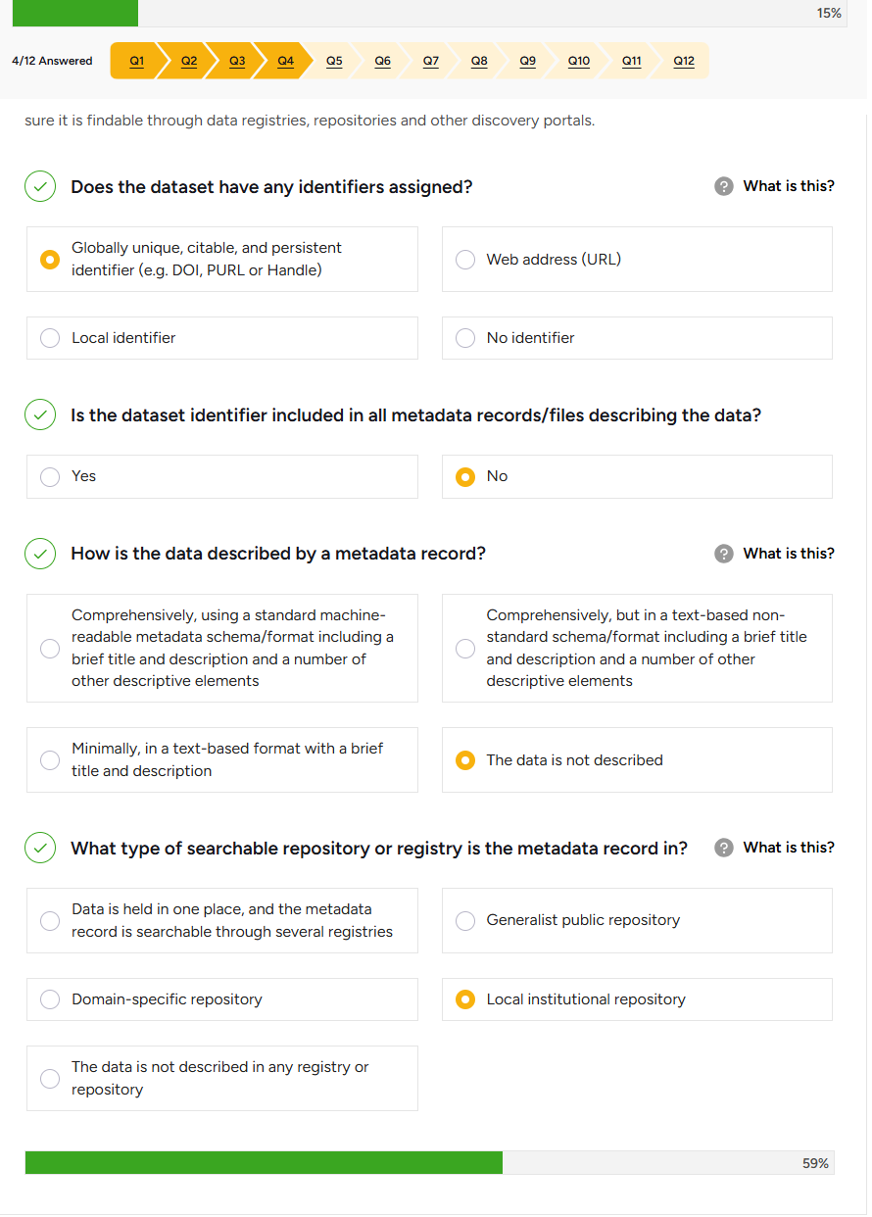
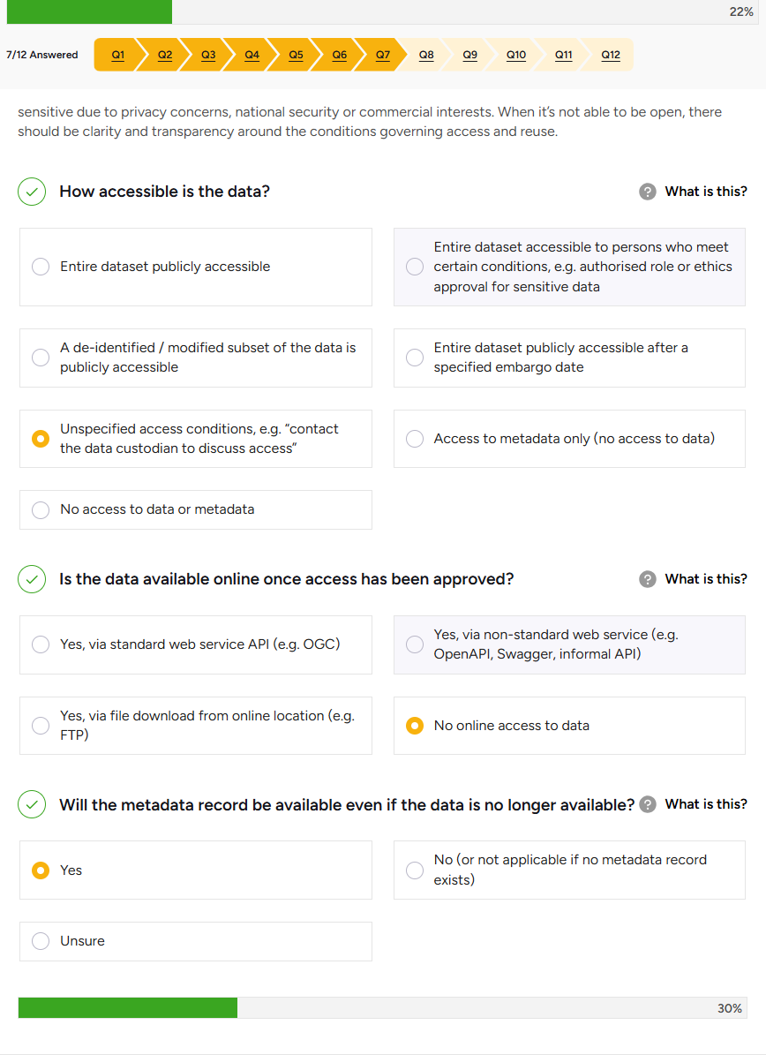

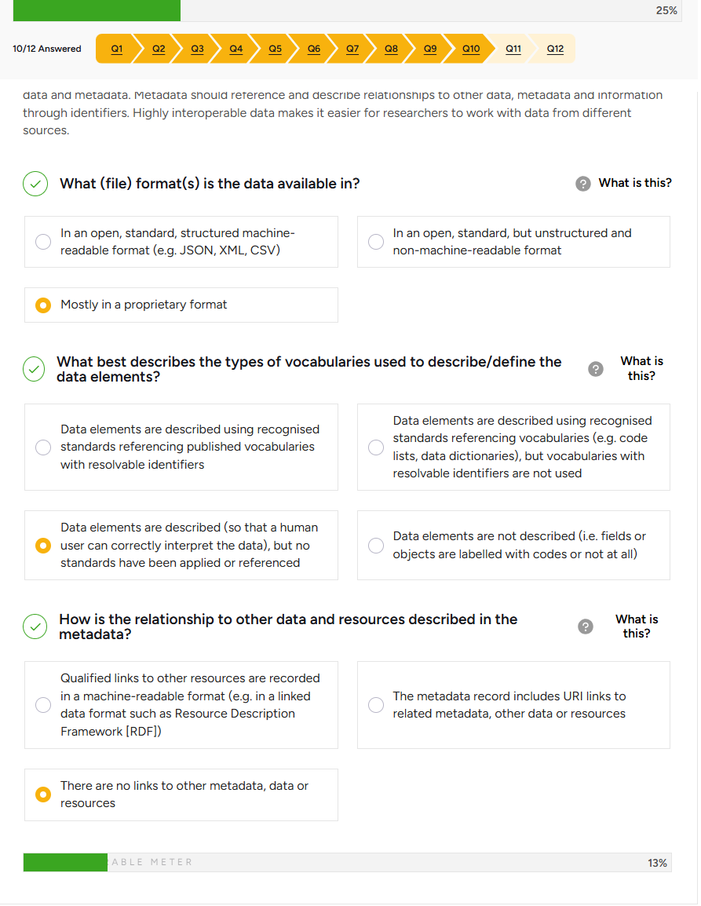

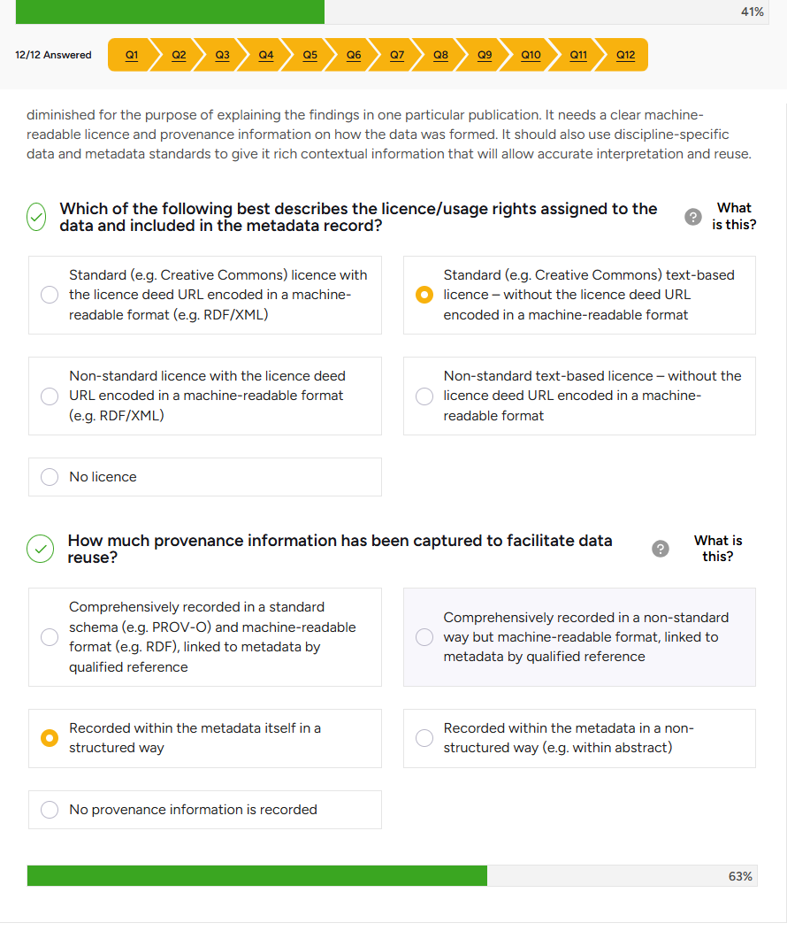

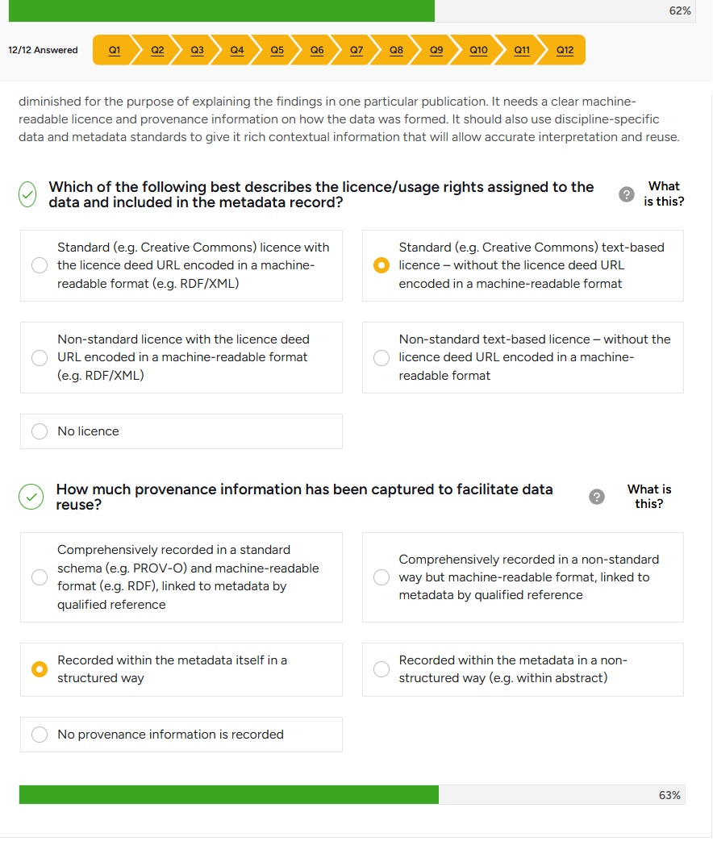

Relationship between Self-Regulated Learning and Student Satisfaction in a Collaborative Science Communication Task [DATASET]
Handle: https://hdl.handle.net/10366/169282 DOI: 10.71636/62ec-4b45 Estado: Abierto
